The following describes the “how to” for Ordering, Billing and Repair of CALSC services, features, equipment, and support services.

Table of Contents

For information specific to the Chicago Area Local Service Contract, please refer to this web site: 2
AT&T Price Quotes 3
AT&T Order Submission 4
Service Order Support and Process 4
Process for Submitting Orders 5
Information for a Service Order 5
Centralized Ordering Process-Migration/Local Service coming from another local provider 5
Centralized Ordering Process- 6
Post Migration/ New/ Change/ Disconnect Service 6
Direct Order Direct Bill Ordering Process- 7
New Local Service coming from another local provider 7
Direct Order Direct Bill Ordering Process- 7
New/ Change/ Disconnect Service 7
CUT SHEET AND PROVISIONING ELEMENTS 8
Service Delivery Points (SDPs) 8
Product Specific Information Required on a Service Order 9
ANALOG SERVICE (POTS) 9
DSL (Digital Subscriber Line) 9
ISDN Prime/PRI 10
ISDN Centrex 10
Electronic Key Line (EKL) Centrex 11
Customer Premises Equipment (CPE) 12
DS1 12
DS3 12
Service Intervals 13
Analog Business Line Interval 13
Centrex Service Intervals 13
ISDN Prime/PRI Service Intervals 14
DS1 Service Interval 15
DS3 Service Intervals 15
AT&T Billing Inquiry 16
Billing Process 16
Points of Contact 16
First Bill Review 16
Billing Disputes 17
AT&T Trouble Reporting 18
Process for Reporting Trouble 18
Escalation Process (Business Hours and After Hours) 18
AT&T Messaging for EM Voicemail 21
APPENDIX A 22
Model 6210T/6210U ISDN Telephone 22
Model 6220T/6220U ISDN Telephone 23
Model 6030X Expansion Module 24
Model 8610T/8610U ISDN Telephone 25
Model 8620T/8620U ISDN Telephone 26
Model 8810T/8810U ISDN Telephone 27
Model 8030X Button Expansion Module 28
APPENDIX B 29
M5316 32
M522 ADD-ON KEYS 15-36 33
APPENDIX C 35
First Bill Review Customer Agreement 35
APPENDIX D 36
Cut sheet-Tab 1 Pages 1 of 2 36
Cut sheet-Tab 1 Pages 2of 2 37
ISDN PRIME/PRI PROVISIONING QUESTIONS 38

For More Information

For additional, general information on AT&T products, services, processes, or policies you may find it at ATT.com

For information specific to the Chicago Area Local Service Contract, please refer to this web site:
http://www.corp.att.com/gov/contracts/chicago_area_local_service_contract.html

AT&T Price Quotes

AT&T’s Government Solutions (AGS) Customer Care Center in Chicago is responsible for all GSA ordering throughout the CALSC area. AT&T provides a toll-free number (1-800-708-0229) or email address (MWFED@ATT.COM) for the GSA to contact for all locations included in the contract. AT&T provides several service representatives to work with the GSA on requests and issues as needed and would include providing price quotes.

- Sr. Sales Support Manager
- Customer Advocates

AT&T Order Submission

One of AT&T’s defining characteristics is its commitment to a culture striving to exceptional Order and Bill Inquiry customer support. AT&T’s philosophy is rooted in a highly personalized approach that values the unique needs of a customer. Our AGS Customer Care vision is to provide world-class service that exceeds our customer’s expectations. AT&T provides several service representatives to work with the GSA on requests and issues as needed and would include initiating and accepting service orders, change orders, and disconnect orders. When needed, AT&T will coordinate with incumbent vendors to assure everything necessary to complete service has been accomplished and will notify the Government as required.

Orders must be written and may be placed by email or fax (see contact information below). Members of your AT&T Government Solutions Customer Care Team are available via phone (toll-free number 1-800-708-0229) to discuss questions you may have. The AT&T Customer Care Team is located in Chicago and is responsible for all ordering throughout the CALSC Area. Following are the means of contacting the AGS Customer Care Team:

Points of Contact

- Toll-Free Customer Contact Number: 1-800-708-0229
- Email Address (to place orders): MWFED@ATT.COM (new requests) or MWFEDWB@ATT.COM (migration orders)
- Fax Number (to place orders): 1-800-477-1176

Service Order Support and Process

The AGS Customer Care Team will assist you with your ordering issues. They include:

- Providing support for customer questions and inquires
- Internal Customer Advocate working to service the account
- Handling your requests about our products and services
- Providing service order price quotes
- Coordinating due dates
- Changing orders as requested
- Disconnecting of services as requested
- Offering products and services to improve customer service
- Handling Direct Order/Direct Bill ordering

Process for Submitting Orders

Submit written orders to AGS Customer Care via email (MWFED@ATT.COM) for new orders, (MWFEDWB@ATT.COM) for migration orders or fax to 1-800-477-1176. Reference CALSC Contract number (GS05T07BMD0009) in subject line.

A receipt acknowledgement will be provided to the Agency within 24 hours (one business day) of receipt.

Agency will be contacted by an AT&T Customer Advocate within 48 hours (two business days) of order receipt.

Once order is completed, AT&T will provide order confirmation. Order confirmation, to include order number, due date, and additional order detail, will be captured on the Service Order Confirmation and Tracking Report. This report will be provided to the cognizant CALSC Contracting Officer and COTR on a weekly basis.

Information for a Service Order

Centralized Ordering Process-Migration/Local Service coming from another local provider

Submit TOPS order to MWFEDWB@ATT.COM.

TOPS order shall contain the following at a minimum:

- Time and date service order was submitted
- Service order number
- Agency Bureau Code – which uniquely identifies the agency
- Billing Account Code – which uniquely identifies the agency cost center
- Location Code – which uniquely identifies the building to be served
- Room number
- User group order number (including priority) – which defines the Class of Service and the features that shall be assigned to the line
- Point of contact and telephone number
- Work description (including specific data such as classmark, equipment assigned)
- Requested completion date. (Note if expedited due date is required and agreement to additional charge.)
- Types of service ordered with applicable CLINs
- Status of service order
- Actual completion date and time
- Cost associated with service order
- Identification of circuit and station line
- Remarks
- Signed LOA giving AT&T permission to transition service
- Indicate on the order request that the order is to be issued and billed under the Chicago Area Local Service Contract, Contract Number GS05T07BMD0009
- Site contact and telephone number and an alternate name and number, if available
- AT&T billing account number (master BTN)
- Agency billing contact name and telephone number
- Additional provisioning information needed. Example: 900/976 blocking, long distance carrier, line features, and SDP location (inside wiring)
- Identify if on-site personnel is required for cut over

Centralized Ordering Process-

Post Migration/ New/ Change/ Disconnect Service

Submit TOPS order to MWFED@ATT.COM.

TOPS order shall contain the following at a minimum:

- Time and date service order was submitted
- Service order number
- Agency Bureau Code – which uniquely identities the agency
- Billing Account Code – which uniquely identifies the agency cost center
- Location Code – which uniquely identifies the building to be served
- Room number
- User group order number (including priority) – which defines the Class of Service and the features that shall be assigned to the line
- Point of contact and telephone number
- Work description (including specific data such as classmark, equipment assigned)
- Requested due date. (Note: if expedited due date is required and agreement to additional charge.)
- Types of service ordered with applicable CLINs
- Status of service order
- Actual completion date and time
- Cost associated with service order
- Identification of circuit and station line
- Remarks
- Indicate on the order request that the order is to be issued and billed under the Chicago Area Local Service Contract, Contract Number GS05T07BMD0009
- Site contact and telephone number and an alternate name and number, if available
- The AT&T billing account number (master BTN)
- Agency billing contact name and telephone number
- Additional provisioning information needed. Example: 900/976 blocking, long distance carrier (PIC/2PICC), line features, and SDP location (inside wiring)
- Identify if on-site personnel is required for cut over

Direct Order Direct Bill Ordering Process-

New Local Service coming from another local provider

Authority must be obtained by Agency Contracting Officer prior to placing orders.

Submit order to MWFEDWB@ATT.COM

Information to be included in order:
- Name of Agency
- Name and telephone number of person placing the order
- Billing contact name and telephone number
- Confirmation of availability of funds (fund citation)
- Signed LOA giving AT&T permission to transition service
- Indicate that order is to be issued and billed under the Chicago Area Local Service Contract, Contract Number GS05T07BMD0009
- Types of service ordered with applicable CLINs
- Additional provisioning information needed. Example: 900/976 blocking, long distance carrier (PIC/2PICC), line features, and SDP location (inside wiring)
- Site contact and telephone number and an alternate name and number, if available
- Requested due date. (Note if expedited due date is required and agreement to additional charge.)

Direct Order Direct Bill Ordering Process-

New/ Change/ Disconnect Service

Authority must be obtained by Agency Contracting Officer prior to placing orders.

Submit order to MWFED@ATT.COM

Information to be included in order:
- Name of Agency
- Name and telephone number of person placing the order
- Billing contact name and telephone number
- Confirmation of availability of funds (fund citation)
- The AT&T billing account number if existing service
- Indicate that order is to be issued and billed under the Chicago Area Local Service Contract, Contract Number GS05T07BMD0009
- Types of service ordered with applicable CLINs
- Additional provisioning information needed. Example: 900/976 blocking, long distance carrier (PIC/2PICC), line features, and SDP location (inside wiring)
- Site contact and telephone number and an alternate name and number, if available
- Requested due date. (Note: if expedited due date is required and agreement to additional charge.)

CUT SHEET AND PROVISIONING ELEMENTS

The cut sheet and provisioning elements were developed as an aid for client visits and data gathering to support the ordering process. The required data elements gathered within the cut sheet are to be provided in the respective Government issued service order remarks section. An example is the remarks section of the TOPS order. See Appendix D

Service Delivery Points (SDPs)

SDP is the interface point for the physical delivery of a service. Each SDP is defined as the combined physical, electrical, and service interface between the AT&T network and the Government’s on-premises equipment, off-premises switching and transmission equipment, and other facilities, such as those provided by telephone central offices. The SDP must be identified on all orders and ordered through use of appropriate CLIN.

- SDP 1
Terminate at the demarcation point.
Tag at the termination point.

- SDP 2-PBX
Tie into the 66 block
Tone and tag on the inside cable from the NID to PBX location
Tag at the termination point

- SDP 2-Multiplexer
Tone and tag on inside cable to multiplexer location
Tag at the termination point

- SDP 3
Terminate at the demarcation point
Tone and tag on the inside cable to Intermediate Distribution Frame (IDF)
Tone and tag on inside cable to jack
Tag at the termination point
Install jack

- SDP 4
Run tone and tag on inside cable to desktop location
Tag at the termination point

Product Specific Information Required on a Service Order

ANALOG SERVICE (POTS)
This information is required to order Analog Service:

- Hunting if required
- Features
- Interlata and Intralata long distance carrier selection (s)
- SDP location:
  - SDP 1
  - SDP 2
  - SDP 3
  - SDP 4

DSL (Digital Subscriber Line)

This information is required to order DSL:
- The phone number the High Speed Internet (HSI) service will line share.
- The DSL Plan: Dynamic or Static
- If Dynamic is ordered: Basic, Express, Pro, Elite
- If Static is ordered: Express-S, Pro-S, Elite-S, Symetric-S
- Equipment options: DSL modem or AT&T Wireless Gateway
- Computer type: Dell, IBM, Apple, etc.
- Operating system: Microsoft, Macintosh, or Linux
- Shipping address: (Note: Cannot ship to a PO Box, must have valid shipping address.)

ISDN Prime/PRI

This information is required to order ISDN Prime/PRI:
- ISDN Protocol: National (N12) or Custom (NI1)
- D channel configuration: Primary or Back-up D channel
- Digits outpulsed: 4-10 digits depending on protocol type and switch type
- Interlata and Intralata long distance carrier selection(s)
- Trunk direction: Two-way call-by-call, One-way DID, or One-way DOD
- Central office hunting: Ascending or Descending
- Glare: CPE yields or Central Office yields
- Quantity of DID station numbers
- Dialing code conflicts
- CPE make/model
- Number of Trunk Groups
- Caller ID Name (Number only is included in the ISDN Prime/PRI)
- SDP location:
- SDP 1
- SDP 2

ISDN Centrex

This information is required to order ISDN Centrex:
- Equipment Set Type:
  - 6210T or 6210U
  - 6220T or 6220U
  - 6030X
  - 8610T or 8610U
  - 8620T or 8620U
  - 8810T or 8810U
  - 8030X
- Equipment set template with key designation. See Appendix A
- Circuit switched voice or circuit switched data
- Interlata and Intralata long distance carrier selection(s)
- SDP location:
  - SDP 1
  - SDP 2
  - SDP 3
  - SDP 4

Electronic Key Line (EKL) Centrex

This information is required to order EKL Centrex:
- Equipment Set type:
  - M5008
  - M5208
  - M5216
  - M5316
  - M522
- Equipment set template with key designation. See Appendix B
- SDP location:
  - SDP 3
  - SDP 4

Customer Premises Equipment (CPE)

This information is required to order CPE:
- Set Type and part number. Example: Set type 8009, Part number A1215-0000-11-99
- Color of phone: Black or Ash
- Drop ship or install
  - If drop ship, provide address, site name and number
  - If install, provide site contact name, telephone number, and applicable labor CLIN on TOPS order.
- Specific type of jack or cable required. Example: RJ11C jack and Cat 5 cable
- Special site requirements. Example: historic building or environmental issues

DS1

This CPE information is required to order DS1:
- The address for each end
- Site contact name and telephone number at each end
- Line coding:
  - Clear Channel with ANSI
  - Clear Channel without ANSI
  - AMI (non clear channel)
- Formatting:
  - D4(super frame)
  - Extended Super Frame-ANSI
  - Extended Super Frame- without ANSI
- If riding a channel of DS3, provide the following:
  - DS3 CFA
  - DS3 Channel
- SDP location:
  - SDP 1
  - SDP 2

DS3

This CPE information is required to order DS3:
- The address for each end
- Site contact name and telephone number at each end
- Line coding:
  - Clear Channel with ANSI
  - Clear Channel without ANSI
  - AMI (non clear channel)
- Formatting:
  - D4 (super frame)
  - Extended Super Frame-ANSI
  - Extended Super Frame- without ANSI
- If riding a SONET node, provide the following:
  - SONET CFA
  - SONET SCID number
  - SONET Slot
- SDP location:
  - SDP 1
  - SDP 2

Service Intervals

Service availability intervals vary by product. Following are standard intervals for routine installations. For expedited service, the intervals are negotiable as they are in emergency situations. AT&T will always work with the ordering agent to meet their requests, if possible.

Analog Business Line Interval
Order Activity | Due Date Interval
New/Change/Disconnect | Within 5 business days

Centrex Service Intervals
Order Activity | Centrex Service | Quantity of Lines | Interval (business days)
New | Noncomplex | 1 to 25 | 5 days
New | Noncomplex | 26 to 50 | 10 days
New | Noncomplex | 51+ | Negotiated
New | Complex | 1 to 50 | 10 days
New | Complex | 51+ | Negotiated
Change | Noncomplex  /Complex (Both) | 1 to 5 | 3 days
Change | Noncomplex  /Complex (Both) | 6 to 25 | 5 days
Change | Noncomplex  /Complex (Both) | 26 to 50 | 10 days
Change | Noncomplex  /Complex (Both) | 51 + | Negotiated
Disconnect | All | All | 3 days
Note:
New is defined as establishing a new Centrex common block or establishing new, any of the features identified as Complex service.
Change activity includes adding, removing or changing features, rearrangements, inside moves, and conversions.
Complex is defined as orders requesting the following services: Automatic Call Distribution (ACD), Automatic Route Selection (ARS), Electronic Key Line Sets (EKL), ISDN Sets, Music On Hold (MOH), and Uniform Call Distribution (UCD).
Non-Complex is defined as orders requesting services that are not identified as complex.

ISDN Prime/PRI Service Intervals
If the Number of Primes/PRI Ordered Is: | And: | And the Switch Type Is: | Then the Due Date Interval Will Be:
Four Primes/PRI or Less | Cards Only are Needed | DMS100 or EWSD | 15 business days.
Four Primes/PRI or Less | Cards Only are Needed | 5ESS | 15 business days
Five or More Primes/PRI | Cards Only are needed | Any Switch Type | Negotiated
Four Primes/PRI or Less | Infrastructure is Needed | Any Switch Type | Due Date cannot be established until the infrastructure is in place.  15 Business Days from the “Facility Available” Date.
Five or More Primes/PRI | Infrastructure is Needed | Any Switch Type | Negotiated

DS1 Service Interval

Order Activity | Due Date Interval
New | 7 business days
Change | 7 business days
Disconnect | 7 business days

DS3 Service Intervals
IF | THEN
1 DS3 - capacity/ construction interval available | 15 business days
1 DS3 - capacity/construction interval not available | Negotiated based on construction.
More than 1 DS3 - capacity/construction interval available  More than 1 DS3 - capacity/construction interval not available | Negotiated  Negotiated based on construction.

AT&T Billing Inquiry

The AT&T Government Solutions (AGS) Custom Billing organization manages all elements of billing whether inquiries, invoices, or adjustments. Government designated representatives may contact the AGS billing representative by telephone or email.

The AGS Custom Billing group is available to support the Government’s billing issues. The contact number is 847-898-3295 or email TM219E@ATT.COM. The GSA designated representatives may contact AT&T via email or phone during office hours of 8 A.M. to 5 P.M. Central time, Monday through Friday.

Billing Process

The AGS Custom Billing Support Team will assist you with billing issues or questions. They include:
- Handling questions about your bill
- Handling customer credits
- Billing reconciliation and validation
- Tracking Centralized and Direct billing or payments

Points of Contact

Following are your primary AGS Custom Billing Support contacts:
- Customer Contact Number: 847-898-3295
- Email Address: tm219e@ATT.COM
- Billing Implementation Manager: Julia Neuberg 847-898-2272
- Billing Specialist: Theresa Malone 847-898-3295

First Bill Review

The Billing Implementation Manager (BIM) will schedule the first bill review with the customer within 10 business days of the customer invoice being sent to the customer.

In the first bill review meeting with the customer, the BIM will:
- Provide the customer pertinent contact information.
- Review the bill, noting any billing discrepancies or changes that may be needed to modify the invoice.
- Document negotiated modifications and follow-up commitments and dates.
- Ensure the customer representative is agreeable with the charges.
- Negotiate and finalize the customer payment process.

The “First Bill Review Customer Agreement” form will be used in the first bill review meeting. A customer signature on the form is appropriate and required upon completion of the review. (Alternatively, email completed form from the customer if not face-to-face meeting, email will substitute for signature). See Appendix C for form.

Billing Disputes

Should a billing dispute arise, the following steps should be followed:
- Contact the customer inquiry line at 847-898-2154
- Provide the bill number and specifics of dispute in writing.
- Government billing agent must contact AT&T within seven business days of receipt of bill, per FAR 52.232-25 Prompt Payment(3) with reasons why it is not a proper invoice. Invoice is due and payable within 30 days.

AT&T Trouble Reporting

AT&T provides trouble reporting for customers as described below:

Hours of Operation: The trouble reporting centers are maintained 24 hours a day, 7 days a week, 365 days a year.

Process for Reporting Trouble

The following information will be required to help ensure adequate trouble handling:
- Telephone or circuit ID number
- General description of the problem
- Location the customer is experiencing the trouble
- Type of equipment currently in use at the premise
- Name and number of person reporting the trouble
- Access Hours and contact number in the event that a dispatch is required

Service Levels are defined by Number and Users Affected
- Severity 1 - 50 or more users affected at a site
- Severity 2 - 2 to 49 users affected at a site
- Severity 3 - Single user affected at a site

Escalation Process (Business Hours and After Hours)

The decision to escalate should be based upon an assessment of whether or not the repair process is proceeding in an acceptable manner for the GSA. All initial trouble reports and escalations should be made to the MAC repair number 1-877-888-5622. At any time, if the GSA’s business needs are not being met, the GSA may escalate a repair situation. The AT&T Service Executive is available to meet your business needs, and may be contacted at any time after a trouble ticket has been submitted via 1-877-888-5622.

Additionally, AT&T will proactively monitor all routine and emergency trouble tickets to promote efficient resolution. In the event that a ticket is not progressing satisfactorily, AT&T will initiate an internal escalation procedure. Additionally, AT&T will proactively monitor all routine and emergency trouble tickets to promote efficient resolution. In the event that a ticket is not progressing satisfactorily, AT&T will initiate an internal escalation procedure. The standard timeframe for the escalation process is one hour. Each hour a ticket remains open after the initial escalation results in escalation to the next level.

Following are some examples of AT&T internal trouble report escalations, which may vary within a repair center and by type of service:

OC-3 and above
- Immediate notification of 1st thru 3rd level managers

DS3
- Immediate notification of 1st thru 2nd level managers

DS1 (includes ISDN PRI)
- After 2 hours, notification of 1st level manager
- After 3 hours, notification of 2nd level manager
- After 4 hours, notification or 3rd level manager

All designed services below DS1
- After 3 hours, notification of 1st level manager
- After 4 hours, notification of 2nd level manager
- After 5 hours, notification of 3rd level manager

This information refers to the escalation within a repair center to their managers and applies to maintenance issues and not to any installation related problems. AT&T will provide trouble report and performance information to customer organizations at mutually agreed upon frequency. Information regarding the number of trouble reports received, the speed at which the telephone is answered, and mean time to restoration will be provided in the performance reports.

If the estimated restoration time at the time trouble is reported is not acceptable, the AT&T representative will follow the existing escalation procedures to negotiate a new restoration date and time.

When making an escalation, the following information should be provided to the Major Accounts Center (MAC):
- AT&T circuit number/or ticket number
- An explanation of the reason for escalation
- The desired commitment for restoration

MW MAC Escalations | ILLINOIS
Repair Escalations | Friday 16:30 to Monday 08:00.  1st Level escalations to 877-888-5622, ask for the weekend duty manager.
1st Escalation | 877-888-5622
2nd Escalation  In addition to 2nd level escalation contact Service executive for critical outages. | Andrew Lusk  Operations Manager  (w) 312-364-7400  (p) 708-988-4896  al4734@att.com  (F) 312-364-1707  Clara Garza  (w) 312-364-1700  cg7465@att.com  (f)312-364-2271  (p) 312-903-0120
3rd Escalation | Kevin Murray  Escalation Manager  (w) 312-364-7447  (p) 312-689-1224  km2727@att.com  (f)312-364-1707
Tier II  3rd LVL Contact | Richard Keppel  Service Executive  (w) 213 743-3725  (C) 213 321-4128  rk2397@att.com
4th Escalation | Michael Kravchuk  Associate Director  (w) 312-364-6900  (p) 312-333-0365  mk4725@att.com  (f) 312-364-1707
OFF HOURS FOLDDOWN  (back-up or carry-over for other management centers) | Jack Reindt  Reg Folddown Mgr  (w) 312-364-6111  (p) 312-839-9774  jr2726@att.com  (f)312-364-1707  Hours: 1600-0000 CST
SERVICE MANAGEMENT | For major outages /critical service in addition to reporting to Repair, the following may be contacted for Tier II support.
Tier II 3rd LVL Contact | Richard Keppel  Service Executive  (w) 213 743-3725  (C) 213 321-4128  rk2397@att.com
3rd LVL Contact | Gary Bell  Area Mgr-Svc Mgmt  (w) 213-743-3722  (p) 951-270-4058  gb1324@att.com  (f)213-742-1872

AT&T Messaging for EM Voicemail

All initial trouble reports and escalations shall be made to the EM Voicemail Repair Center 1-888-808-8818. The AT&T EM Voicemail Technical Services Manager is available to meet your business needs, and may be contacted at any time after a report has been submitted.

Techincal Services Executive: Sharon Amerson 713-567-1688
Hours: 24 hours a day, 7 days a week

Technical Services Executive: Jennifer Berend 760-942-1762
Hours: 24 hours a day, 7 days a week

APPENDIX A

Model 6210T/6210U ISDN Telephone

A-1

Model 6220T/6220U ISDN Telephone

A-2

Model 6030X Expansion Module
(with 6210 / 7210 telephone) (with 6220 / 7220 telephone)

A-3

Model 8610T/8610U ISDN Telephone

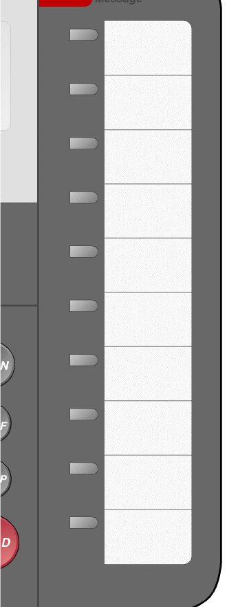

A-4

Model 8620T/8620U ISDN Telephone
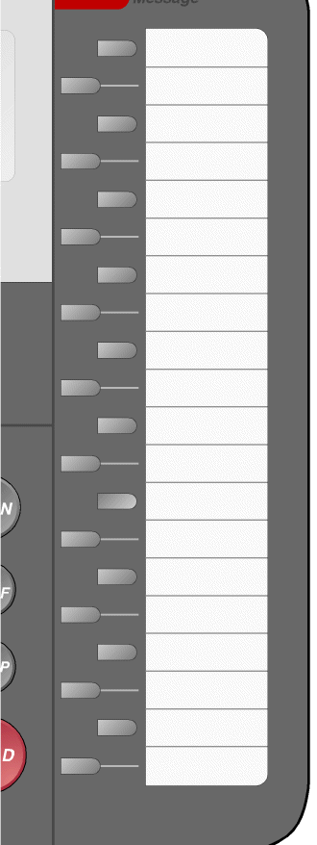

A-5

Model 8810T/8810U ISDN Telephone

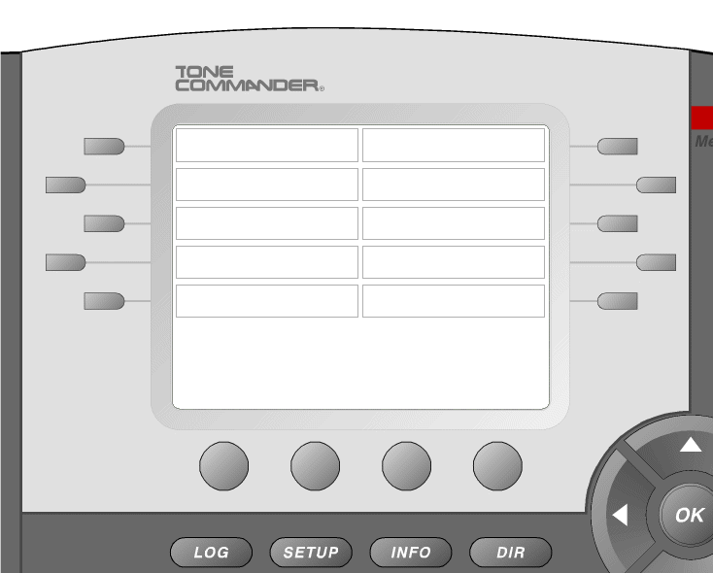

A-6

Model 8030X Button Expansion Module

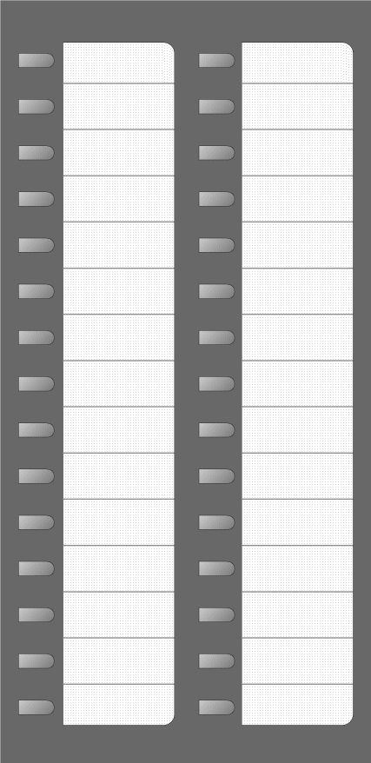

A-7

APPENDIX B
M5008

M5008
KEY 8:
KEY 7:
KEY 6:
KEY 5:
KEY 4:
KEY 3:
KEY 2:
KEY 1:

B-1

M5208

M5208
KEY 8:
KEY 7:
KEY 6:
KEY 5:
KEY 4:
KEY 3:
KEY 2:
KEY 1:

B-2

M5216

M5216
HANDSFREE | MUTE
PROGRAM | KEY 7:
KEY 13: | KEY 6:
KEY 12: | KEY 5:
KEY 11: | KEY 4:
KEY 10: | KEY 3:
KEY 9: | KEY 2:
KEY 8: | KEY 1:

B-3

M5316

M5316
HANDSFREE | MUTE
PROGRAM | KEY 7:
KEY 13: | KEY 6:
KEY 12: | KEY 5:
KEY 11: | KEY 4:
KEY 10: | KEY 3:
KEY 9: | KEY 2:
KEY 8: | KEY 1:

B-4

M522 ADD-ON KEYS 15-36

M522 | ADD ON KEY 15-36
KEY 25: | KEY 36:
KEY 24: | KEY 35:
KEY 23: | KEY 34:
KEY 22: | KEY 33:
KEY 21: | KEY 32:
KEY 20: | KEY 31:
KEY 19: | KEY 30:
KEY 18: | KEY 29:
KEY 17: | KEY 28:
KEY 16: | KEY 27:
KEY 15: | KEY 26:

B-5
M522 ADD-ON KEYS 37-58

M522 | ADD ON KEYS 37-58
KEY 47: | KEY 58:
KEY 46: | KEY 57:
KEY 45: | KEY 56:
KEY 44: | KEY 55:
KEY 43: | KEY 54:
KEY 42: | KEY 53:
KEY 41: | KEY 52:
KEY 40: | KEY 51:
KEY 39: | KEY 50:
KEY 38: | KEY 49:
KEY 37: | KEY 48:

B-6

APPENDIX C

First Bill Review Customer Agreement



AT&T GOVERNMENT SOLUTIONS CUSTOM BILLING
FIRST BILL REVIEW CUSTOMER AGREEMENT FOR EACH PRODUCT

CUSTOMER NAME:______________________________

CUSTOMER REPRESENTATIVE REVIEWING BILL:_________________
TITLE:_____________________ORGANIZATION:________________________

CONTRACT NAME____________ CONTRACT # :__________________________

DATE OF FIRST BILL:____________________
FBR MEETING DATE: ________________________

BIM NAME:___________________________
PROGRAM/PROJECT/ACCOUNT MANAGER NAME:______________________
DATE/TIME OF FIRST BILL REVIEW MEETING/CALL:________________

DISCREPANCIES UNCOVERED: _____ YES _____NO
TARGETED DATE TO RESOLVE DISCREPANCIES: _____________________

CUSTOMER ACKNOWLEDGEMENT:

I ______________________, have reviewed the bill and understand the charges on the bill. I agree that this meets the contractual requirements for payment to AT&T.

Customer Signature:____________________________________Date:_____________
C-1

APPENDIX D

Cut sheet-Tab 1 Pages 1 of 2

GSA TOPS ACCOUNT NUMBER | TOPS VENDOR ORDER NUMBER | CUSTOMER NAME | TYPE OF SERVICE (CENTREX/EKL/ISDN CENTREX) | CLIN | TYPE OF ORDER(MIGRATION/NEW) | PHONE NUMBER

D-1

Cut sheet-Tab 1 Pages 2of 2

NON FEATURES/ FEATURE PKG # | PIC/2PIC | KEY SHEET/ CONFIG NAME | ISDN NATIONAL/CUSTOM | SDP | LINE BLOCKING 411/555 | LOCATION(FLR, SUITE) | REMARKS
D-2

ISDN PRIME/PRI PROVISIONING QUESTIONS

AT&T Local Voice Services
General Service Request Form
Provisioning Questions for ISDN PRIMES/PRI
Local ACCESS CONTACT NAME AND NUMBER?
TYPE OF ISDN PRIME LINE? Custom (NI1) or National (NI2)?
# OF PRIMES?
CODE CONFLICTS?
D CHANNEL CONFIGURATION, 1 per prime or back up?
# OF TRUNK GROUPS?
# OF DIGITS OUTPULSED ?(from central office to pbx)
# OF DID TELEPHONE NUMBERS?
PIC_ ____ AND 2 PIC_ ______?
CENTRAL OFFICE HUNTING: ascend (2wf) or decending (2wb)?
GLARE: CPE YIELD OR CENTRAL OFFICE YIELD?
TRUNK DIRECTION:
CALL BY CALL (MOST COMMON) OR DEDICATED DID/DOD’S?
CALLER ID WITH NAME?
WHAT MAKE & MODEL OF CPE?
D-3

