AT&T IP Flexible Reach
Cisco Unified Communication Manager SIP
Configuration Guide

Issue 1.6
5/11/2009

TABLE OF CONTENTS

1 Introduction 3
2 Special Notes 3
3 Overview 5
3.1 Cisco Unified Communication Manager Site 5
3.2 TFTP and DHCP Configuration Guidelines 6
3.3 Cisco Unified Communications Manager Cluster Routing 6
3.3.1 Cisco Unified Communications Manager Initiated Calls 6
3.3.2 AT&T Initiated Calls 6
4 Configuration Guide 7
4.1 Cisco Unified Communication Manager/Unity Version 8
4.2 SIP Trunk 10
4.3 SIP Trunk Security Profile 14
4.4 SIP Profile 15
4.5 Route Group 17
4.6 Route List 17
4.7 Route Pattern 18
4.8 Calling Party Number Translation Configuration 21
4.9 Incoming Call Routing on Telephone Number 23
4.10 Region - WAN 26
4.11 Region – Default 27
4.12 Device Pool – WAN 28
4.13 Device Pool – Default 29
4.14 Media Resource Group 30
4.15 Media Resource Group List 31
4.16 Conference Bridge 32
4.17 Transcoder 33
4.18 Phone Configuration 34
4.19 Service Parameters 35
5 Incremental Cluster Configuration 36
5.1 Cisco Unified Communications Manager Servers used in the Cluster 36
5.2 Cisco Unified Communications Managers used in the Cluster 38
5.3 Cisco Unified Communications Manager Group used in the Cluster 40
5.4 Device Pool used in the Cluster 41
6 Appendix A: Router Version/Configuration for Transcoding and Fax 43
6.1 Router Version 43
6.2 Transcoding Configuration 43
6.3 T.38 Fax Configuration 45
7 Appendix B: Firewall Rules 46

Introduction
This document provides a configuration guide to assist Cisco Unified Communication Manager administrators in connecting to AT&T IP Flexible Reach Services. Please consult your Cisco Unified Communication Manager service manual and user guides for more complete information.

Special Notes

Emergency 911/E911 Services Limitations

While AT&T IP Flexible Reach services support E911/911 calling capabilities in certain circumstances, there are significant limitations on how these capabilities are delivered. Please review the AT&T IP Flexible Reach Service Guide in detail to understand these limitations and restrictions.

Specific IP endpoints are supported – Specific IP endpoints are supported with IP FlexReach. These endpoints must support SCCP and NTE.

The Cisco IP endpoints that support SCCP and NTE are:

VG224
7902, 7905, 7911,7912, 7931, 7937, 7940, 7941, 7942, 7945,
7960, 7961, 7962, 7965, 7970, 7971, 7975
Future new phone models

The Cisco IP endpoints that do NOT support NTE and thus are NOT supported with IP Flexible Reach are:

7910, 7920, 7935, 7936
VG248
DPA-7610, DPA-7630

Please go to the following Cisco link for further information.

http://www.cisco.com/en/US/docs/voice_ip_comm/cucm/srnd/6x/media.html#wp1055031

AT&T IP Teleconferencing Service is not Supported when G.729 is configured on Cisco Unified Communication Manager
Cisco Unified Communication Manager only supports a single codec on an IP trunk. Since the AT&T IP Teleconferencing (IPTC) Service supports G.711, a Cisco Unified Communication Manager configured for G.729 will not work with the IPTC service.

Overview
This section provides a service overview of the Cisco Unified Communication Manager integration with AT&T IP Flexible Reach. The components are shown next.

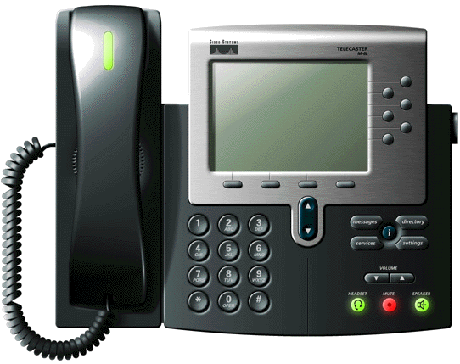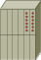
Call Manager IP PBX
Private Side
Legacy Circuit
PBX
Cisco router
With
Voice GW
Public Side
FAX
Cisco
Switch
AT&T
Managed
Router
With NAT
IP Border
Element
Network
Gateway
Border
Element
Application
Server
PSTN
Cisco GW
SIP

Cisco Unified Communication Manager Site
The Cisco Unified Communication Manager site consists of the following components.
- Cisco phones (customer managed) – These may be hard phones or soft phones.
- Cisco switch (customer managed) – This is the Cisco switch to provide power to the phones.
- Cisco Unified Communication Manager IP PBX (customer managed) – This is the Cisco Unified Communication Manager server.
- Cisco analog gateway (customer managed) – This is a Cisco gateway running SIP. The gateway has analog ports for fax. The gateway uses the T.38 protocol to communicate to the Cisco Unified Communication Manager for fax. Note: Fax is supported at speeds up to 9.6kbps. In certain cases, speeds may be limited to 7.2kbps.
- AT&T Managed Router (AT&T managed) – This is the router managed by AT&T. The router shall perform packet marking and QOS for voice. This router will support NAT (dynamic NAT for the phones, static NAT for the Cisco Unified Communication Manager) in the VoPNT VPN configuration.

TFTP and DHCP Configuration Guidelines
The guidelines must be followed for TFTP configuration. Phones at the Cisco Unified Communication Manager must have their TFTP server set to the private address of the local Cisco Unified Communication Manager. This can be configured in the DHCP server used by the Cisco Unified Communication Manager site phones.

Cisco Unified Communications Manager Cluster Routing

The customer must inform AT&T that they have a Cisco Unified Communications Manager cluster. The cluster can be handled by the AT&T IP Flexible Reach Service as described in the following subsections.

Cisco Unified Communications Manager Initiated Calls

If the Cisco IP Phone’s primary CCM is unreachable, the phone will register with the alternate CCM and all calls will be completed using the alternate CCM. When the primary CCM recovers, the phones will re-register to the primary CCM. The AT&T IP Flexible Reach Service can be provisioned to accept calls from both the primary and alternate CCMs. IP Flexible Reach will support up to 5 servers in a cluster.

AT&T Initiated Calls

AT&T will send calls to up to 5 clustered CCM servers in a round robin approach. AT&T sends the SIP options message to determine the availability of each server in the cluster. If one server fails, AT&T may take up to 5 minutes to determine that the server is down. At this point, AT&T will not send any calls to this server. AT&T will send calls to the other servers. AT&T sends out SIP options to periodically check the availability of the failed server. It may take up to 30 minutes to detect the recovery of the failed server.

Configuration Guide
This configuration guide specifies the Cisco Unified Communication Manager screens that must be configured and updated to support the AT&T IP Flexible Reach.

Cisco Unified Communication Manager/Unity Version
For IP Flexible Reach, the Cisco Unified Communication Manager must be running a release of 5.1, 6.0 or 6.1 that is the same or later than the ones shown below. The most recent service release is adequate. You can check the version of Cisco Unified Communication Manager from the about option on the help menu as shown next.

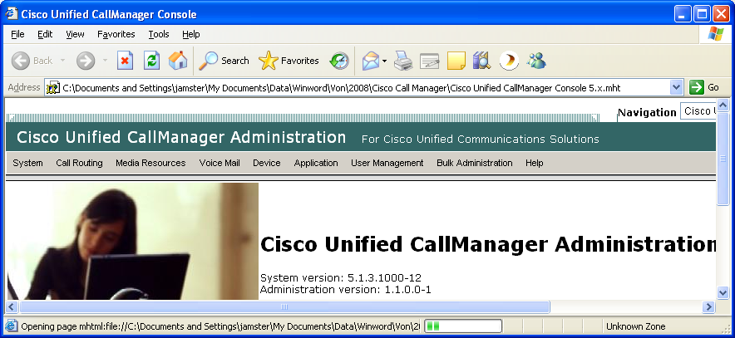

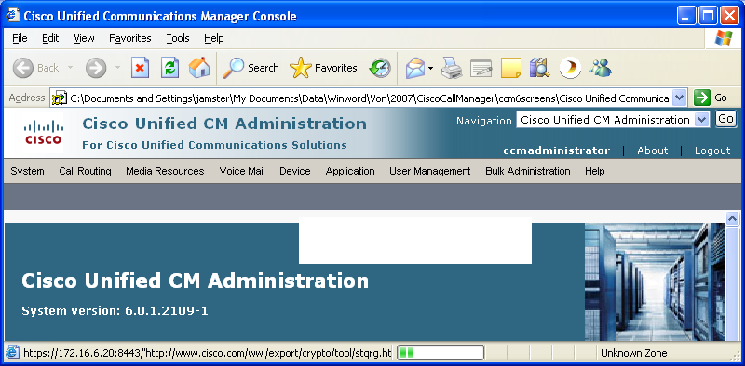

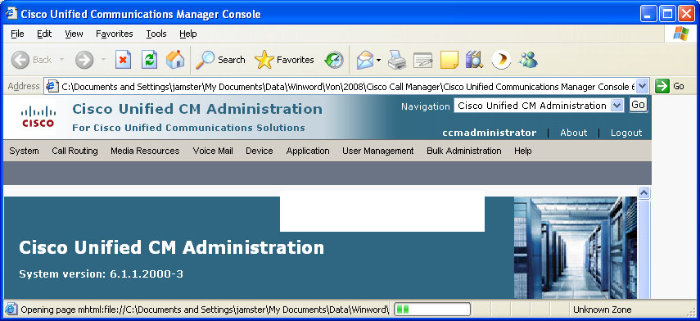

The required Unity Voice Mail version is the following. Without this patch, the customer will experience “blank voice mail” when using Unity as an auto attendant.

TSP 821ES4.

Defects Fixed:
CSCsj13401 - Unity failover results from OpenSSL errors
CSCsk30869 - CME connection reset causes Unity network connectivity issues
CSCsk33686 - RFC2833 digits from secure SIP phones don't work with Unity
CSCsk73751 - Unity should able to record mismatch packetization size
New Behavior: N/A
Post Install Instructions:
1) Stop all Unity services.
2) Extract all files to some location on the Unity server's hard drive.
3) Run SkinnySetup.exe from that location, and follow all instructions.
4) When SkinnySetup.exe completes, reboot the Unity server.
To remove this ES and revert to a previous TSP version, simply perform the installation of the previous version.

SIP Trunk
This screen specifies the parameters for connecting to each of the AT&T Border Elements. Two SIP trunks must be configured (i.e. one for each border element). Note that only border element is shown. It is accessed from the Device menu. Key parameters are:

Device Name: This is the IP address of the AT&T Border Element specified in this trunk screen. Two trunk screens are recommended (one for each AT&T Border Element). Sample IP addresses are shown in the screens.

PLEASE CONTACT YOUR CUSTOMER CARE REPRESENTATIVE FOR THE AT&T IP BORDER ELEMENT IP ADDRESSES FOR YOUR SPECIFIC PBX.

Device Pool: Device pool points to a region that specifies the codec and media resources (e.g. conference bridge, transcoder, etc) to be used.

Significant Digits: Number of right most digits that will be extracted from the called number. For the virtual telephone number (VTN) feature, this field must be set to ALL.

Calling Search Space – If the Cisco Unified Communication Manager phones are assigned to a calling search space, then the calling search space on the gateway form must be set to the same value.

Calling Line ID Presentation – Must set to “Allowed”.

Under SIP information, the following fields must be set.

Destination Address - This is the IP address of the AT&T Border Element specified in this trunk screen. Two trunk screens are recommended (one for each AT&T Border Element). Sample IP addresses are shown in the screens.

Destination Port – Set this to 5060.

SIP Trunk Security Profile – Set this to the “Non Secure SIP Trunk Profile” described in the next section.

SIP Profile – Set this to “Standard SIP Profile-INVITE TIME_3S”. This profile will be discussed in the next section.

DTMF Signaling Method – Set this to RFC 2833.

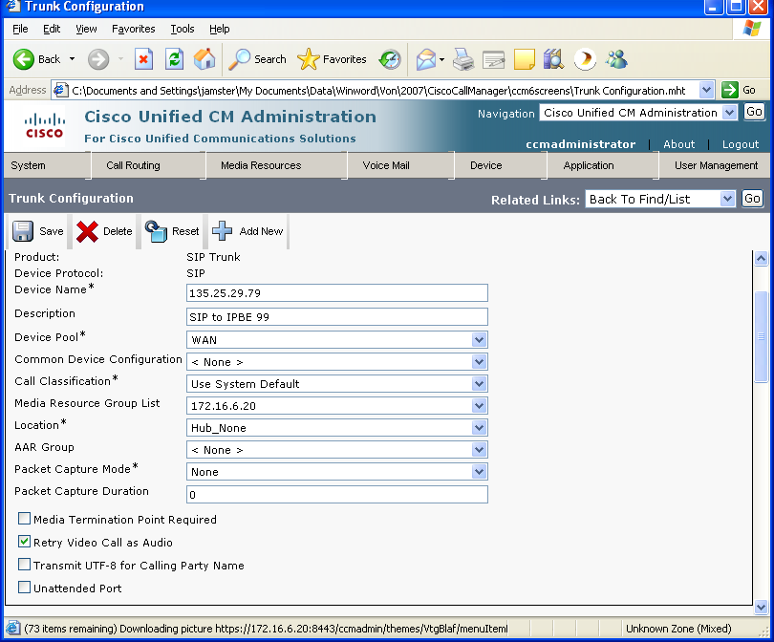

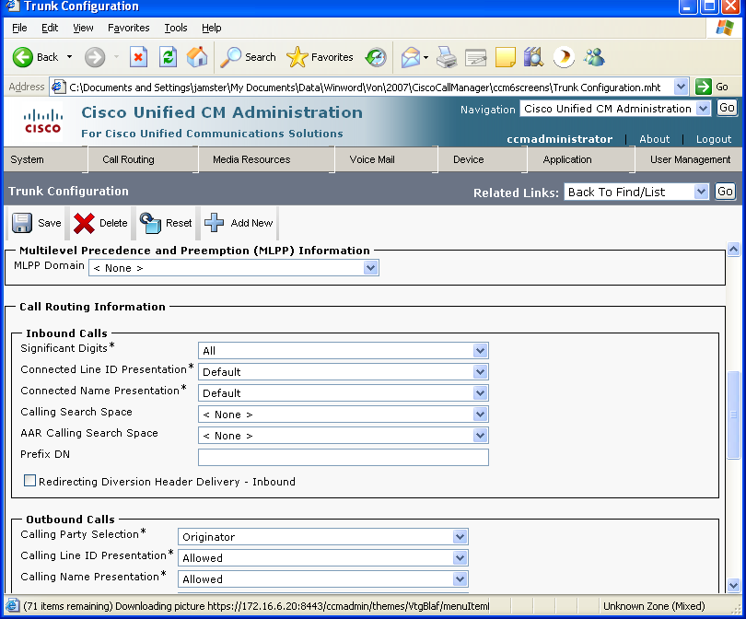

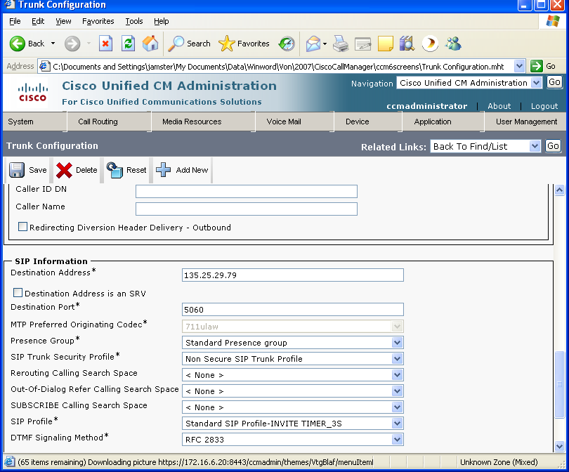

SIP Trunk Security Profile

The SIP trunk security profile is configured from the “security profile” option on the “system” menu.

Key fields are:
Device Security Mode – Set to “Non Secure”

Outgoing Transport Type – Must be set to “UDP”.

Incoming Port – Set to “5060”

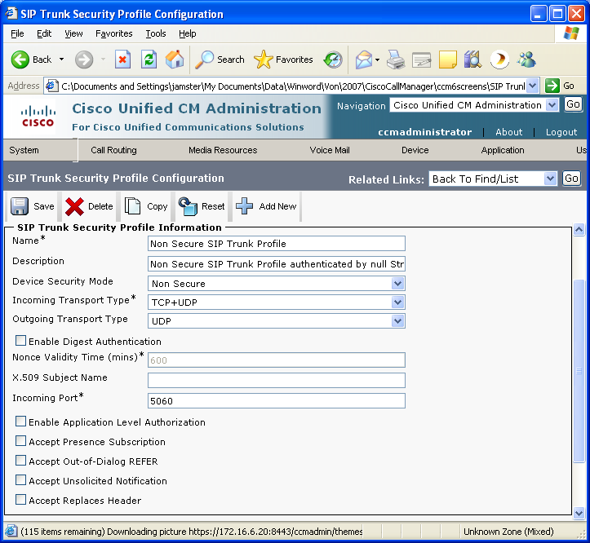

SIP Profile
The SIP profile is configured from the “device profile” option on the “device” menu. Key fields are:

Timer Invite Expires – Must be set to “3”. This is used as the alternate route timer for accessing an alternate AT&T Border Element.

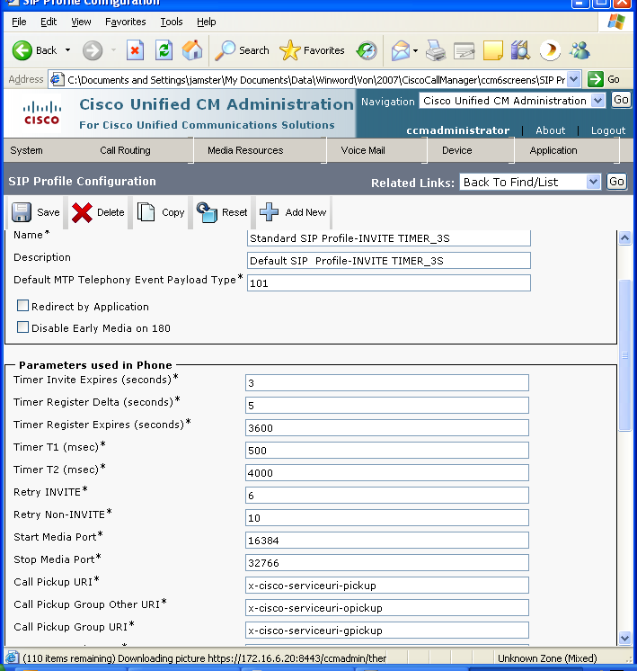

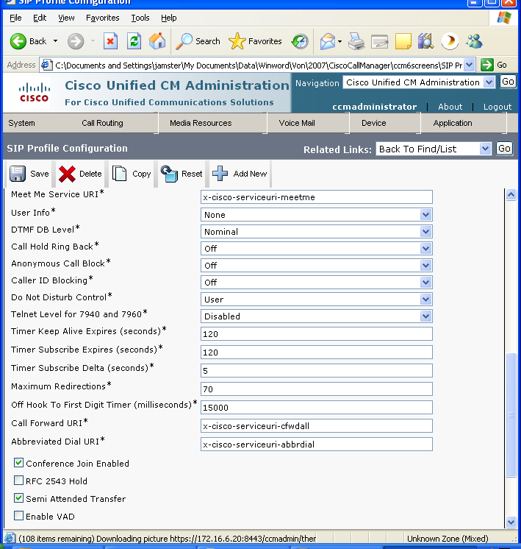

Route Group
The route group specifies a set of alternate routes. If the connection to one AT&T Border element fails, Cisco Unified Communication Manager will attempt a connection to the other border element based on the “Timer Invite Expires” parameter described in the previous section. It is accessed from the Route Plan menu. Key fields are:

Route Group Name: This is name of the route group.
Distribution Algorithm: Set this to top down. The first BE will be primary and the second will be backup.
Selected Devices: These are the trunk devices previously configured.

Route List
In order for the route group to be used in a route pattern, a route group must be put in a route list. It is accessed from the route plan menu. Key fields are:

Route List Name: The name of the route list.
Selected Groups: This is the route group previously defined for the 2 AT&T Border Elements.

Route Pattern
This screen specifies the called number patterns that should be used to determine which calls are to be sent to the AT&T IP Flexible Reach. It is accessed from the Route Plan menu. Multiple route patterns may need to be configured (e.g. for site to site, US offnet and international offnet calls). Key fields include:

Route Pattern: Specifies the dialing prefix and called number match.
Gateway/Route List: Must be set to the route list configured for the dual AT&T Border Elements. If only one border element is being used, this field can contain the trunk defined for that border element.
Use Calling Party’s External Phone Number Mask – It is recommended (but not required) that this field be checked. If this field is checked, then the external phone number mask from the directory number form is used as the calling party number. If desired, a single calling party number mask can be configured in the “Calling Party Transform Mask” on the route pattern screen.
Discard Digits: Discard the dialed digits before the dot.

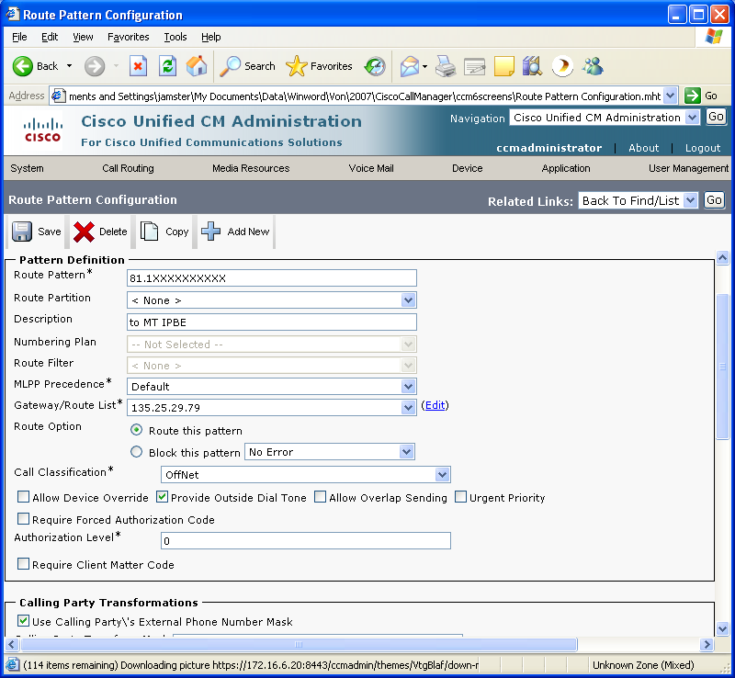

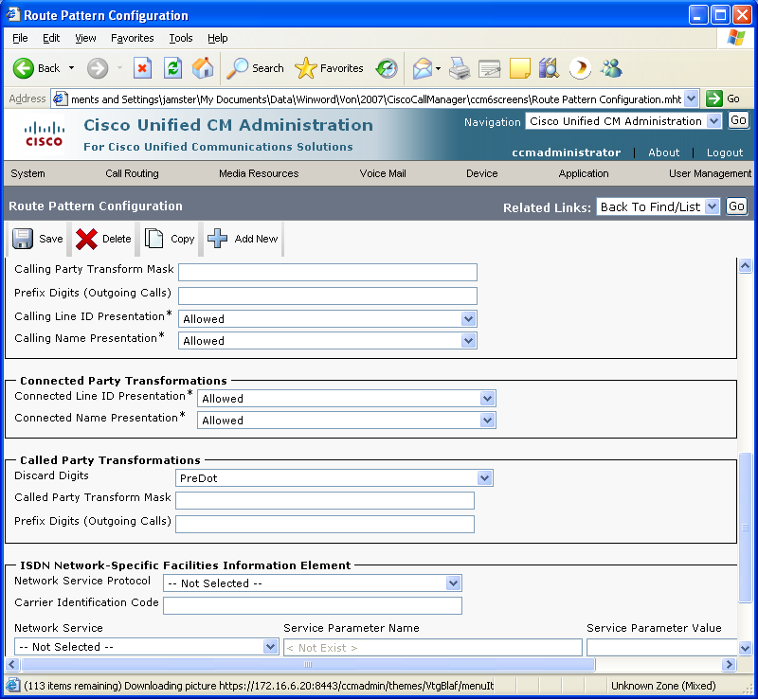

Calling Party Number Translation Configuration

This section specifies how to configure a calling party number translation from an internal extension to a completely different external number. This configuration is required for the Virtual Telephone Number (VTN) feature.

On the directory number screen for the internal extension, set the External Phone Number Mask to the desired external calling party number.

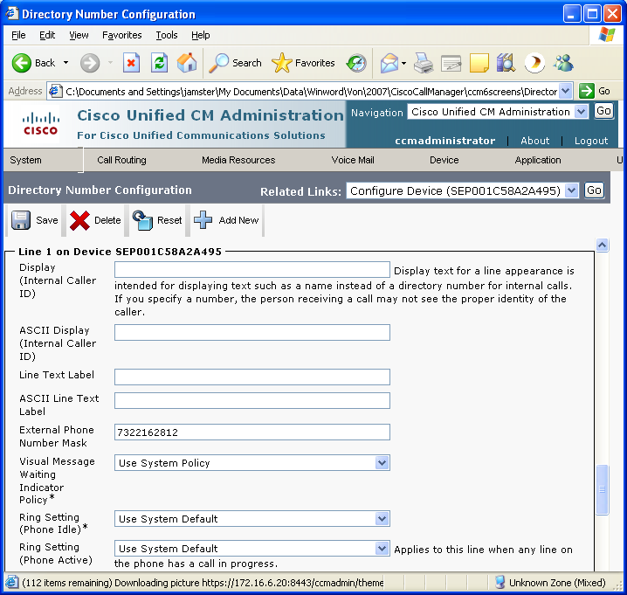

On each route pattern used to route to the AT&T network, check the Use Calling Party’s External Phone Number Mask field. You must remove the entries in the other calling party transformation fields.

Incoming Call Routing on Telephone Number

When using the AT&T Virtual Telephone Number feature (VTN), the AT&T network will send the call to the PBX using a full E.164 public number. This number can be mapped to an internal extension on the following screen.

When using a non virtual Telephone Number, the AT&T network will send the call to the PBX using 7 digits or less as requested by the customer.

On the translation pattern screen, put the called number sent from AT&T in the translation pattern field and put the internal extension in the called party transform mask field. This example maps the public called number “7323684812” to the internal extension “6004” for internal routing.

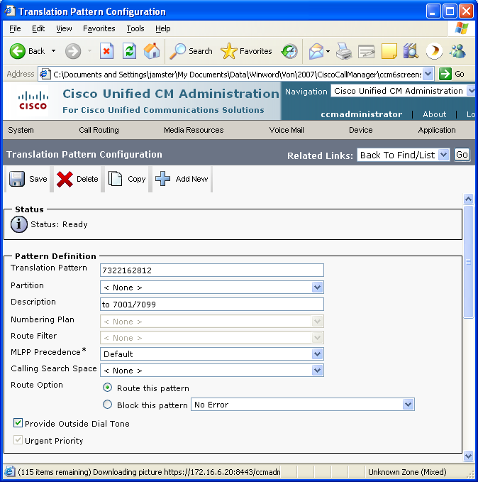

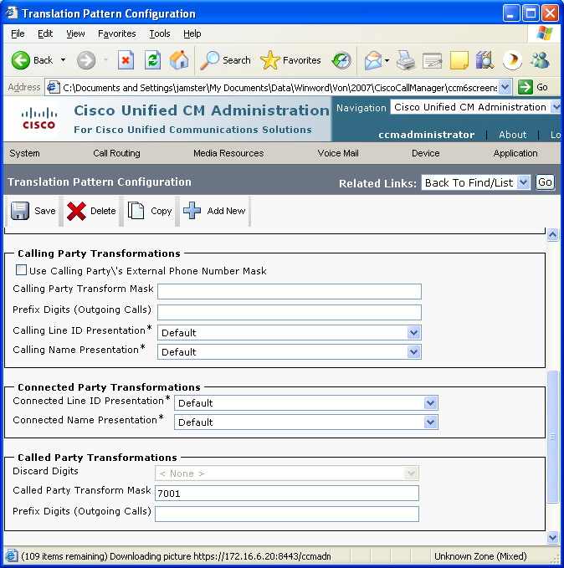

Region - WAN
The region specifies the codec to be used for devices that point to this region. This particular region is used by devices associated with the AT&T Border Elements. This screen is accessed from the system menu. Key fields are:

Default: Specifies that the G.729 codec to be used with the default region.
WAN: Specifies that the G.729 codec to be used with other devices in this region.

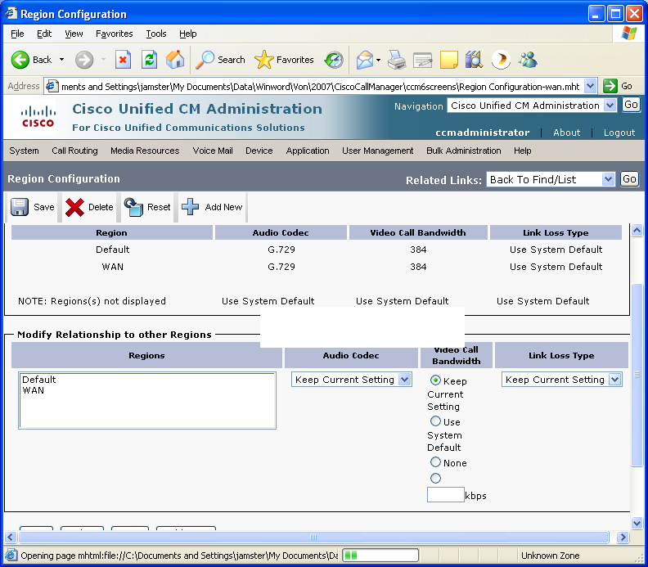

Region – Default
The region specifies the codec to be used for devices that point to this region. This particular region is used by devices associated with non AT&T components (i.e. phones). This screen is accessed from the system menu. Key fields are:

Default: Specifies that the G.711 codec to be used with the default region. This means that G.711 will be used between the Cisco Unified Communication Manager phones at this site.
WAN: Specifies that the G.729 codec to be used with devices in the WAN region. This means that G.729 will be used between the Cisco Unified Communication Manager phones and any endpoint reach via the AT&T Border Element.

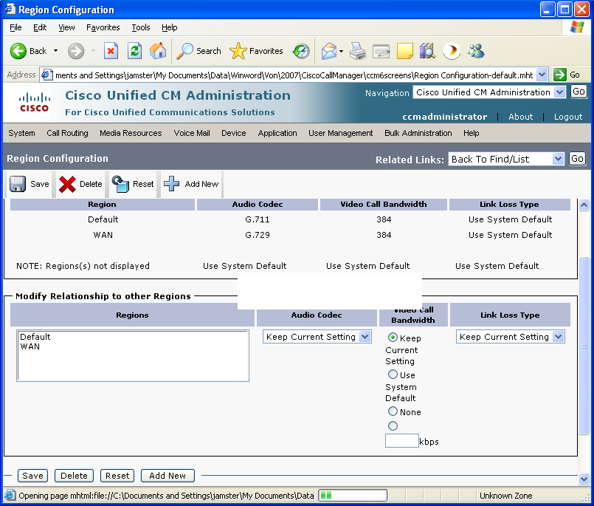

Device Pool – WAN
The device pool specifies parameters to be used by devices that point to this device pool. This particular device pool is used by devices associated with the AT&T Gatekeeper. This screen is accessed from the system menu. Key fields are:

Region: The region specifies the codec to be used for this device pool.
Media Resource Group List: This points to a media resource group that specifies media resources (i.e. conference bridges, transcoders, etc) to be used for this device pool.

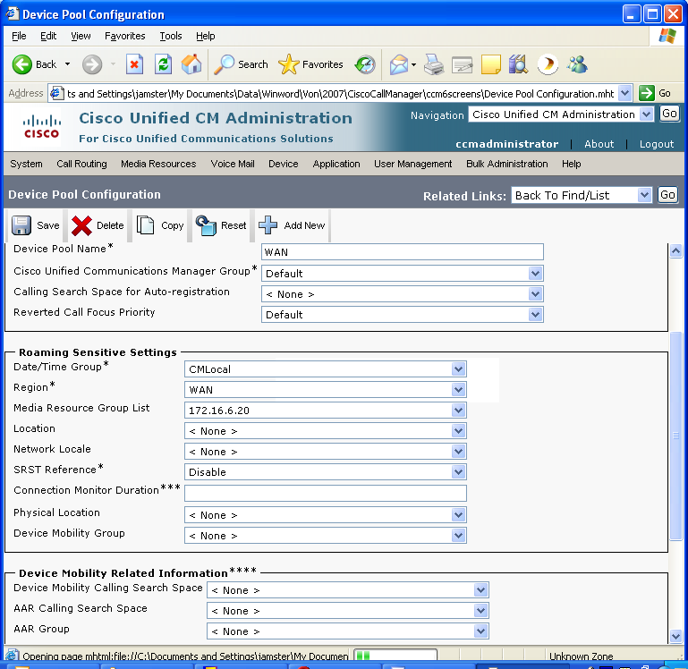

Device Pool – Default
The device pool specifies parameters to be used by devices that point to this device pool. This particular device pool is used by devices associated with non AT&T components (i.e. phones). This screen is accessed from the system menu. Key fields are:

Region: The region specifies the codec to be used for this device pool.
Media Resource Group List: This points to a media resource group that specifies media resources (i.e. conference bridges, transcoders, etc) to be used for this device pool.

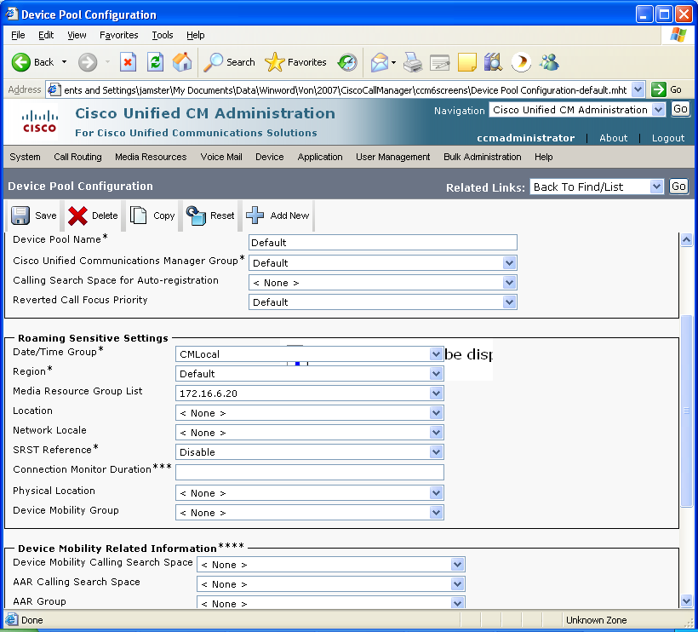

Media Resource Group
The media resource group specifies a grouping of media resources (i.e. conference bridge, transcoder, etc). This particular media resource group contains a conference bridge and a transcoder. This screen is accessed from the service/media resource menu. Key fields are:

Selected Media Resources: Points to profiles for conference bridge (CFB) and transcoder (XCODE) resources to be used in this group.

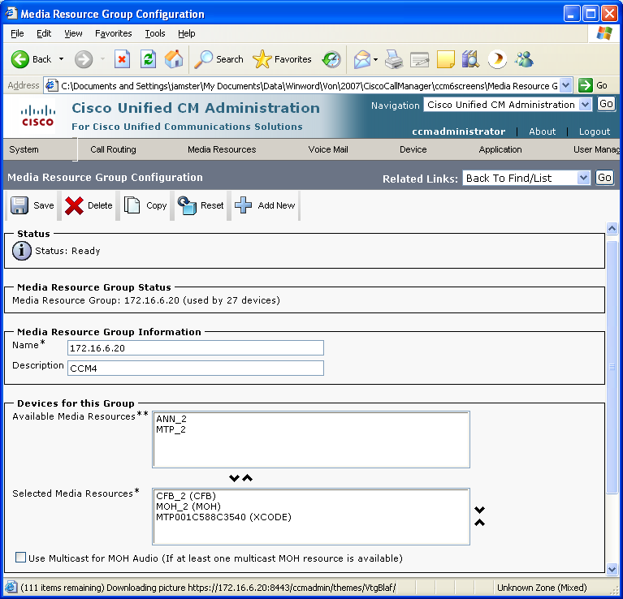

Media Resource Group List
The media resource group list is a grouping of media resource groups. This screen is accessed from the service/media resource menu.

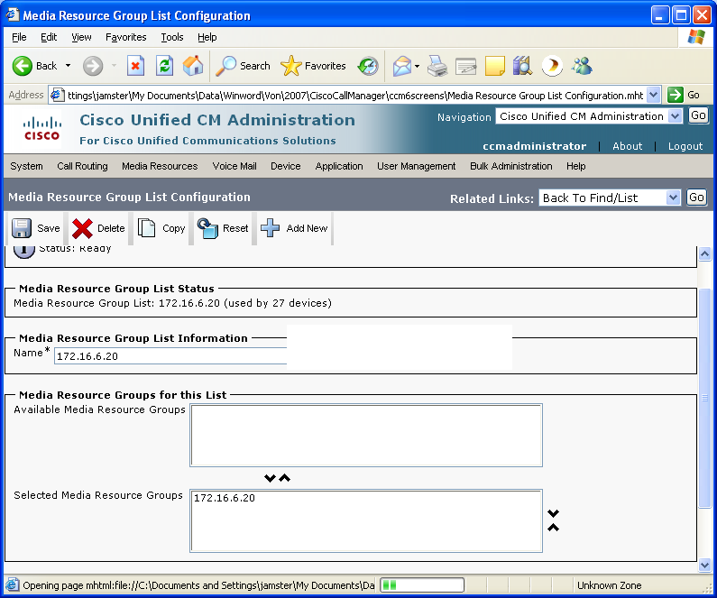

Conference Bridge
The conference bridge specifies the conferencing resources to be used by the Cisco Unified Communication Manager phone users when the phone’s conference button is selected. This screen is accessed from the service/media resource menu.

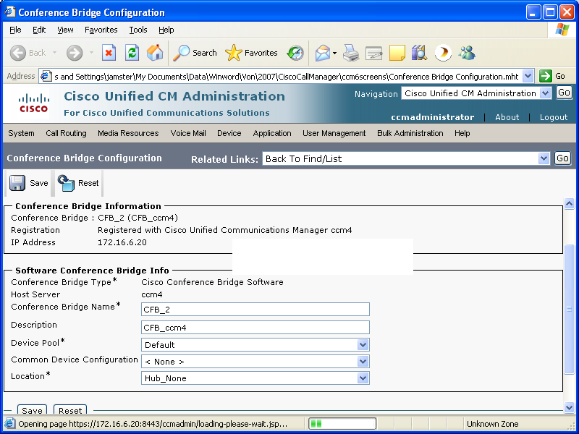

Transcoder
The transcoder specifies the transcoding resources to be used to convert from the G.729 to G.711 codecs for conference calls that include a call leg to the AT&T IP Flexible Reach. This screen is accessed from the service/media resource menu. Key fields include:

Host name: This is a pointer to the transcoding resource. The host name is the string “MTP” followed by the MAC address of the Cisco router or switch with the DSP resources being used for transcoding.

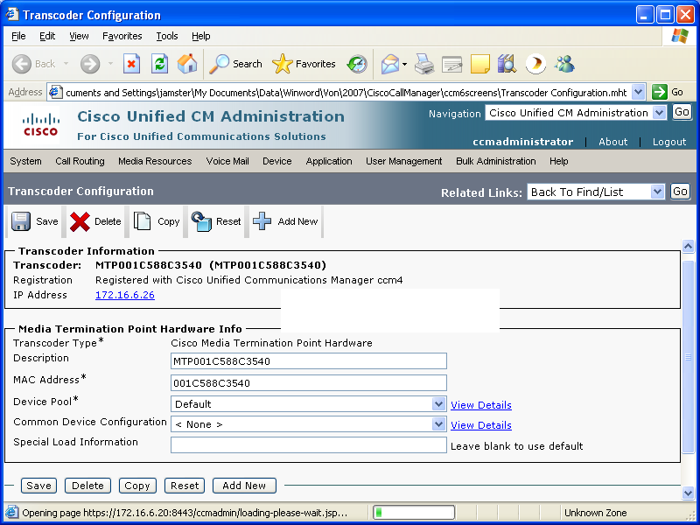

Phone Configuration
This screen specifies the parameters for the Cisco Unified Communication Manager phones. It is accessed from the Device menu. Key parameters are:

Device Pool: This phone will use the parameters in the “default” device pool.
Media Resource Group List: This phone will use the resources specifies in the designated Media Resource Group List which include the conference bridge and transcoder.

Service Parameters
This screen specifies the parameters for the Cisco Unified Communication Manager. It is accessed from the Service menu.

The full list of service parameters are in the following attachment.

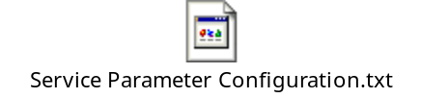

Key parameters are:

Max Call Duration: This parameter specifies how long a call should last in minutes. The default is 720 (i.e. 12 hours). AT&T recommends that this parameter be set to “0” (no max call duration limit).

Duplex Streaming: This parameter specifies whether 2 way voice streaming will occur when music on hold is implemented. AT&T requires that the default setting of “true” be used.

SIP Rel1XX Enabled: In order to support early media voice cut-through, this parameter must be set to “TRUE”. With this parameter enabled, the Cisco Unified Communication Manager will use PRACK to send its media information on a Cisco Unified Communication Manager to AT&T call.

Incremental Cluster Configuration
This section provides the incremental Cisco Unified Communications Manager screens used to support a Cisco Unified Communications Manager cluster. This section does not replace the Cisco documentation for cluster configuration. The screens, shown in this section, contain information that will assist in configuring the AT&T IP Flexible Reach service to support the cluster.

Cisco Unified Communications Manager Servers used in the Cluster

Each Cisco Unified Communications Manager in the cluster must be configured with a Cisco Unified Communications Manager Server entry. The Cisco Unified Communications Manager server screen contains an IP address and description field. The IP address field must contain the IP address of the individual Cisco Unified Communications Manager server. The description is a free form description field. A following screen shows a list of the Cisco Unified Communications Manager servers in a cluster.

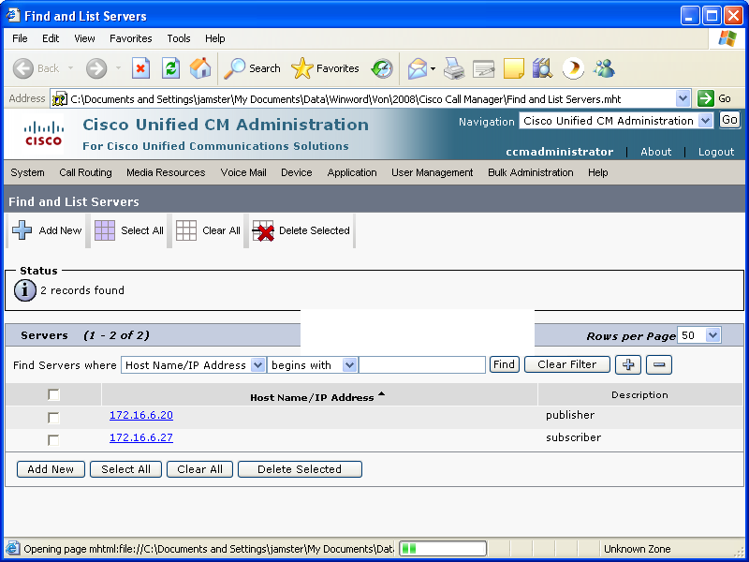

The following screen shows a sample of server entry. If there are 2 servers in the cluster, then there must be 2 server entries.

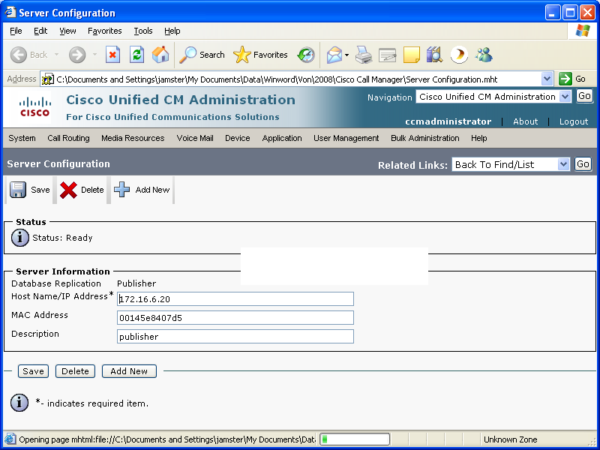

Cisco Unified Communications Managers used in the Cluster

Each Cisco Unified Communications Manager in the cluster must be configured with a Cisco Unified Communications Manager entry. The Cisco Unified Communications Manager screen contains a Cisco Unified Communications Manager name field and a number of other fields. The Cisco Unified Communications Manager name field must contain the IP address of the individual Cisco Unified Communications Manager.

Note that each Cisco Unified Communications Manager server entry must have a corresponding Cisco Unified Communications Manager entry.

A following screen shows a list of the Cisco Unified Communications Managers in a cluster.

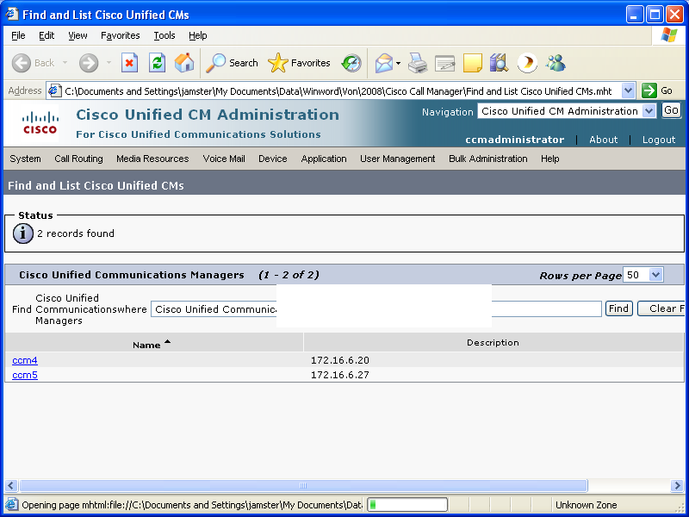

The following screen shows a sample of a Cisco Unified Communications Manager entry. If there are 2 Cisco Unified Communications Managers in the cluster, then there must be 2 Cisco Unified Communications Manager entries.

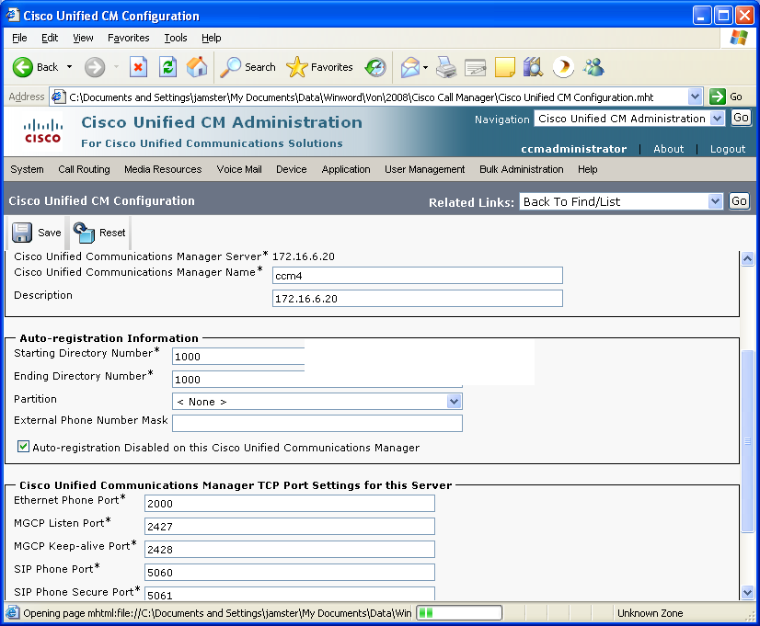

Cisco Unified Communications Manager Group used in the Cluster
The Cisco Unified Communications Manager group ties the Cisco Unified Communications Managers into the cluster. The following screen shows 2 Cisco Unified Communications Managers in a group. This group forms a Cisco Unified Communications Manager cluster.

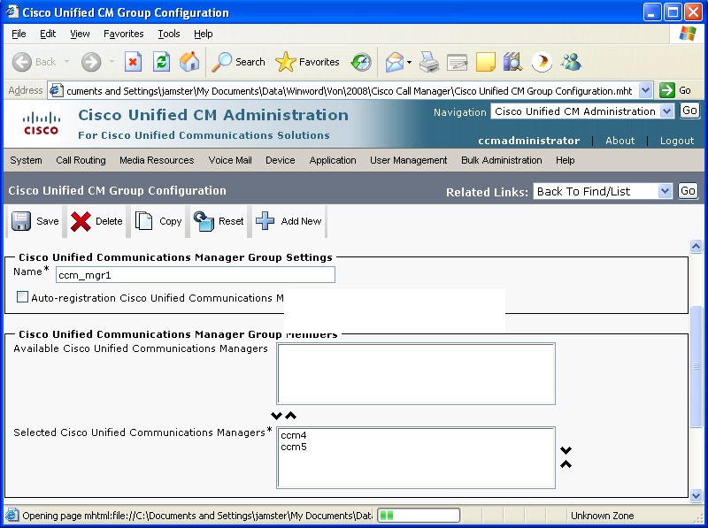

Device Pool used in the Cluster
The Cisco Unified Communications Manager group (defined in the previous section) must be assigned to a device pool. This device pool is then used in the IP phone configuration (also shown after the device pool screen). As a result of this configuration, the phones will pull down all of the servers in the cluster during phone startup.

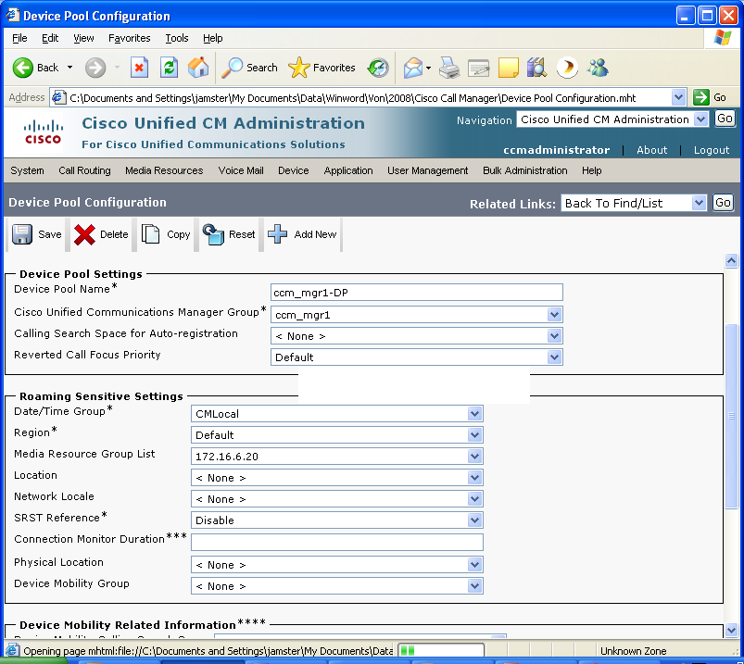

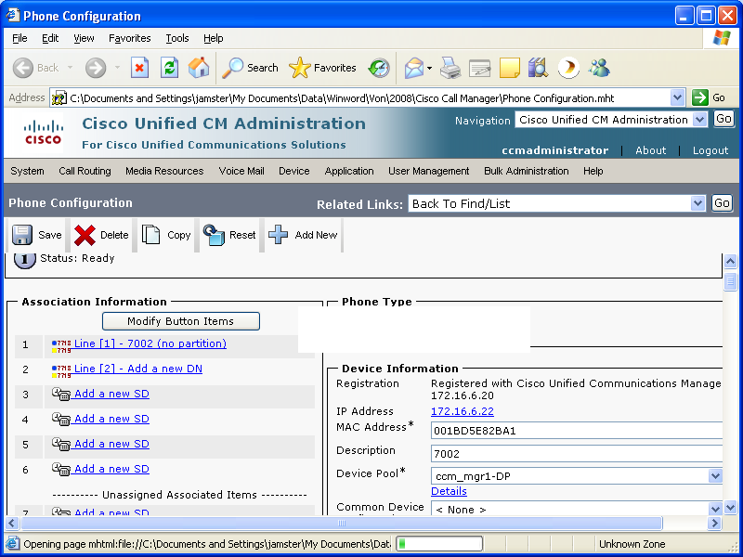

Appendix A: Router Version/Configuration for Transcoding and Fax

Router Version

AT&T has tested 12.3.11T11 for transcoding and T.38 fax support with Cisco Unified Communication Manager 6.0. A sample “show version” output is shown next.

Cisco IOS Software, 2800 Software (C2800NM-ADVIPSERVICESK9-M), Version 12.3(11)T
11, RELEASE SOFTWARE (fc3)
Technical Support: http://www.cisco.com/techsupport
Copyright (c) 1986-2006 by Cisco Systems, Inc.
Compiled Thu 24-Aug-06 18:44 by dchih

ROM: System Bootstrap, Version 12.4(13r)T, RELEASE SOFTWARE (fc1)

ccm60-xcoder uptime is 4 weeks, 2 days, 5 hours, 1 minute
System returned to ROM by power-on
System image file is "flash:c2800nm-advipservicesk9-mz.123-11.T11.bin"

Transcoding Configuration

The router configuration for transcoding is shown next.

! Sets dsp services in voice card in slot 0
voice-card 0
no dspfarm
dsp services dspfarm

! Connection to Cisco Unified Communication Manager
sccp local GigabitEthernet0/0
sccp ccm 172.16.6.20 identifier 1
sccp ip precedence 3
sccp
!
sccp ccm group 118
description CCM60 Transcoder
bind interface GigabitEthernet0/0
associate ccm 1 priority 1
associate profile 1 register MTP001C588C3540
!
dspfarm profile 1 transcode
description Transcoder for CCM 6.0
codec g711ulaw
codec g711alaw
codec g729ar8
codec g729abr8
codec gsmfr
codec g729br8
codec g729r8
maximum sessions 8
associate application SCCP
!

T.38 Fax Configuration

The router configuration for T.38 fax is shown next.

! Default IP route
ip route 0.0.0.0 0.0.0.0 172.16.6.1

! Set up T.38 fax support
voice service voip
fax protocol t38 ls-redundancy 1 hs-redundancy 0 fallback cisco

! Set up voice class
voice class codec 729
codec preference 1 g729br8

! Set fax rate outgoing calls and set session target to Cisco Unified Communication Manager
dial-peer voice 71 voip
description "SIP to BE, 1 + 10"
destination-pattern 811..........
progress_ind setup enable 3
rtp payload-type comfort-noise 13
session protocol sipv2
session target ipv4:172.16.6.20
dtmf-relay rtp-nte
codec g729br8
fax rate 14400

! Set fax rate for incoming calls.
dial-peer voice 99 voip
session protocol sipv2
incoming called-number .T
dtmf-relay rtp-nte
fax rate 14400
fax protocol t38 ls-redundancy 0 hs-redundancy 0 fallback none

! FXS ports
voice-port 0/1/0
description "FXS port #1"
!
voice-port 0/1/1
description "FXS port #2"
!
!
dial-peer voice 301 pots
destination-pattern 7100
port 0/1/0
!
dial-peer voice 302 pots
destination-pattern 7101
port 0/1/1

Appendix B: Firewall Rules
If the customer implements a firewall, then the following access control rules shall be required.

- Accept AT&T Border Element traffic from UDP port 5060
- Accept AT&T Border Elements traffic from UDP ports 16384-32767

This Customer Configuration Guide ("CCG") is offered as a convenience to AT&T's customers. The specifications and information regarding the product in this CCG are subject to change without notice. All statements, information, and recommendations in this CCG are believed to be accurate but are presented without warranty of any kind, express or implied, and are provided “AS IS”. Users must take full responsibility for the application of the specifications and information in this CCG.

In no event shall AT&T or its suppliers be liable for any indirect, special, consequential, or incidental damages, including, without limitation, lost profits or loss or damage arising out of the use or inability to use this CCG, even if AT&T or its suppliers have been advised of the possibility of such damage.

