



Mitel 3300 ICP
Configuration Guide
For use with the AT&T IP Flexible Reach Service



August 2008

About this document
This How-To-Guide is intended for certified Customer Service and Installation Personnel involved in the installation and maintenance of Mitel 3300 ICPs.

NOTICE
The information contained in this document is believed to be accurate in all respects but is not warranted by Mitel Networks Corporation. The information is subjected to change without notice and should not be construed in any way as a commitment by Mitel or any of its affiliates or subsidiaries. Mitel and its affiliates and subsidiaries assume no responsibility for any errors or omissions in this document. Revisions of this document or new editions of it may be issued to incorporate changes.

How-To-Guide for 3300 SIP Trunking to AT&T Flexreach Service

August 2008

®,™ Trademark of MITEL Networks Corporation
© Copyright 2008, MITEL Networks Corporation
All rights reserved

Table of Contents
Overview 4
Software & Hardware Interop Setup 4
Limitations 5
3300 Setup Notes 5
Network Requirements 5
Assumptions for the 3300 ICP programming 5
Licensing and Option Selection - SIP Licensing 6
Class of Service Options Assignment 7
Trunk Service Assignment 9
Trunk Service Assignment – 4 digit delivery 10
SIP Peer Profile 11
SIP Peer Profile – 4 digit delivery 13
Digit Modification Assignment 17
Route Assignment 18
ARS Digits Dialed Assignment 19
Failover to an Alternate AT&T Border Element (optional) 20
Appendix A – Linksys SPA2102 ATA Faxing Configuration 25
Licensing and Option Selection - SIP Licensing 25
Multiline IP Set Configuration 26
Class of Service Assignment 27
SIP Device Capabilities Assignment 30
Station Service Assignment 31
Multiline Set Key Assignment 32
LINKSYS SPA2102 SIP Phone Setup Notes 33
Appendix B – Mediatrix 4108 ATA Faxing Configuration 36
Licensing and Option Selection - SIP Licensing 36
Multiline IP Set Configuration 37
Class of Service Assignment 38
SIP Device Capabilities Assignment 41
Station Service Assignment 42
Multiline Set Key Assignment 43
Mediatrix 4108 Setup Notes 44

Overview
This document provides a reference to Mitel Authorized Solutions providers for configuring a Mitel 3300ICP to connect to the AT&T SIP Service Provider. The different devices can be configured in various configurations depending on your VoIP solution. This document covers a basic setup with basic SIP trunking routing rules.

Software & Hardware Interop Setup

This was the test setup for interop testing using SIP Trunking between AT&T Softswitch and the 3300 ICP.
Mitel Interop Hardware
Manufacturer | Variant | Software Version
Mitel | 3300 ICP – MXe platforms | 8.0 UR4 GA  (8.0.10.7_1)
Sets | Tested with 5220, 5235, 5330 | Minet
Teleworker | TW MSL 8.2.8.0 | 4.5.35
Mobile Extension | ME MSL 8.2.8.0 | 1.5.217
ATA (Faxing) | Linksys SPA2102  Mediatrix 4108 | 3.3.6  5.0.123.149
Quintum | Quintum Analog Tenor | P104.12.02

AT&T Interop Setup
Manufacturer | Variant
AT&T | Configuration as of March 2008

Disclaimer: Although Mitel has attempted to setup the interop testing facility as closely as possible to a customer premise environment, implementation setup could be different onsite. YOU MUST EXERCISE YOUR OWN DUE DILIGENCE IN REVIEWING, planning, implementing, and testing a customer configuration.

Limitations
The following limitations are related to the integration of 3300 ICP with AT&T.

- Calls placed through the AT&T network can only be directed to a subset of Mitel devices. These include all dual-mode sets (5215, 5220, 5212, 5224) Navigator, 5235, 5330, 5340. Other devices, end points and gateways must support 30ms packetization.
- Conferencing is currently not supported using the 3300.
- Call holding not supported with Quintum Analog Tenors.
- Faxing is only supported using an Analog Telephone Adapter (ATA) that supports 30ms packetization. Tested ATA devices with the AT&T Flexreach service are the Linksys SPA2102 and Mediatrix 4108 ATA. Refer to Appendix A and B for configuration details.
- While AT&T IP Flexible Reach services support E911/911 calling capabilities in certain circumstances, there are significant limitations on how these capabilities are delivered. Please review the AT&T IP Flexible Reach service Guide in detail to understand these limitations and restrictions.

3300 Setup Notes
The following steps show how to program a 3300 ICP to interconnect with the AT&T using SIP trunking.

Network Requirements
- There must be adequate bandwidth to support the voice over IP connections between the 3300 ICP and AT&T. As a guide, the Ethernet bandwidth is approx 85 Kb/s per G.711 voice session and 29 Kb/s per G.729 voice session. As an example, for 20 simultaneous SIP sessions, the Ethernet bandwidth consumption will be approx 1.7 Mb/s for G.711 and 0.6Mb/s. Almost all Enterprise LAN networks can support this level of traffic without any special engineering. Please refer to the 3300 Engineering guidelines for further information.
- For high quality voice, the network connectivity must support a voice-quality grade of service (packet loss <1%, jitter < 30ms, one-way delay < 80ms).

Assumptions for the 3300 ICP programming
- The SIP signaling connection uses UDP on Port 5060.

Licensing and Option Selection - SIP Licensing
Ensure that the 3300 ICP is equipped with enough SIP trunking licences for the connection to AT&T. This can be verified within the License and Option Selection form.

Enter the total number of licenses in the SIP Trunk Licences field. This is the maximum number of SIP trunk sessions that can be configured in the 3300 to be used with all service providers and applications.

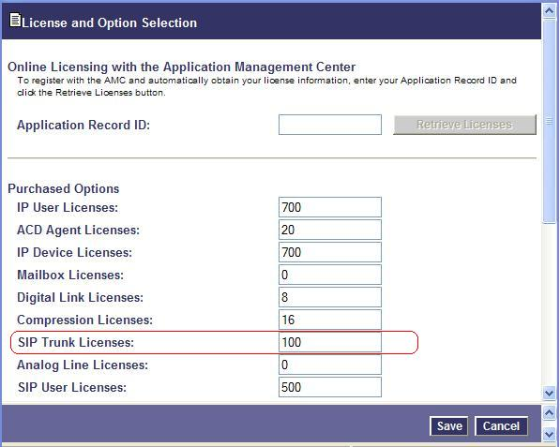
Figure 1: Example of SIP Licensing

Class of Service Options Assignment
Ensure that “Public Network Access via DPNSS” Class of Service Option is configured for all devices that make outgoing calls through the SIP trunks in the 3300.

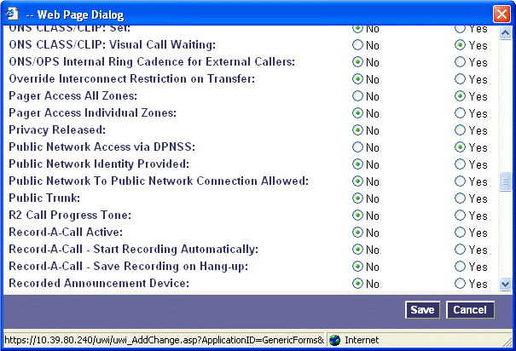
Figure 2: Example of Class of Service Options Assignment
Network Element Assignment

Create a network element for AT&T. In this example, the softswitch is reachable by an IP Address and is defined as “ATT” in the network element assignment form. The FQDN or IP addresses of the SIP Peer (Network Element), the External SIP Proxy and Registrar are provided by your service provider.

If your service provider is trusting your network connection by asking for your gateway external IP address, then programming the IP address for the SIP Peer, Outbound Proxy and Registrar is not required for SIP trunk integration. This will need to be verified with your service provider. Set the transport to UDP and port to 5060.

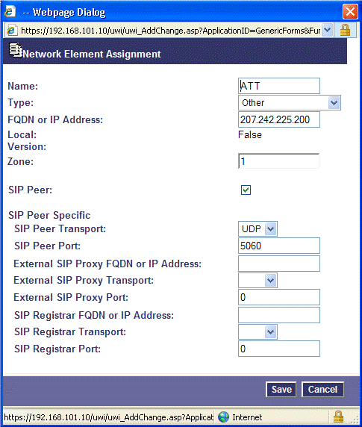
Figure 3: Example of Network Element Assignment

Trunk Service Assignment
This is configured in the Trunk Service Assignment form. In this example the Trunk Service Assignment is defined for Trunk Service Number 4 which will be used to direct incoming calls to an answer point in the 3300.

Program the Non-dial In or Dial In Trunks (DID) according to the site requirements and what type of service was ordered from your service provider.

The example below shows configuration for incoming DID calls. The 3300 will absorb the first 6 digits of the DID number from AT&T leaving 4 digits for the 3300 to translate and ring the remaining 4 digit extension. For example, the AT&T IP Flexreach service delivers 732-320-4009 through the SIP trunk to the 3300. The 3300 will absorb the first 6 digits (732320) leaving the 3300 to ring extension 4009. Extension 4009 must be programmed as a valid dialable number in the 3300. Please refer to the 3300 System Administration documentation for further programming information.

Note: AT&T IP Flexreach service also provides 4 digit number delivery. Please refer to following section for more information.

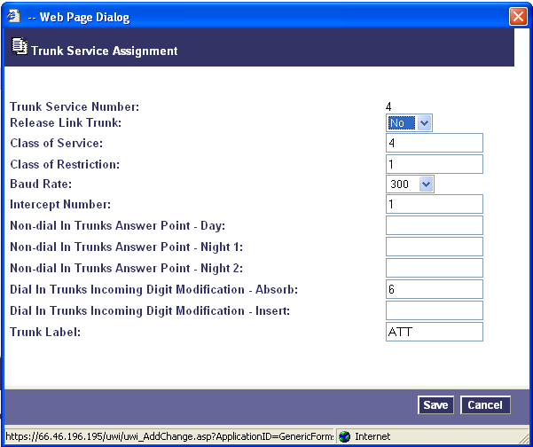
Figure 4: Example of Trunk Service Assignment – 10 digit number delivery

Trunk Service Assignment – 4 digit delivery
AT&T IP Flexreach service also provides 4 digit number delivery type SIP trunks. The 3300 programming requires these types of trunks to be programmed separately in order to properly route incoming calls.

The example below shows configuration for incoming DID calls. The 3300 will not absorb any digits of the DID number from AT&T leaving 4 digits for the 3300 to translate and ring the appropriate 4 digit extension. For example, the AT&T IP Flexreach service delivers 4012 through the SIP trunk to the 3300. The 3300 will not absorb any digits leaving the 3300 to ring extension 4012. Extension 4012 must be programmed as a valid dialable number in the 3300. Please refer to the 3300 System Administration documentation for further programming information.

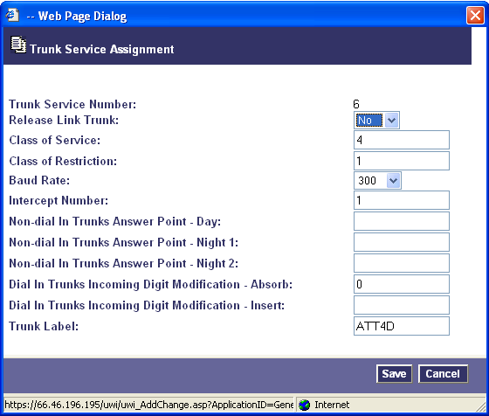
Figure 5: Example of Trunk Service Assignment – 4 digit number delivery

SIP Peer Profile
The recommended connectivity via SIP Trunking does not require additional physical interfaces. IP/Ethernet connectivity is part of the base 3300 ICP Platform. The SIP Peer Profile should be configured with the following options:

- Network Element: The selected SIP Peer Profile needs to be associated with previously created “ATT” Network Element.
- Registration User Name: A registration username is not required to connect to AT&T. The 3300 does not support Bulk Registration, therefore trunks will have to be registered individually. Enter the DIDs assigned by AT&T. Enter one or more numbers. The field has a maximum of 60 characters. The maximum number of digits per number is 26. You can enter a mix of ranges and single numbers (for example, "6135554000-6135554400, 6135554500"). Use a comma to separate telephone numbers and ranges. Use a dash (-) to indicate a range of telephone numbers. The first and last characters cannot be a comma or a dash.
- Address Type: Use IP Address in SIP messages.
- Outbound Proxy Server: Select the Network Element previously configured for the Outbound Proxy Server.
- Calling Line ID: The default CPN is applied to all calls unless there is a match in the "Outgoing DID Ranges" of the SIP Peer Profile. This number will be provided by your service provider. Do not use a Default CPN if you want public numbers to be preserved through the SIP interface. Add private numbers into the DID ranges for CPN Substitution form (see DID Ranges for CPN Substitution). Then select the appropriate numbers in the Outgoing DID Ranges in this form (SIP Peer Profile).
- Trunk Service Assignment: Enter the trunk service assignment previously configured.
- SMDR: If Call Detail Records are required for SIP Trunking, the SMDR Tag should be configured (by default there is no SMDR and this field is left blank).
- Maximum Simultaneous Calls: This entry should be configured to maximum number of SIP trunks provided by your service provider.

NOTE: Ensure the remaining SIP Peer profile policy options are similar the screen capture below.
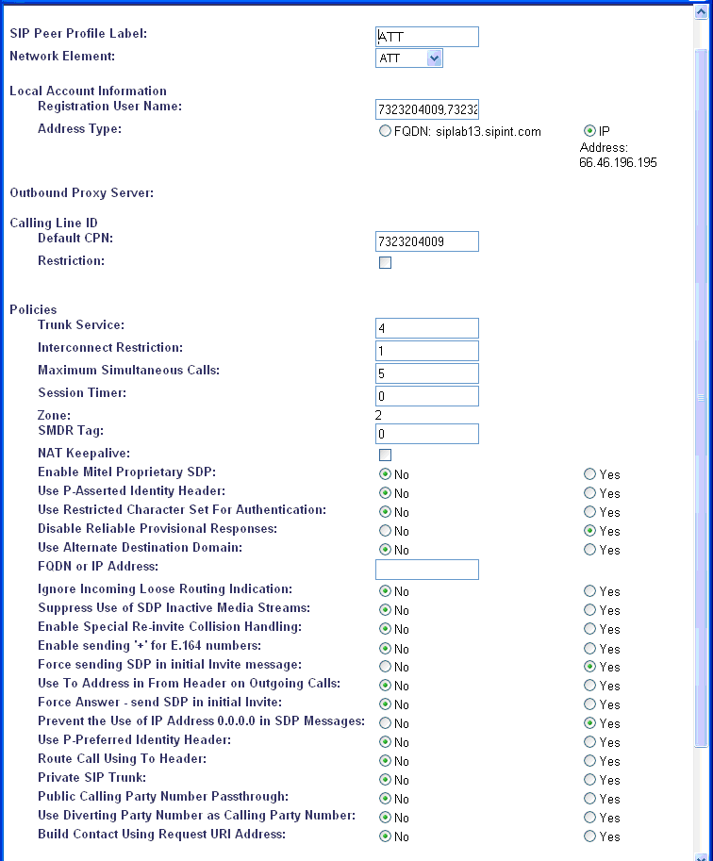

Figure 6: Example of SIP Peer Profile

SIP Peer Profile – 4 digit delivery
For 4 digit number delivery from AT&T IP Flexreach service, a separate SIP Peer Profile needs to be programmed. The SIP Peer Profile should be configured with the following options:

- Network Element: The selected SIP Peer Profile needs to be associated with previously created “ATT” Network Element.
- Registration User Name: A registration username is not required to connect to AT&T. The 3300 does not support Bulk Registration, therefore trunks will have to be registered individually. Enter the DIDs numbers for the 4 digit number delivery SIP trunks assigned by AT&T. Enter one or more numbers. The field has a maximum of 60 characters. The maximum number of digits per number is 26. You can enter a mix of ranges and single numbers (for example, "6135554000-6135554400, 6135554500"). Use a comma to separate telephone numbers and ranges. Use a dash (-) to indicate a range of telephone numbers. The first and last characters cannot be a comma or a dash.
- Address Type: Use IP Address in SIP messages.
- Outbound Proxy Server: Select the Network Element previously configured for the Outbound Proxy Server.
- Calling Line ID: The default CPN is applied to all calls unless there is a match in the "Outgoing DID Ranges" of the SIP Peer Profile. This number will be provided by your service provider. Do not use a Default CPN if you want public numbers to be preserved through the SIP interface. Add private numbers into the DID ranges for CPN Substitution form (see DID Ranges for CPN Substitution). Then select the appropriate numbers in the Outgoing DID Ranges in this form (SIP Peer Profile).
- Trunk Service Assignment: Enter the trunk service assignment previously configured for 4 digit numer delivery.
- SMDR: If Call Detail Records are required for SIP Trunking, the SMDR Tag should be configured (by default there is no SMDR and this field is left blank).
- Maximum Simultaneous Calls: This entry should be configured to maximum number of SIP trunks provided by your service provider.

NOTE: Ensure the remaining SIP Peer profile policy options are similar the screen capture below.

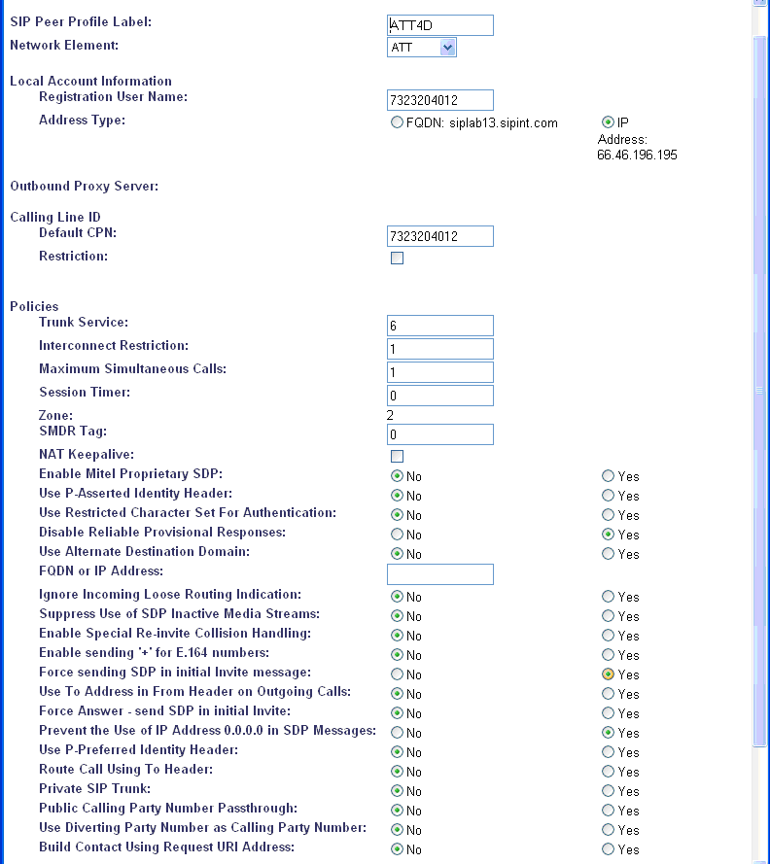
Figure 7: Example of SIP Peer Profile – 4 digit delivery

SIP Peer Profile Assignment by Incoming DID
This form is used to assign incoming digits from AT&T IP Flexreach service. DID range numbers assigned by a AT&T are associated to a particular SIP Peer.
Enter one or more telephone numbers. The maximum number of digits per telephone number is 26. You can enter a mix of ranges and single numbers (for example, "6135554000-6135554400, 6135554500"). The entire field width is limited to 60 characters.
Use a comma to separate telephone numbers and ranges. Use a dash (-) to indicate a range of telephone numbers. The first and last characters cannot be a comma or a dash. If the numbers do not fit within the 60 character maximum, you can create a new entry for the same profile.
Use a '*' to reduce the number of entries that need to be programmed. This is a type of "prefix identifier", and cannot be used as a range with '-'. For example, the string "11*" would be used to associate a peer with any number in the range from 110 up to the maximum digits per telephone number (In this case, 11999999999999999999999999.) Note that the string "11" by itself would not count as a match, as the '*' represents 1 or more digits.
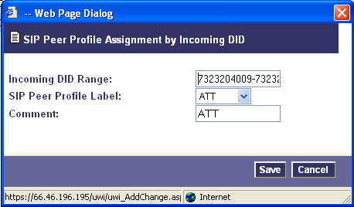
Figure 8: Example of SIP Peer Profile Assignment by Incoming

SIP Peer Profile Assignment by Incoming DID – 4 digit delivery
For 4 digit number delivery from AT&T IP Flexreach service, a separate SIP Peer Profile Assignment by Incoming DID needs to be programmed. Characteristics of the values of each field are the same as the previous section above. The SIP Peer Profile Assignment should be configured with the following options:

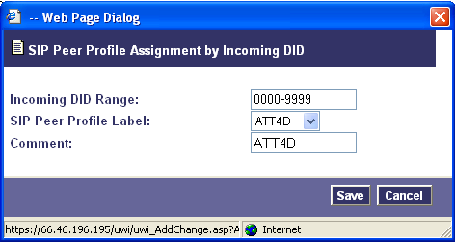
Figure 9: Example of SIP Peer Profile Assignment by Incoming – 4 digit delivery

Digit Modification Assignment

Ensure that Digit Modification for outgoing calls on the SIP trunk to AT&T absorbs or inject additional digits according to your dialling plan. In this example, we will be absorbing 3 digits (in this case will be 978 to dial out).

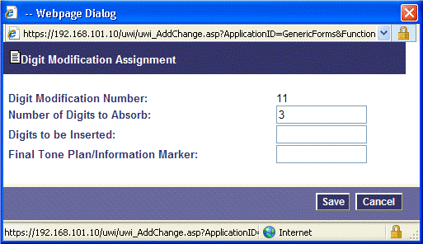

Figure 10: Example of Digit Modification Assignment

Route Assignment

Create a route for SIP Trunks connecting a trunk to AT&T. In this example, the SIP trunk is assigned to Route Number 17. Choose SIP Trunk as a routing medium and choose the SIP Peer Profile and Digit Modification entry created earlier.

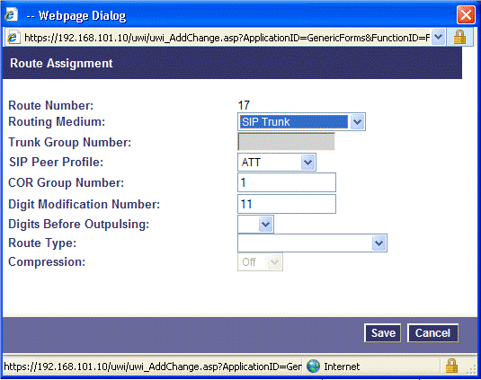

Figure 11: Example SIP Trunk Route Creation

ARS Digits Dialed Assignment
ARS initiates the routing of trunk calls when certain digits are dialed from a station. In this example, when a user dials 988, the call will be routed to AT&T.

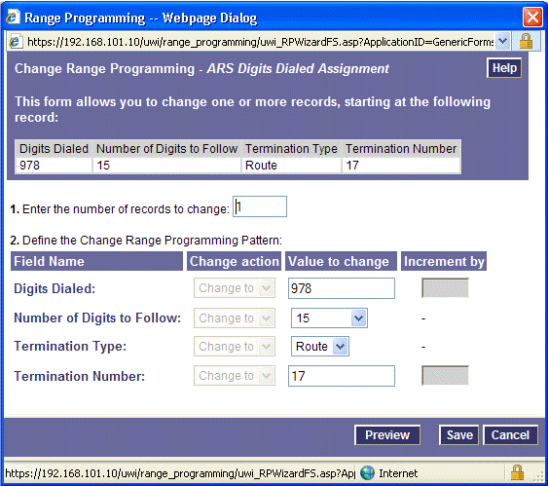
Figure 12: Create an ARS Digits dialled Assignment

Failover to an Alternate AT&T Border Element (optional)
AT&T provides access to a secondary border element for failover or redundancy purposes. The following programming steps will allow calls from the 3300 ICP to automatically switch over to the secondary AT&T border element in the event the primary is not available.

First, program a secondary Network Element in the 3300 controller point to the alternate AT&T Border Element. The FQDN or IP addresses of the secondary Network Element, the External SIP Proxy and Registrar is provided by your service provider.

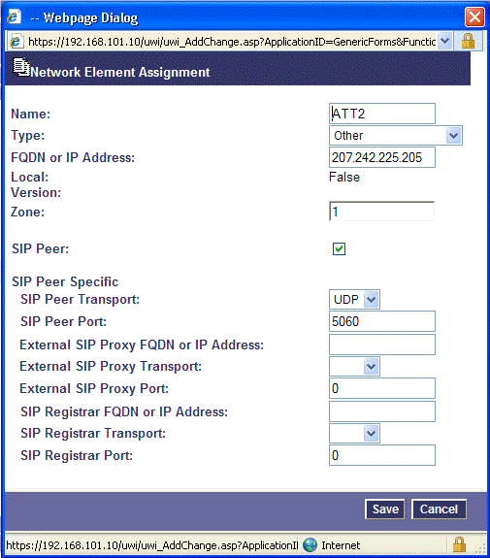
Figure 13: Create an additional Network Element

Next, program a secondary SIP Peer profile using the secondary Network Element. Use the same Local account information, Outbound Proxy Server and SIP Peer profile policies previously configured for the primary SIP Peer profile.

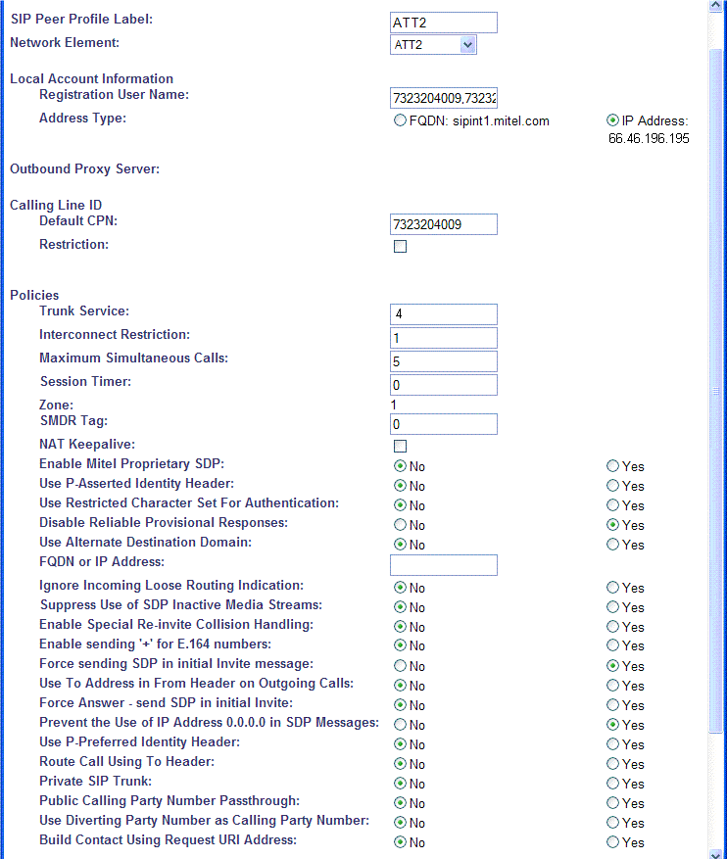
Figure 14: Example of the alternate SIP Peer Profile
Next, create a route for alternate SIP Trunks connecting a trunk to AT&T. In this example, the SIP trunk is assigned to Route Number 27. Choose SIP Trunk as a routing medium and choose the second SIP Peer Profile and Digit Modification entry created earlier.

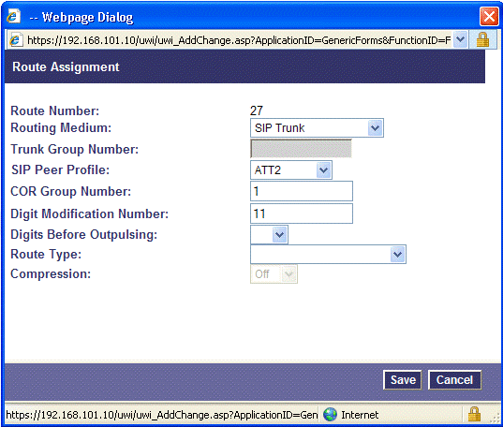
Figure 15: Example secondary SIP Trunk Route Creation

Next, create a route list. The Route List Assignment form provides a list of trunk routes to call according to customer requirements or when a failover is required. A type of terminal hunting is performed through this form by the ARS software in that the list of routes is scanned beginning with the first route specified, progressing to next route only if the first route is not available. During call processing the list is used to select from up to three available routes. Enter the routes numbers previously configured.

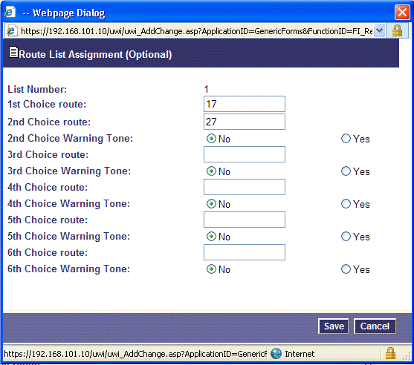
Figure 16: Example of the Route List Assignment

Finally, the ARS Digits Dialed Assignment previously configured will need to be adjusted to use the new formed route list. Change the terminate type from route to list and enter the list number previously defined.

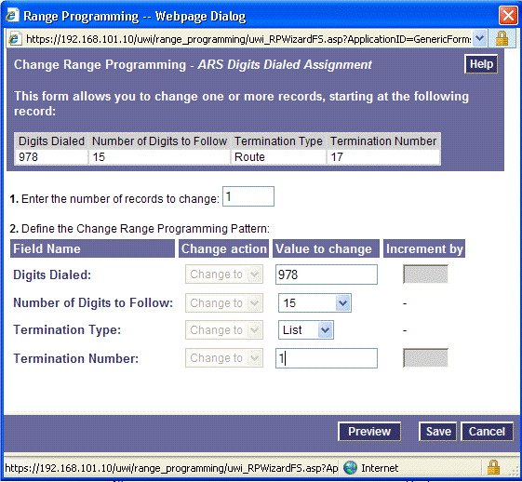
Figure 17: Example of the Modified ARS Digit Assignment

Appendix A – Linksys SPA2102 ATA Faxing Configuration
This appendix provides a reference to Mitel Authorized Solutions providers for configuring the Mitel 3300 ICP to host the LINKSYS SPA2102 SIP device. The different devices can be configured in various configurations depending on your VoIP solution. This section covers a basic setup for faxing with AT&T Flexreach service with required option setup.

Licensing and Option Selection - SIP Licensing
Ensure that the 3300 ICP is equipped with enough SIP Device licences for the connection of SIP end points. This can be verified within the License and Option Selection form.

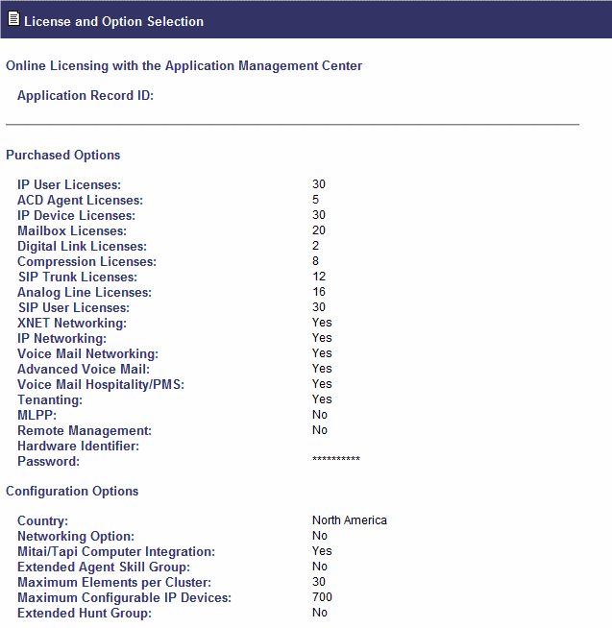

Figure 1 – License and Option Selection

Multiline IP Set Configuration
On the Mitel 3300 ICP, a SIP device can be programmed either in the User Configuration form or the Multiline IP Set Configuration form and are programmed as a “Generic SIP Phone”. Enterprise Manager can also be used to provision where this application is installed.

The Login PIN is the SIP authentication password and the username is the DN. The Number and Login PIN must match the information in the LINKSYS SPA2102 SIP device configuration. All other field names should be programmed according to the site requirements or left at default.

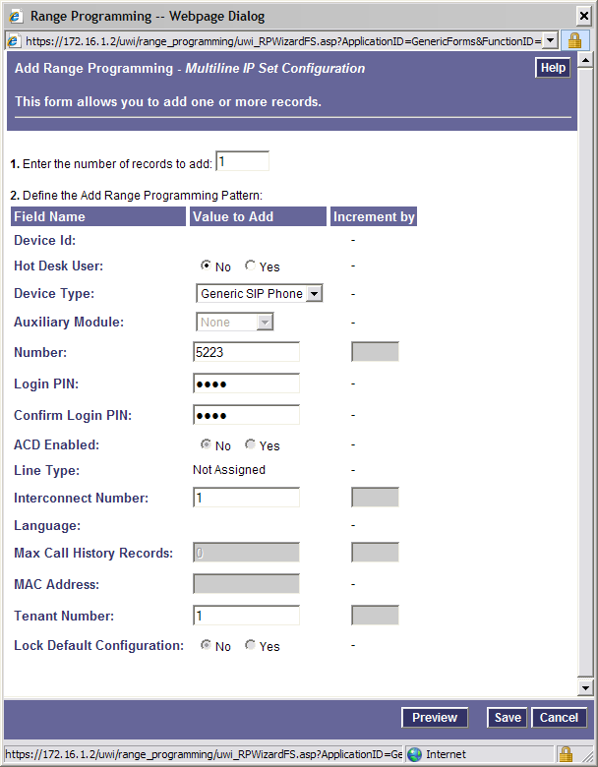

Figure 2 – Multiline IP Set Configuration

Class of Service Assignment

The Class of Service Options Assignment form is used to create or edit a Class of Service and specify its options. Classes of Service, identified by Class of Service numbers, are referenced by the Station Service Assignment form for the SIP devices. The changes to a default COS are:
Call forwarding external set to yes
HCI/CTI/TAPI Call Control Allowed set to yes
HCI/CTI/TAPI Monitor Allowed set to yes
Public Network Access via DPNSS set to yes
Auto Campon Times is set to Blank

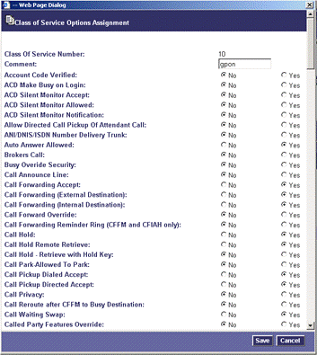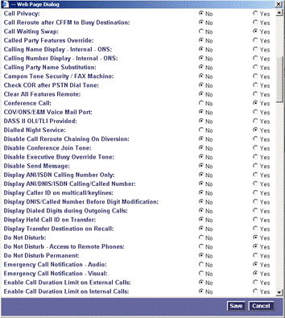
Figure 3 – Class of Service Assignment
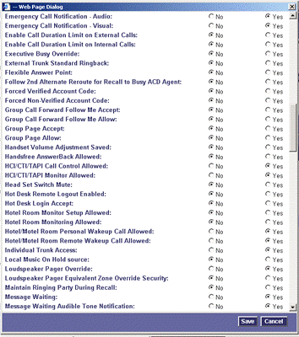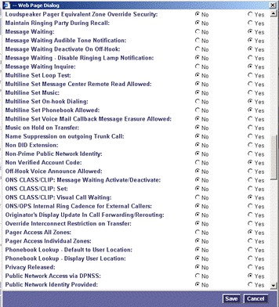
Figure 4 – Class of Service Assignment

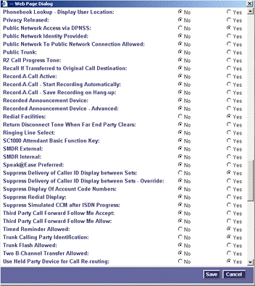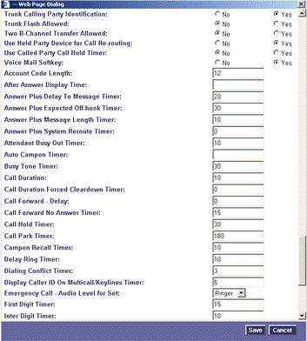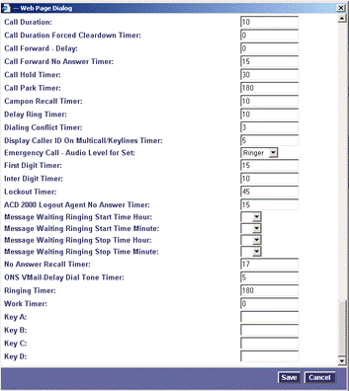

Figure 5 – Class of Service Assignment (C)

SIP Device Capabilities Assignment
This form provides configuration options that can be applied to various types of SIP devices. The association between the SIP device and the form is similar to how the Class of Service options work. The SIP Device Capabilities number provides a SIP profile that can be applied to particular SIP devices to allow for alternate capabilities as recommended through the Mitel interop process.

The LINKSYS SPA2102 can only be associated with a single SIP Device Capabilities Assignment form, though a form may be assigned to several devices, for example, one SIP Device Capabilities Assignment form can be assigned to all of one type of SIP device.

In the Device Capabilities form, program a SIP Device Capabilities Number for the LINKSYS SPA2102. Ensure that Replace System based with Device based In-Call Feature is set to ‘Yes’.

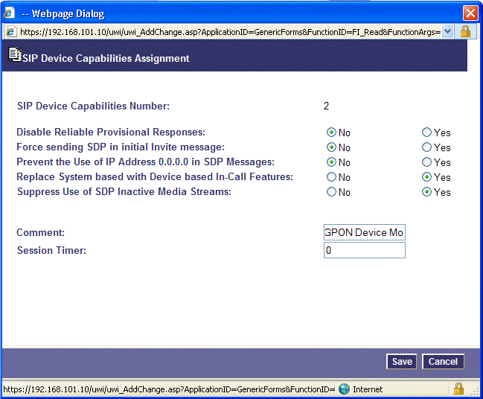

Figure 6 – SIP Device Capabilities Assignment

Station Service Assignment

Use the Station Service Assignment form to assign the previously configured Class of Service and SIP Device Capability number to each of the LINKSYS SPA2102 SIP devices in the 3300. This form utilizes Range programming.

Select the LINKSYS SPA2102 SIP device number then select Change. Enter the previously configured SIP Device Capability number and Class of Service for Day, Night 1 & Night 2.

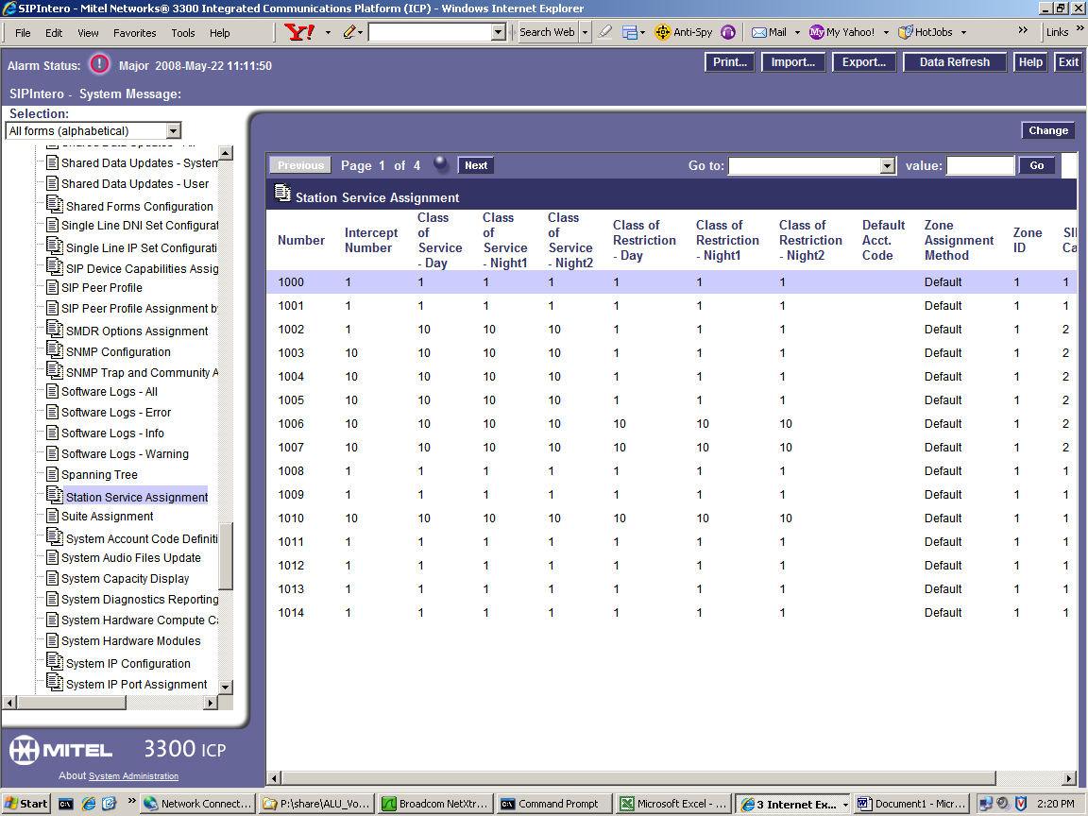

Figure 7 – Station Service Assignment

Multiline Set Key Assignment

You use the Multiline Set Key Assignment form to assign the line type, ring type, and directory number to each line select key of the LINKSYS SPA2102 SIP Device.

The LINKSYS SPA2102 will support 1 additional key line appearance for each programmed port (refer to Appendix B for the Linksys Phone Adapter Comparison Chart). Each key assignment of the LINKSYS SPA2102 SIP device should be defined as multicall type and should specify that a call to the key’s directory number will ring the set.

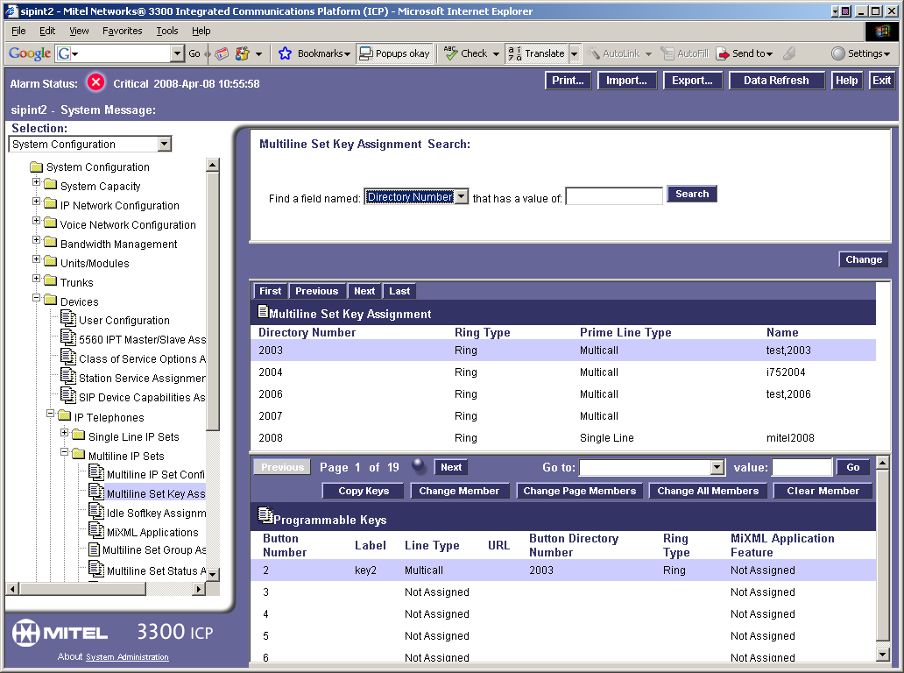

Figure 8 – Multiline Set Key Assignment Form

LINKSYS SPA2102 SIP Phone Setup Notes

The following steps show how to program the LINKSYS SPA2102 phone adapter to interconnect with the 3300 ICP.

LINKSYS SPA2102 phone adapter User Manual is provided to guide for operation and setup.
http://www.linksys.com/servlet/Satellite?c=L_Product_C2&childpagename=US%2FLayout&cid=1146582254856&pagename=Linksys%2FCommon%2FVisitorWrapper

STEP 1

Connecting the Phone Adapter
- Power off your network devices, including your modem and PC.
2. Connect the RJ-11 phone cable to the Phone Adapter’s PHONE 1 port. Connect the other end to your analog telephone or fax machine.
3. Repeat step 2 with the PHONE 2 port.
4. Connect one end of an Ethernet network cable (included) to the ETHERNET port of the Phone Adapter.
Connect the other end to the Ethernet port of your PC.
5. Connect one end of a different Ethernet network cable to the INTERNET port of the Phone Adapter. Connect the other end to your cable/DSL modem.
6. Power on the broadband modem.
7. Connect the included power adapter to the Phone Adapter’s power port, and then plug the power adapter into an electrical outlet. The power LED on the front panel will light up as soon as the Phone Adapter powers on.
8. Power on your PC.
NOTE: Make sure your PC’s Ethernet adapter is set to obtain an IP address automatically.

STEP 2
Configuring the Phone Adapter
1. Launch the web browser on the PC.
2. Enter 192.168.0.1/advanced in the Address field (192.168.0.1 is the default local IP address of the Phone Adapter). Then press the Enter key.
3. The Router - Status screen will appear. Click the WAN Setup tab.
4. Proceed to the appropriate instructions for your Internet Connection Type.
5. Select DHCP from the Connection Type drop-down menu and Click the Submit All Changes button.

STEP 3
Next, choose from the main menu 'Voice' and then Line.

Enter proxy server address into Registration/Proxy Server field. This is the IP address of the 3300 ICP Repeat Step 2 for line 2.

Select Yes from the Register drop down list otherwise you will not be able to receive calls through the 3300.

Enter the subscriber information, such as Auth ID and password into the Authenticate Password field. This is the DN number as the User ID and PIN as the password that was previously programmed in the Multiline IP Set Assigment form in the 3300.

Example:
Proxy: 192.168.101.11
Display Name: Enter your full name, this will show up as part of your caller ID.
User ID: Enter the directory number (DN) programmed on the 3300 controllers.
Password: Enter the PIN number that was programmed on the 3300 controllers.

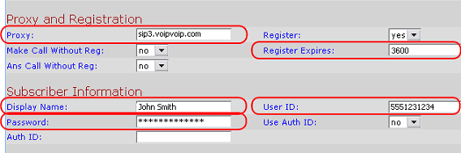

Click the Submit All Changes button.

STEP 4

Change the “Preferred Codec” to your preferred codex for that device. If the DN is located in a compression zone, then choose G729a. Also change the “Use Pref Codec Only” to No and click the Submit All Changes button.
Example:

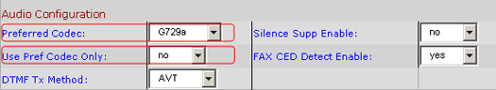
STEP 5

Open a web browser and type in 192.168.0.1/admin/voice/advanced and change the packet size to 0.02 it means that packetization time is 20ms. This is because 3300ICP support 20ms only.

STEP 6
Start to place a call.

Appendix B – Mediatrix 4108 ATA Faxing Configuration
This appendix provides a reference to Mitel Authorized Solutions providers for configuring the Mitel 3300 ICP to host the Mediatrix 4108 SIP device. The different devices can be configured in various configurations depending on your VoIP solution. This section covers a basic setup for faxing with AT&T Flexreach service with required option setup.

Licensing and Option Selection - SIP Licensing
Ensure that the 3300 ICP is equipped with enough SIP Device licences for the connection of SIP end points. This can be verified within the License and Option Selection form.

Figure 1 – License and Option Selection

Multiline IP Set Configuration
On the Mitel 3300 ICP, a SIP device can be programmed either in the User Configuration form or the Multiline IP Set Configuration form and are programmed as a “Generic SIP Phone”. Enterprise Manager can also be used to provision where this application is installed.

The Login PIN is the SIP authentication password and the username is the DN. The Number and Login PIN must match the information in the Mediatrix 4108 configuration. All other field names should be programmed according to the site requirements or left at default.

Figure 2 – Multiline IP Set Configuration

Class of Service Assignment

The Class of Service Options Assignment form is used to create or edit a Class of Service and specify its options. Classes of Service, identified by Class of Service numbers, are referenced by the Station Service Assignment form for the SIP devices. The changes to a default COS are:
Call forwarding external set to yes
HCI/CTI/TAPI Call Control Allowed set to yes
HCI/CTI/TAPI Monitor Allowed set to yes
Public Network Access via DPNSS set to yes
Auto Campon Times is set to Blank

Figure 3 – Class of Service Assignment
Figure 4 – Class of Service Assignment

Figure 5 – Class of Service Assignment (Cont)

SIP Device Capabilities Assignment
This form provides configuration options that can be applied to various types of SIP devices. The association between the SIP device and the form is similar to how the Class of Service options work. The SIP Device Capabilities number provides a SIP profile that can be applied to particular SIP devices to allow for alternate capabilities as recommended through the Mitel interop process.

The Mediatrix 4108 can only be associated with a single SIP Device Capabilities Assignment form, though a form may be assigned to other SIP devices, for example, one SIP Device Capabilities Assignment form can be assigned to all of one type of SIP device.

In the Device Capabilities form, program a SIP Device Capabilities Number for the Mediatrix 4108. Ensure that Replace System based with Device based In-Call Feature is set to ‘Yes’.

Figure 6 – SIP Device Capabilities Assignment

Station Service Assignment

Use the Station Service Assignment form to assign the previously configured Class of Service and SIP Device Capability number to each of the Mediatrix 4108s in the 3300. This form utilizes Range programming.

Select the Mediatrix 4108 number then select Change. Enter the previously configured SIP Device Capability number and Class of Service for Day, Night 1 & Night 2.

Figure 7 – Station Service Assignment

Multiline Set Key Assignment

You use the Multiline Set Key Assignment form to assign the line type, ring type, and directory number to each line select key of the Mediatrix 4108.

The Mediatrix 4108 will support up to 2 additional key line appearances. Each key assignment of the Mediatrix 4108 should be defined as multicall type and should specify that a call to the key’s directory number will ring the set.

Figure 8 – Multiline Set Key Assignment Form

Mediatrix 4108 Setup Notes
The following steps show how to program the Mediatrix 4108 to interconnect with the 3300 ICP.

- The configuration of the Mediatrix 4108 is done via a Web browser. To access the device enter the IP address of the Mediatrix 4108 in the Address field of the browser. Default User Name is ‘admin’, default password is ‘1234’.

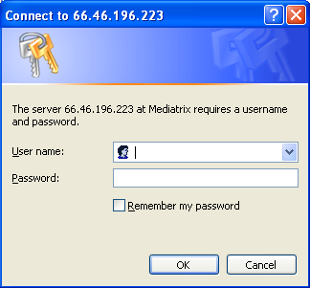

- After login into the Mediatrix 4108, you will see management page. The first line is the main menu and the second line is the sub-menu. The first screen you will see is the Device Info, check and make sure the Firmware is the latest version
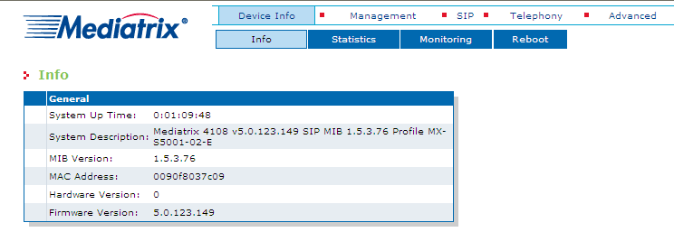
- Network Settings. Clicking on Management from the top line and then go to Network Settings from the second line, enter the IP address and other network settings for Mediatrix 4108.
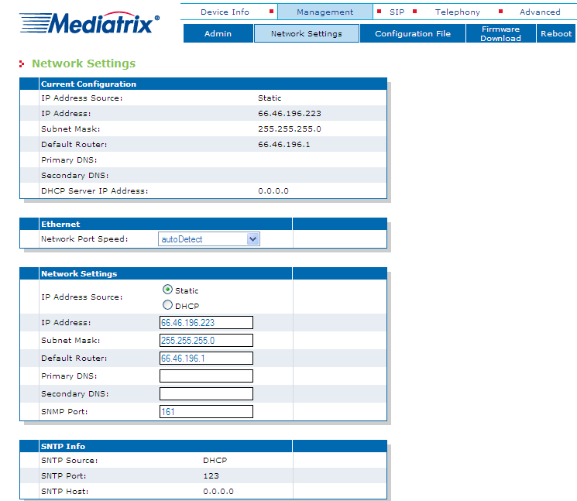

- SIP Parameter Configuration. Clicking on SIP from the first line and on Configuration from the second line. You can enter SIP Registration, SIP Proxy and Outbound Proxy information etc. SIP User Configuration is also programmed on this page. User authentication is configured on another page.
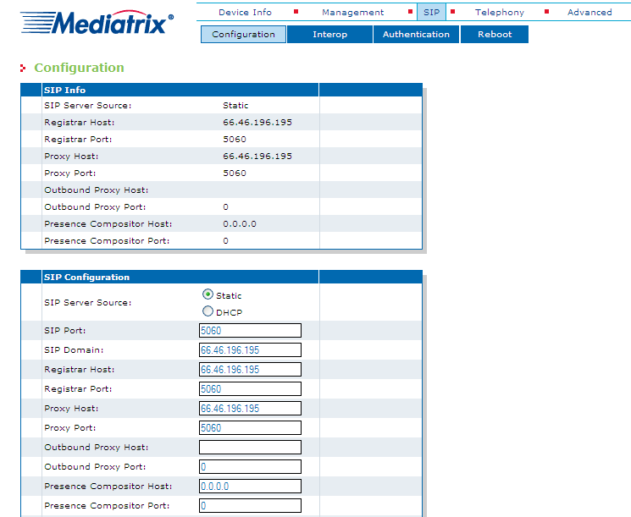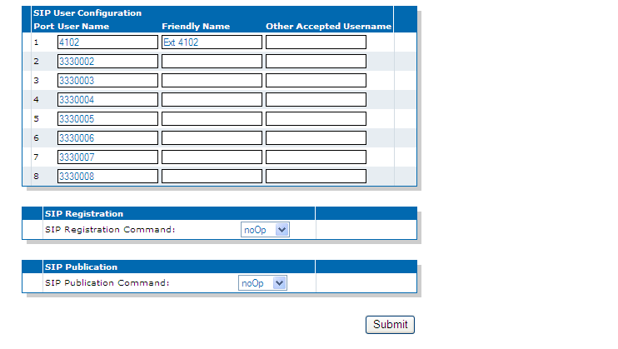
- SIP Authentication. There are two types of authentication information:
  - User Agent Authentication: You can define up to five user names and five passwords for each agent of the Mediatrix 4108. A user agent can thus register with five different realms.
  - Unit Authentication: You can define up to five user names and five passwords for the Mediatrix 4108. These user names and passwords apply to all lines of the unit.
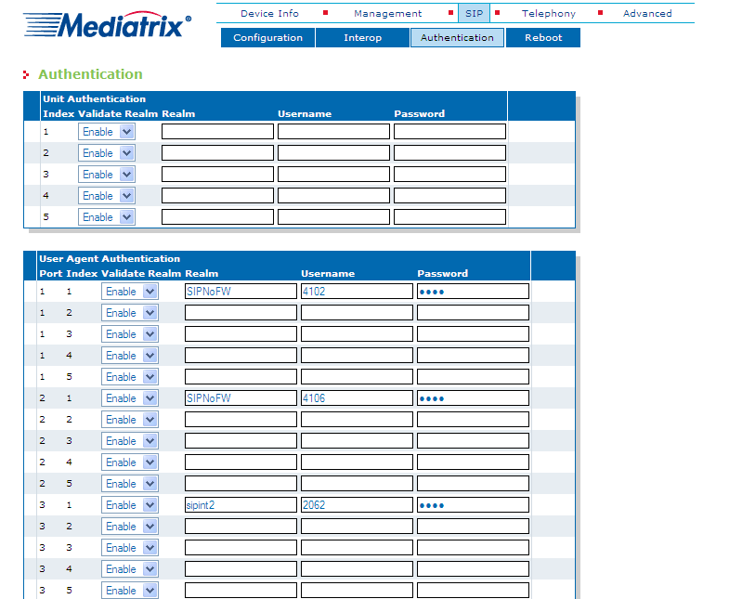
- Digit Maps. A digit map allows you to compare the number users just dialed to a string of arguments. If they match, users can make the call. If not, user can not make the call and get an error signal.
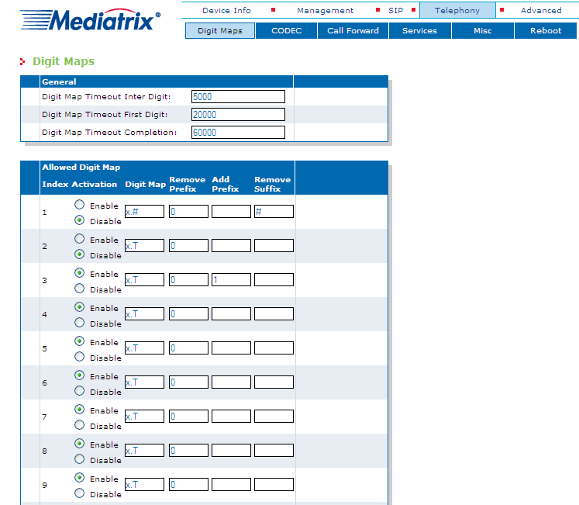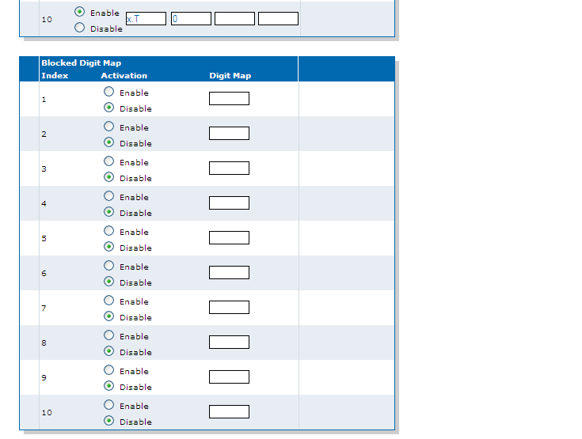

- Voice & Fax Codecs. The lines of the Mediatrix 4108 can simultaneously use the same codec, or a mix of any of the supported codecs.
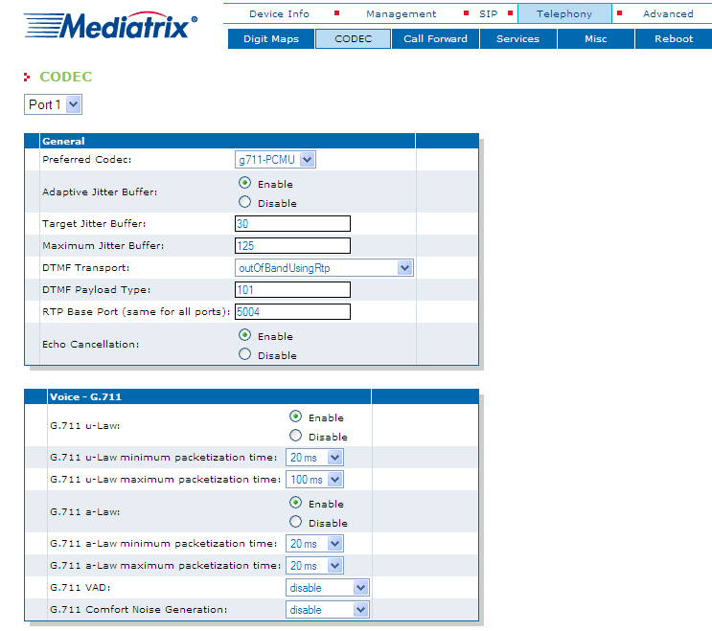
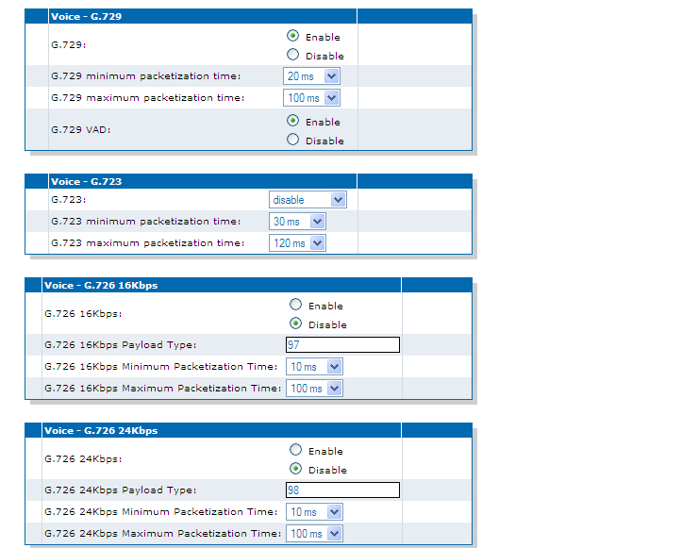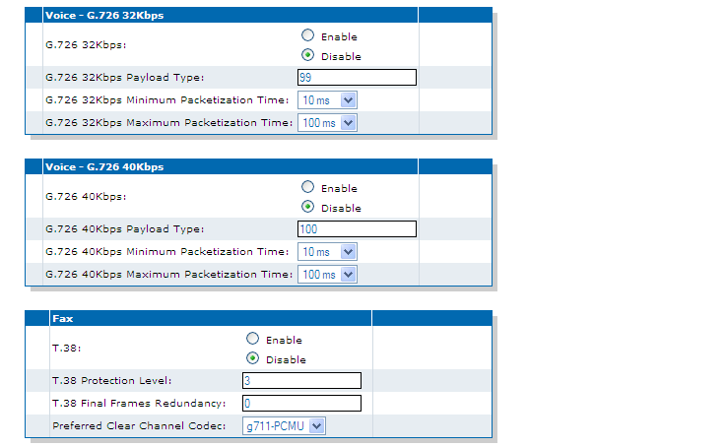

- Call Forward. If you are using Device based in-call features, you can configure the call forward feature on this page.
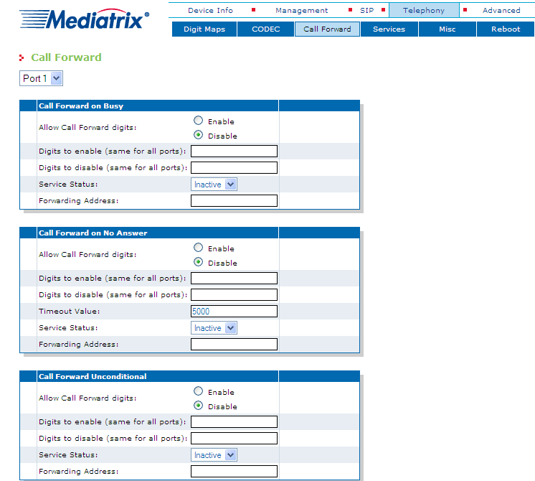

- Telephony Services. Telephone services include Call Transfer, Call Hold, Conference, Call Waiting, Second Call and Automatic Call. You can configure each port with these services.
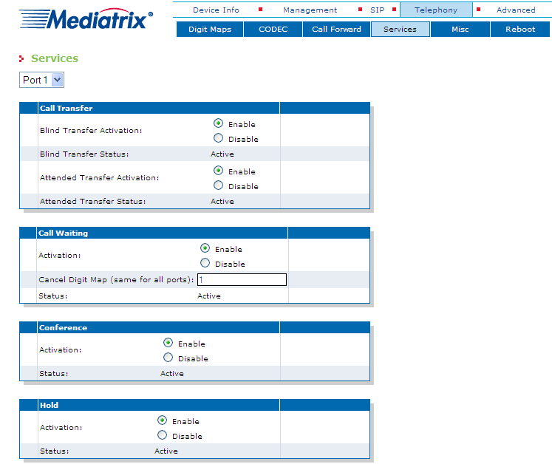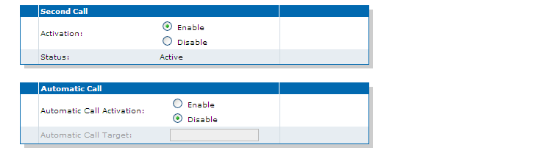

- Telephony Misc. On the page, you can select Country, Customized Tone and Message Waiting Indicator settings.
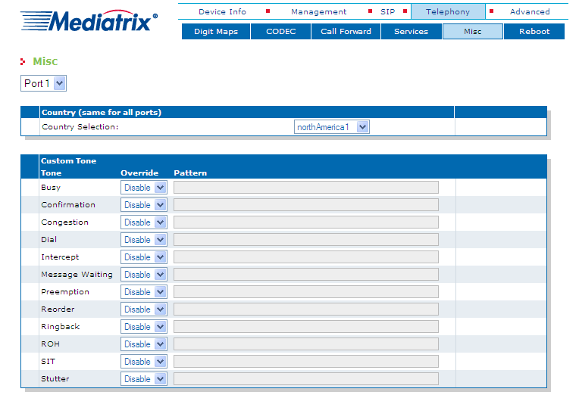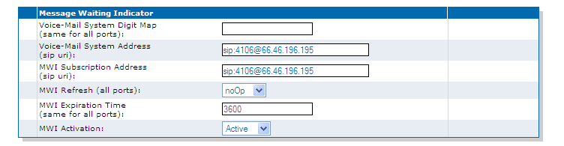

This Customer Configuration Guide ("CCG") is offered as a convenience to AT&T's customers. The specifications and information regarding the product in this CCG are subject to change without notice. All statements, information, and recommendations in this CCG are believed to be accurate but are presented without warranty of any kind, express or implied, and are provided “AS IS”. Users must take full responsibility for the application of the specifications and information in this CCG.

In no event shall AT&T or its suppliers be liable for any indirect, special, consequential, or incidental damages, including, without limitation, lost profits or loss or damage arising out of the use or inability to use this CCG, even if AT&T or its suppliers have been advised of the possibility of such damage.

