

AT&T VPN Service (AT&T VPN)

Cisco Unified Communications Manager (CUCM) 6.1.5 and Cisco Unified Border Element (CUBE) 1.4
using SIP

Customer Configuration Guide
for
AT&T IP Flexible Reach on AT&T VPN

March 8, 2010
Version 1.10

Table of Contents

Introduction 3
Change History 4
Network Topology 5
System Components 6
Hardware Components 6
Software Requirements 6
Features 6
Features Supported 6
Features Not Supported 7
Emergency 911/E911 Services Limitations and Restrictions 7
Caveats 8
CUCM/CUBE Topology Example: 9
Configuring Cisco Unified Border Element (CUBE) at Central Site 10
Configuring Cisco Unified Border Element (CUBE) at Remote Site 20
Configuring the Cisco Unified Communications Manager 30
SIP Trunk configuration 31
Route Group and Route List Configurations 41
Regions (codec settings) 47
Transcoder configuration 69
IP phone sample configurations 71
Set G.729 codec to 30 byte payload 79
Turning Silence Suppression on /off 80
Enabling PRACK for early-media negotiation 81
(Optional) SIP Trunk for fax interface (fax is connected via FXS port on an IOS Gateway) 82
Configuring the Cisco IOS Gateway for T.38 using SIP 86
Acronyms 89

Introduction
AT&T IP Flexible Reach on AT&T Virtual Private Network (AT&T VPN) Service is an offering that allows calls from a customer managed VoIP environment to connect to the PSTN and offers the customer a viable alternative to traditional PSTN.

- This application note describes how to configure a Cisco Unified Communications Manager (CUCM) 6.1.5.12900-7 with a Cisco Unified Border Element (CUBE) 1.4 for connectivity to AT&T’s IP Flexible Reach on AT&T VPN service including Calling plans IP Long Distance and IP Local as described below:

Calling Plans | Description
IP LD  (Calling Plan A) | - Provides unlimited on-net calling between AT&T VoIP enabled sites  - Provides Long Distance and International Off-net calling at competitive per minute rates  - Standard VoIP feature/functionality
Local and Long Distance  (Calling Plan B) | - All features described above plus  - Unlimited inbound and outbound Local calling  - Provides IP based local trunk feature/ functionality
Local and Long Distance Package  (Calling Plan C) | - All features described above plus  - Flat rate plan with included 300 LD off-net minutes per concurrent call
Note: In order to dial 911, customers that select Calling Plan A, are required to maintain an outbound PSTN line at each of their locations.

- The deployment model covered in this application note is central site (headquarters) customer premise equipment (CUCM/CUBE) and remote site (branch) customer premise equipment (CUBE) to PSTN (IPFlex over AVPN). IPFlex over AVPN provides inbound and outbound call service.

- Laboratory testing was performed for the preparation of this guide. Key features verified were: Outbound Basic Calls, Calling Name delivery, Codec Negotiation, Intra-site Transfers, Intra-site Conferencing, Call Hold and Resume, Call Forward (forward all, busy and no answer), Fax using T.38 (with G3 and SG3 fax machines), conferencing, inbound and outbound calls to TDM networks, hop-off and hop-on calls to the PSTN.

- The CUBE configuration detailed in this document is based on a lab environment with a simple dial-plan used to ensure proper interoperability between AT&T SIP network and Cisco Unified Communications. The configuration described in this document details the important commands to have enabled for interoperability to be successful and care must be taken, by the network administrator deploying CUBE, to ensure these commands are set per each dial-peer required to interoperate with the AT&T SIP network.

- A cluster containing a publisher and up to 4 subscribers are supported at the central site. Outbound calls can originate from any of the CUCM servers. Inbound calls route to one server as primary with failover to a secondary.

- This application note does not cover the use of Calling Search Spaces (CSS) or Partitions on CUCM. To understand and learn how to apply CSS and Partitions refer to the cisco.com link below:

- http://www.cisco.com/en/US/docs/voice_ip_comm/cucm/admin/6_0_1/ccmsys/a03ptcss.html

- This Application Note uses the c2821 IOS-voice-gateway, however other Cisco voice gateways are also an option to use since CUBE implementation does not depend on the platform. Here is a list of Cisco Products capable of CUBE functionality. CUBE 1.4 will be available on IOS release 15.1.1T. Note: Only ISR G1 models were tested, ISR G2 models were not tested.

  - Cisco 3900 Series Integrated Services Routers
  - Cisco 2900 Series Integrated Services Routers
  - Cisco 2800 Series Integrated Services Routers
  - Cisco 3800 Series Integrated Services Routers

NOTE: N11 (including 911) calls are not supported unless VoIP Local Service is ordered!!!

Change History
The following table will be maintained with the history of document changes and updates.

ETG Version | Date Issued | Author(s) | Reason for Issue
1.0 | 8/13/2009 | EP, JC | First issue of this CCG.
1.1 | 10/5/2009 | JC | Modify Caveats section for defects CSCsy32904 and CSCta52819
1.2 | 1/8/2010 | EP | Added details for WinEyeQ Probe PC to network topology section.
1.3 | 1/15/2010 | EP | Updated WinEyeQ Probe PC naming convention. Updated network diagrams.
1.4 | 1/15/2010 | EP | Additional changes to network topology diagram.
1.5 | 2/3/2010 | AL | Changes to footers
1.6 | 2/13/2010 | EP | Incorporate changes from legal
1.7 | 3/1/2010 | EP | Changes to SIP profile on CUBE
1.8 | 3/8/2010 | EP | Add information on calling plans
1.9 | 8/13/2010 | EP | Change CUBE version from 1.2 to 1.4
1.9a | 10/13/2010 | MDT | Added clarification regarding Direct Media

Network Topology

Following is a sample diagram of a network topology for a site with a CUCM and CUBE. In this design, the Customer Edge Router (CER) and CUBE are two separate routers. The Visual CSU/DSU (optional) and Voice Probe are both AT&T Managed Devices. Note: The Voice Probe should be plugged into the CER (not the CUBE router). The Voice Probe must be plugged into its own Ethernet port on the CER. All other equipment is managed by the customer.

Note: A remote site would not have CUCM servers.

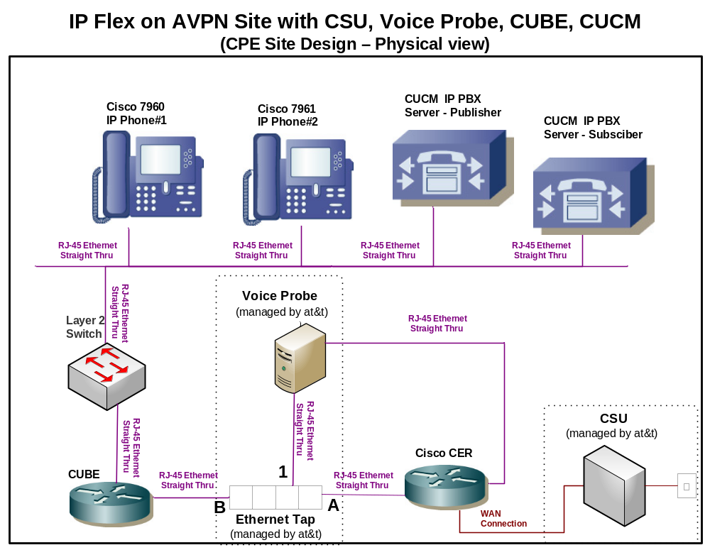

System Components

Hardware Components
- Cisco IOS gateway running CUBE 1.4 (IOS image version 15.1.(1)T) on a Cisco 2800 ISR.

- CUBE is an integrated Cisco IOS Software application that runs on various IOS platforms, follow the link for more details: http://www.cisco.com/go/cube

- Cisco Packet Voice Data Module (PVDM) contains multiple DSPs. . You will need to install PVDM on CUBE if you require MTP, Transcoding or Conference Bridge resources.

- Cisco MCS 7800 Series server (CUCM)

- Cisco IP Phones: any Cisco IP phone model supporting both RFC2833 and RTCP can be used. Note: RTCP is supported on the following Cisco IP phone models: 7906,7911,7912, 7931,7941,7942,7945,7961,7962,7965,7970,7971,7975,8961, 9951

- Cisco IOS Gateway (only needed if Fax, analog phones or TDM systems are to interconnect). This component may be a H.323, SIP or MGCP gateway; the protocol is optional and the choice is left up to the customer’s network design. A sample configuration is shown in the “Configuring a Cisco IOS Gateway for T.38 using SIP” section.

Software Requirements
- This solution was tested with 6.1.5.12900-7..
- This solution was tested with CUBE version 1.4 IOS version 15.1(1)T., ADVANCED ENTERPRISE SERVICES (adventerprisek9-mz.).
- The documented CUBE configuration can be supported with the following IOS feature sets: IP VOICE, SP SERVICES, ADVANCED IP SERVICES, ADVANCED ENTERPRISE SERVICES, INT VOICE/VIDEO, IPIP GW, TDMIP GW,INT VOICE/VIDEO, IPIPGW, TDMIP GW AES. Consult Cisco for additional information.
- Consult your Cisco representative for the correct IOS image for the specific application and Device Unit License and Feature License requirements for CUCM and CUBE.

Features

Features Supported
- Basic Call using G.729 across the WAN and G.711ulaw across the LAN
- Calling Name
- Intra-site Call Transfer
- Intra-site Conference, see caveat section for details.
- Call Hold and Resume
- Call Forward All, Busy and No Answer
- AT&T IP Teleconferencing
- Fax using T.38
- CUBE: performs Delayed-Offer-to-Early-Offer conversion of an initial SIP INVITE without SDP
- Outbound and inbound calls to AT&T’s IP and TDM networks
- Remote Sites with CUBE (for Direct Media).
  - Direct Media allows the RTP steam from the phones at the remote site to directly flow to the hop-off gateway and not to be routed through the CUCM site.

Features Not Supported
- CUCM/CUBE Codec negotiation of G.726
- AT&T does not support SIP ”Session Timer” (Session-Expires and Min-SE headers)

Emergency 911/E911 Services Limitations and Restrictions
Emergency 911/E911 Services Limitations and Restrictions - Although AT&T provides 911/E911 calling capabilities, AT&T does not warrant or represent that the equipment and software (e.g., IP PBX) reviewed in this customer configuration guide will properly operate with AT&T IP Flexible Reach to complete 911/E911 calls; therefore, it is Customer’s responsibility to ensure proper operation with its equipment/software vendor.

While AT&T IP Flexible Reach services support E911/911 calling capabilities under certain Calling Plans, there are circumstances when that E911/911 service may not be available, as stated in the Service Guide for AT&T IP Flexible Reach found at http://new.serviceguide.att.com. Such circumstances include, but are not limited to, relocation of the end user’s CPE, use of a non-native or virtual telephone number, failure in the broadband connection, loss of electrical power, and delays that may occur in updating the Customer’s location in the automatic location information database. Please review the AT&T IP Flexible Reach Service Guide in detail to understand the limitations and restrictions.

Caveats
- When using G.729 between AT&T IP Flexible Reach on AT&T VPN and CUBE/CUCM SIP trunk it is required to configure a Conference Bridge (CFB) resource on CUBE in order for CUCM IP phone to initiate a three-way conference between G729 media end-points.
- Cisco Unified IP phones using SIP as the registration protocol (SIP-line) do not support G.729 with annex B. This current SIP line side support causes failed call attempts when CUBE is set for codec ”g729br8” negotiation. Workaround is to remove ”g729br8” from the preference codec list and only enable ”g729r8”.
- For forwarded calls from CISCO UCM user to PSTN (out to AT&T’s IP Flex-reach service) some AT&T serviced areas require that the SIP Diversion header contain the full 10-digit DID number of the forwarding party. If a customer uses a 4-digit extension on CISCO UCM IP phones it is necessary to expand the 4-digit extension, included in the Diversion: header of a forwarding INVITE message, to its full 10-digit DID number when the IP phone is set to call-forward. The requirement to expand the Diversion-Header has been achieved by the use of a SIP profile in CUBE (See configuration section for details.). Alternatives methods, such as the recommended use of a translation profile have been inconsistent (CSCsx62600) and as such using a SIP profile is the recommended solution. An example is shown below (to add 732320 onto a 4 digit extension):

voice class sip-profiles 1
request INVITE sip-header Diversion modify "<sip:(.*)@(.*)>" "<sip:732320\1@\2>"

CUCM/CUBE Topology Example:

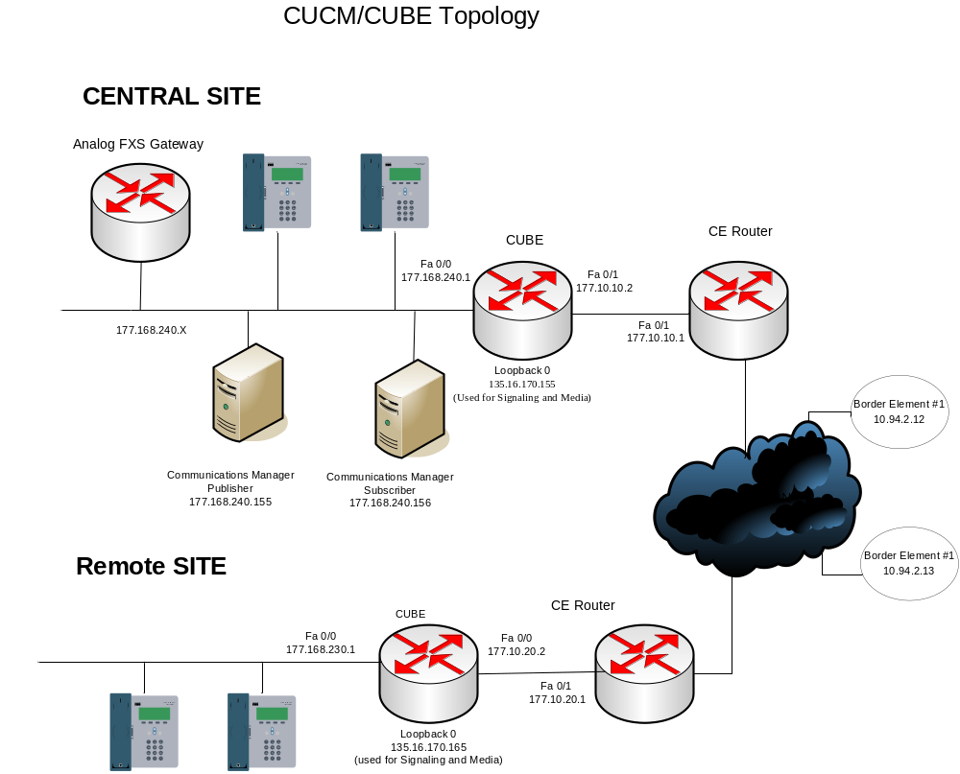

Configuring Cisco Unified Border Element (CUBE) at Central Site
Critical commands are marked bold with footnote and description at bottom of the page.

CUBE1#sh run
Building configuration...

Current configuration : 9249 bytes
!
version 15.1
service timestamps debug datetime msec
service timestamps log datetime msec
no service password-encryption
!
hostname CUBE1
!
boot-start-marker
boot system flash c2800nm-adventerprisek9-mz.151-1.T.bin
boot-end-marker
!
logging message-counter syslog
logging buffered 51200 warnings
enable password attlabs
!
no aaa new-model
!
dot11 syslog
ip source-route
!
!
ip cef
!
!
no ip domain lookup
ip domain name yourdomain.com
no ipv6 cef
!
multilink bundle-name authenticated
!
!
!
!
!
!
!
voice service voip
allow-connections sip to sip
redirect ip2ip
fax protocol t38 version 0 ls-redundancy 0 hs-redundancy 0 fallback none
h323
sip
bind control source-interface Loopback0
bind media source-interface Loopback0
header-passing
error-passthru
no update-callerid
midcall-signaling passthru
privacy-policy passthru
g729 annexb-all
!
voice class codec 20
codec preference 1 g729br8 bytes 30
codec preference 2 g729r8 bytes 30
codec preference 3 g711ulaw
!
voice class sip-profiles 1
request INVITE sip-header Diversion modify "<sip:(.*)@(.*)>" "<sip:352610\1@\2>"
request REINVITE sdp-header Attribute modify "a=T38FaxFillBit Removal:0" ""
request INVITE sdp-header Audio-Attribute add "a=ptime:30"
!

!
!
!
!
!
!
!
!
!
!
!
voice-card 0
dspfarm
dsp services dspfarm
!
!
license udi pid CISCO2821 sn FTX1407A0G4
username tmlabs
!
redundancy
!
!
!
!
!
!
!
!
!
interface Loopback0
description Public Signaling and Media IP address
ip address 135.16.170.155 255.255.255.255
!
interface FastEthernet0/0
description Facing CM
ip address 177.168.240.1 255.255.255.0
duplex full
speed 100
!
interface FastEthernet0/1
description Facing CE
ip address 177.10.10.1 255.255.255.0
duplex full
speed 100
!
interface Serial0/0/0
no ip address
shutdown
!
ip forward-protocol nd
no ip http server
no ip http secure-server
!
ip default-gateway 177.10.10.2
ip forward-protocol nd
ip route 0.0.0.0 0.0.0.0 177.10.10.2
!
!
dialer-list 1 protocol ip permit
dialer-list 1 protocol ipx permit

!
!
!
!
control-plane
!
!
!
mgcp fax t38 ecm

!
!
sccp local Loopback0
sccp ccm 177.168.240.156 identifier 1 version 6.0
sccp ccm 177.168.240.155 identifier 2 version 6.0
sccp
!
sccp ccm group 1
associate ccm 1 priority 1
associate profile 2 register ATTCUBE-TRANS
associate profile 1 register ATTCUBE
!
dspfarm profile 2 transcode
codec g711ulaw
codec g711alaw
codec g729ar8
codec g729abr8
codec g729br8
maximum sessions 6
associate application SCCP
!
dspfarm profile 1 conference
codec g711ulaw
codec g729br8
codec g729r8
maximum sessions 8
associate application SCCP
!
dial-peer voice 1900 voip
description Outbound Call from CUCMs to IP BEs - Inside
session protocol sipv2
incoming called-number 1T
voice-class codec 20
voice-class sip asymmetric payload full
voice-class sip asserted-id pai
voice-class sip privacy-policy passthru
no voice-class sip early-offer forced
voice-class sip profiles 1
dtmf-relay rtp-nte
fax-relay sg3-to-g3
fax rate 14400 bytes 48
fax protocol t38 version 0 ls-redundancy 0 hs-redundancy 0 fallback none
!
dial-peer voice 1901 voip
description Outbound Call From CUCMs to IP BE#1 -Outside
destination-pattern 1T
session protocol sipv2
session target ipv4:10.94.2.12
voice-class codec 20
voice-class sip asymmetric payload full
voice-class sip asserted-id pai
voice-class sip privacy-policy passthru
voice-class sip early-offer forced
voice-class sip profiles 1
dtmf-relay rtp-nte
fax-relay sg3-to-g3
fax rate 14400 bytes 48
fax protocol t38 version 0 ls-redundancy 0 hs-redundancy 0 fallback none
!
dial-peer voice 1902 voip
description From CUCMs to IP BE#2 Outside
destination-pattern 1T
session protocol sipv2
session target ipv4:10.94.2.13
voice-class codec 20
voice-class sip asymmetric payload full
voice-class sip asserted-id pai
voice-class sip privacy-policy passthru
voice-class sip early-offer forced
voice-class sip profiles 1
dtmf-relay rtp-nte
fax-relay sg3-to-g3
fax rate 14400 bytes 48
fax protocol t38 version 0 ls-redundancy 0 hs-redundancy 0 fallback none
!
dial-peer voice 1920 voip
description Incoming Virtual TN Call from IP BEs to CUCMs - Outside
session protocol sipv2
incoming called-number [2-9].........
voice-class codec 20
voice-class sip asserted-id pai
voice-class sip privacy-policy passthru
voice-class sip profiles 1
dtmf-relay rtp-nte
fax-relay sg3-to-g3
fax rate 14400 bytes 48
fax protocol t38 version 0 ls-redundancy 0 hs-redundancy 0 fallback none
!
dial-peer voice 1921 voip
description Incoming Virtual TN Call from IP BEs to CUCM#1 - Inside
destination-pattern [2-9].........
session protocol sipv2
session target ipv4:177.168.240.155
voice-class codec 20
voice-class sip asserted-id pai
voice-class sip privacy-policy passthru
voice-class sip profiles 1
dtmf-relay rtp-nte
fax-relay sg3-to-g3
fax rate 14400 bytes 48
fax protocol t38 version 0 ls-redundancy 0 hs-redundancy 0 fallback none
!
dial-peer voice 1922 voip
description Incoming Virtual TN Call from IP BEs to CUCM#2 - Inside
destination-pattern [2-9].........
session protocol sipv2
session target ipv4:177.168.240.156
voice-class codec 20
voice-class sip asserted-id pai
voice-class sip privacy-policy passthru
voice-class sip profiles 1
dtmf-relay rtp-nte
fax-relay sg3-to-g3
fax rate 14400 bytes 48
fax protocol t38 version 0 ls-redundancy 0 hs-redundancy 0 fallback none
!
dial-peer voice 1930 voip
description Incoming non-Virtual TN Call from IPBEs to CUCMs - Outside
session protocol sipv2
incoming called-number [2-9]......
voice-class codec 20
voice-class sip asserted-id pai
voice-class sip privacy-policy passthru
voice-class sip profiles 1
dtmf-relay rtp-nte
fax-relay sg3-to-g3
fax rate 14400 bytes 48
fax protocol t38 version 0 ls-redundancy 0 hs-redundancy 0 fallback none
!
dial-peer voice 1931 voip
description Incoming Non-Virtual TN Call from IP BEs to CUCM#1 - Inside
destination-pattern [2-9]......
session protocol sipv2
session target ipv4:177.168.240.155
voice-class codec 20
voice-class sip asserted-id pai
voice-class sip privacy-policy passthru
voice-class sip profiles 1
dtmf-relay rtp-nte
fax-relay sg3-to-g3
fax rate 14400 bytes 48
fax protocol t38 version 0 ls-redundancy 0 hs-redundancy 0 fallback none
!
dial-peer voice 1932 voip
description Incoming Non-Virtual TN Call from IP BEs to CUCM#2 - Inside
destination-pattern [2-9]......
session protocol sipv2
session target ipv4:177.168.240.156
voice-class codec 20
voice-class sip asserted-id pai
voice-class sip privacy-policy passthru
voice-class sip profiles 1
dtmf-relay rtp-nte
fax-relay sg3-to-g3
fax rate 14400 bytes 48
fax protocol t38 version 0 ls-redundancy 0 hs-redundancy 0 fallback none
!
dial-peer voice 1940 voip
description Outgoing N11 calls from CUCMs to IP BEs - Inside
session protocol sipv2
incoming called-number [2-9]11
voice-class codec 20
voice-class sip asymmetric payload full
voice-class sip asserted-id pai
voice-class sip privacy-policy passthru
voice-class sip profiles 1
dtmf-relay rtp-nte
fax-relay sg3-to-g3
fax rate 14400 bytes 48
fax protocol t38 version 0 ls-redundancy 0 hs-redundancy 0 fallback none
!
dial-peer voice 1941 voip
description Outgoing N11 calls from CUCMs to IP BE #1 - Outside
destination-pattern [2-9]11
session protocol sipv2
session target ipv4:10.94.2.12
voice-class codec 20
voice-class sip asymmetric payload full
voice-class sip asserted-id pai
voice-class sip privacy-policy passthru
voice-class sip early-offer forced
voice-class sip profiles 1
dtmf-relay rtp-nte
fax-relay sg3-to-g3
fax rate 14400 bytes 48
fax protocol t38 version 0 ls-redundancy 0 hs-redundancy 0 fallback none
!
dial-peer voice 1942 voip
description Outgoing N11 calls from CUCMs to IP BE #2 - Outside
destination-pattern [2-9]11
session protocol sipv2
session target ipv4: 10.94.2.13
voice-class codec 20
voice-class sip asymmetric payload full
voice-class sip asserted-id pai
voice-class sip privacy-policy passthru
voice-class sip early-offer forced
voice-class sip profiles 1
dtmf-relay rtp-nte
fax-relay sg3-to-g3
fax rate 14400 bytes 48
fax protocol t38 version 0 ls-redundancy 0 hs-redundancy 0 fallback none
!
dial-peer voice 1960 voip
description Outgoing International Call From CUCMs to IP BEs – Inside
session protocol sipv2
incoming called-number 011T
voice-class codec 20
voice-class sip asymmetric payload full
voice-class sip asserted-id pai
voice-class sip privacy-policy passthru
voice-class sip profiles 1
dtmf-relay rtp-nte
fax-relay sg3-to-g3
fax rate 14400 bytes 48
fax protocol t38 version 0 ls-redundancy 0 hs-redundancy 0 fallback none
!
dial-peer voice 1961 voip
description Outgoing International Call from CUCMs to IP BE#1 - Outside
destination-pattern 011T
session protocol sipv2
session target ipv4:10.94.2.12
voice-class codec 20
voice-class sip asymmetric payload full
voice-class sip asserted-id pai
voice-class sip privacy-policy passthru
voice-class sip early-offer forced
voice-class sip profiles 1
dtmf-relay rtp-nte
fax-relay sg3-to-g3
fax rate 9600 bytes 48
fax protocol t38 version 0 ls-redundancy 0 hs-redundancy 0 fallback none
!
dial-peer voice 1962 voip
description Outgoing International Call from CUCMs to IP BE#2 - Outside
destination-pattern 011T
session protocol sipv2
session target ipv4:10.94.2.13
voice-class codec 20
voice-class sip asymmetric payload full
voice-class sip asserted-id pai
voice-class sip privacy-policy passthru
voice-class sip early-offer forced
voice-class sip profiles 1
dtmf-relay rtp-nte
fax-relay sg3-to-g3
fax rate 14400 bytes 48
fax protocol t38 version 0 ls-redundancy 0 hs-redundancy 0 fallback none
!
!
!
dial-peer hunt 1
sip-ua
retry invite 2
!
!
line con 0
login local
line aux 0
line vty 0 4
password attlabs
login
transport preferred telnet
transport input all
!
scheduler allocate 20000 1000
end

Configuring Cisco Unified Border Element (CUBE) at Remote Site
The Remote Site CUBE configuration is almost identical to the Central Site CUBE configuration with the exception of changing the LAN interface address, Loopback interface addresses and possibly the IPBE IP address (depending on the location of the remote site, the IPBE address may or may not be the same as the IPBE address configured in the Central Site CUBE configuration).

Note: This is the "Direct media" configuration

Critical commands are marked bold with a footnote and description at bottom of the page.

CUBE1#sh run
Building configuration...

Current configuration : 9249 bytes
!
version 15.1
service timestamps debug datetime msec
service timestamps log datetime msec
no service password-encryption
!
hostname CUBE1
!
boot-start-marker
boot system flash c2800nm-adventerprisek9-mz.151-1.T.bin
boot-end-marker
!
logging message-counter syslog
logging buffered 51200 warnings
enable password attlabs
!
no aaa new-model
!
dot11 syslog
ip source-route
!
!
ip cef
!
!
no ip domain lookup
ip domain name yourdomain.com
no ipv6 cef
!
multilink bundle-name authenticated
!
!
!
!
!
!
!
voice service voip
allow-connections sip to sip
redirect ip2ip
fax protocol t38 version 0 ls-redundancy 0 hs-redundancy 0 fallback none
h323
sip
bind control source-interface Loopback0
bind media source-interface Loopback0
header-passing
error-passthru
no update-callerid
midcall-signaling passthru
privacy-policy passthru
g729 annexb-all
!
voice class codec 20
codec preference 1 g729br8 bytes 30
codec preference 2 g729r8 bytes 30
codec preference 3 g711ulaw
!
voice class sip-profiles 1
request INVITE sip-header Diversion modify "<sip:(.*)@(.*)>" "<sip:352610\1@\2>"
request REINVITE sdp-header Attribute modify "a=T38FaxFillBit Removal:0" ""
request INVITE sdp-header Audio-Attribute add "a=ptime:30"
!

!
!
!
!
!
!
!
!
!
!
!
voice-card 0
dspfarm
dsp services dspfarm
!
!
license udi pid CISCO2821 sn FTX1407A0G4
username tmlabs
!
redundancy
!
!
!
!
!
!
!
!
!
interface Loopback0
description Public Signaling and Media IP address
ip address 135.16.170.165 255.255.255.255
!
interface FastEthernet0/0
description Facing CM
ip address 177.168.230.1 255.255.255.0
duplex full
speed 100
!
interface FastEthernet0/1
description Facing CE
ip address 177.10.20.1 255.255.255.0
duplex full
speed 100
!
interface Serial0/0/0
no ip address
shutdown
!
ip forward-protocol nd
no ip http server
no ip http secure-server
!
ip default-gateway 177.10.20.2
ip forward-protocol nd
ip route 0.0.0.0 0.0.0.0 177.10.10.2
!
!
dialer-list 1 protocol ip permit
dialer-list 1 protocol ipx permit

!
!
!
!
control-plane
!
!
!
mgcp fax t38 ecm

!
!
sccp local Loopback0
sccp ccm 177.168.240.156 identifier 1 version 6.0
sccp ccm 177.168.240.155 identifier 2 version 6.0
sccp
!
sccp ccm group 1
associate ccm 1 priority 1
associate profile 2 register ATTCUBE-TRANS
associate profile 1 register ATTCUBE
!
dspfarm profile 2 transcode
codec g711ulaw
codec g711alaw
codec g729ar8
codec g729abr8
codec g729br8
maximum sessions 6
associate application SCCP
!
dspfarm profile 1 conference
codec g711ulaw
codec g729br8
codec g729r8
maximum sessions 8
associate application SCCP
!
dial-peer voice 1900 voip
description Outbound Call from CUCMs to IP BEs - Inside
session protocol sipv2
incoming called-number 1T
voice-class codec 20
voice-class sip asymmetric payload full
voice-class sip asserted-id pai
voice-class sip privacy-policy passthru
no voice-class sip early-offer forced
voice-class sip profiles 1
dtmf-relay rtp-nte
fax-relay sg3-to-g3
fax rate 14400 bytes 48
fax protocol t38 version 0 ls-redundancy 0 hs-redundancy 0 fallback none
!
dial-peer voice 1901 voip
description Outbound Call From CUCMs to IP BE#1 -Outside
destination-pattern 1T
session protocol sipv2
session target ipv4:10.94.2.12
voice-class codec 20
voice-class sip asymmetric payload full
voice-class sip asserted-id pai
voice-class sip privacy-policy passthru
voice-class sip early-offer forced
voice-class sip profiles 1
dtmf-relay rtp-nte
fax-relay sg3-to-g3
fax rate 14400 bytes 48
fax protocol t38 version 0 ls-redundancy 0 hs-redundancy 0 fallback none
!
dial-peer voice 1902 voip
description From CUCMs to IP BE#2 Outside
destination-pattern 1T
session protocol sipv2
session target ipv4:10.94.2.13
voice-class codec 20
voice-class sip asymmetric payload full
voice-class sip asserted-id pai
voice-class sip privacy-policy passthru
voice-class sip early-offer forced
voice-class sip profiles 1
dtmf-relay rtp-nte
fax-relay sg3-to-g3
fax rate 14400 bytes 48
fax protocol t38 version 0 ls-redundancy 0 hs-redundancy 0 fallback none
!
dial-peer voice 1920 voip
description Incoming Virtual TN Call from IP BEs to CUCMs - Outside
session protocol sipv2
incoming called-number [2-9].........
voice-class codec 20
voice-class sip asserted-id pai
voice-class sip privacy-policy passthru
voice-class sip profiles 1
dtmf-relay rtp-nte
fax-relay sg3-to-g3
fax rate 14400 bytes 48
fax protocol t38 version 0 ls-redundancy 0 hs-redundancy 0 fallback none
!
dial-peer voice 1921 voip
description Incoming Virtual TN Call from IP BEs to CUCM#1 - Inside
destination-pattern [2-9].........
session protocol sipv2
session target ipv4:177.168.240.155
voice-class codec 20
voice-class sip asserted-id pai
voice-class sip privacy-policy passthru
voice-class sip profiles 1
dtmf-relay rtp-nte
fax-relay sg3-to-g3
fax rate 14400 bytes 48
fax protocol t38 version 0 ls-redundancy 0 hs-redundancy 0 fallback none
!
dial-peer voice 1922 voip
description Incoming Virtual TN Call from IP BEs to CUCM#2 - Inside
destination-pattern [2-9].........
session protocol sipv2
session target ipv4:177.168.240.156
voice-class codec 20
voice-class sip asserted-id pai
voice-class sip privacy-policy passthru
voice-class sip profiles 1
dtmf-relay rtp-nte
fax-relay sg3-to-g3
fax rate 14400 bytes 48
fax protocol t38 version 0 ls-redundancy 0 hs-redundancy 0 fallback none
!
dial-peer voice 1930 voip
description Incoming non-Virtual TN Call from IPBEs to CUCMs - Outside
session protocol sipv2
incoming called-number [2-9]......
voice-class codec 20
voice-class sip asserted-id pai
voice-class sip privacy-policy passthru
voice-class sip profiles 1
dtmf-relay rtp-nte
fax-relay sg3-to-g3
fax rate 14400 bytes 48
fax protocol t38 version 0 ls-redundancy 0 hs-redundancy 0 fallback none
!
dial-peer voice 1931 voip
description Incoming Non-Virtual TN Call from IP BEs to CUCM#1 - Inside
destination-pattern [2-9]......
session protocol sipv2
session target ipv4:177.168.240.155
voice-class codec 20
voice-class sip asserted-id pai
voice-class sip privacy-policy passthru
voice-class sip profiles 1
dtmf-relay rtp-nte
fax-relay sg3-to-g3
fax rate 14400 bytes 48
fax protocol t38 version 0 ls-redundancy 0 hs-redundancy 0 fallback none
!
dial-peer voice 1932 voip
description Incoming Non-Virtual TN Call from IP BEs to CUCM#2 - Inside
destination-pattern [2-9]......
session protocol sipv2
session target ipv4:177.168.240.156
voice-class codec 20
voice-class sip asserted-id pai
voice-class sip privacy-policy passthru
voice-class sip profiles 1
dtmf-relay rtp-nte
fax-relay sg3-to-g3
fax rate 14400 bytes 48
fax protocol t38 version 0 ls-redundancy 0 hs-redundancy 0 fallback none
!
dial-peer voice 1940 voip
description Outgoing N11 calls from CUCMs to IP BEs - Inside
session protocol sipv2
incoming called-number [2-9]11
voice-class codec 20
voice-class sip asymmetric payload full
voice-class sip asserted-id pai
voice-class sip privacy-policy passthru
voice-class sip profiles 1
dtmf-relay rtp-nte
fax-relay sg3-to-g3
fax rate 14400 bytes 48
fax protocol t38 version 0 ls-redundancy 0 hs-redundancy 0 fallback none
!
dial-peer voice 1941 voip
description Outgoing N11 calls from CUCMs to IP BE #1 - Outside
destination-pattern [2-9]11
session protocol sipv2
session target ipv4:10.94.2.12
voice-class codec 20
voice-class sip asymmetric payload full
voice-class sip asserted-id pai
voice-class sip privacy-policy passthru
voice-class sip early-offer forced
voice-class sip profiles 1
dtmf-relay rtp-nte
fax-relay sg3-to-g3
fax rate 14400 bytes 48
fax protocol t38 version 0 ls-redundancy 0 hs-redundancy 0 fallback none
!
dial-peer voice 1942 voip
description Outgoing N11 calls from CUCMs to IP BE #2 - Outside
destination-pattern [2-9]11
session protocol sipv2
session target ipv4: 10.94.2.13
voice-class codec 20
voice-class sip asymmetric payload full
voice-class sip asserted-id pai
voice-class sip privacy-policy passthru
voice-class sip early-offer forced
voice-class sip profiles 1
dtmf-relay rtp-nte
fax-relay sg3-to-g3
fax rate 14400 bytes 48
fax protocol t38 version 0 ls-redundancy 0 hs-redundancy 0 fallback none
!
dial-peer voice 1960 voip
description Outgoing International Call From CUCMs to IP BEs – Inside
session protocol sipv2
incoming called-number 011T
voice-class codec 20
voice-class sip asymmetric payload full
voice-class sip asserted-id pai
voice-class sip privacy-policy passthru
voice-class sip profiles 1
dtmf-relay rtp-nte
fax-relay sg3-to-g3
fax rate 14400 bytes 48
fax protocol t38 version 0 ls-redundancy 0 hs-redundancy 0 fallback none
!
dial-peer voice 1961 voip
description Outgoing International Call from CUCMs to IP BE#1 - Outside
destination-pattern 011T
session protocol sipv2
session target ipv4:10.94.2.12
voice-class codec 20
voice-class sip asymmetric payload full
voice-class sip asserted-id pai
voice-class sip privacy-policy passthru
voice-class sip early-offer forced
voice-class sip profiles 1
dtmf-relay rtp-nte
fax-relay sg3-to-g3
fax rate 9600 bytes 48
fax protocol t38 version 0 ls-redundancy 0 hs-redundancy 0 fallback none
!
dial-peer voice 1962 voip
description Outgoing International Call from CUCMs to IP BE#2 - Outside
destination-pattern 011T
session protocol sipv2
session target ipv4:10.94.2.13
voice-class codec 20
voice-class sip asymmetric payload full
voice-class sip asserted-id pai
voice-class sip privacy-policy passthru
voice-class sip early-offer forced
voice-class sip profiles 1
dtmf-relay rtp-nte
fax-relay sg3-to-g3
fax rate 14400 bytes 48
fax protocol t38 version 0 ls-redundancy 0 hs-redundancy 0 fallback none
!
!
!
dial-peer hunt 1
sip-ua
retry invite 2
!
!
line con 0
login local
line aux 0
line vty 0 4
password attlabs
login
transport preferred telnet
transport input all
!
scheduler allocate 20000 1000
end

Configuring the Cisco Unified Communications Manager
Cisco Unified Communications Manager version:

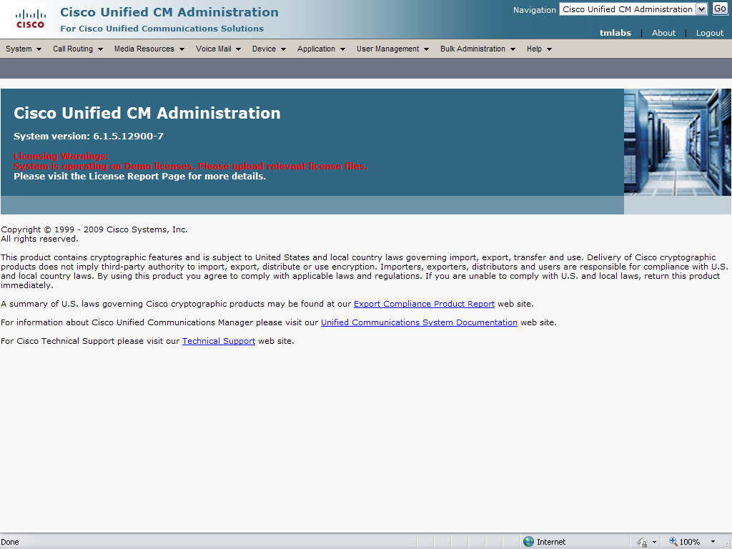

SIP Trunk configuration
Main Page: Two trunks are required to the Central Site CUBE (Central Site CUBE addr is 135.16.170.155 in this example) and two trunks for a Remote Site CUBE (Remote Site CUBE is 135.16.170.165 in this example). The first trunk at a site will be configured for G.729 only (which is the preferred codec across the WAN). The second trunk at a site will be configured for G711 and will be used in the event that a G729 call cannot be established.

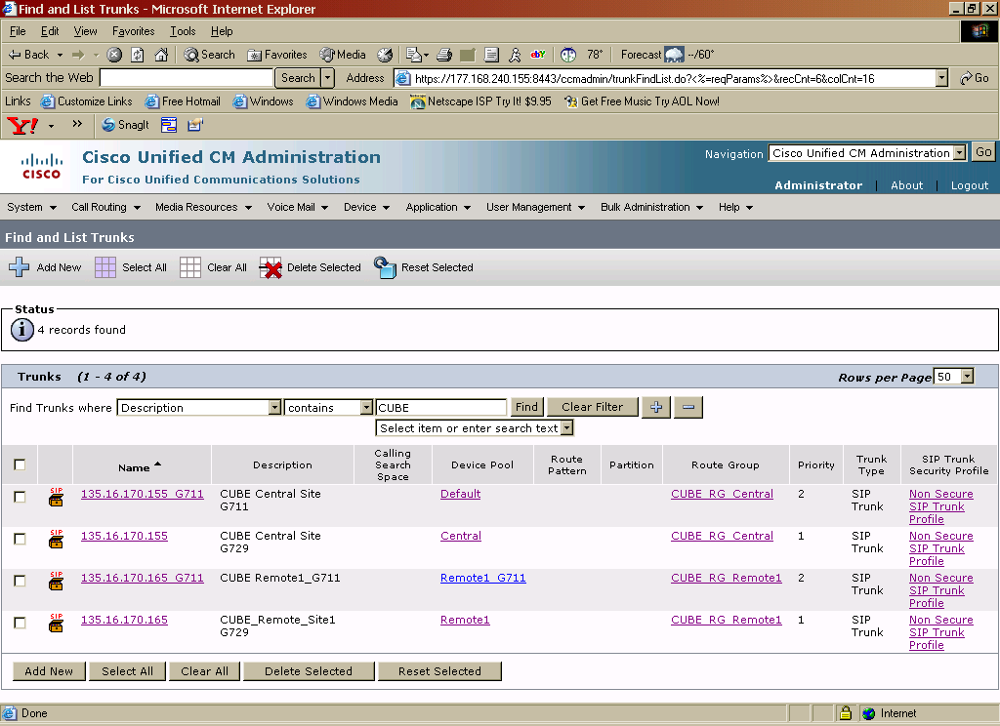

Note: The device pool setting, along with the region setting within the device pool, determines the codec choice.

Central Site CUBE Trunk for G729

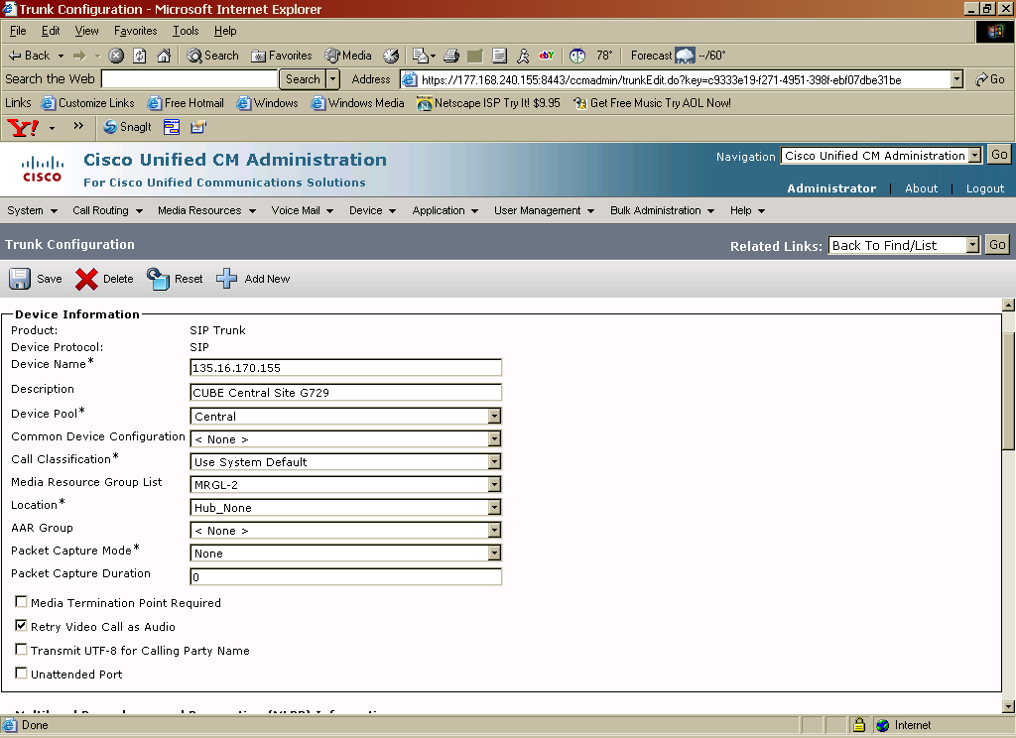
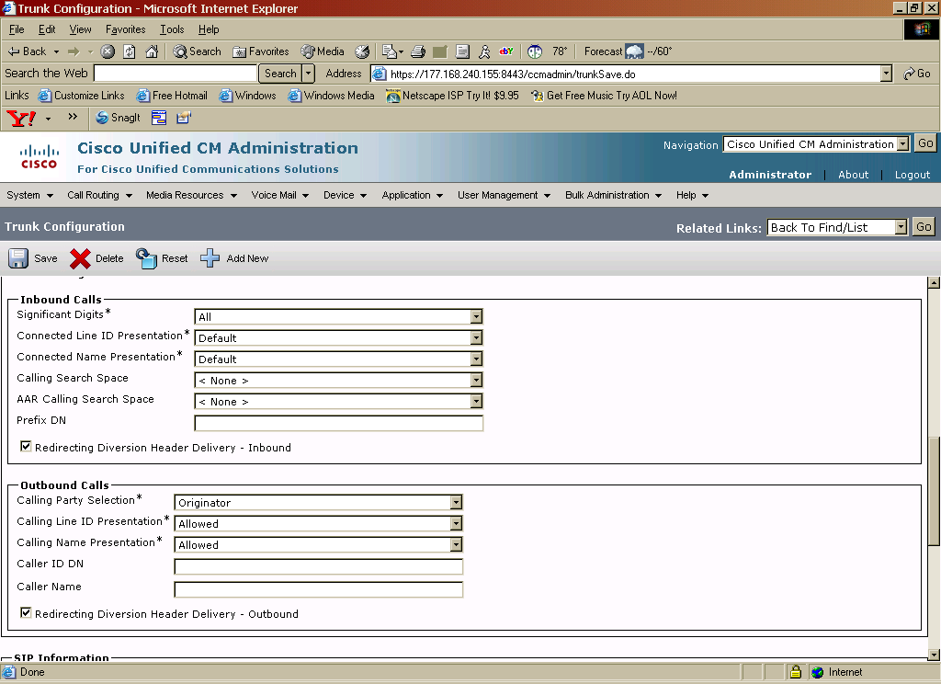
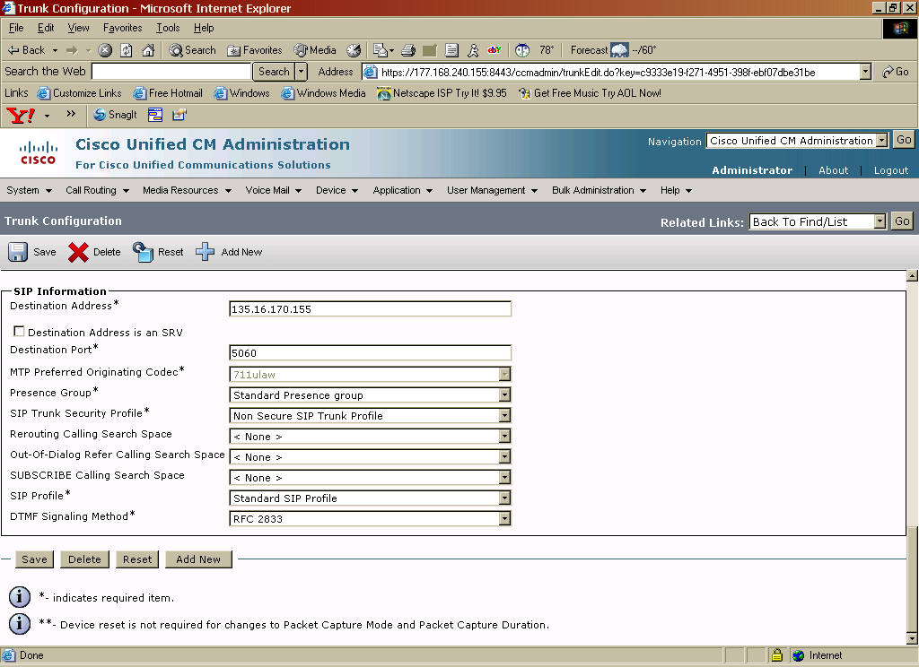
Central Site CUBE Trunk for G711

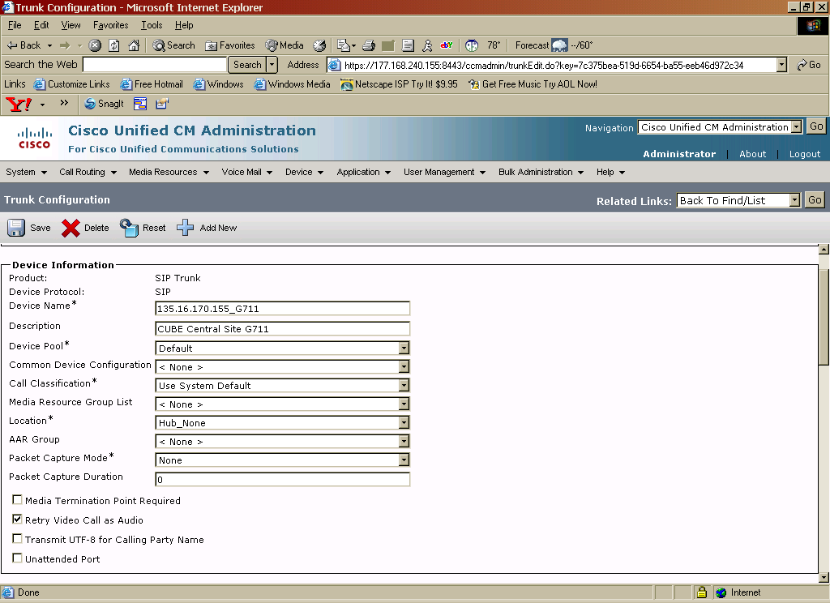
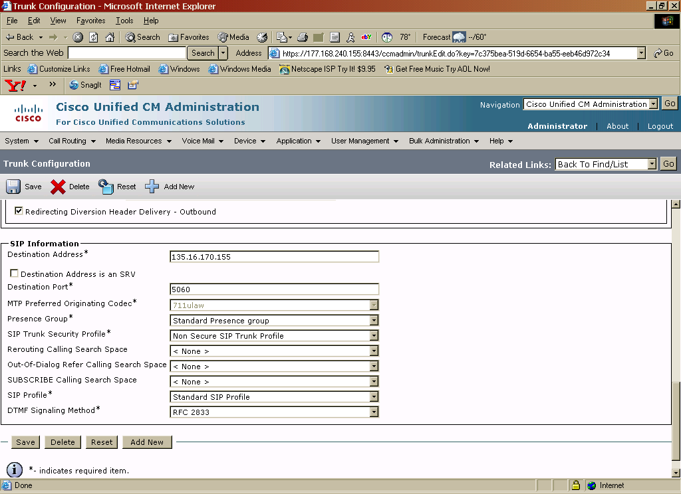
Remote Site CUBE Trunk for G729
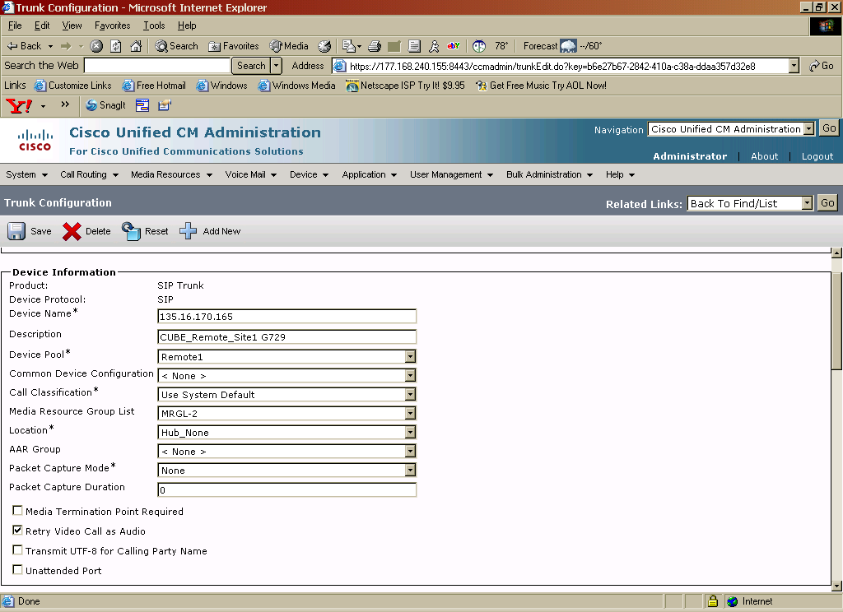

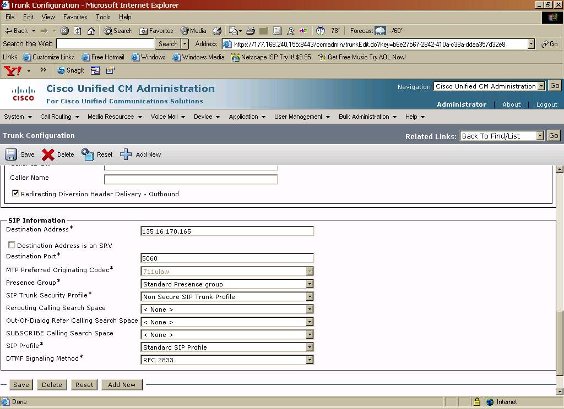
Remote Site CUBE Trunk for G711
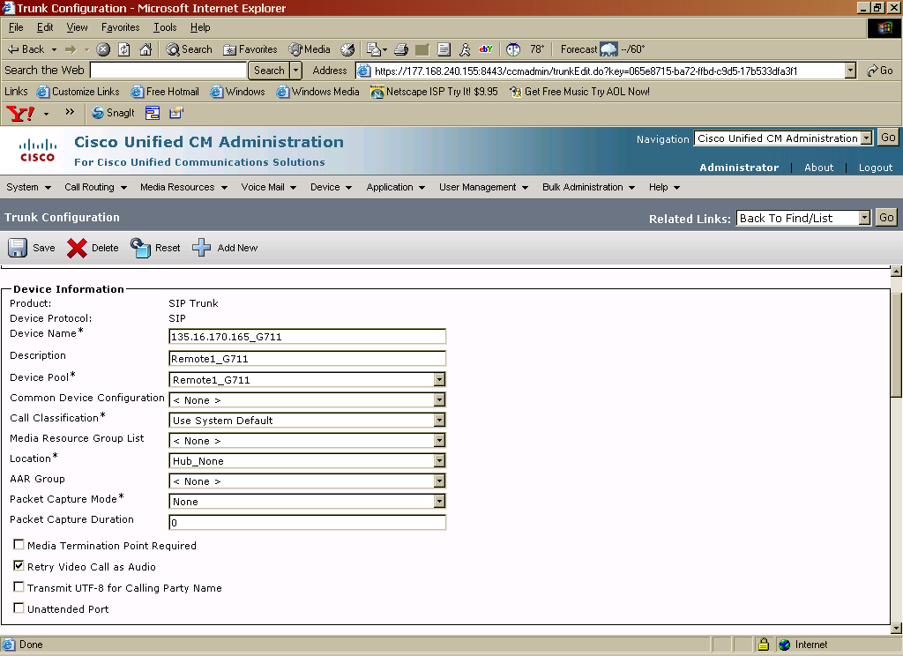
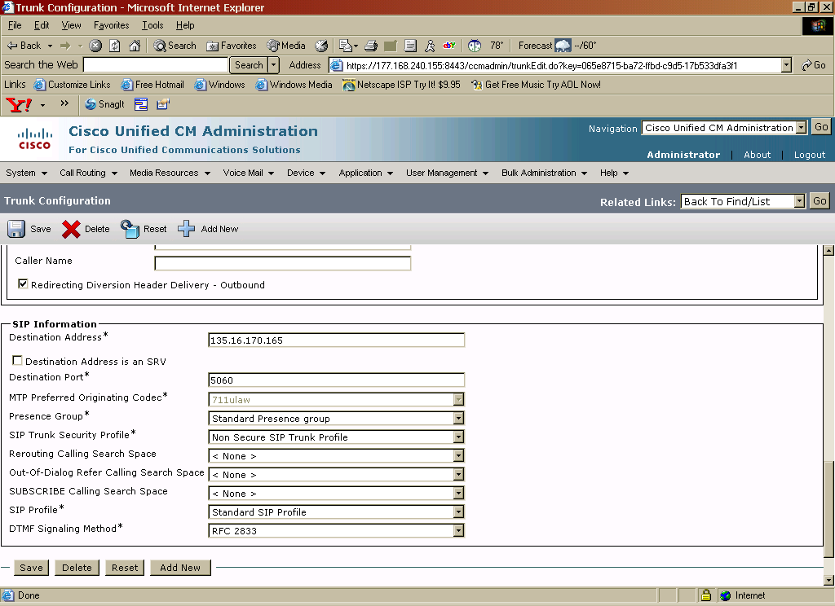
SIP Trunk Profile
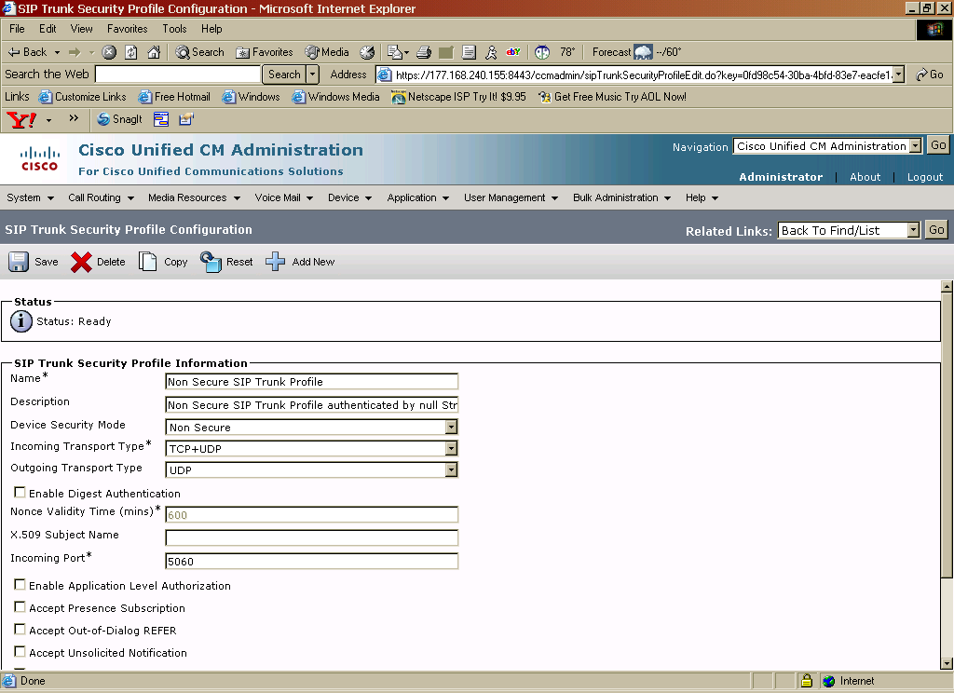
Route Group and Route List Configurations

Route group- A route group will be required for each site.

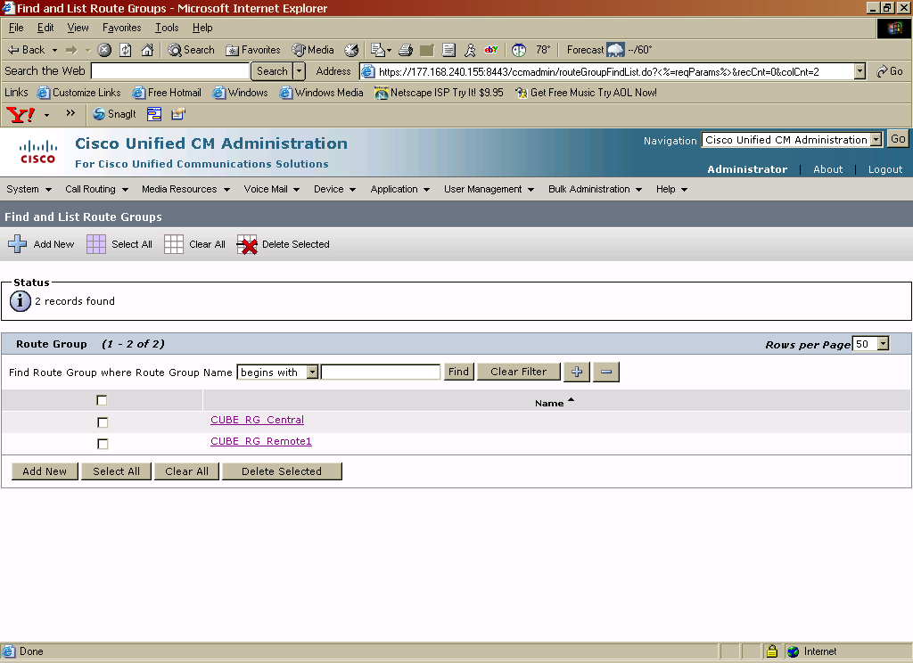

Central Site Route Group - contains two trunks for the Central site CUBE (one for G729 and one for G711 codec)

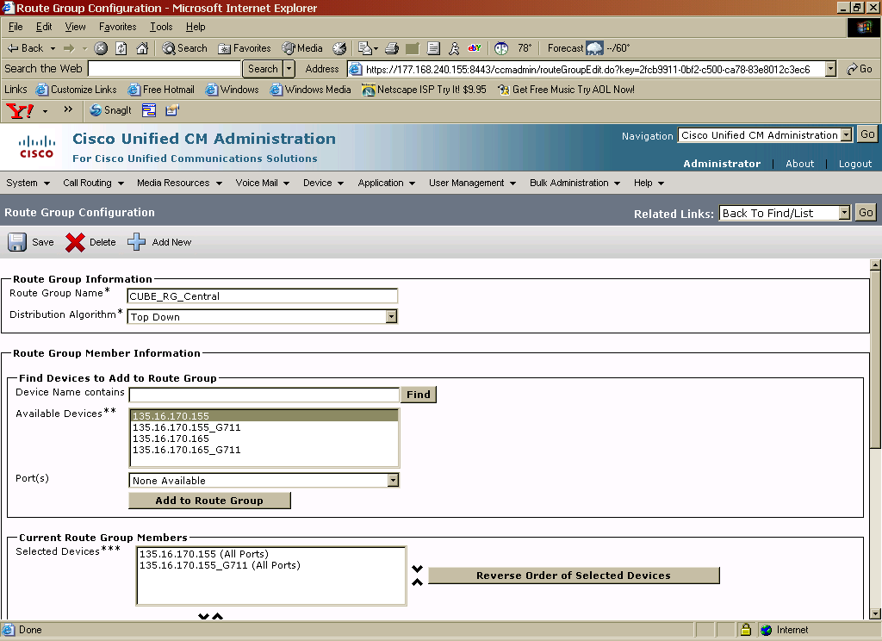

Remote Site 1 Route Group - contains two trunks for the Remote site CUBE (one for G729 and one for G711 codec)
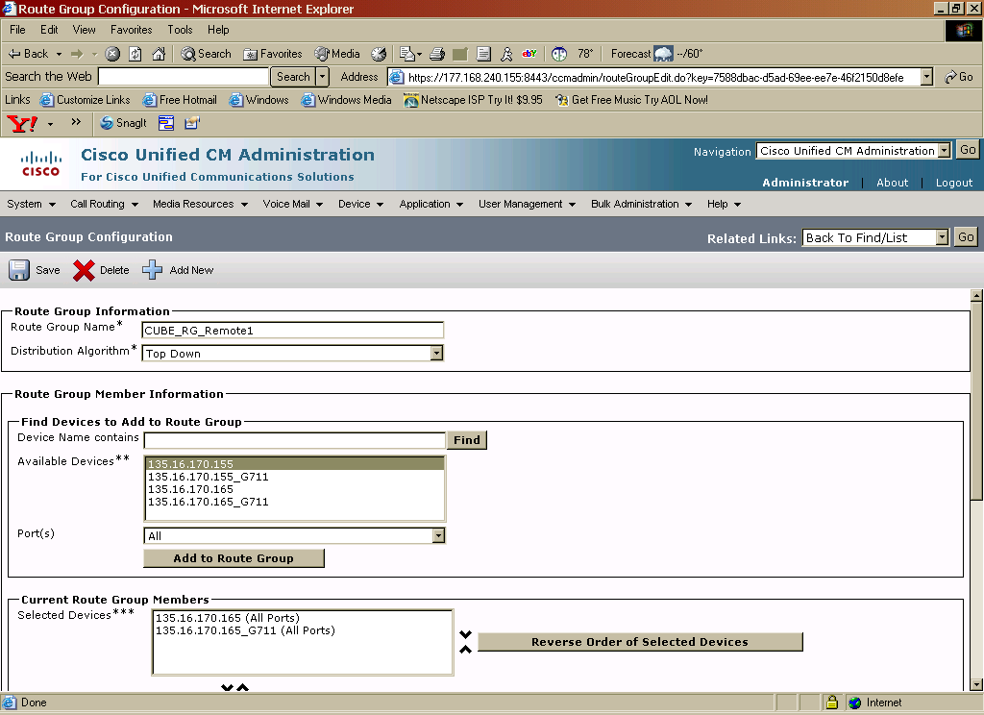

Route List- Main Page
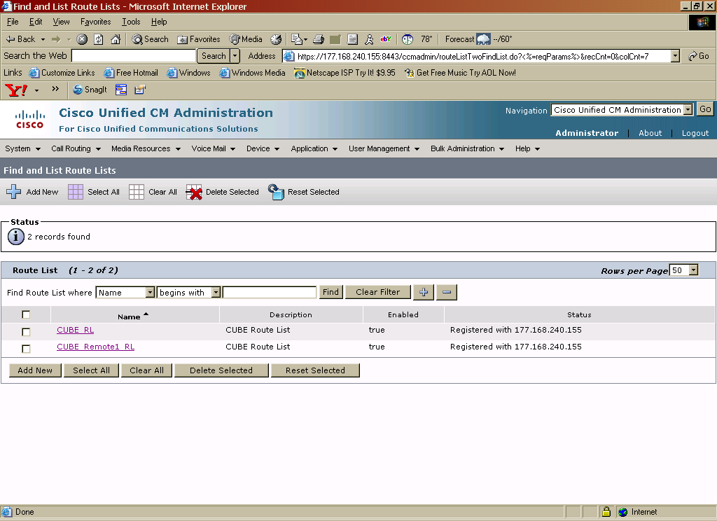

Route List – Central Site
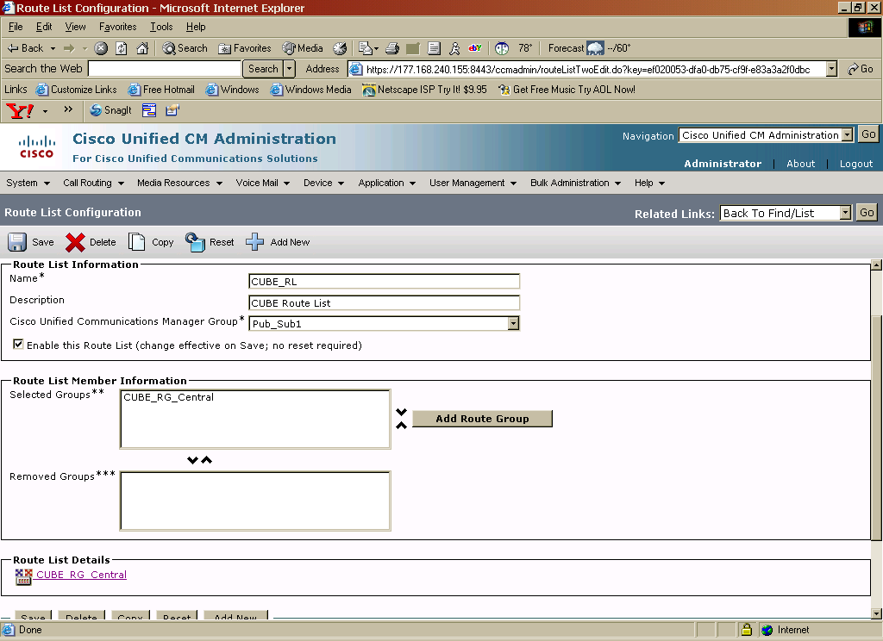
Route List – Remote Site

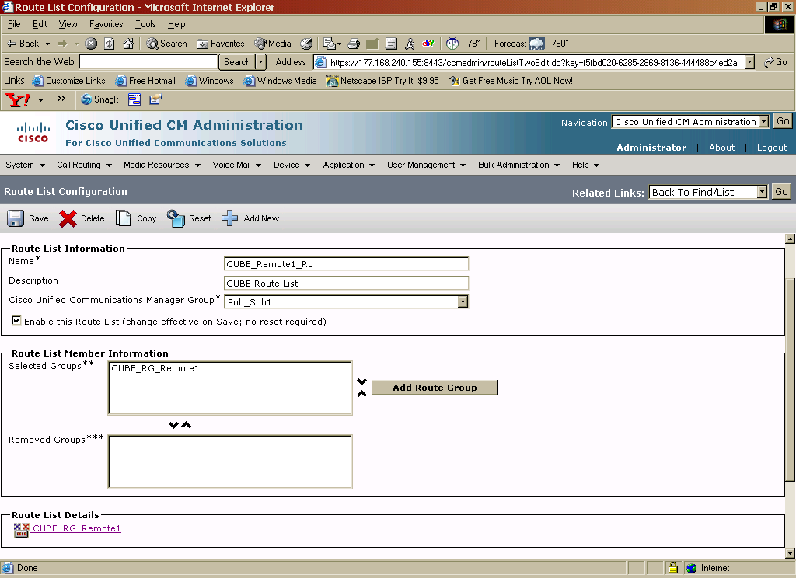

Regions (codec settings)
Main Page:
The “Central” region is used for the Central Site CUBE (G729 codec)
The “Default”region is used for the Central Site CUBE (G711 codec)
The “Phones” region is used for Central Site IP Phones.
The “ Remote Phones” region is for IP phones at the remote site.
The “Remote1” region is for the Remote CUBE (G729 codec)
The “Remote1_G711” region is for the Remote CUBE (G711 codec)
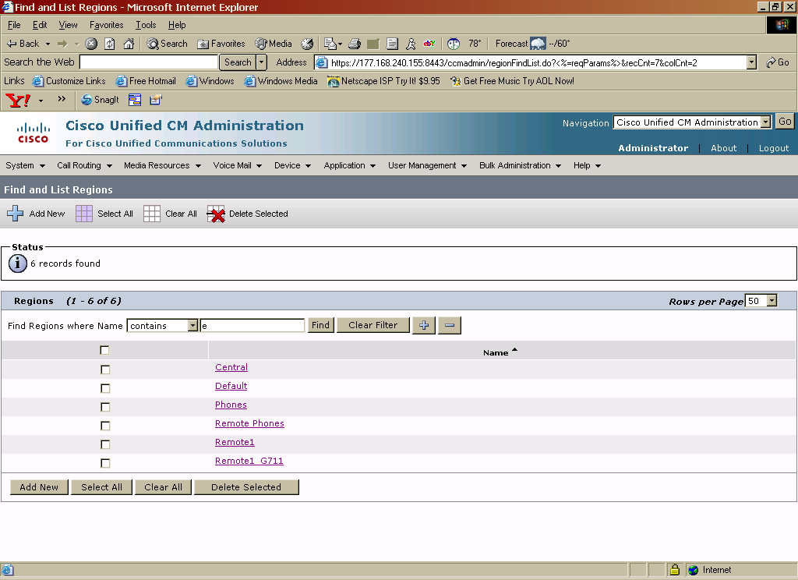

Region – Central
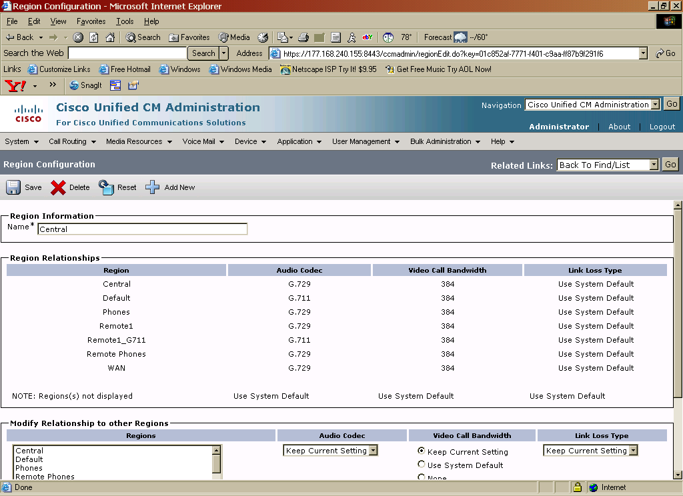
Region – Default

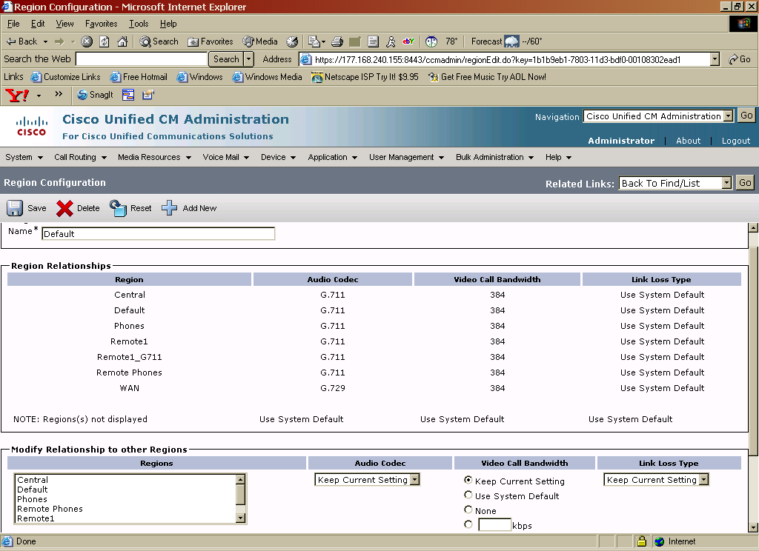
Region – Phones
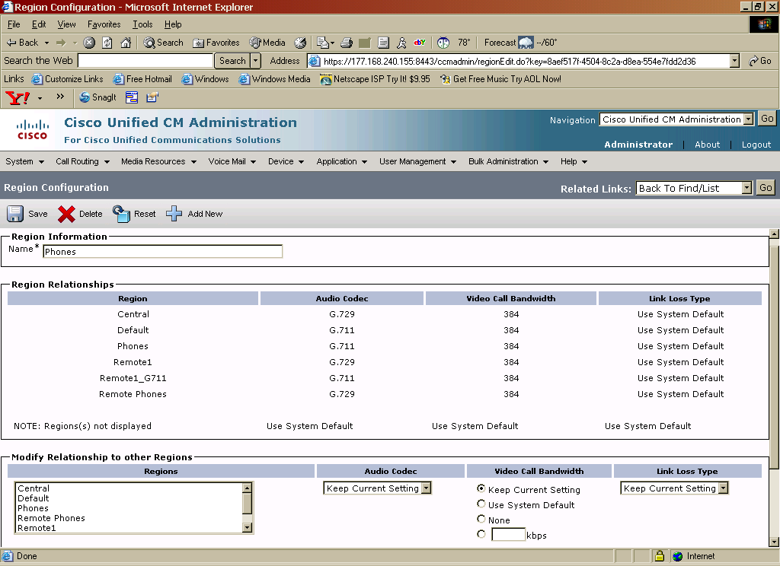
Region – Remote Phones
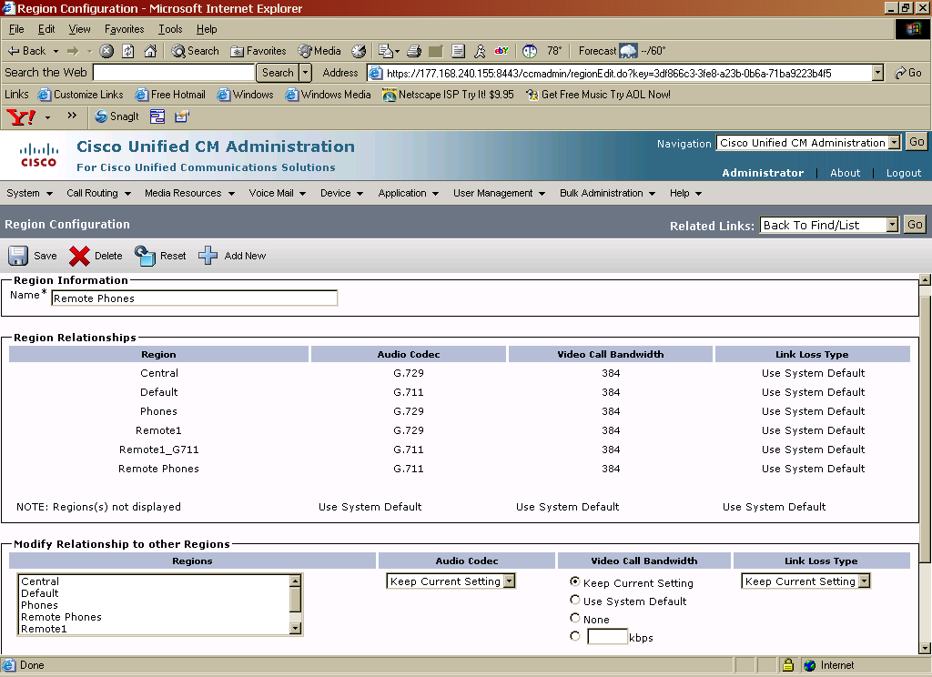
Region – Remote1

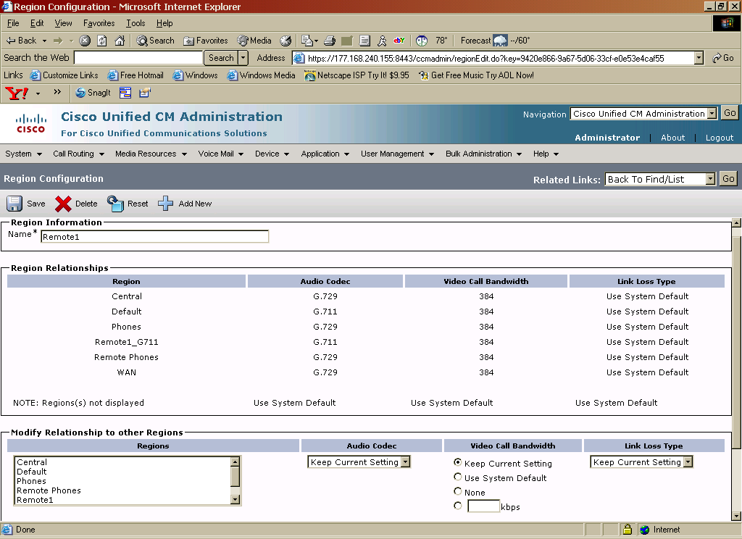
Region – Remote1_G711
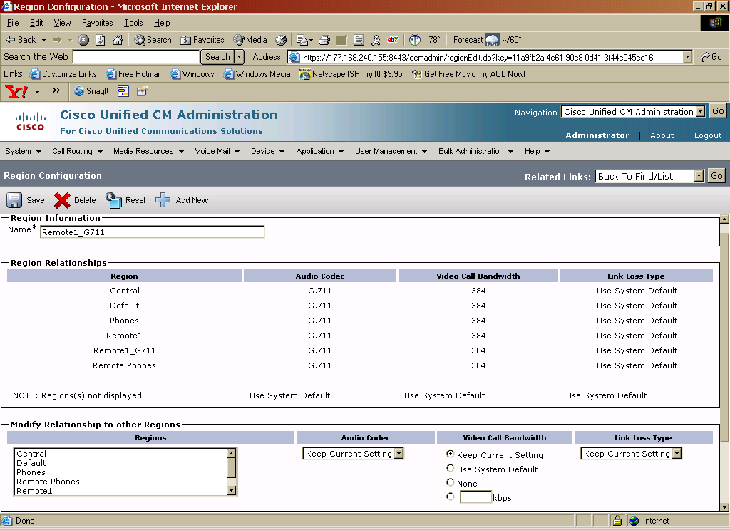
Device Pools
Main Page:
“Central” device pool is used for the central site CUBE (G729)
“Central_Phones” device pool is used for the central site phones.
“Default” device pool is used for the central site CUBE (G711).
“Remote1” device pool is used for the remote site CUBE (G729).
“Remote1_G711” device pool is used for the remote site CUBE (G729).
“Remote1_Phones” device pool is used for the remote site phones.
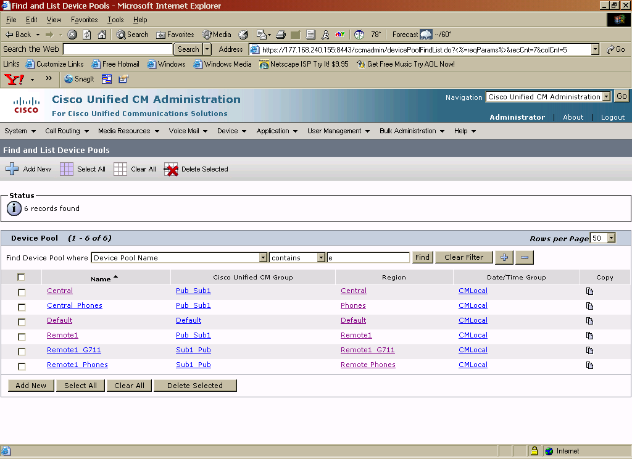
Device Pool – Central
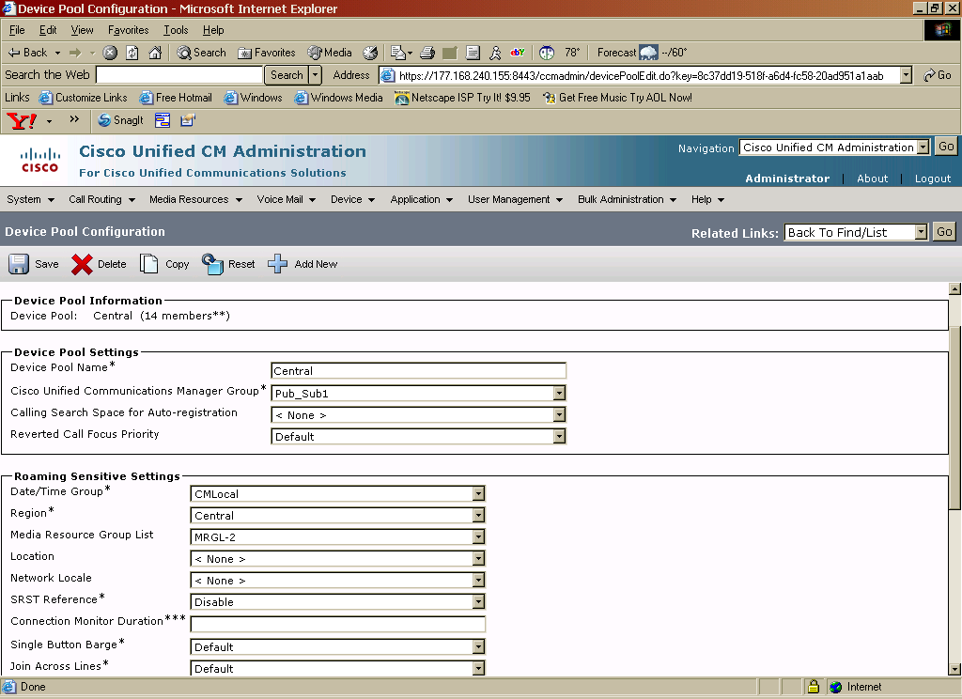
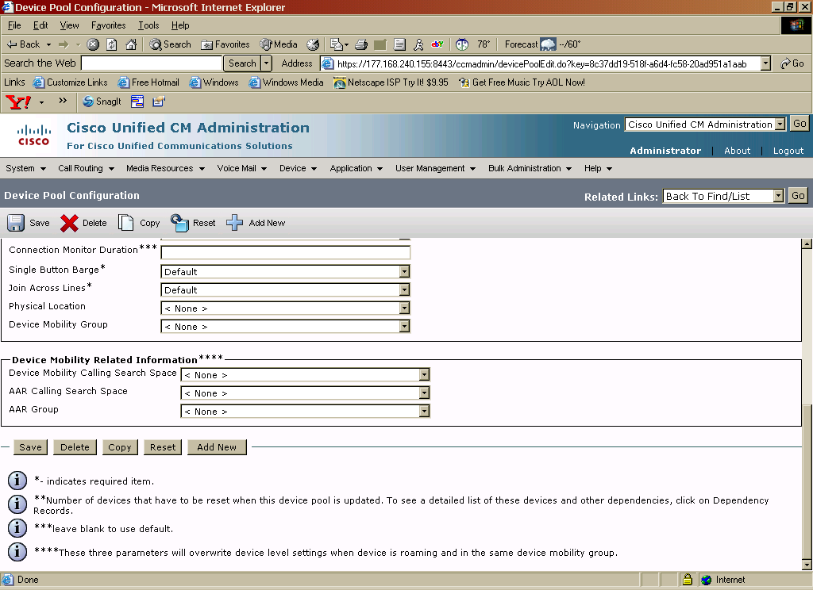
Device Pool – Central_Phones - missing screenshot

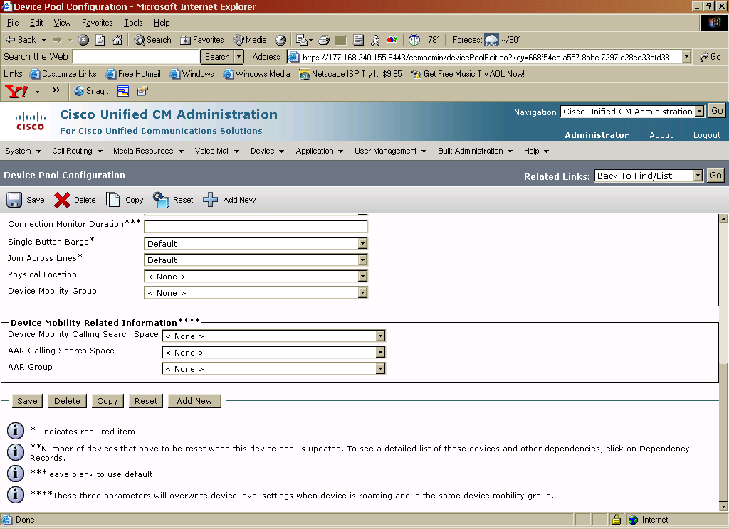
Device Pool – Default
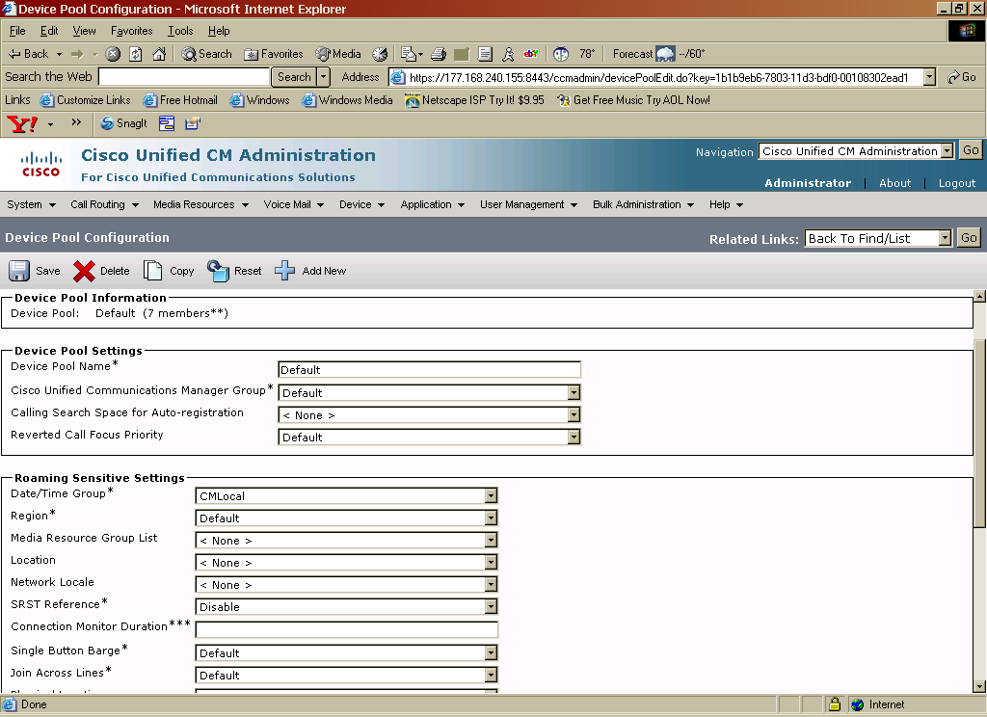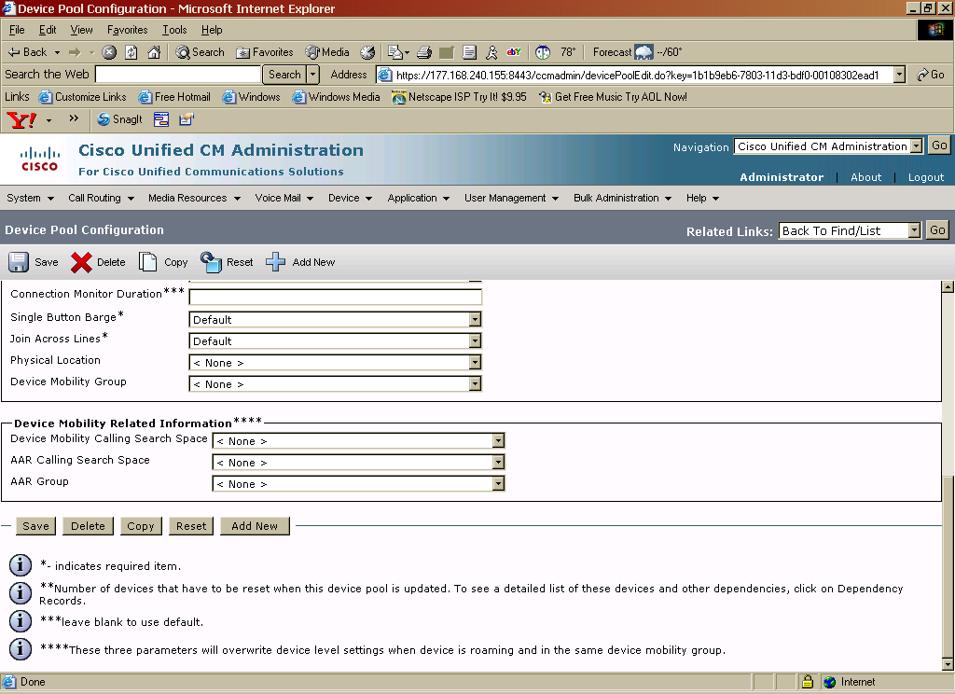
Device Pool – Remote1
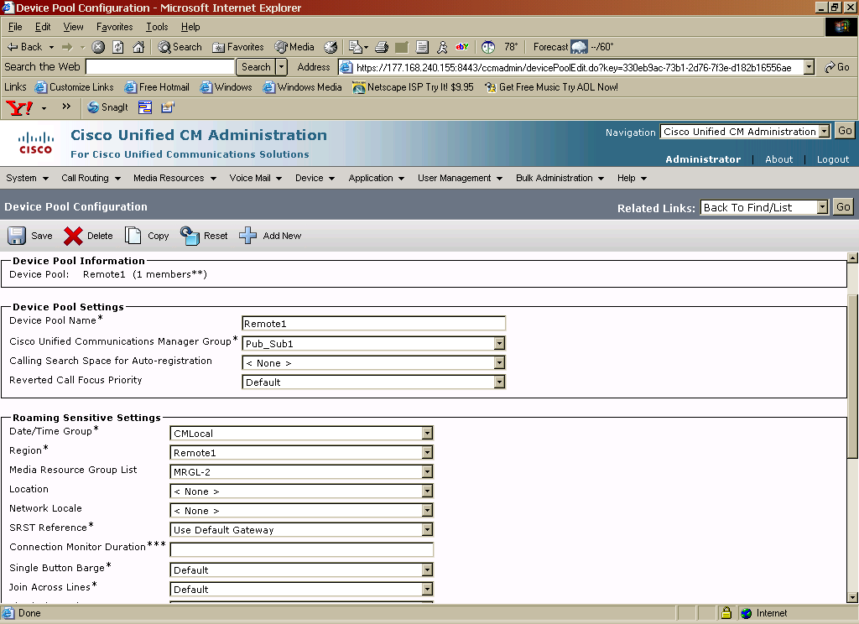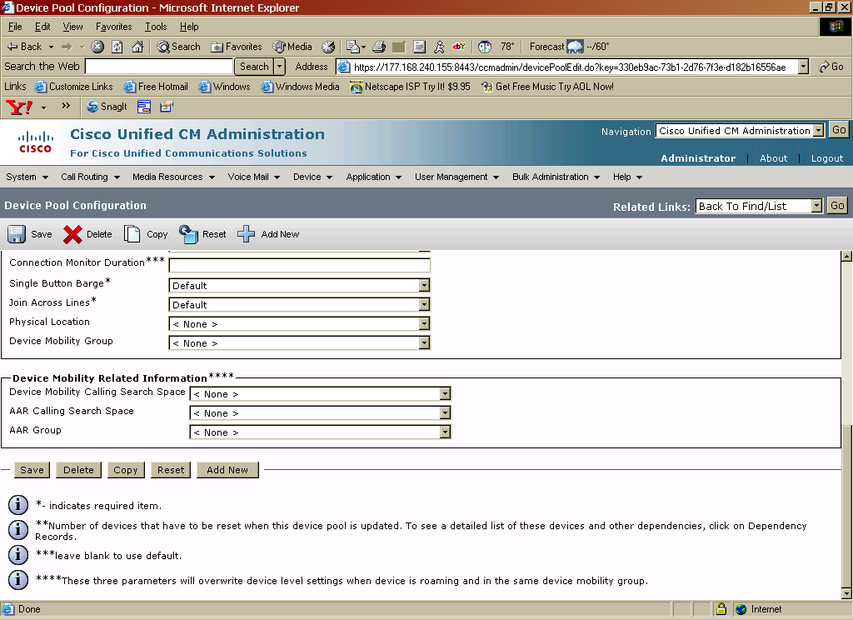
Device Pool – Remote1_G711
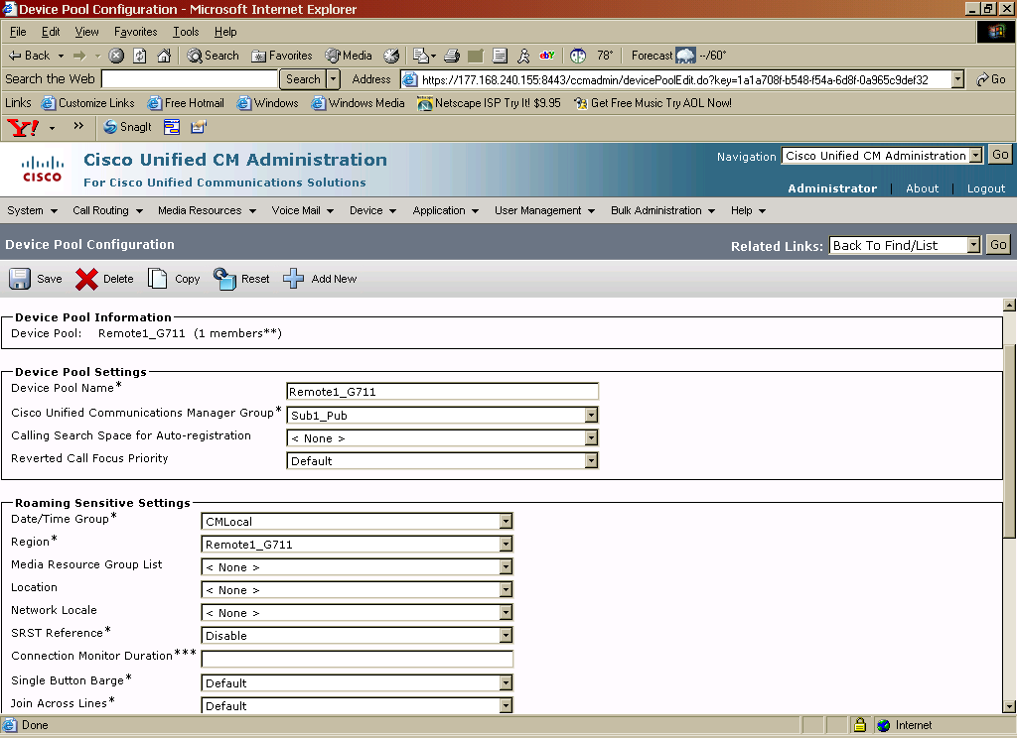
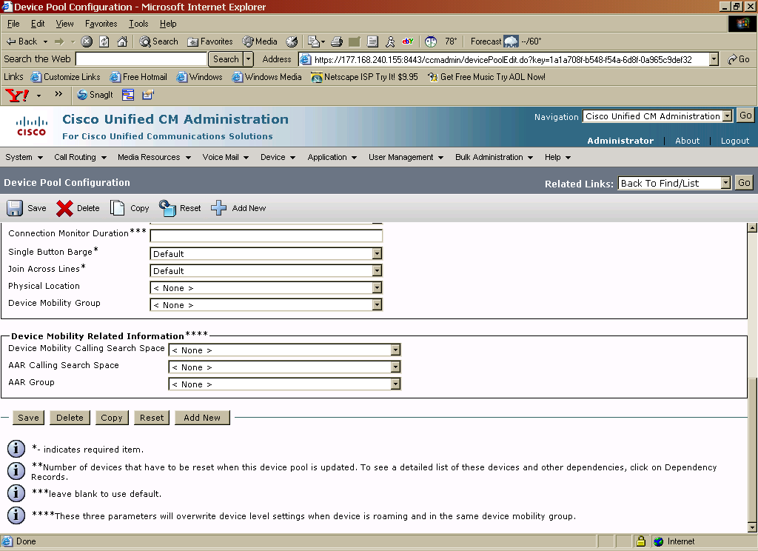
Device Pool – Remote1_Phones

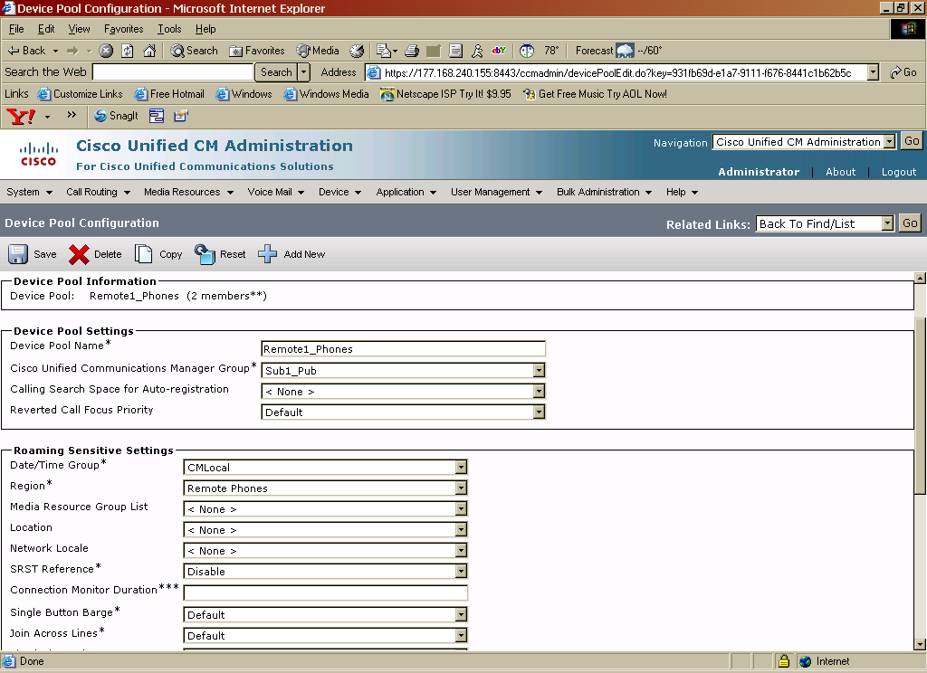
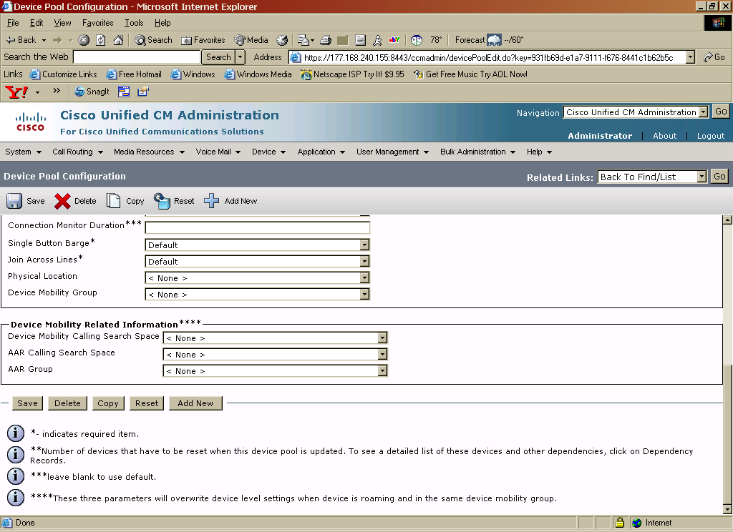
Route Patterns
Main Page

Note: In this example, users at Central site dial a “9” to get an outside line. Users at the remote site dial a “7” to get an outside line.

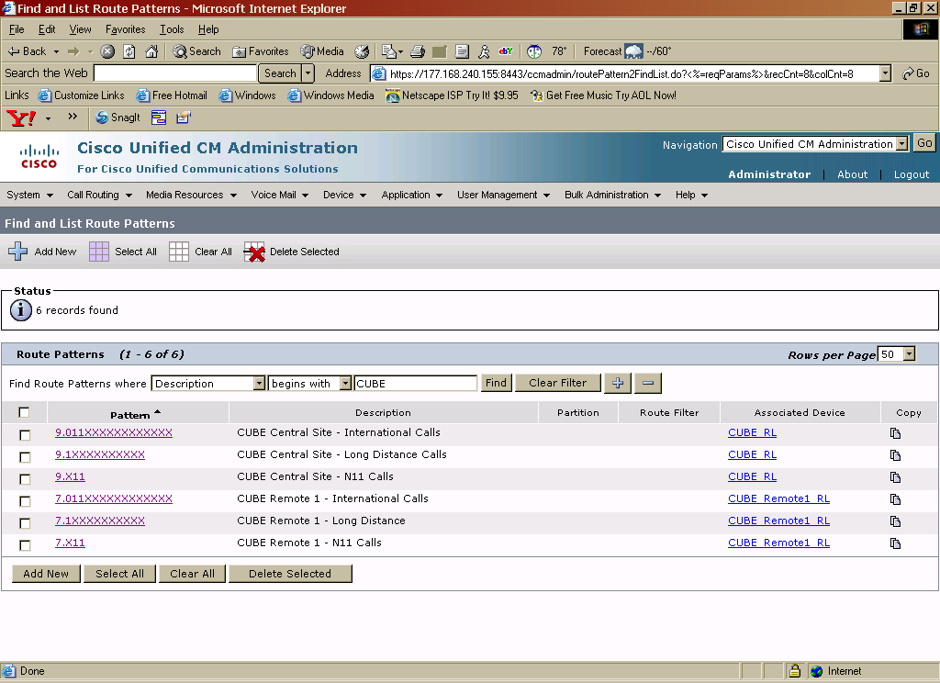

Route Pattern for Central Site International Calls
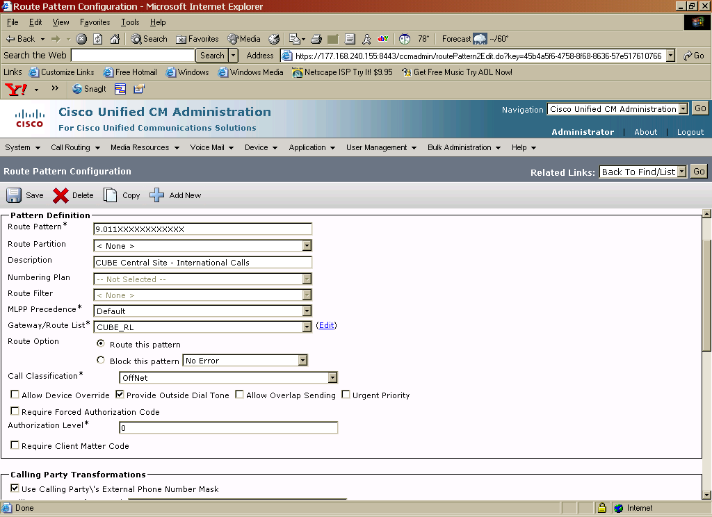
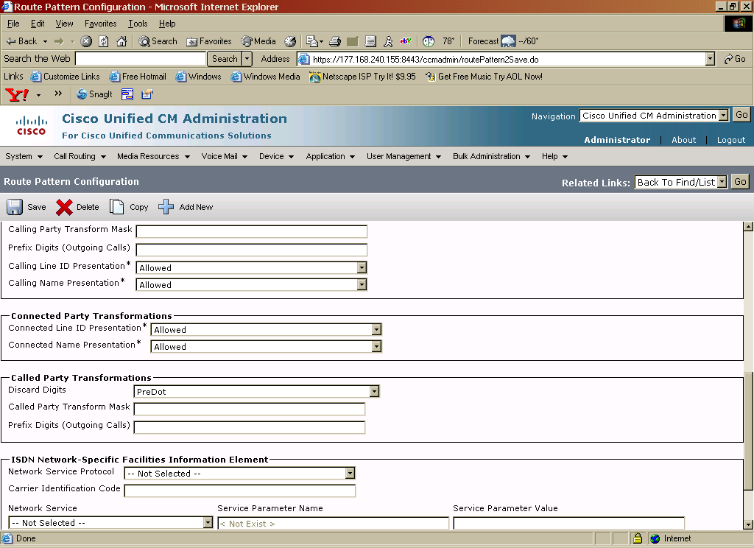
Route Pattern for Central Site Long Distance Calls
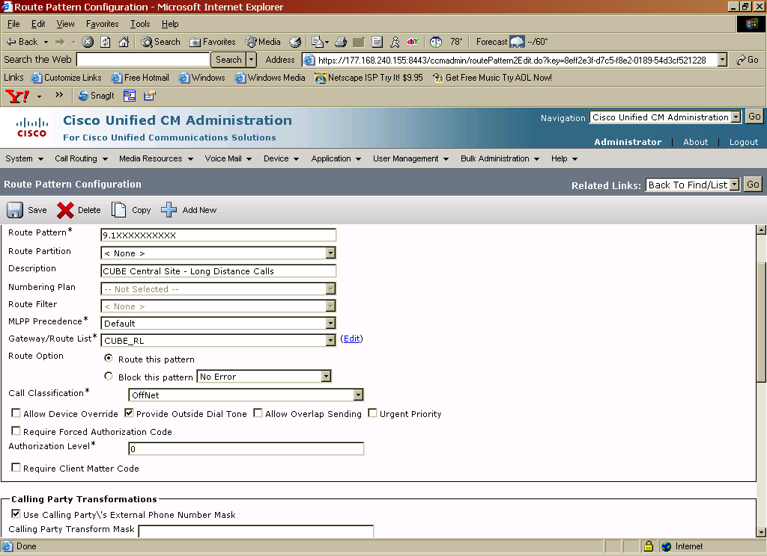
Route Pattern for Central Site N11 Calls

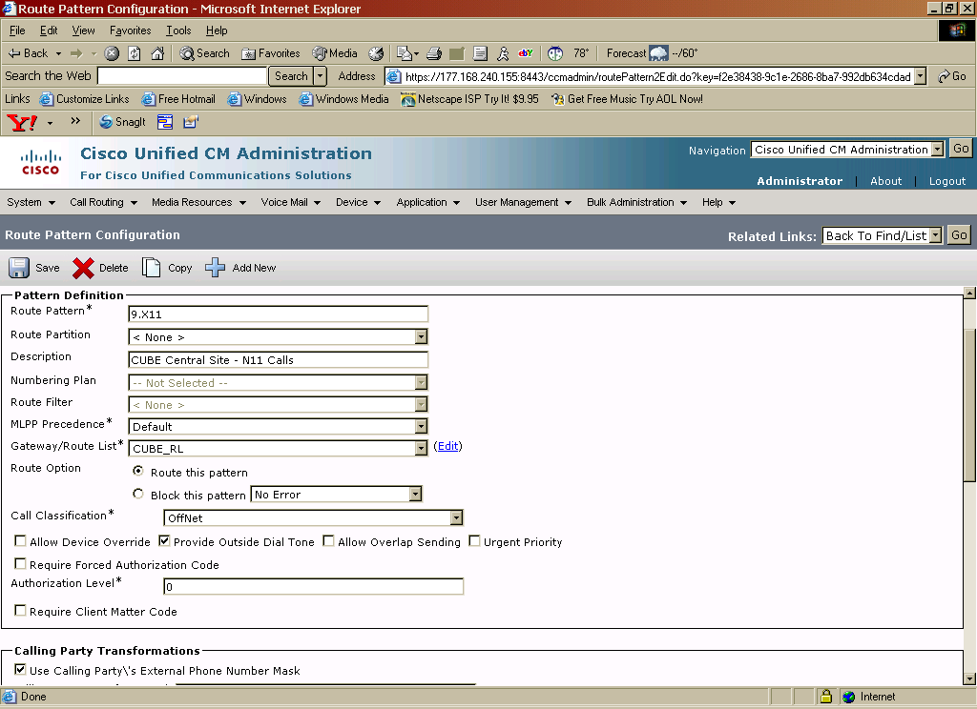
Route Pattern for Remote Site International Calls
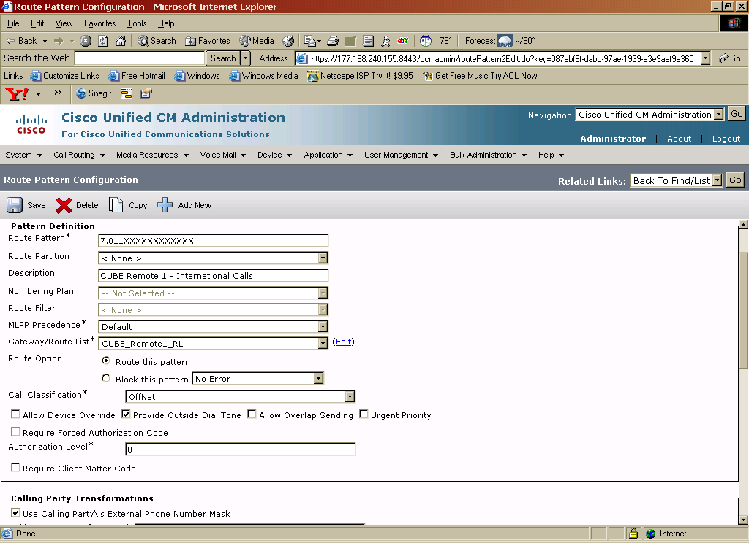

Route Pattern for Remote Site Long Distance Calls
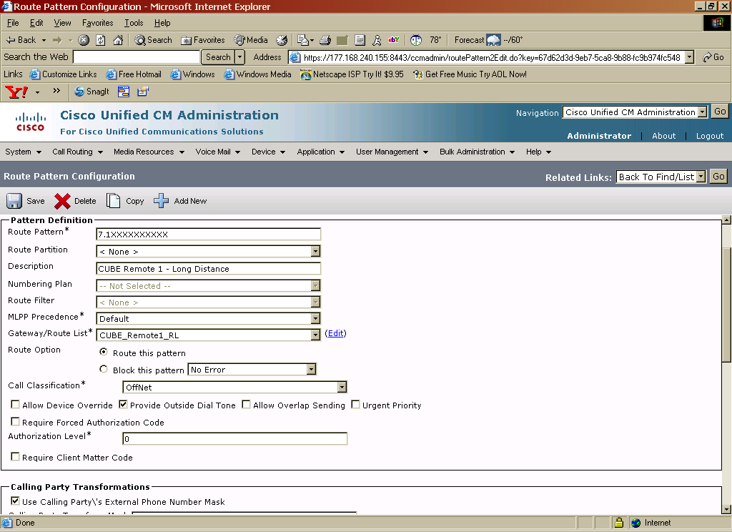
Route Pattern for Remote Site N11 Calls

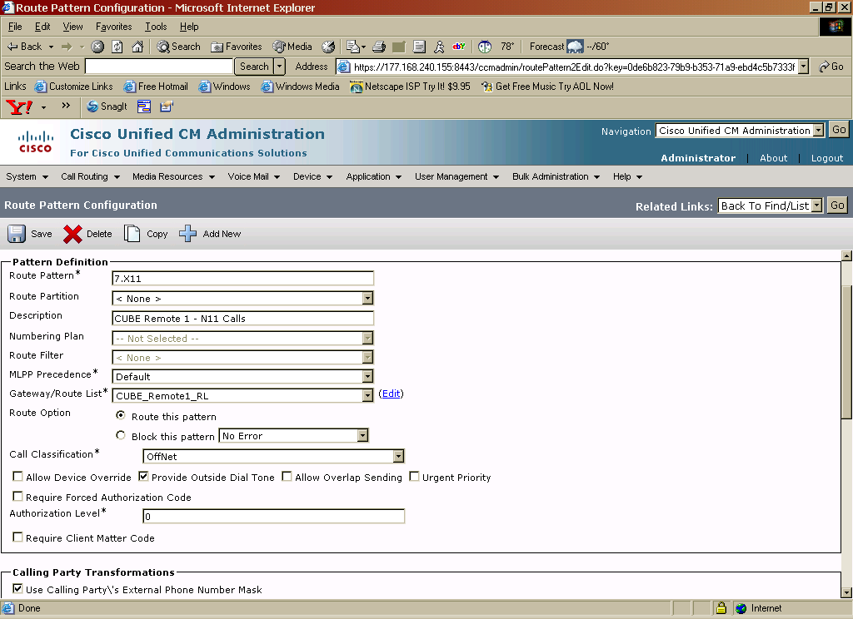
IOS conference bridge on the CUBE
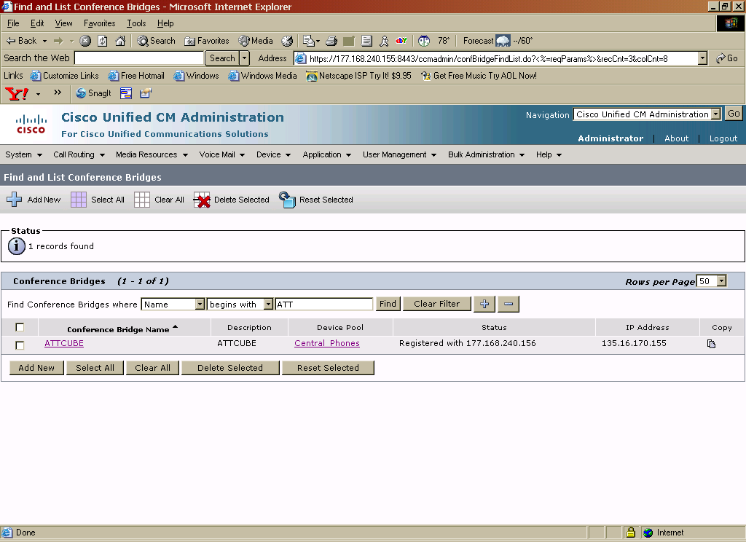

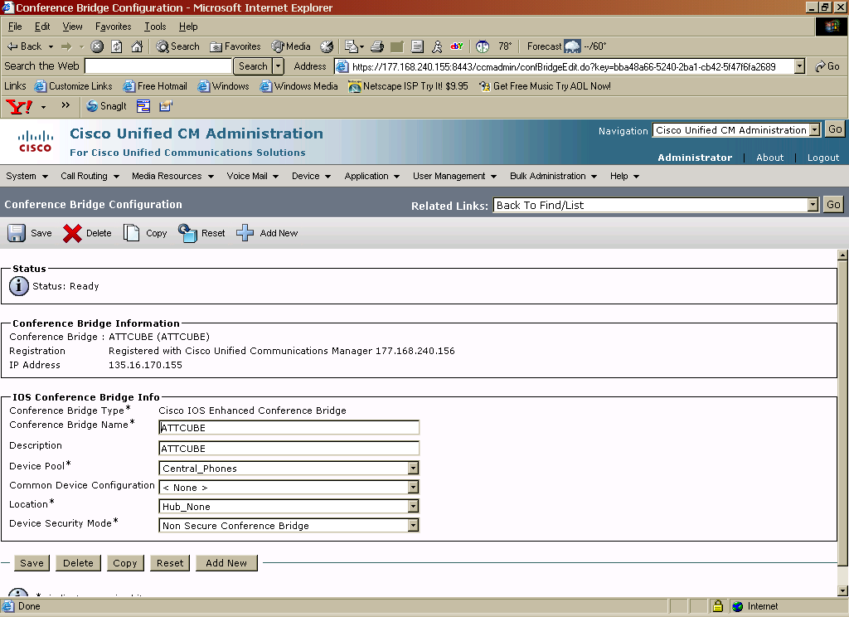

Transcoder configuration

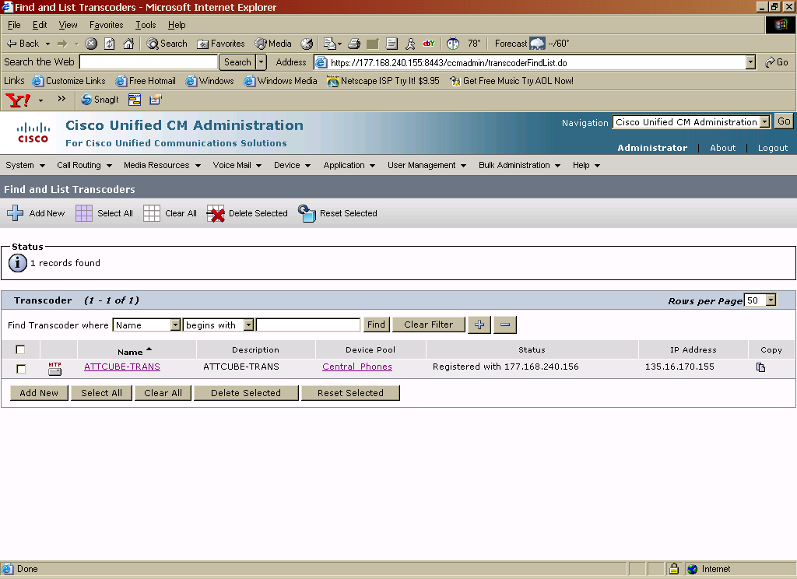
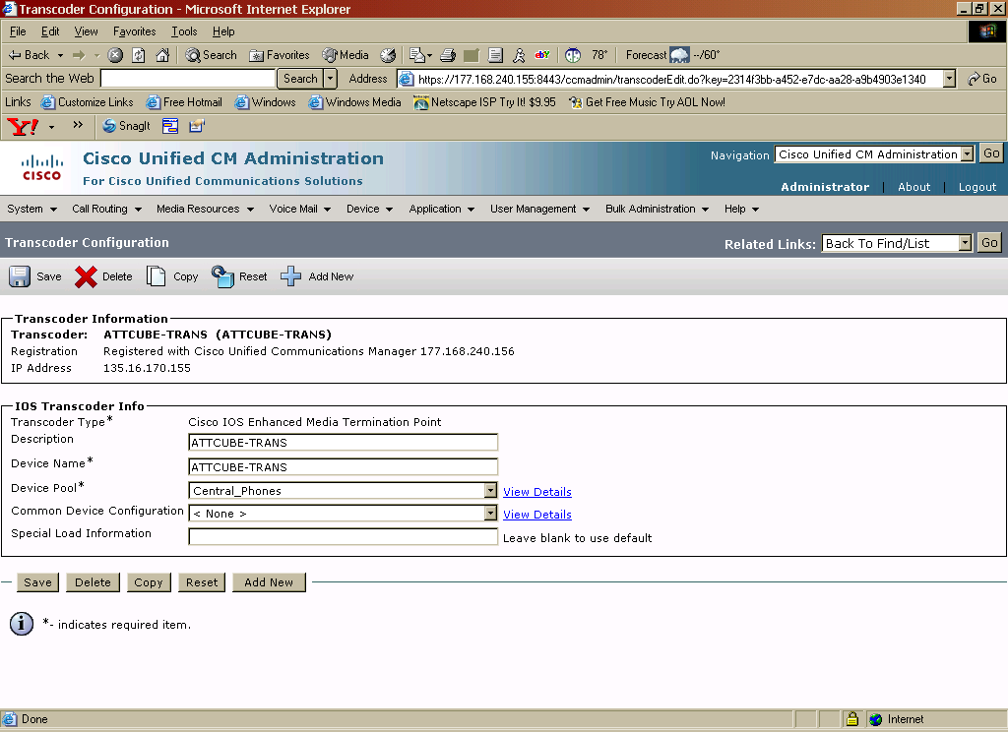

Note: If your network will support more than one codec flavor, it is recommended to have a transcoder resource on Cisco Unified CM.

Sample IOS gateway configuration for transcoder registration to Cisco Unified CM
voice-card 0
dsp services dspfarm
!
sccp local FastEthernet0/0
sccp ccm 172.20.110.254 identifier 1
sccp
!
sccp ccm group 1
associate ccm 1 priority 1
associate profile 1 register mtp001121fb3644
!
dspfarm profile 1 transcode
codec g711ulaw
codec g711alaw
codec g729br8
codec g729r8
codec g729abr8
codec g729ar8
maximum sessions 27
associate application SCCP

IP phone sample configurations
Central Site
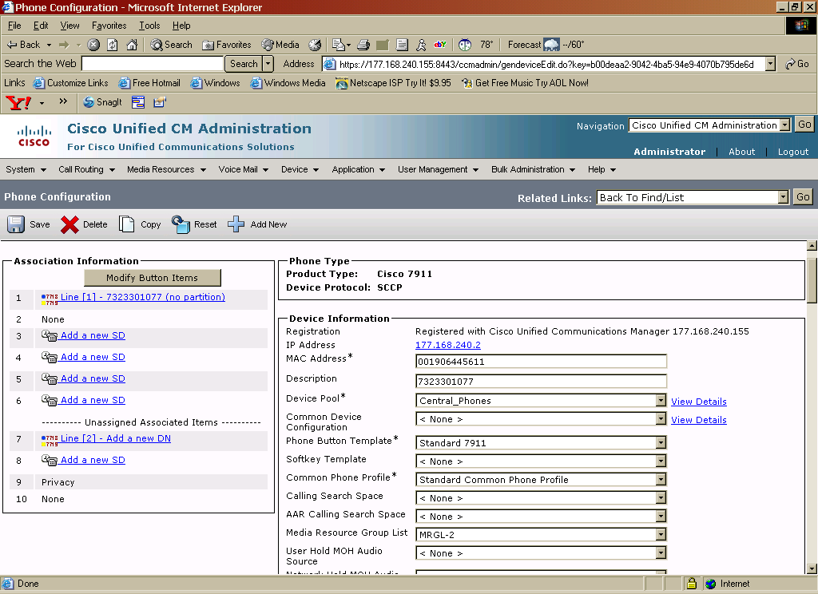
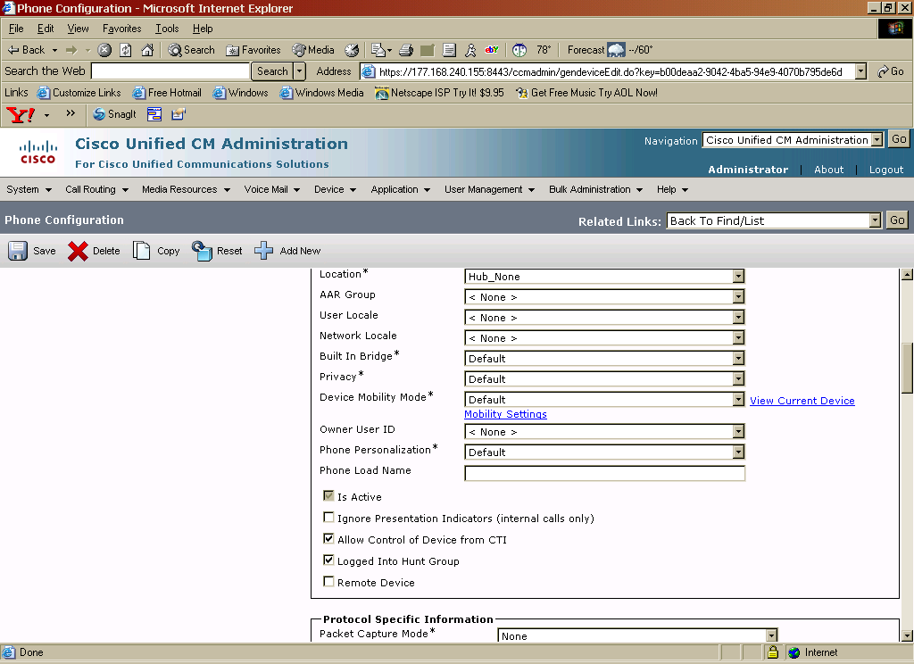
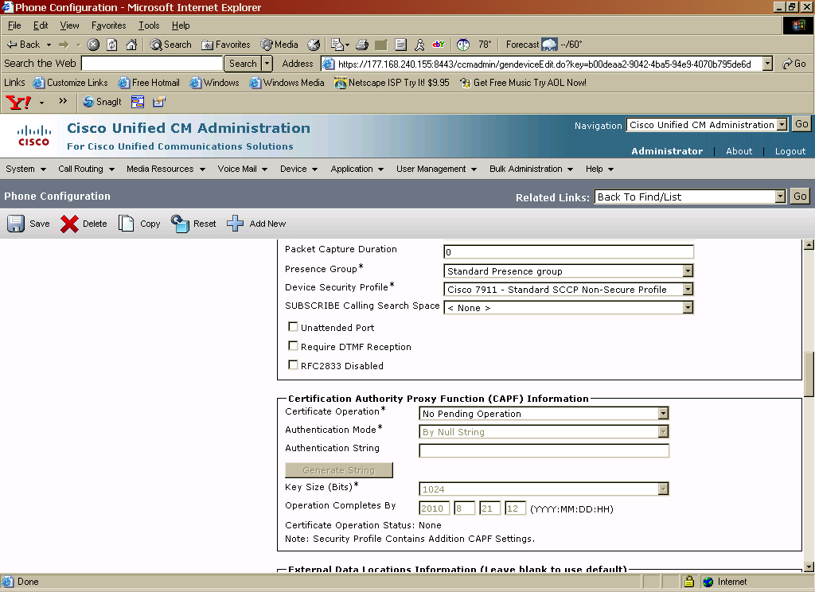
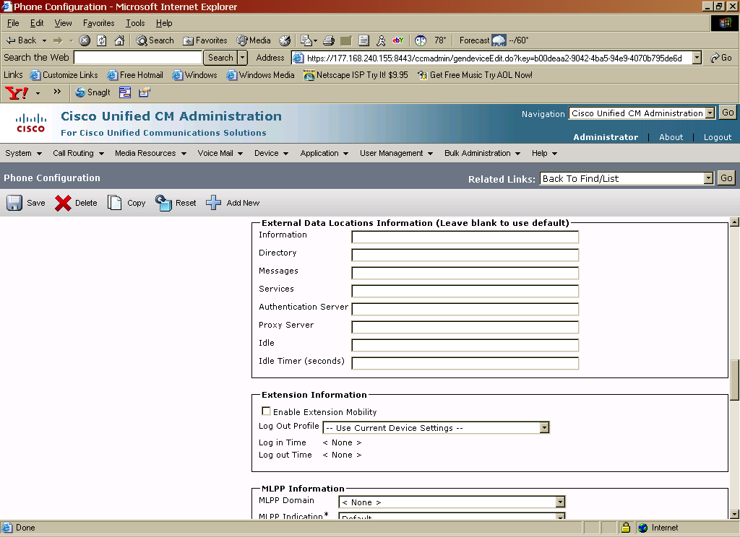

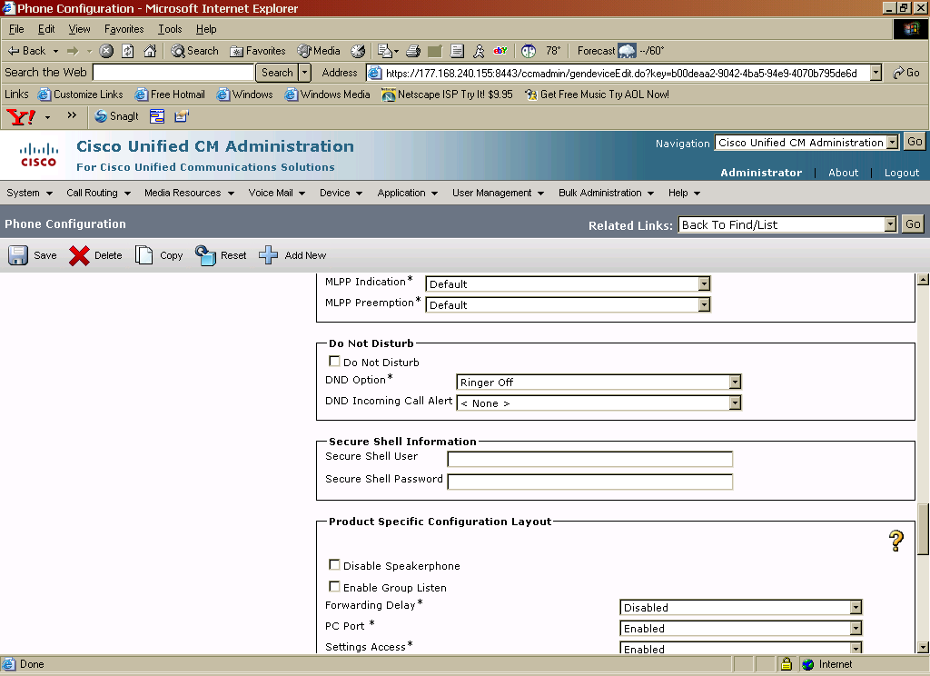
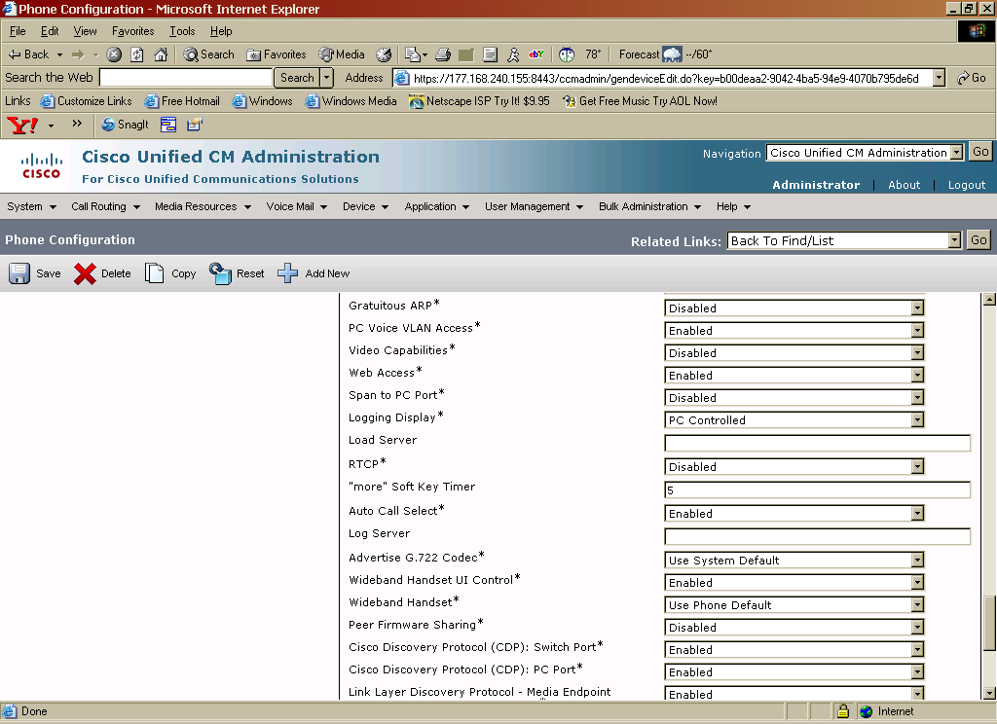
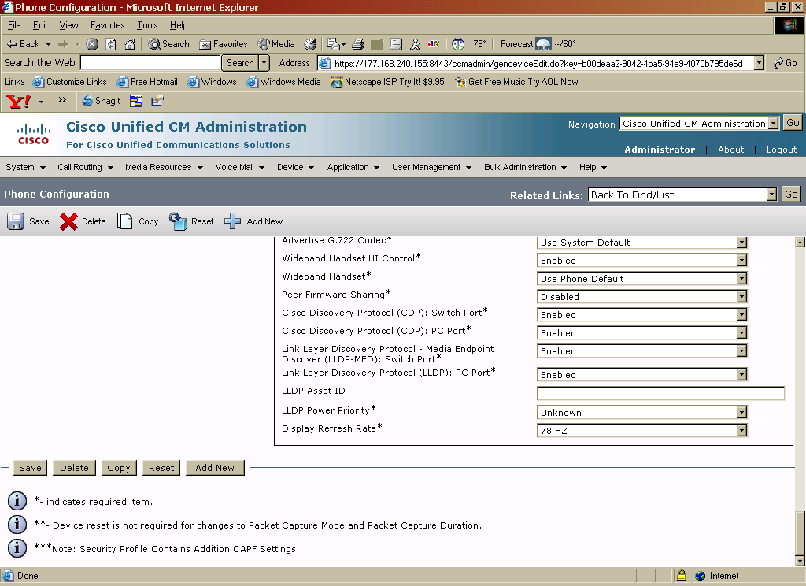
IP Phone Sample Configuration – Remote Site
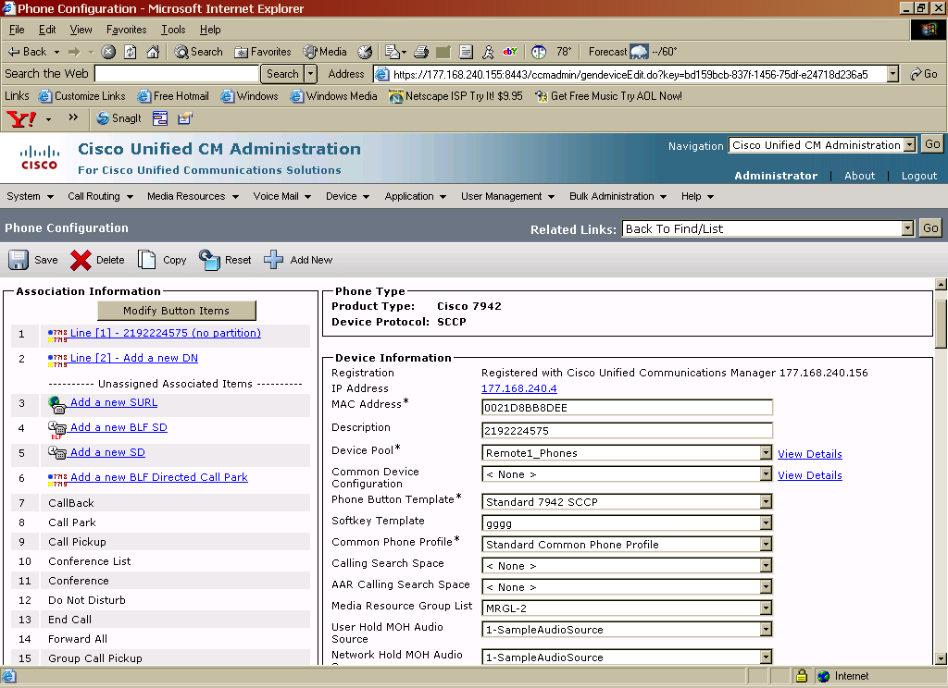

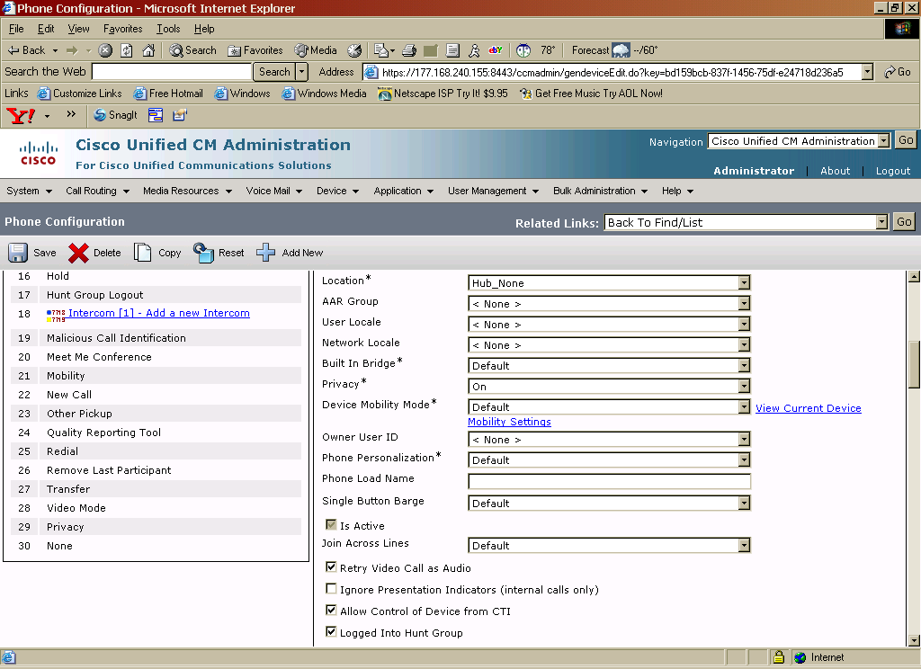

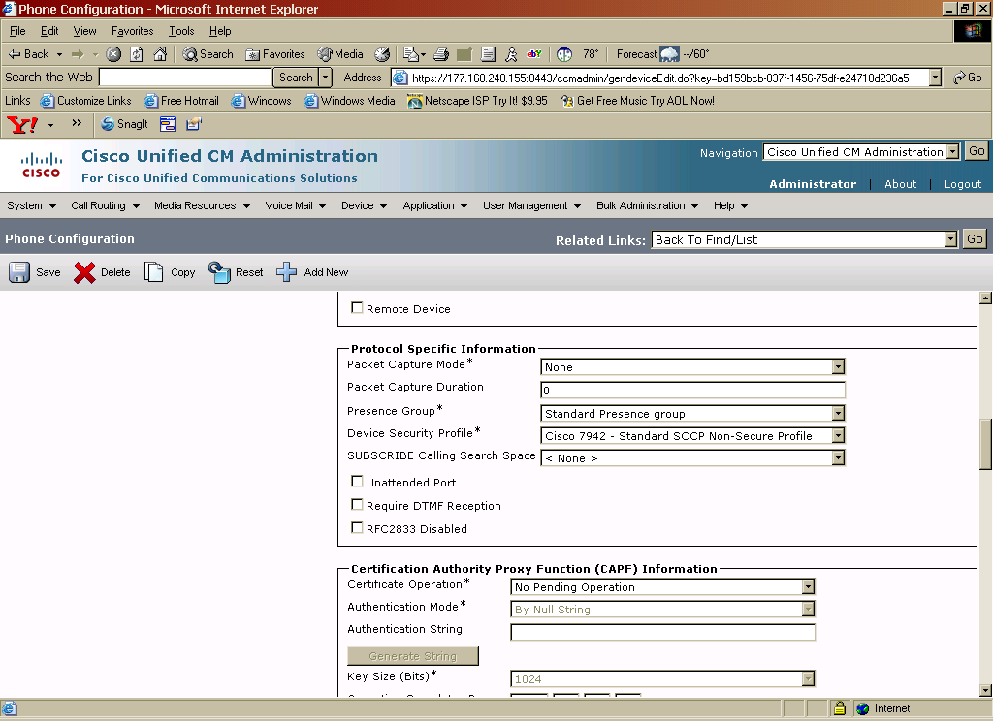

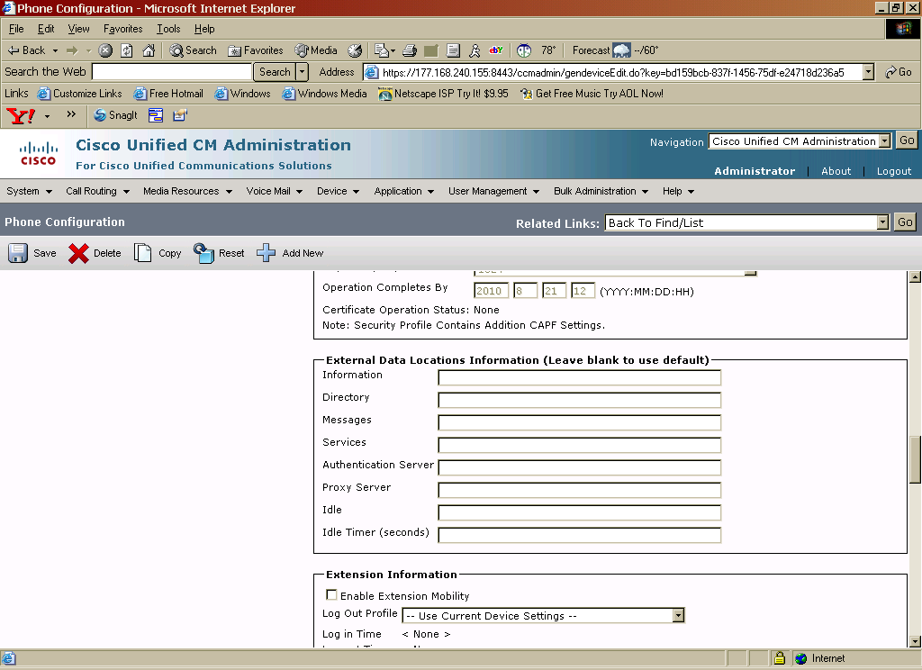

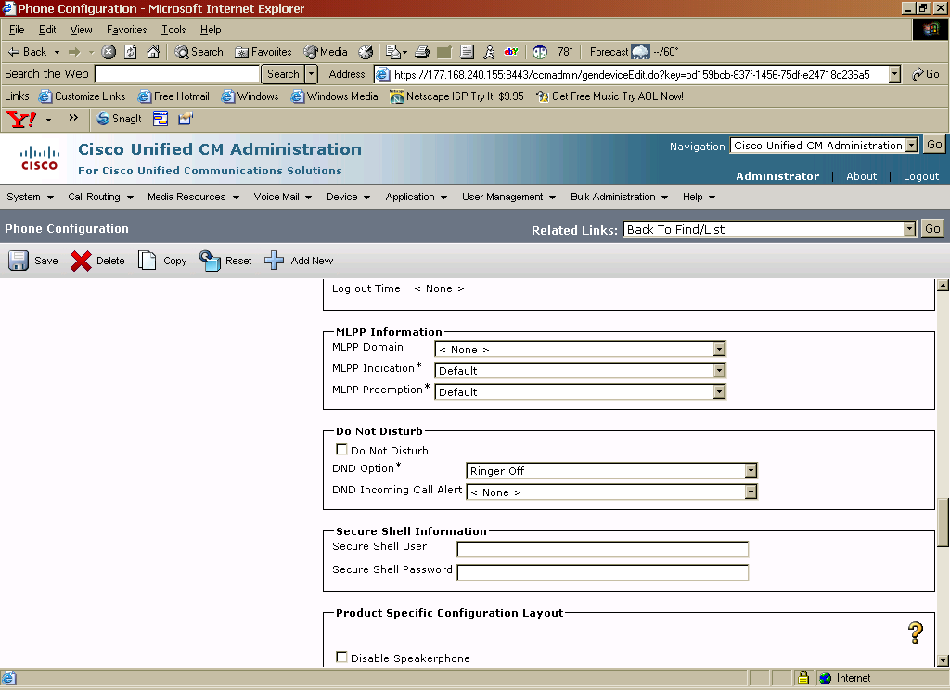

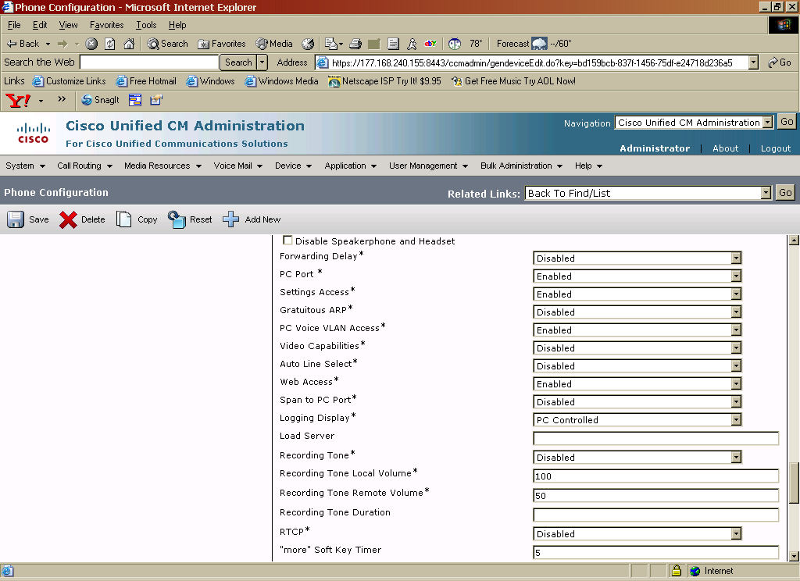

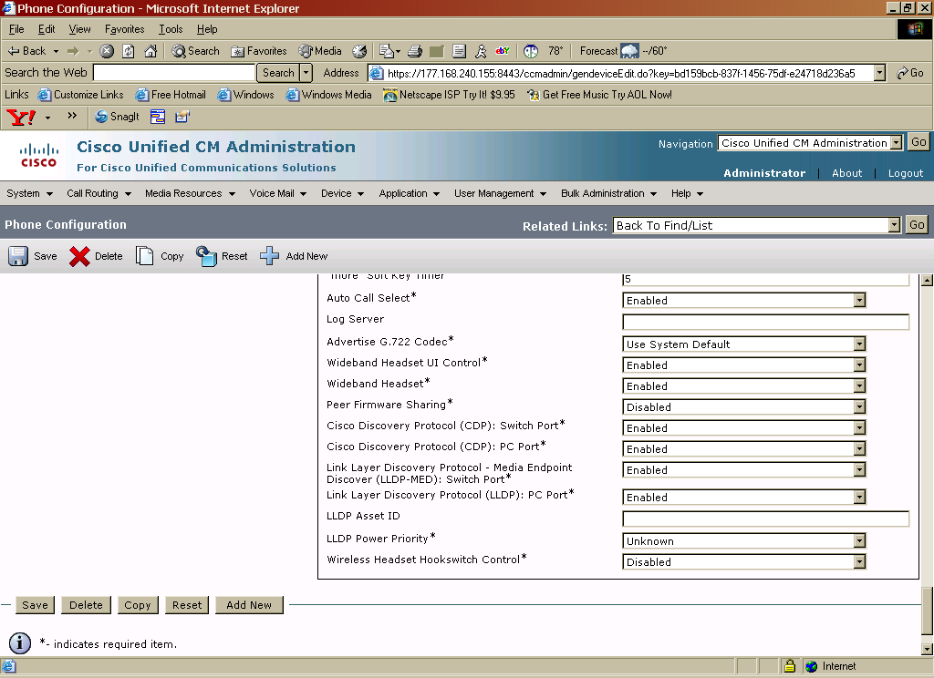

Set G.729 codec to 30 byte payload
(required to achieve the lowest bandwidth per call)
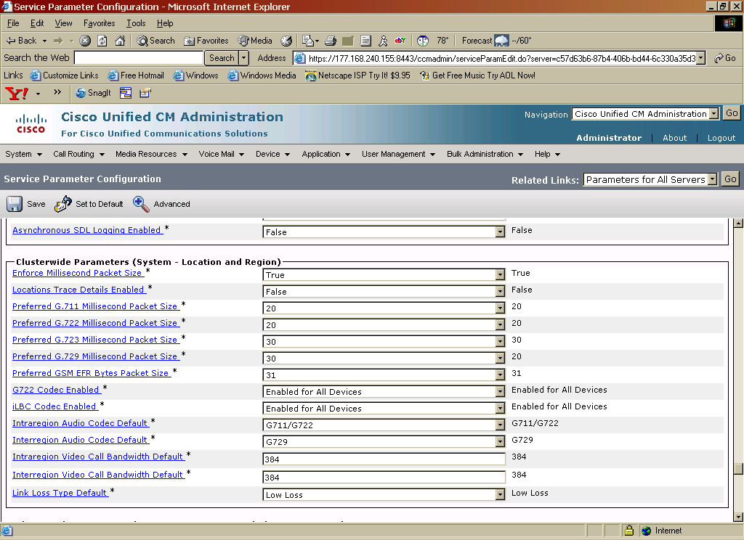

Under Service Parameters menu, set “Preferred G.729 Millisecond Packet Size” to 30 (from the default of 20).
Turning Silence Suppression on /off

Silence Suppression can be turned on or off from the “Service Parameters” menu.

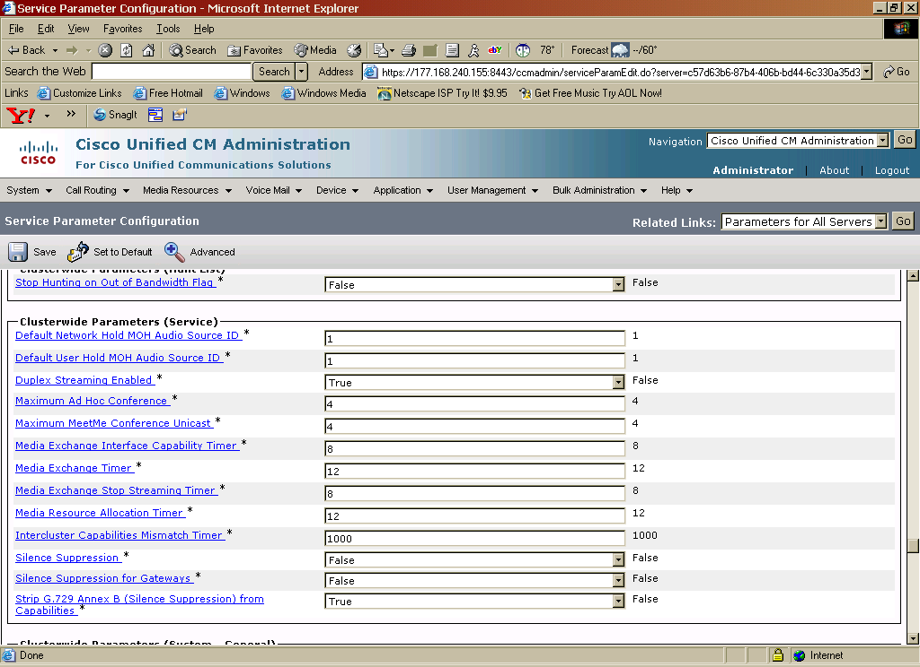

To turn Silence Suppression off:

- Set “Silence Suppression” to false.
- Set “Strip G.729 Annex B (Silence Suppression ) from Capabilities to “true”

To turn Silence Suppression on:
- Set “Silence Suppression” to true.
- Set “Strip G.729 Annex B (Silence Suppression ) from Capabilities to “false”

Enabling PRACK for early-media negotiation
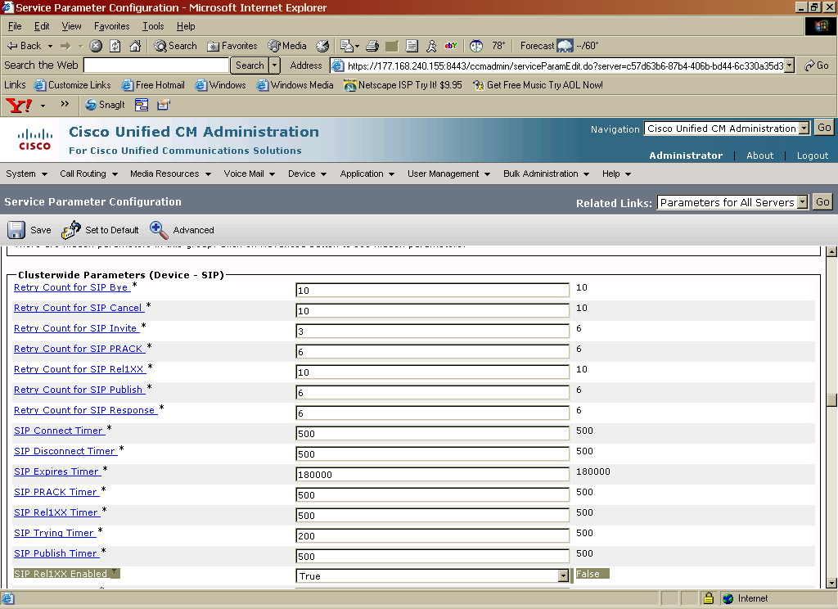
Note: PSTN network call prompters that utilize early-media cut-through to offer menu options to the caller (DTMF select menu) before the call is connected. In order for the CUCM/CUBE solution to achieve successful early-media cut-through the CUCM to CUBE call leg must be enabled with SIP PRACK. To enable SIP PRACK on Cisco Unified CM you must set the parameter “SIP Rel1XXX Enabled” to “True”. The parameter is found under System->Service Parameters-><Server Name or IP address>->Cisco CallManager (service)->Clusterwide Parameters (Device-SIP), in the Cisco Unified CM.

(Optional) SIP Trunk for fax interface (fax is connected via FXS port on an IOS Gateway)
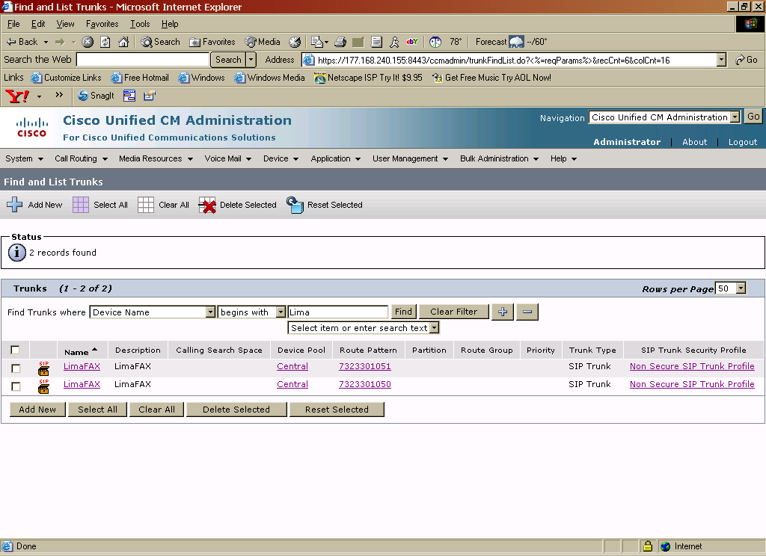
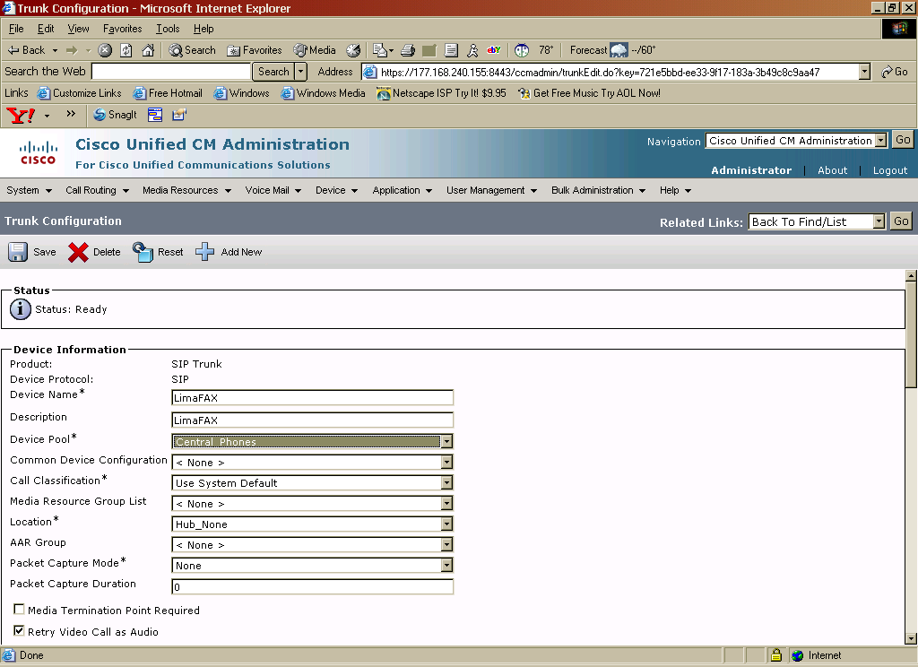

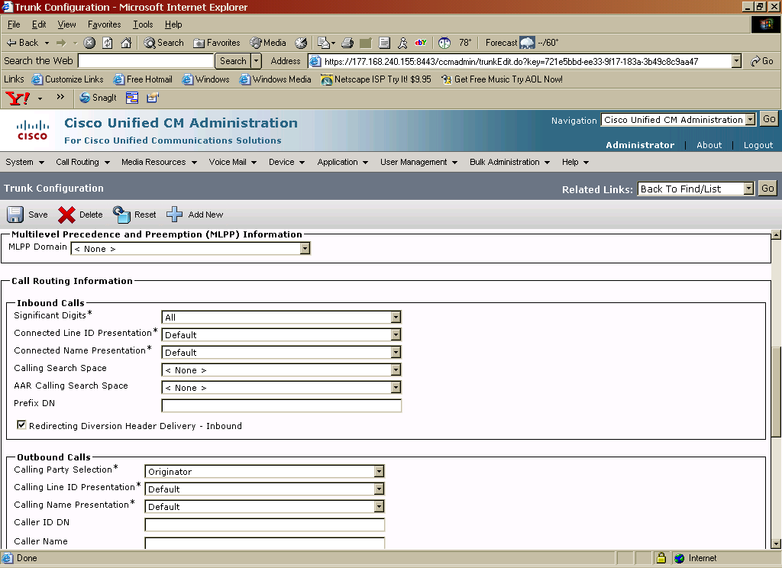

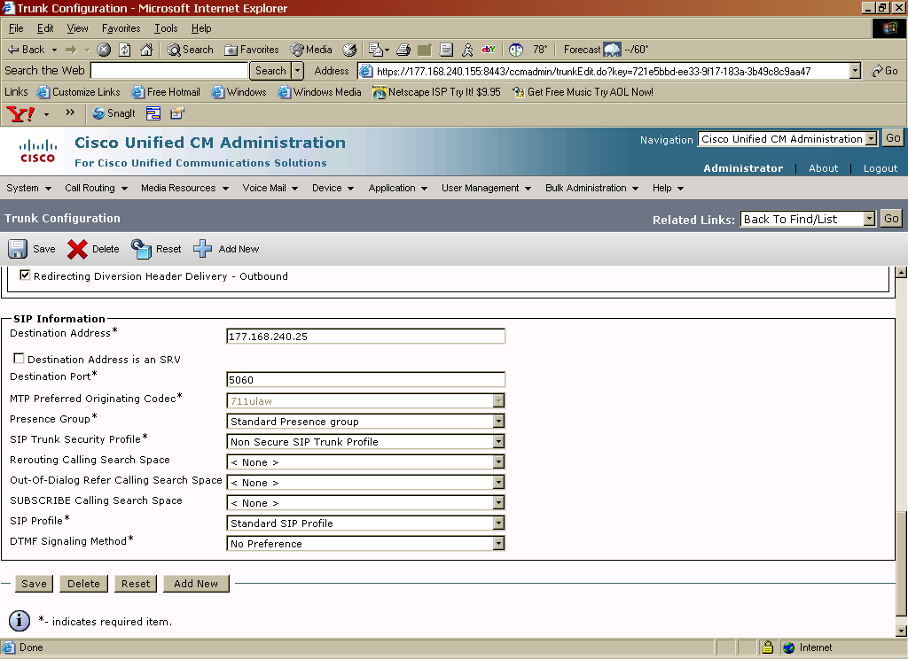
Route Pattern for SIP Gateway
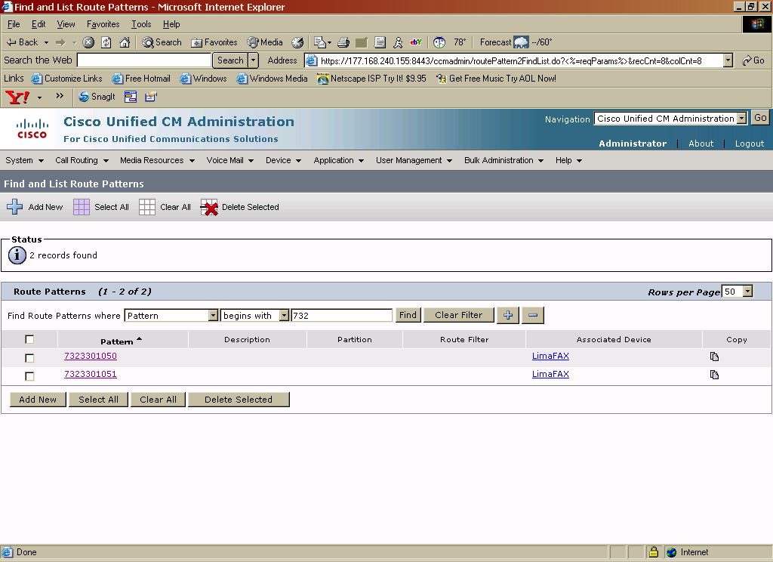

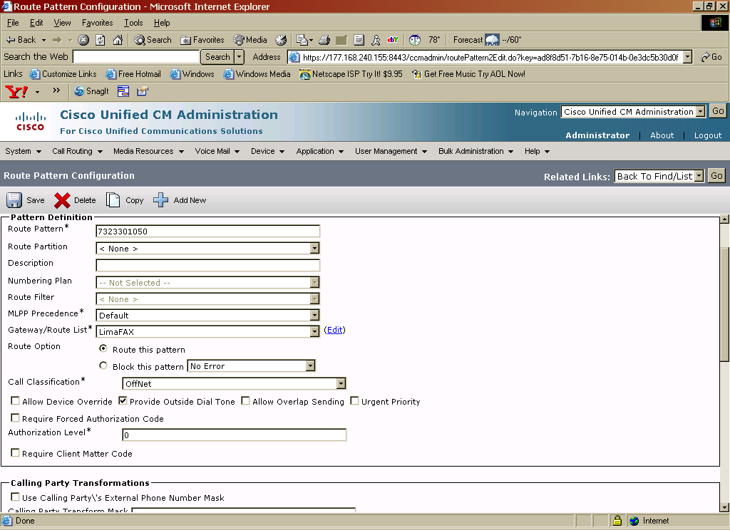

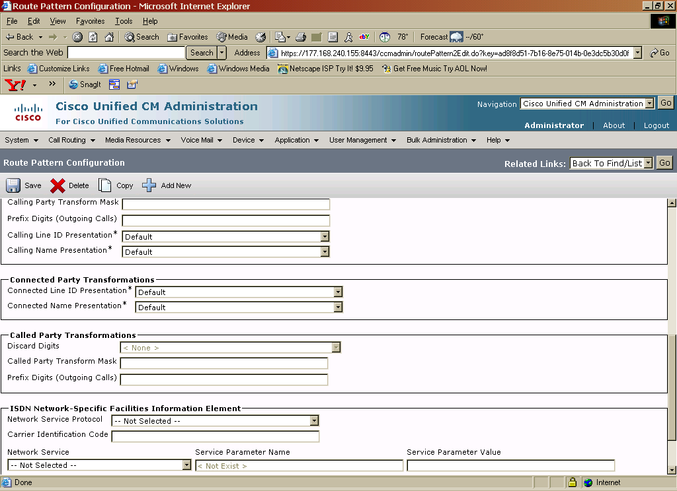

Configuring the Cisco IOS Gateway for T.38 using SIP
Critical commands have been bolded

term length 0
Lima#sh run
Building configuration...

Current configuration : 6148 bytes
!
version 12.4
service timestamps debug datetime msec
service timestamps log datetime msec
no service password-encryption
!
hostname Lima
!
boot-start-marker
boot-end-marker
!
logging buffered 51200 warnings
enable password cisco
!
no aaa new-model
dot11 syslog
ip cef
!
!
!
!
no ip domain lookup
ip domain name yourdomain.com
multilink bundle-name authenticated
!
!
voice-card 0
!
!
!
voice service voip
h323
!
!
voice class codec 1
codec preference 1 g729br8 bytes 30
codec preference 2 g729r8 bytes 30
!
!
!
interface FastEthernet0/0
shutdown
speed 100
full-duplex
!
interface FastEthernet0/1
ip address 177.168.240.25 255.255.255.0
duplex auto
speed auto
!
!
ip forward-protocol nd
ip route 0.0.0.0 0.0.0.0 177.168.240.1
!
!
ip http server
ip http access-class 23
ip http authentication local
ip http secure-server
ip http timeout-policy idle 60 life 86400 requests 10000
!
control-plane
!
!
!
voice-port 0/0/0
!
voice-port 0/0/1
!
!
dial-peer voice 1999 voip
description outgoing fx call to AT&T
destination-pattern 91..........
rtp payload-type nse 99
rtp payload-type nte 100
voice-class codec 1
session protocol sipv2
session target ipv4:177.168.240.155
dtmf-relay rtp-nte
fax-relay sg3-to-g3
fax rate 14400 bytes 48
fax protocol t38 ls-redundancy 0 hs-redundancy 0 fallback pass-through g711ulaw
!
dial-peer voice 4060 voip
rtp payload-type nse 99
rtp payload-type nte 100
voice-class codec 1
session protocol sipv2
session target ipv4:177.168.240.155
incoming called-number 732330105.
dtmf-relay rtp-nte
fax-relay sg3-to-g3
fax rate 14400 bytes 48
fax protocol t38 ls-redundancy 0 hs-redundancy 0 fallback pass-through g711ulaw
!
!
dial-peer voice 4067 pots
description Fax test set
destination-pattern 7323301050
port 0/0/0
forward-digits 0
!
dial-peer voice 4068 pots
description Fax test set
destination-pattern 7323301051
port 0/0/1
forward-digits 0

!
!
line con 0
login local
line aux 0
line vty 0 4
access-class 23 in
privilege level 15
login local
transport input telnet ssh
line vty 5 15
access-class 23 in
privilege level 15
login local
transport input telnet ssh
!

Acronyms
Acronym | Definitions
AT&T BVoIP | AT&T Business Voice over Internet Protocol
AT&T VPN | AT&T Virtual Private Network (aka AVPN)
CE | Customer Edge
Cisco GW | Cisco Gateway
CSU/DSU | Channel Service Unit/Data Service Unit
CUBE | Cisco Unified Border Element
CUCM | Cisco Unified Communications Manager
DSP | Digital Signal Processor
DTMF | Dual Tone Multi-Frequency
FXS | Foreign Exchange Station
GW | Gateway
HIPCS | A specific type of AT&T PER
MGCP | Media Gateway Control Protocol
MTP | Media Termination Point
PER | Provider Edge Router
PSTN | Public Switched Telephone Network
PVDM | Packet Voice Data Module
RTP; cRTP | Real-time Transport Protocol ; compressed Real-time Transport Protocol
SCCP | Skinny Client Control Protocol
SDP | Session Description Protocol
SIP | Session Initiation Protocol
TDM | Time Division Multiplex

This Customer Configuration Guide ("CCG") is offered as a convenience to AT&T's customers. The specifications and information regarding the product in this CCG are subject to change without notice. All statements, information, and recommendations in this CCG are believed to be accurate, but are presented without warranty of any kind, express or implied, and are provided “AS IS”. Users must take full responsibility for the application of the specifications and information in this CCG.

In no event shall AT&T or its suppliers be liable for any indirect, special, consequential, or incidental damages, including, without limitation, lost profits or loss or damage arising out of the use or inability to use this CCG, even if AT&T or its suppliers have been advised of the possibility of such damage.

This command enables CUBEs basic IP-to-IP voice communication feature.
This command enables T.38 fax at a global level, meaning all VoIP dial-peers not configured for a specific fax protocol will utilize this setting. If T.38 protocol should be applied to individual dial-peers only this command must be disabled using the “no” form of the command and configure the command under the appropriate dial-peers
These commands are used to bind SIP signaling and media established via the SIP signaling to interface loopback 1. This makes sure that all SIP handling is done using the single interface and no other intreface which prevents possible SIP signaling loops or errors. If you are using two interfaces (inside interface, outside interface) to provide address-hiding these commands are not necessary.
This command allows for SIP error messages to pass-through end-to-end without modification through CUBE.
This command must be enabled at a global level to maintain integrity of SIP signaling between AT&T network and Cisco Unified CM across CUBE.
This command allows for privacy settings to be transparently passed across between AT&T network and Cisco Unified CM. The command can be set either at a global level, as it is in this example, or it can be set at the dial-peer level.
This command allows CUBE to negotiate all flavors of G729 codec and must be configured in order to interoperate seamlessly across AT&T’s BVOIP services. The command can be enabled either globally, such as in this example, or per dial-peer basis using the “voice-class sip g729 annexb-all” command.
This command enables multiple codec support and performs codec filtering required for correct interoperability between AT&T SIP network and Cisco Unified CM.
Cisco IP phones registered to Cisco UCM using SIP protocol will not support g729 with annexB. If you are registering phones to Cisco UCM using SIP protocol remove this “codec preference 1 g729br8” command from your voice class codec list.
The “codec preference” commands also controls the payload packet size. Use “codec preference 1 g729r8 bytes 30” to set your payload packet size rate to 30 bytes. Make sure you match the packet size rate set on CUBE to the packet size rate set on CISCO UCM, see CISCO UCM config for details.
If using a 4 digit extension, this SIP profile expands the Diversion header number from a 4-digit extension to a full 10-digit DID number in order to obtain interoperability with AT&T’s HIPCS (NSN) served users during call-forward calls. Note: Customer must modify the “352610” in this statement to reflect the site specific TN’s
This SIP profile removes the SDP attribute “T38FaxFillBitRemoval:0” from a Cisco IOS gateway upspeed Re-INVITE (inbound call to CPE). Some SIP components within AT&T’s SIP core do not support the “:0” as the boolean value, instead some AT&T devices interpret the full attribute as the boolean value (1=attribute present, 0=attribute not present). For this reason we remove the attribute completely to achieve fax t.38 interoperability across AT&T’s entire SIP core.
This SIP profile is required in order to advertise the ptime=30 attribute in the outgoing SIP INVITE from CUBE to AT&T, currently RFC’s do not have a standard method to advertise ptime values for each offered codec within a SDP offering with multiple codecs. This SIP profile allows for CUBE to include the ptime attribute with a value of 30ms.
This command enables DSP farming, allowing DSP resources to register to Cisco Unified CM as MTP, CFB or Transcoder devices
Commands to configure DSP resources as conference bridge (CFB) device for Cisco Unified CM
Assigns voice class codec 20 settings to dial-peer (codec support and filtering)
This command forces RFC2833 RTP packets to utilize symmtric payload-type values between the SIP call-legs. This command is optional.
The asserted-id pai command enables the delivery of caller id information using P-asserted-ID method, across the SIP trunk, on CUBE. This command can be enabled at the global level under “voice service voip” to affect all SIP dial-peers or under a specific dial-peer to only affect the dial-peer with the command configured.
This command allows for privacy settings to be transparently passed across between AT&T network and Cisco Unified CM. In this example the command is set at the dial-peer level, you can also set the command at a global level to affect all dial-peers without needing to set the command on each dial-peer.
This command disables delay offer-to-early offer conversion of initial SIP INVITE message to calls matched to this dial-peer level. This command only used on “inside” dial peers.
This command enables the SIP profiles feature for calls matching this dial-peer.
This command enables DTMF digit passing using RTP NTE (RFC2833) to calls matching this dial-peer.
This command enables delay offer-to-early offer conversion of initial SIP INVITE message to calls matched to this dial-peer level. Used on “outside” dial peers.
Dial-peer hunt 1 indicates that dial peers will be selected by the following criteria 1) longest match in phone number,2) explicit preference and 3) random selection. This creates a load balancing across multiple dial-peers with the same destination-pattern and the same preference.
This command enables CUBEs basic IP-to-IP voice communication feature.
This command enables T.38 fax at a global level, meaning all VoIP dial-peers not configured for a specific fax protocol will utilize this setting. If T.38 protocol should be applied to individual dial-peers only this command must be disabled using the “no” form of the command and configure the command under the appropriate dial-peers
These commands are used to bind SIP signaling and media established via the SIP signaling to interface loopback 1. This makes sure that all SIP handling is done using the single interface and no other intreface which prevents possible SIP signaling loops or errors. If you are using two interfaces (inside interface, outside interface) to provide address-hiding these commands are not necessary.
This command allows for SIP error messages to pass-through end-to-end without modification through CUBE.
This command must be enabled at a global level to maintain integrity of SIP signaling between AT&T network and Cisco Unified CM across CUBE.
This command allows for privacy settings to be transparently passed across between AT&T network and Cisco Unified CM. The command can be set either at a global level, as it is in this example, or it can be set at the dial-peer level.
This command allows CUBE to negotiate all flavors of G729 codec and must be configured in order to interoperate seamlessly across AT&T’s BVOIP services. The command can be enabled either globally, such as in this example, or per dial-peer basis using the “voice-class sip g729 annexb-all” command.
This command enables multiple codec support and performs codec filtering required for correct interoperability between AT&T SIP network and Cisco Unified CM.
Cisco IP phones registered to Cisco UCM using SIP protocol will not support g729 with annexB. If you are registering phones to Cisco UCM using SIP protocol remove this “codec preference 1 g729br8” command from your voice class codec list.
The “codec preference” commands also controls the payload packet size. Use “codec preference 1 g729r8 bytes 30” to set your payload packet size rate to 30 bytes. Make sure you match the packet size rate set on CUBE to the packet size rate set on CISCO UCM, see CISCO UCM config for details.
If using a 4 digit extension, this SIP profile expands the Diversion header number from a 4-digit extension to a full 10-digit DID number in order to obtain interoperability with AT&T’s HIPCS (NSN) served users during call-forward calls.
This SIP profile removes the SDP attribute “T38FaxFillBitRemoval:0” from a Cisco IOS gateway upspeed Re-INVITE (inbound call to CPE). Some SIP components within AT&T’s SIP core do not support the “:0” as the boolean value, instead some AT&T devices interpret the full attribute as the boolean value (1=attribute present, 0=attribute not present). For this reason we remove the attribute completely to achieve fax t.38 interoperability across AT&T’s entire SIP core.
This SIP profile is required in order to advertise the ptime=30 attribute in the outgoing SIP INVITE from CUBE to AT&T, currently RFC’s do not have a standard method to advertise ptime values for each offered codec within a SDP offering with multiple codecs. This SIP profile allows for CUBE to include the ptime attribute with a value of 30ms.
This command enables DSP farming, allowing DSP resources to register to Cisco Unified CM as MTP, CFB or Transcoder devices
Commands to configure DSP resources as conference bridge (CFB) device for Cisco Unified CM
Assigns voice class codec 20 settings to dial-peer (codec support and filtering)
This command forces RFC2833 RTP packets to utilize symmtric payload-type values between the SIP call-legs. This command is optional.
The asserted-id pai command enables the delivery of caller id information using P-asserted-ID method, across the SIP trunk, on CUBE. This command can be enabled at the global level under “voice service voip” to affect all SIP dial-peers or under a specific dial-peer to only affect the dial-peer with the command configured.
This command allows for privacy settings to be transparently passed across between AT&T network and Cisco Unified CM. In this example the command is set at the dial-peer level, you can also set the command at a global level to affect all dial-peers without needing to set the command on each dial-peer.
This command disables delay offer-to-early offer conversion of initial SIP INVITE message to calls matched to this dial-peer level. This command only used on “inside” dial peers.
This command enables the SIP profiles feature for calls matching this dial-peer.
This command enables DTMF digit passing using RTP NTE (RFC2833) to calls matching this dial-peer.
This command enables delay offer-to-early offer conversion of initial SIP INVITE message to calls matched to this dial-peer level. Used on “outside” dial peers.
Dial-peer hunt 1 indicates that dial peers will be selected by the following criteria 1) longest match in phone number,2) explicit preference and 3) random selection. This creates a load balancing across multiple dial-peers with the same destination-pattern and the same preference.

