AT&T IP Flexible Reach Service with Enhanced Features Using MIS / PNT or AT&T Virtual Private Network Transport with Cisco Unified Communications Manager v. 11.0 and Cisco UBE v. 11.1.0 on an ISR G2 Router with IPv6 SIP Interface
MAR 2016

Table of Contents
Introduction 4
Network Topology 5
Hardware Components 6
Software Requirements 6
Features 7
Features – Supported 7
Network Based Features - Supported 7
Features - Not Supported 7
Caveats 8
Auto-Attendant 8
Hold/Resume & Music on Hold (MOH) 8
PBX Based Call Forward Unconditional 8
SIP Provisional Acknowledgement/Early media 8
AT&T IP Teleconferencing (IPTC) 8
Configuration Considerations 9
Emergency 911/E911 Services Limitations and Restrictions 9
ISR Configuration 10
Cisco UCM Configuration 32
Cisco UCM Version 32
Cisco UCM Audio Codec Preference List 33
Cisco UCM Region Configuration 34
Device Pool Configuration 35
Annunciator Configuration 38
Conference Bridge Configuration 39
Media Termination Point Configuration 40
Music on Hold Server Configuration 41
Music on Hold Service (IP Voice Media Streaming App) Parameter Settings 42
Music on Hold Service (Duplex Streaming) Parameter Settings 43
Media Resource Group Configuration 44
Media Resource Group List Configuration 45
UC Service Configuration 46
Service Profile Configuration 49
End User Configuration 51
Cisco IP Phone 7975 SIP Configuration 55
Cisco IP Phone 9971 SIP Configuration 66
SIP Trunk Security Profile Configuration used by SIP trunk to Cisco UBE 78
SIP Profile Configuration used by SIP trunk to Cisco UBE 79
SIP Trunk to Cisco UBE Configuration 83
Route Pattern Configuration 91
Jabber Client Configuration 98
Voicemail Port Configuration 104
Voicemail Pilot Configuration 106
FAX Gateway Configuration 107
Cisco UCM SCCP Integration with Cisco Unity Connection (CUC) 124
CUC Version 124
CUC Telephony Integration with Cisco UCM 125
CUC Port Group 126
CUC Port Settings 128
CUC Sample User Basic Settings 129
Auto Attendant 131
Cisco UCM Integration with Cisco Unified CM IM and Presence (CUP/IMP) 133
CUP/IMP Version 134
Presence Topology 134
Node Configuration 135
Users 136
Presence gateway configuration 137
Acronyms 139
Important Information 140

Introduction

Service Providers today, such as AT&T, are offering alternative methods to connect to the PSTN via their IP network. Most of these services utilize SIP as the primary signaling method and a centralized IP to TDM gateway to provide on-net and off-net services. AT&T IP Flexible Reach is a service provider offering that allows connection to the PSTN and may offer the end customer a viable alternative to traditional PSTN connectivity via either analog or T1 lines. A demarcation device between these services and customer owned services is recommended. The Cisco Unified Border Element (Cisco UBE) provides demarcation, security, interworking and session management services.

- This application note describes the necessary steps and configurations of Cisco Unified Communications Manager (Cisco UCM) 11.0, Cisco Unity Connection 11.0, Cisco Unified CM IM and Presence 11.0, Cisco Integrated Services Routers (ISR) Version 15.5(3)M1 with connectivity to AT&T’s IP Flex-Reach IPV6 SIP trunk service. It also covers support and configuration example of Cisco Unity Connection (CUC) messaging integrated with Cisco Unified Communications Manager (Cisco UCM). The deployment model covered in this application note is Cisco Integrated Services Routers (ISR) to PSTN (AT&T IP Flexible Reach SIP). AT&T IP Flexible Reach provides inbound and outbound call service.

- Testing was performed in accordance to AT&T’s IP Flexible Reach test plan and all features were verified. Key features verified are: inbound and outbound basic call (including international calls), calling name delivery, calling number and name restriction, CODEC negotiation, intra-site transfers, intra-site conferencing, call hold and resume, call forward (forward all, busy and no answer), leaving and retrieving voicemail (Cisco Unity Connection), CISCO auto-attendant (BACD), fax G.711 and T38 (G3 and SG3 speeds), teleconferencing, failover of unresponsive SIP network to PSTN and outbound/inbound calls to/from TDM networks.
- The Cisco Unified Border Element function configuration detailed in this document is based on a lab environment with a simple dial-plan used to ensure proper interoperability between AT&T SIP network and Cisco Integrated services router. The configurations described in this document details the important commands for successful interoperability. Care must be taken by the network administrator deploying Cisco ISR to ensure these commands are set per each dial-peer required, to interoperate done AT&T SIP network.
- Consult your Cisco representative for the correct IOS image and for the specific application and Device Unit License and Feature License requirements for all your Cisco Unified Communication Manager with Cisco Unified Border Element components.

Network Topology

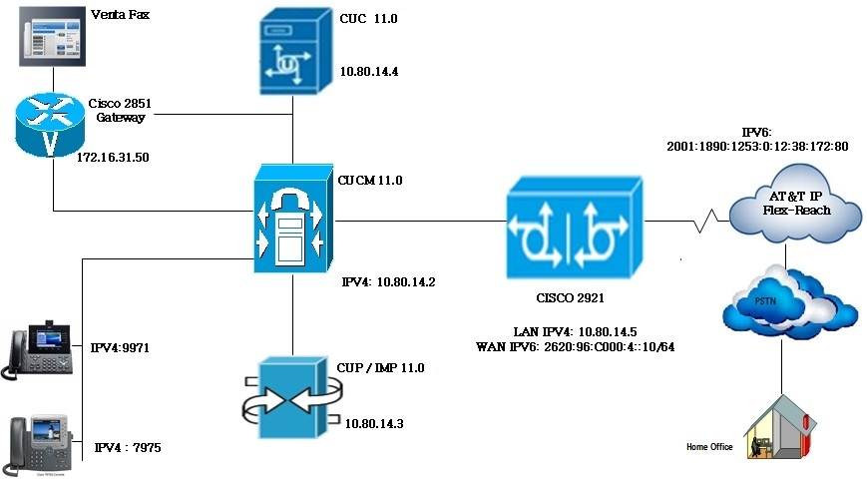

Hardware Components

- UCS-C240 VMWare server running ESXi 5.5
- Cisco IP Phones. This solution was tested with Cisco 7975 & Cisco 9971 phones
- Cisco CISCO2921/K9 (revision 1.0) with 483328K/40960K bytes of memory.
- Processor board ID FTX1746AJCB
- 3 Gigabit Ethernet interfaces
255K bytes of non-volatile configuration memory.

Software Requirements

- Cisco UCM: System version: 11.0.1.10000-10, including Business Edition 6000 and Business Edition 7000.
- ISR: Cisco IOS Software, C2900 Software (C2900-UNIVERSALK9_NPE-M), Version 15.5(3)M1, RELEASE SOFTWARE (fc2)
- Cisco UBE Software Release 11.1.0
- System image file is “c2900-universalk9_npe-mz.SPA.155-3.M1.bin".
- Cisco Unity Connection version: System version: 11.0.1.10000-10
- Cisco Unified CM IM and Presence: System version: 11.0.1.10000-6
- Cisco Jabber client version: 11.0.0 Build 65527
- VentaFax client version: 7.6.244.598 I

Features

Features – Supported
- Basic Call using G.729 and G711
- Calling Party Number Presentation and Restriction
- Calling Name Presentation
- AT&T Advanced 8YY Call Prompter (8YY)
- Cisco UBE Delayed-Offer-to-Early-Offer conversion of an initial SIP INVITE without SDP
- Intra-site Call Transfer
- Intra-site Conference
- Call Hold and Resume
- Call Forward All, Busy and No Answer
- AT&T IP Teleconferencing
- Fax over G.711
- Fax using T.38
- Incoming DNIS Translation and Routing
- Outbound calls to AT&T’s IP and TDM networks
- Inbound calls from AT&T’s IP and TDM networks
- CPE voicemail managed service, leave and retrieve voice messages via incoming AT&T SIP trunk (Cisco Unity Connection)
- Auto-attendant transfer-to service (See Caveat section for details)
- Failover (From non-responsive SIP network to ATT SIP network)
- Inbound & Outbound Calls using Cisco Jabber
- Emergency and 411 calls were terminated to a voicemail platform in lab environment within AT&T for test
- RTCP

Network Based Features - Supported

- Call forward (Unconditional, Busy, No Answer, Not reachable)
- Sequential Ringing
- Simultaneous Ringing

NOTE: Using the AT&T IP Flexible Reach Portal, provision TN(s) on the CPE with the Sequential Ring and simultaneous feature. Provisioning is self-explanatory. Please contact your AT&T representative, if you need help with the provisioning Network based feature.

Features - Not Supported

- Cisco UCM Codec negotiation of G.722.1
- Network-Based Blind Call Transfer
- Network-Based Consultative Call Transfer

Caveats

Auto-Attendant
- The CUC auto-attendant feature was used to test attendant functionality using the default codec G711 for auto attendant prompts. G729 prompts can be used but was not tested.

Hold/Resume & Music on Hold (MOH)
- Re-invites for hold/resume from PSTN network is potentially dependent on the carrier/network through which the call is traversing.

PBX Based Call Forward Unconditional
- PBX Based Unconditional Call Forwarding test is temporarily blocked due to AT&T Flexible Reach network issue.

Operator Call
- Operator Call (Call to 0) is not working in AT&T VIT lab.

SIP Provisional Acknowledgement/Early media
- To play early media sent by ATT, Cisco UCM needs to be enabled with PRACK if 1XX contains SDP on Cisco UCM SIP Profile.
- Some PSTN network call prompters utilize early-media cut-through to offer menu options to the caller (DTMF select menu) before the call is connected. In order for Cisco UCM/Cisco UBE solution to achieve successful early-media cut-through, the Cisco UCM to Cisco UBE call leg must be enabled with SIP PRACK. To enable SIP PRACK on the Cisco UCM, the SIP Profile “SIP Rel1XX Options” setting must be set to “Send PRACK”. The SIP Profile is found under Device>Device Settings>SIP Profile, This feature can be assigned on a per SIP trunk basis using SIP profiles. SIP PRACK provisioning on Cisco UCM 9.X and newer software versions is enabled under SIP Profile configuration page, while SIP PRACK support on Cisco UCM 7.X and older software versions is enabled under the Service Parameters configuration page.

AT&T IP Teleconferencing (IPTC)
Following scenarios were not executed due to limitations on AT&T network
- IPTC - Hold & Resume
- IPTC - PBX-Based Attended Transfer
- IPTC - PBX-Based 3-way Call Conference

Configuration Considerations

- To enable conference on AT&T IP Flexible Reach and Cisco UCM SIP trunk, it is required to configure a conference bridge (CFB) resource to initiate a three-way conference between end-points. See configuration section for details.
- Forwarded calls from Cisco UCM user to PSTN (out to AT&T’s IP Flexible Reach service), AT&T serviced areas require that the SIP Diversion header contain the full 10-digit DID number of the forwarding party. In this application note the assumption has been made that a typical customer will utilize extension numbers (4-digit assignments in this example) and map 10-digit DID number using Cisco UBE translation profile. This is because the Cisco UCM uses 4-digit extensions on Cisco UCM IP phones and it is necessary to expand the 4-digit extension included in the Diversion header of a forwarding INVITE message to its full 10-digit DID number when the IP phone is set to call-forward. The requirement to expand the Diversion-Header has been achieved by the use of a SIP profile in Cisco UBE (See configuration section for details).
- Upon receiving inbound calls, AT&T SIP network will always have the first choice codec presented in the initial SIP INVITE (unless the end-device does not support the listed preferred codec), and processes calls accordingly. Customers wishing to place/receive G.711-only calls must configure separate voice class codec on Cisco UBE with G.711 as the first choice.
- SIP Profiles may also be employed to advertise desired RTP payload packet size.
- “voice-class sip privacy id” needs to configure in Cisco UBE dial peer to make call From a CPE Phone to PSTN phone, Pass Calling Party Number (CPN), marked private.
- This test environment is not configured with Cisco UBE High Availability (HA)
- Cisco UCM sends a SIP UPDATE message to Cisco UBE for a call transfer. AT&T network does not support the SIP UPDATE message causing the Cisco UBE to timeout and the call transfer is not completed. As a workaround, SIP profile has been applied on the Cisco UBE to remove UPDATE from the allowed headers (See configuration section for details).

Emergency 911/E911 Services Limitations and Restrictions

- Emergency 911/E911 Services Limitations and Restrictions - Although AT&T provides 911/E911 calling capabilities, AT&T does not warrant or represent that the equipment and software (e.g., IP PBX) reviewed in this customer configuration guide will properly operate with AT&T IP Flexible Reach to complete 911/E911 calls; therefore, it is Customer's responsibility to ensure proper operation with its equipment/software vendor
- While AT&T IP Flexible Reach services support E911/911 calling capabilities under certain Calling Plans, there are circumstances when E911/911 service may not be available, as stated in the Service Guide for AT&T IP Flexible Reach found at http://new.serviceguide.att.com. Such circumstances include, but are not limited to, relocation of the end user’s CPE, use of a non-native or virtual telephone number, failure in the broadband connection, loss of electrical power and delays that may occur in updating the Customer’s location in the automatic location information database. Please review the AT&T IP Flexible Reach Service Guide in detail to understand the limitations and restrictions

ISR Configuration

ATT-IPV6#show version
Cisco IOS Software, C2900 Software (C2900-UNIVERSALK9_NPE-M), Version 15.5(3)M1, RELEASE SOFTWARE (fc2)
Technical Support: http://www.cisco.com/techsupport
Copyright (c) 1986-2015 by Cisco Systems, Inc.
Compiled Mon 16-Nov-15 19:25 by prod_rel_team

ROM: System Bootstrap, Version 15.0(1r)M16, RELEASE SOFTWARE (fc1)

ATT-IPV6 uptime is 2 weeks, 5 days, 23 hours, 6 minutes
System returned to ROM by reload at 07:05:03 UTC Wed Mar 9 2016
System image file is "flash:c2900-universalk9_npe-mz.SPA.155-3.M1.bin"
Last reload type: Normal Reload
Last reload reason: Reload Command

This product contains cryptographic features and is subject to United
States and local country laws governing import, export, transfer and
use. Delivery of Cisco cryptographic products does not imply
third-party authority to import, export, distribute or use encryption.
Importers, exporters, distributors and users are responsible for
compliance with U.S. and local country laws. By using this product you
agree to comply with applicable laws and regulations. If you are unable
to comply with U.S. and local laws, return this product immediately.

A summary of U.S. laws governing Cisco cryptographic products may be found at:
http://www.cisco.com/wwl/export/crypto/tool/stqrg.html

If you require further assistance please contact us by sending email to
export@cisco.com.

Cisco CISCO2921/K9 (revision 1.0) with 483328K/40960K bytes of memory.
Processor board ID FTX1746AJCB
3 Gigabit Ethernet interfaces
1 terminal line
DRAM configuration is 64 bits wide with parity enabled.
255K bytes of non-volatile configuration memory.
250880K bytes of ATA System CompactFlash 0 (Read/Write)

License Info:

License UDI:

-------------------------------------------------
Device# PID SN
-------------------------------------------------
*1 CISCO2921/K9 FTX1746AJCB

Suite License Information for Module:'c2900'

--------------------------------------------------------------------------------
Suite Suite Current Type Suite Next reboot
--------------------------------------------------------------------------------
FoundationSuiteK9_npe None None None
securityk9_npe
datak9

AdvUCSuiteK9 None None None
uck9
cme-srst
cube

Technology Package License Information for Module:'c2900'

------------------------------------------------------------------------
Technology Technology-package Technology-package
Current Type Next reboot
------------------------------------------------------------------------
ipbase ipbasek9 Permanent ipbasek9
security None None None
uc uck9 Permanent uck9
data None None None

Configuration register is 0x2102

ATT-IPV6#sh running-config
Building configuration...

Current configuration : 11224 bytes
!
! Last configuration change at 06:08:57 UTC Thu Mar 17 2016 by cisco
!
version 15.5
service timestamps debug datetime msec
service timestamps log datetime msec
no service password-encryption
service sequence-numbers
!
hostname ATT-IPV6
!
boot-start-marker
boot system flash c2900-universalk9_npe-mz.SPA.155-3.M1.bin
boot-end-marker
!
aqm-register-fnf
!
logging queue-limit 1000000000
logging buffered 30000000
logging rate-limit 10000
no logging console
no logging monitor
enable secret 4 Pe0NhiWw5IXZpE.k5VhTSCoGPcuVeRyrer9kEPz20Z6
!
no aaa new-model
ethernet lmi ce
!
!
!
!
!
!
!
!
!
!
!
!
no ip domain lookup
ip cef
ipv6 unicast-routing
ipv6 cef
multilink bundle-name authenticated
!
!
!
!
!
cts logging verbose
!
!
voice-card 0
dspfarm
dsp services dspfarm
!
!
!
voice service voip
no ip address trusted authenticate
address-hiding
mode border-element
allow-connections sip to sip
redirect ip2ip
fax protocol t38 version 0 ls-redundancy 0 hs-redundancy 0 fallback none
no fax-relay sg3-to-g3
sip
header-passing
error-passthru
no update-callerid
early-offer forced
midcall-signaling passthru
privacy-policy passthru
g729 annexb-all
!
voice class codec 2
codec preference 1 g711ulaw
codec preference 2 g729r8 bytes 30
!
voice class codec 3
codec preference 1 g711ulaw
!
voice class codec 1
codec preference 1 g729r8 bytes 30
codec preference 2 g711ulaw
!
!
voice class sip-profiles 1
response ANY sip-header Allow-Header modify "UPDATE," ""
request INVITE sip-header Diversion modify "<sip:(.*)@(.*)>" "<sip:732216\1@\2>"
request INVITE sdp-header Audio-Attribute modify "a=ptime:20" "a=ptime:30"
response ANY sdp-header Audio-Attribute modify "a=ptime:20" "a=ptime:30"
request INVITE sdp-header Audio-Attribute add "a=ptime:30"
!
!
!
!
!
voice translation-rule 1
rule 1 /^.*\(435.\)/ /732320\1/
!
!
!
voice translation-profile NPA
translate calling 1
!
!
!
license udi pid CISCO2921/K9 sn FTX1746AJCB
hw-module pvdm 0/0
!
!
!
username cisco privilege 15 password 0 cisco
!
redundancy
!
!
!
!
!
!
interface Embedded-Service-Engine0/0
no ip address
shutdown
!
interface GigabitEthernet0/0
description WAN to ATT
no ip address
duplex auto
speed auto
ipv6 address 2620:96:C000:4::10/64
ipv6 enable
!
interface GigabitEthernet0/1
description LAN Interface
ip address 10.80.14.5 255.255.255.0
duplex auto
speed auto
!
interface GigabitEthernet0/2
no ip address
shutdown
duplex auto
speed auto
!
ip forward-protocol nd
!
no ip http server
no ip http secure-server
!
ip route 0.0.0.0 0.0.0.0 192.65.79.33
ip route 10.64.0.0 255.255.0.0 10.80.14.1
ip route 10.64.0.0 255.255.0.0 10.80.22.1
ip route 10.80.0.0 255.255.0.0 10.80.14.1
ip route 172.16.0.0 255.255.0.0 10.80.14.1
!
ipv6 route ::/0 2620:96:C000:4::1
!
!
!
control-plane
!
!
!
!
!
!
mgcp behavior rsip-range tgcp-only
mgcp behavior comedia-role none
mgcp behavior comedia-check-media-src disable
mgcp behavior comedia-sdp-force disable
!
mgcp profile default
!
!
!
!
dial-peer voice 200 voip
description "Outgoing To AT&T .IP PBX facing side"
session protocol sipv2
incoming called-number [2-9][0-9]........
voice-class codec 1
voice-class sip asymmetric payload full
voice-class sip asserted-id pai
voice-class sip privacy-policy passthru
voice-class sip bind control source-interface GigabitEthernet0/1
voice-class sip bind media source-interface GigabitEthernet0/1
dtmf-relay rtp-nte
no fax-relay sg3-to-g3
fax rate 14400
fax protocol t38 version 0 ls-redundancy 0 hs-redundancy 0 fallback none
no vad
!
dial-peer voice 214 voip
description "Outgoing To AT&T"-AT&T facing side
destination-pattern [2-9][0-9]........
session protocol sipv2
session target ipv6:[2001:1890:1253:0:12:38:172:80]
voice-class codec 1
voice-class sip asymmetric payload full
voice-class sip asserted-id pai
voice-class sip privacy-policy passthru
voice-class sip early-offer forced
voice-class sip profiles 1
voice-class sip bind control source-interface GigabitEthernet0/0
voice-class sip bind media source-interface GigabitEthernet0/0
dtmf-relay rtp-nte
no fax-relay sg3-to-g3
fax rate 14400
fax protocol t38 version 0 ls-redundancy 0 hs-redundancy 0 fallback none
no vad
!
dial-peer voice 800 voip
description " Incoming AT&T to IP-PBX . AT&T facing side "
translation-profile incoming test+1
huntstop
session protocol sipv2
incoming called-number [37][13][24][12]......
voice-class codec 1
voice-class sip asymmetric payload full
no voice-class sip asserted-id
voice-class sip privacy-policy passthru
voice-class sip profiles 1
voice-class sip bind control source-interface GigabitEthernet0/0
voice-class sip bind media source-interface GigabitEthernet0/0
dtmf-relay rtp-nte
no fax-relay sg3-to-g3
fax rate 14400
fax protocol t38 version 0 ls-redundancy 0 hs-redundancy 0 fallback none
no vad
!
dial-peer voice 700 voip
description " Incoming AT&T to IP-PBX - IP-PBX facing side "
huntstop
destination-pattern [37][13][24][12]......
no modem passthrough
session protocol sipv2
session target ipv4:10.80.14.2:5060
voice-class codec 1
voice-class sip asymmetric payload full
no voice-class sip asserted-id
voice-class sip privacy-policy passthru
voice-class sip early-offer forced
voice-class sip profiles 1
voice-class sip bind control source-interface GigabitEthernet0/1
voice-class sip bind media source-interface GigabitEthernet0/1
dtmf-relay rtp-nte
no fax-relay sg3-to-g3
fax rate 14400
fax protocol t38 version 0 ls-redundancy 0 hs-redundancy 0 fallback none
no vad
!
dial-peer voice 100 voip
description "Outgoing To AT&T"-AT&T facing side
destination-pattern 73236.....
no modem passthrough
session protocol sipv2
session target ipv6:[2001:1890:1253:0:12:38:172:80]
voice-class codec 1
voice-class sip asymmetric payload full
voice-class sip asserted-id pai
voice-class sip privacy-policy passthru
voice-class sip profiles 1
voice-class sip bind control source-interface GigabitEthernet0/0
voice-class sip bind media source-interface GigabitEthernet0/0
dtmf-relay rtp-nte
fax rate 14400
fax protocol t38 version 0 ls-redundancy 0 hs-redundancy 0 fallback none
no vad
!
dial-peer voice 300 voip
description " Int'l calls to AT&T - AT&T facing side "
destination-pattern 011T
no modem passthrough
session protocol sipv2
session target ipv6:[2001:1890:1253:0:12:38:172:80]
voice-class codec 1
voice-class sip asymmetric payload full
voice-class sip asserted-id pai
voice-class sip privacy-policy passthru
voice-class sip early-offer forced
voice-class sip profiles 1
voice-class sip bind control source-interface GigabitEthernet0/0
voice-class sip bind media source-interface GigabitEthernet0/0
dtmf-relay rtp-nte
fax rate 14400
fax protocol t38 version 0 ls-redundancy 0 hs-redundancy 0 fallback none
no vad
!
dial-peer voice 400 voip
description " Int'l calls to AT&T - IP-PBX facing side "
no modem passthrough
session protocol sipv2
incoming called-number 011T
voice-class codec 1
voice-class sip asymmetric payload full
voice-class sip asserted-id pai
voice-class sip privacy-policy passthru
voice-class sip profiles 1
voice-class sip bind control source-interface GigabitEthernet0/1
voice-class sip bind media source-interface GigabitEthernet0/1
dtmf-relay rtp-nte
fax rate 14400
fax protocol t38 version 0 ls-redundancy 0 hs-redundancy 0 fallback none
no vad
!
dial-peer voice 500 voip
description " N11 Calls to AT&T - AT&T facing side "
destination-pattern .11
no modem passthrough
session protocol sipv2
session target ipv6:[2001:1890:1253:0:12:38:172:80]
voice-class codec 1
voice-class sip asymmetric payload full
voice-class sip asserted-id pai
voice-class sip privacy-policy passthru
voice-class sip early-offer forced
voice-class sip profiles 1
voice-class sip bind control source-interface GigabitEthernet0/0
voice-class sip bind media source-interface GigabitEthernet0/0
dtmf-relay rtp-nte
fax rate 14400
fax protocol t38 version 0 ls-redundancy 0 hs-redundancy 0 fallback none
no vad
!
dial-peer voice 600 voip
description " N11 Calls to AT&T - IP-PBX facing side "
no modem passthrough
session protocol sipv2
incoming called-number .11
voice-class codec 1
voice-class sip asymmetric payload full
voice-class sip asserted-id pai
voice-class sip privacy-policy passthru
voice-class sip profiles 1
voice-class sip bind control source-interface GigabitEthernet0/1
voice-class sip bind media source-interface GigabitEthernet0/1
dtmf-relay rtp-nte
fax rate 14400
fax protocol t38 version 0 ls-redundancy 0 hs-redundancy 0 fallback none
no vad
!
dial-peer voice 122 voip
description "OPERATOR TESTING"
destination-pattern 0
no modem passthrough
session protocol sipv2
session target ipv6:[2001:1890:1253:0:12:38:172:80]
voice-class codec 1
voice-class sip asymmetric payload full
voice-class sip asserted-id pai
voice-class sip privacy-policy passthru
voice-class sip early-offer forced
voice-class sip profiles 1
voice-class sip bind control source-interface GigabitEthernet0/0
voice-class sip bind media source-interface GigabitEthernet0/0
dtmf-relay rtp-nte
fax rate 14400
fax protocol t38 version 0 ls-redundancy 0 hs-redundancy 0 fallback none
no vad
!
dial-peer voice 141 voip
description "Network Feature"
translation-profile outgoing NPA
destination-pattern *..
no modem passthrough
session protocol sipv2
session target ipv6:[2001:1890:1253:0:12:38:172:80]
voice-class codec 1
voice-class sip asymmetric payload full
voice-class sip asserted-id pai
voice-class sip privacy-policy passthru
voice-class sip early-offer forced
voice-class sip profiles 1
voice-class sip bind control source-interface GigabitEthernet0/0
voice-class sip bind media source-interface GigabitEthernet0/0
dtmf-relay rtp-nte
fax rate 14400
fax protocol t38 version 0 ls-redundancy 0 hs-redundancy 0 fallback none
no vad
!
dial-peer voice 2151 voip
description "Outgoing To AT&T"-AT&T facing side
destination-pattern 7323204607
no modem passthrough
session protocol sipv2
session target ipv6:[2001:1890:1253:0:12:38:172:80]
voice-class codec 1
voice-class sip asymmetric payload full
voice-class sip asserted-id pai
voice-class sip privacy-policy passthru
voice-class sip early-offer forced
voice-class sip profiles 1
voice-class sip bind control source-interface GigabitEthernet0/0
voice-class sip bind media source-interface GigabitEthernet0/0
dtmf-relay rtp-nte
fax rate 14400
fax protocol t38 version 0 ls-redundancy 0 hs-redundancy 0 fallback none
no vad
!
!
gateway
media-inactivity-criteria all
timer receive-rtcp 5
timer receive-rtp 86400
!
sip-ua
no remote-party-id
retry invite 2
timers expires 1800000
connection-reuse
protocol mode dual-stack
!
!
!
gatekeeper
shutdown
!
!
!
line con 0
logging synchronous
line aux 0
line 2
no activation-character
no exec
transport preferred none
transport output pad telnet rlogin lapb-ta mop udptn v120 ssh
stopbits 1
line vty 0 4
exec-timeout 960 0
logging synchronous
login local
transport input all
!
scheduler allocate 20000 1000
!
end

Cisco UCM Configuration

The configuration screen shots shows general over view of lab configuration for this interoperability testing.

Cisco UCM Version

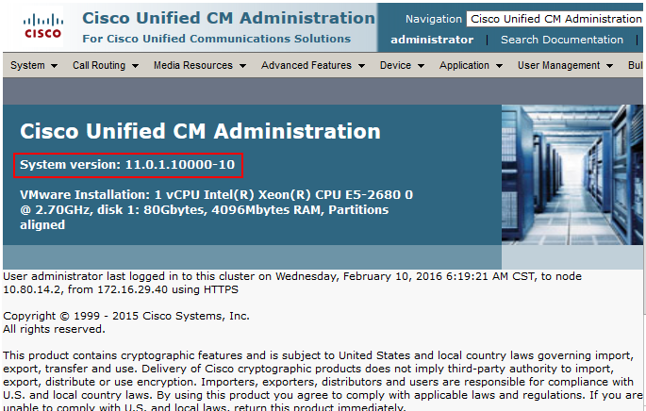

Cisco UCM Audio Codec Preference List
Navigation Path: System Region Information Audio codec preference list
Cisco UCM 11.0 has a feature called Audio Codec Preference List. This feature allows to configure the order of audio codec preference both for Inter and Intra Region calls. Audio Codec Preference list is assigned to the Region used by the Device Pool for Phones and by Conference Bridges. Based on user requirement, different codec regions can be assigned as their first choice codec with this configuration for inbound calls as well as conferences initiated by Cisco IP phones. Audio codec preference for outbound calls is determined by Cisco UBE (via configuration of voice-class codec)
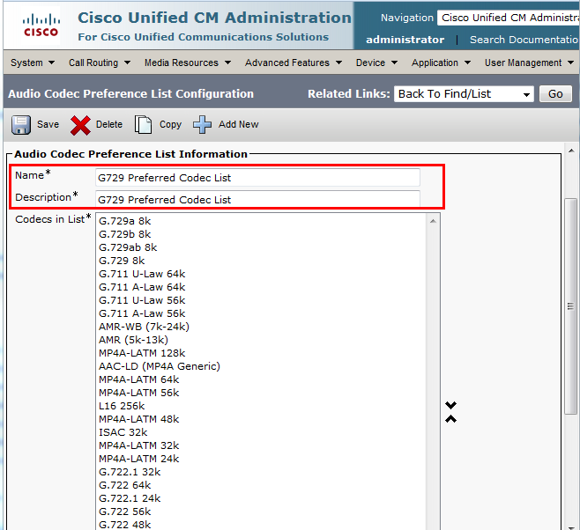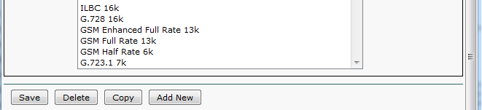

Cisco UCM Region Configuration
Navigation Path: System Region Information Region
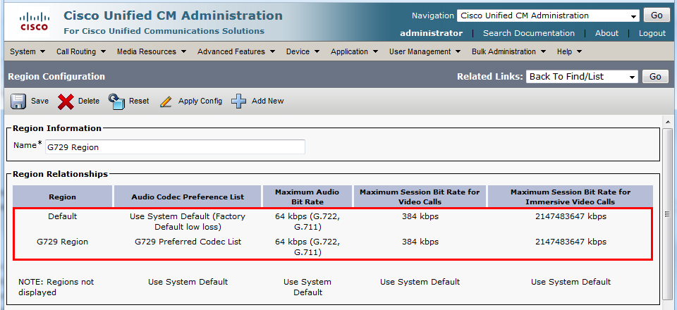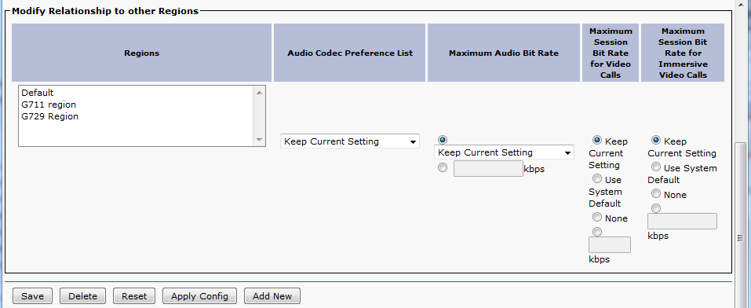

Device Pool Configuration
Navigation Path: System Device Pool
“G729” Device Pool is configured for testing the interoperability. No special consideration needs to be taken when configuring the Device Pools. Optionally, a Media Resource Group List can be added to the Device Pools, if needed, to assign selected Media Resources (Conference Bridges, Transcoders, MoH servers, Annunciators) to devices.
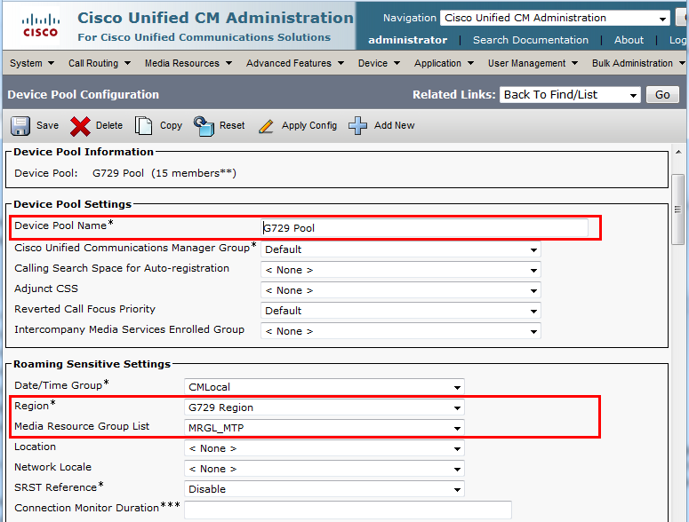
Device Pool Configuration (continued…)
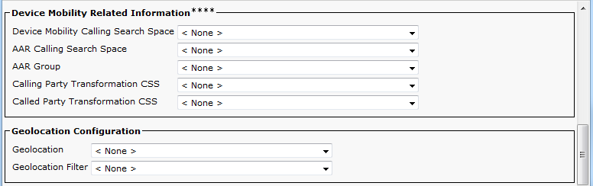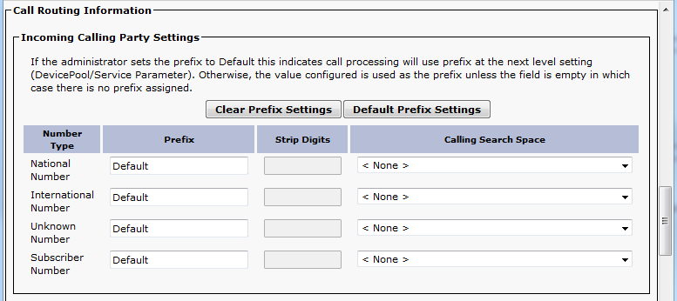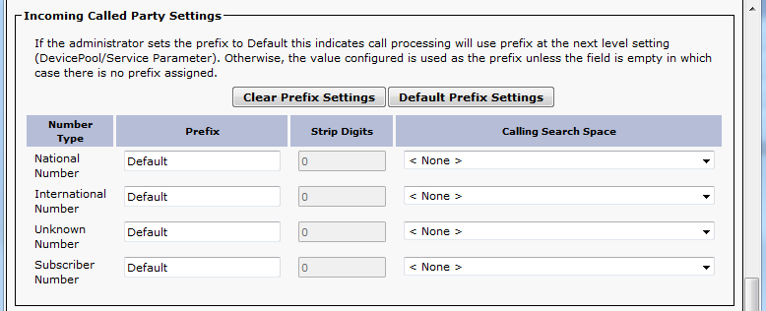
Device Pool Configuration (continued…)
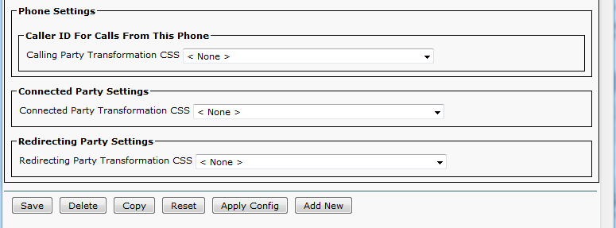

Annunciator Configuration
Navigation: Media Resource Annunciator
Set Name* = ANN_2.
Set Description = ANN_clus24pubsub. This is used for this example
Set Device Pool* = G729.

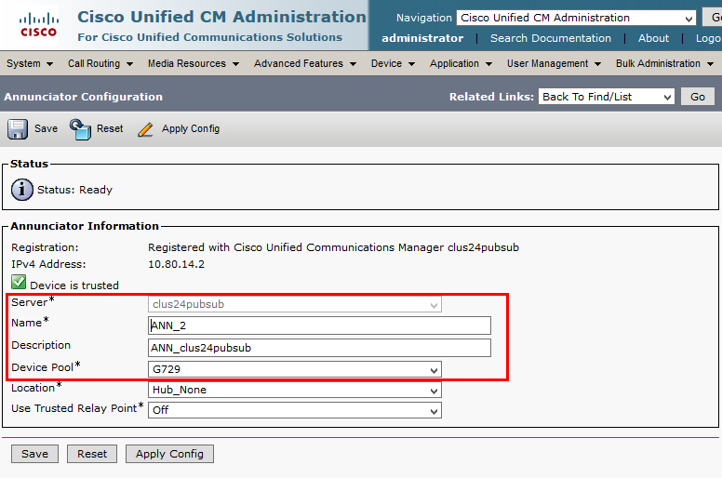

Conference Bridge Configuration
Navigation: Media Resources Conference Bridge
Set Conference Bridge Type* = Cisco Conference Bridge Software.
Set Host Server = clus24pubsub. This is used for this example.
Set Conference Bridge Name* = CFB_2.
Set Description = CFB_clus24pubsub. This is used in this example.
Set Device Pool* = G729.
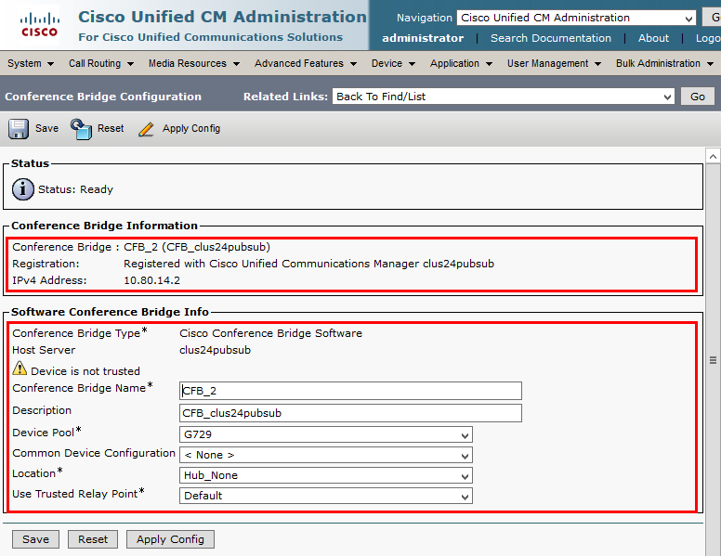

Media Termination Point Configuration
Navigation: Media ResourceMedia Termination Point

Set Media Termination Point Name* = MTP_2
Set Description = MTP_clus24pubsub. This is used for this example
Set Device pool* = G729

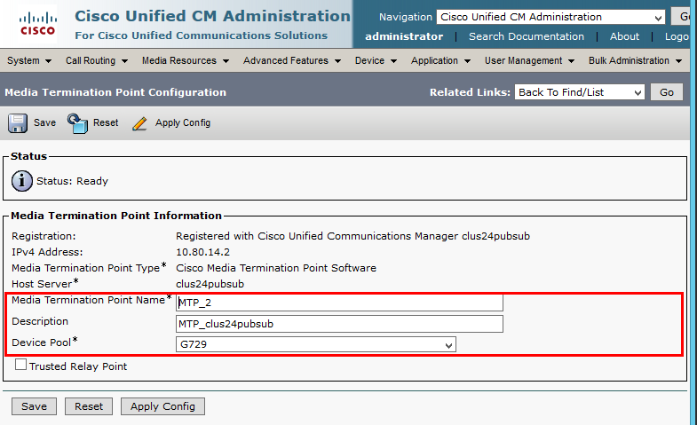

Music on Hold Server Configuration
Navigation: Media Resources Music on Hold Server
Set Music on Hold Server Name* = MOH_2.
Set Description = MOH_clus24pubsub. This is used for this example.
Set Device Pool* = G729
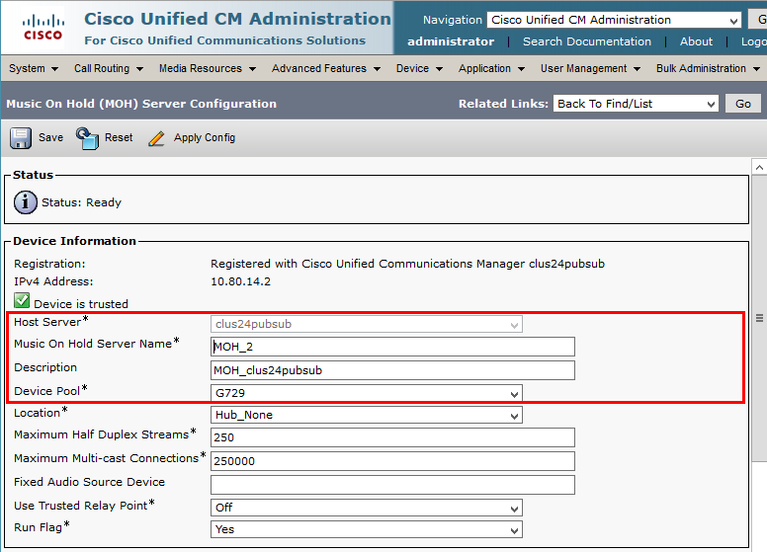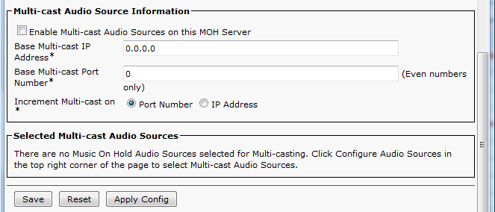

Music on Hold Service (IP Voice Media Streaming App) Parameter Settings
Navigation: System Service Parameter
Note: Make sure codecs G.729 Annex A and G.711 mulaw are configured in parameter Supported MOH Codecs.
Select Server* = clus24pubsub--CUCM Voice/Video (Active). This is used in this example.
Select Service* = Cisco IP Voice Media Streaming App (Active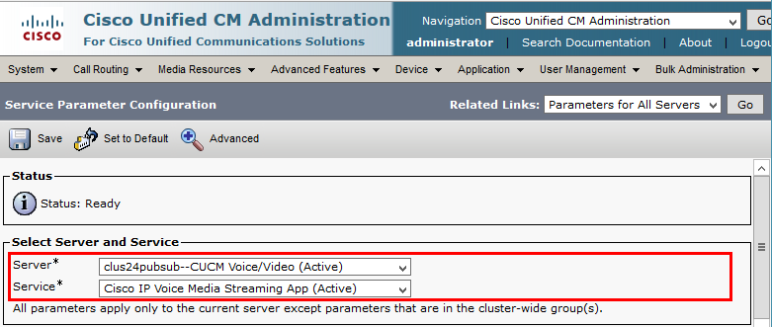 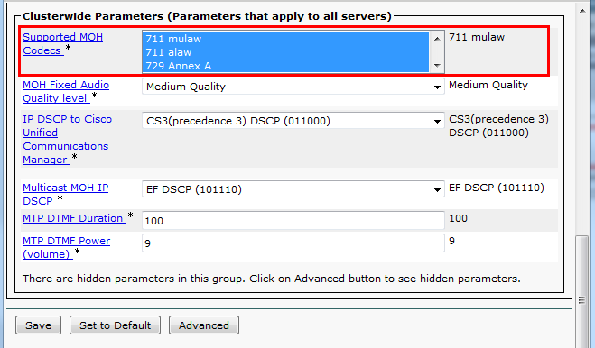

Music on Hold Service (Duplex Streaming) Parameter Settings
Navigation: System Service Parameter
Select Server* = clus24pubsub--CUCM Voice/Video (Active). This is used in this example.
Select Service* = Cisco CallManager (Active).
Select Duplex Streaming Enabled * = True
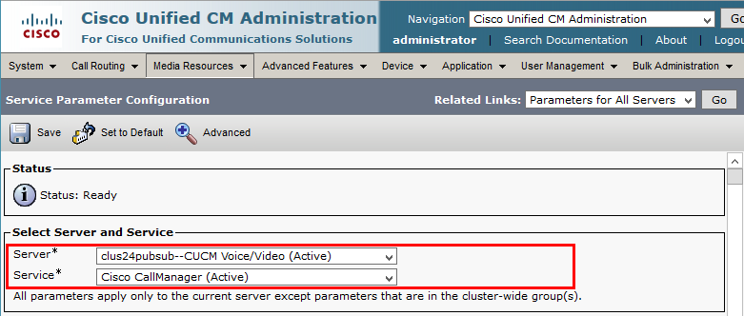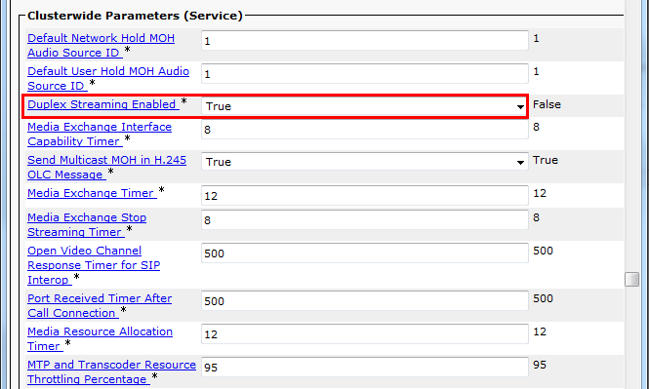

Media Resource Group Configuration
Navigation Path: Media Resources Media Resources group
The Media Resource Group (MRG) contains media resources, such as Conference Bridge, Transcoder, MoH server and Annunciator. It will be assigned to a Media Resource Group List (MRGL) which is used to allocate media resources to groups of devices through Device Pools, or individually by configuring a valid MRGL at the device configuration page.

Set Name*= MRG_MTP - This is used for this example.
Set Description = MRG_MTP - This text is used to define this Media Resource Group List.
Set all Resources in the selected Media Resources Box.

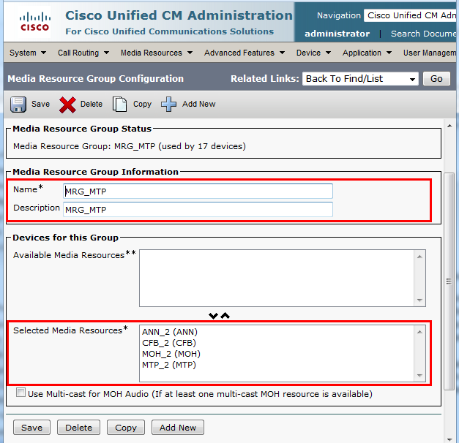

Media Resource Group List Configuration
Navigation Path: Media Resources Media Resource Group List
Set Name = MRGL_MTP.
Set selected Media Resource Groups = MRG_MTP.

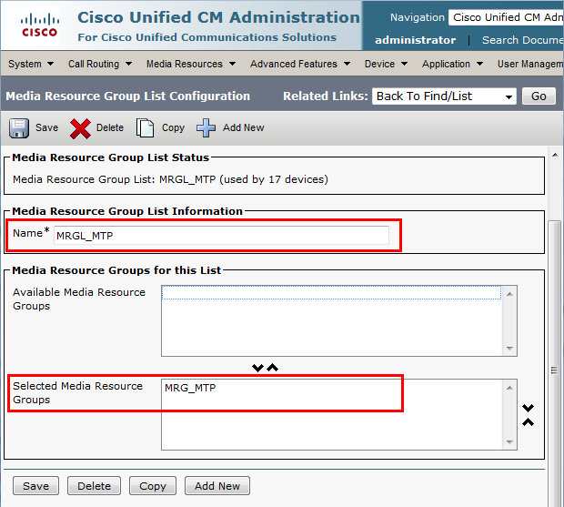

UC Service Configuration
Navigation: User Management User Settings UC Service
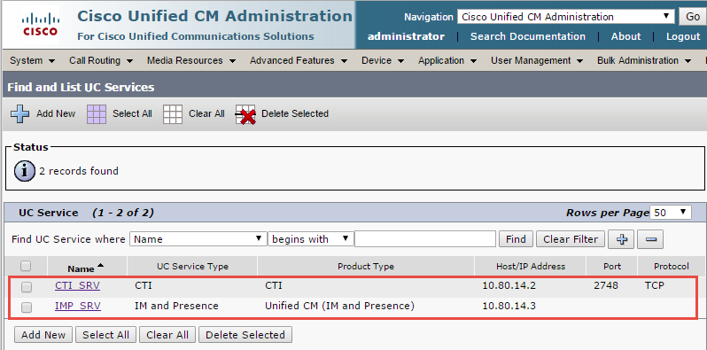

UC Service Configuration (Contd…)
Select UC Service Type: = CTI
Set Name* = CTI_SRV. This is used in this example.
Set Description = CTI for Jabber Clients. This is used in this example.
Set Host Name/IP Address* = 10.80.14.2 (Cisco UCM Address)
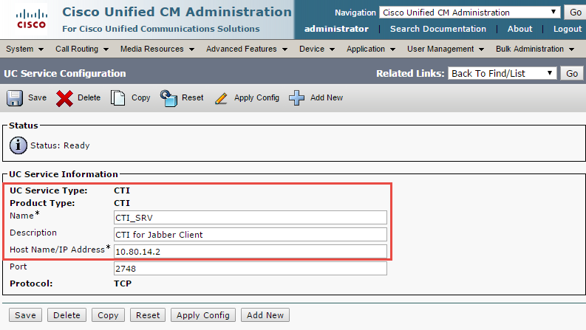

UC Service Configuration (Contd…)
Select UC Service Type: = IM and Presence
Set Name* = IMP_SRV. This is used in this example.
Set Description = IM Presence. This is used in this example.
Set Host Name/IP Address* = 10.80.14.3 (Cisco UCM IM & Presence IP Address)

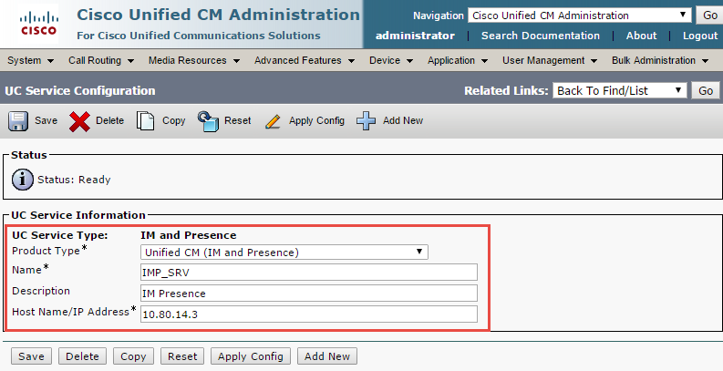

Service Profile Configuration
Navigation: User Management User Settings Service Profile
Set Name* = Jabber_SVC_Profile. This is used in this example.
Set Description = Jabber Service Profile. This is used in this example.
Check - Make this the default service profile for the system.

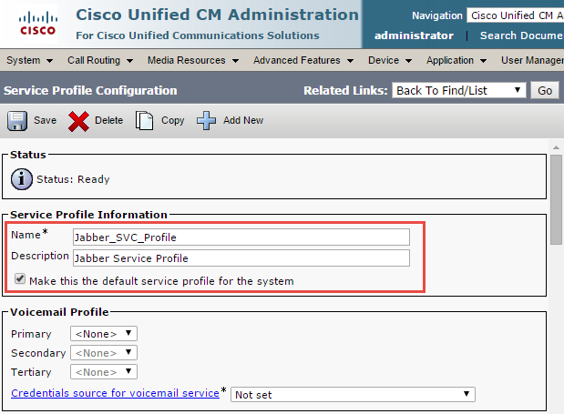
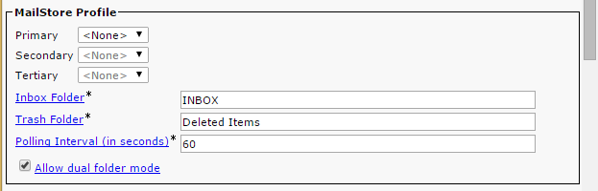
Service Profile Configuration (Contd…)
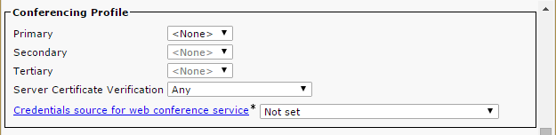
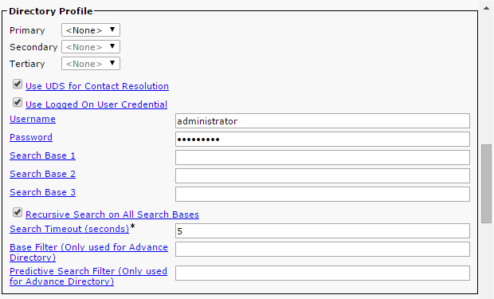
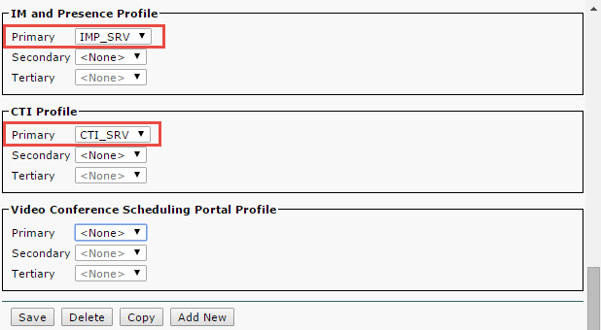

End User Configuration
Navigation: User Management End User

Set User ID* = jabber1 – This is used in this example.
Set Password = Password for profile.
Set Directory URI = jabber1@lab.tekvizion.com.

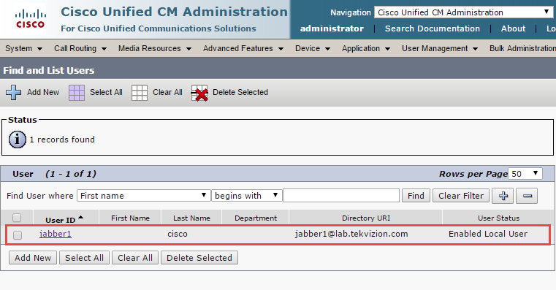

End User Configuration (continued…)
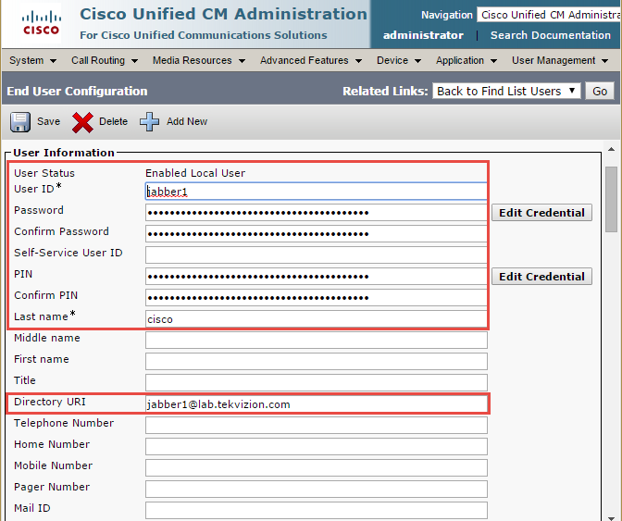
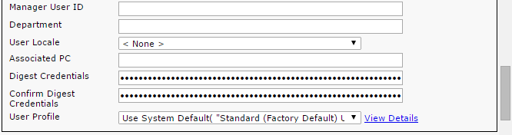

End User Configuration (continued…)
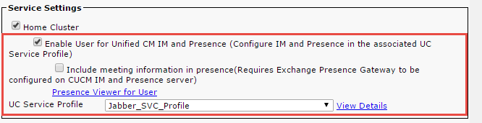
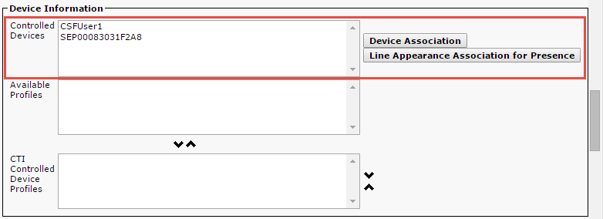
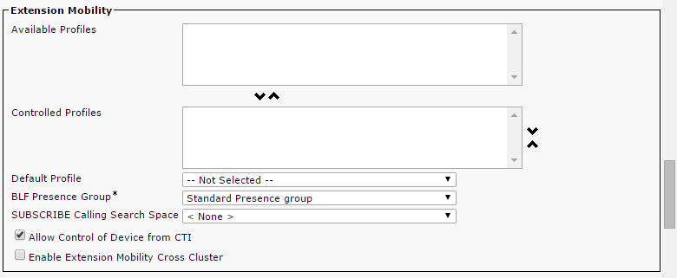

End User Configuration(continued… )
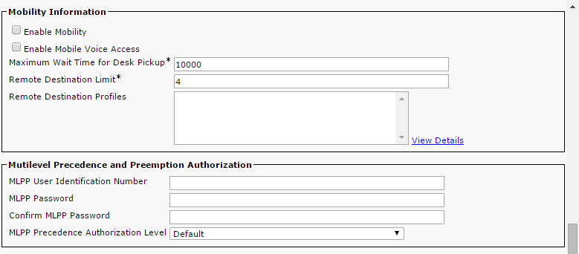
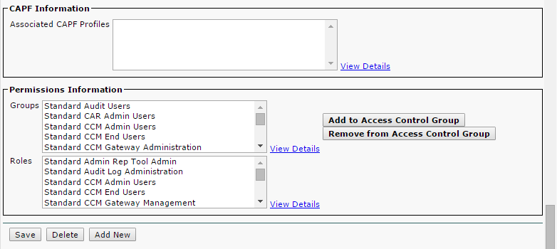

Cisco IP Phone 7975 SIP Configuration

Set MAC Address* = the below mac is used in this example.
Set Description = SIP-2754. This text is used to identify this Phone.
Set Device Pool*= G729 Pool. This is used in this example.
Set Phone Button Template*= Standard 7975 SIP. This is used in this example. Set Media Resource Group List = MRGL_MTP. This is used in this example.
Set User Hold MOH Audio Source = 1-SampleAudioSource.
Set Network Hold MOH Audio Source = 1-SampleAudioSource
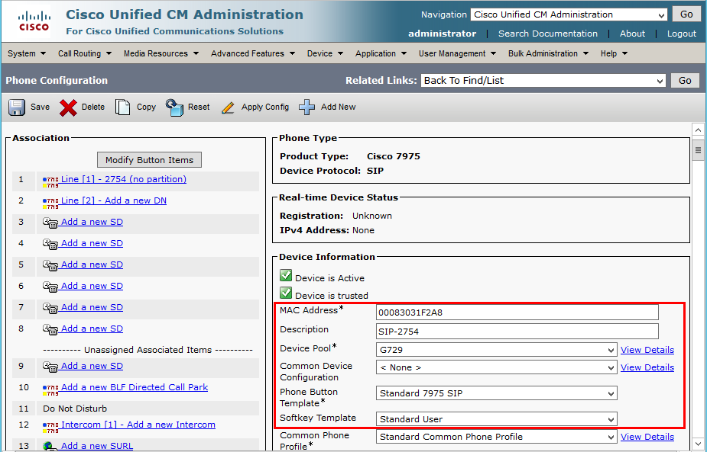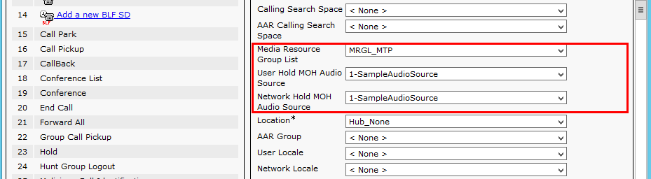
Cisco IP Phone 7975 SCCP Configuration (Continued…)
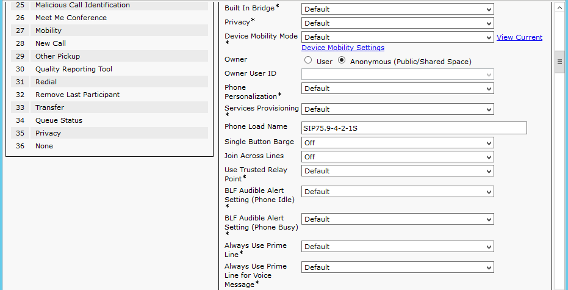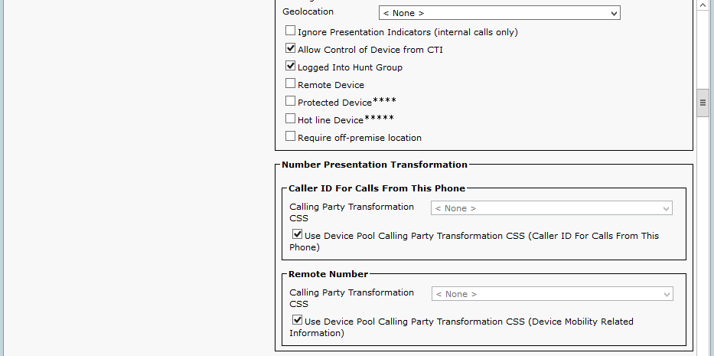

Cisco IP Phone 7975 SCCP Configuration (Continued…)
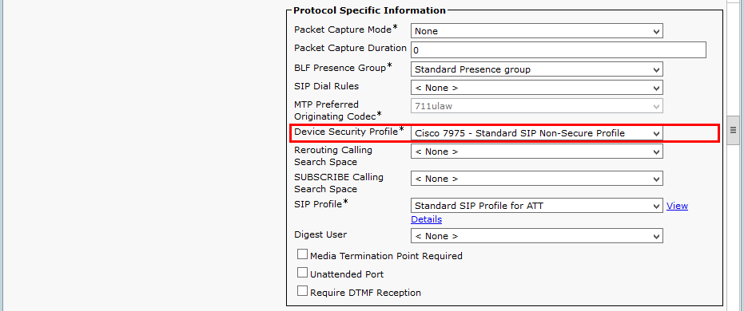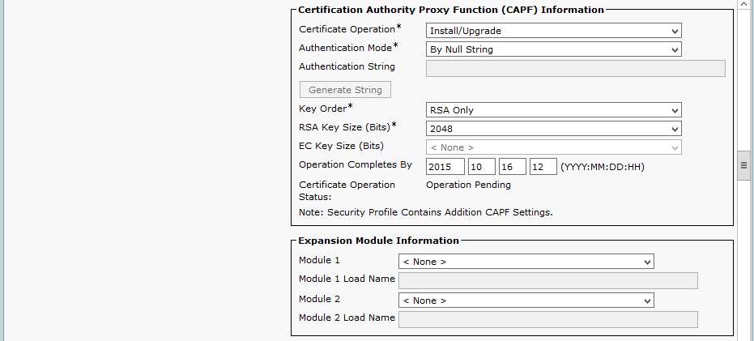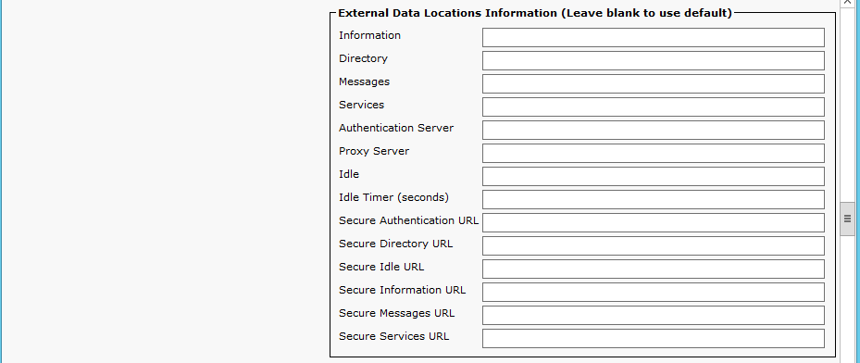
Cisco IP Phone 7975 SCCP Configuration (Continued…) 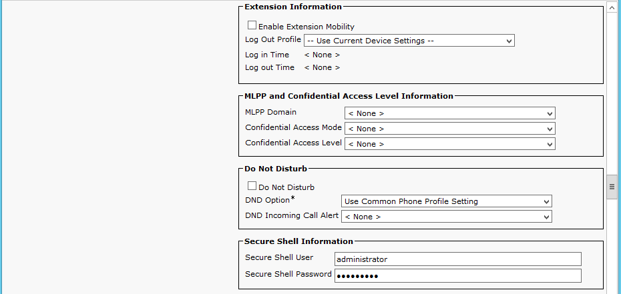 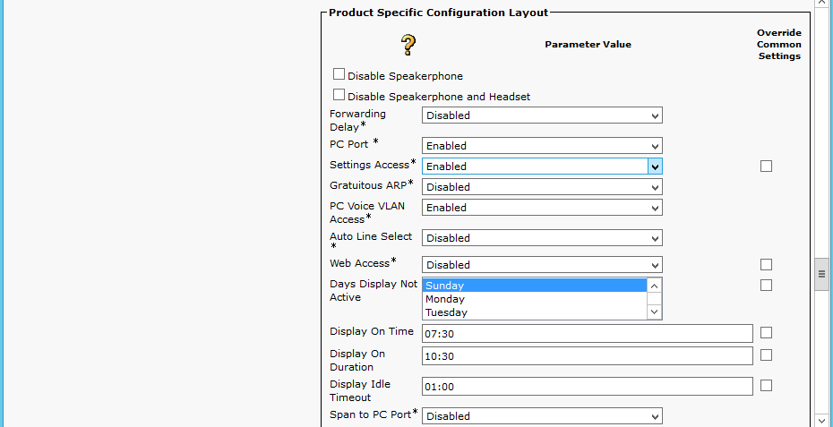

Cisco IP Phone 7975 SCCP Configuration (Continued…)
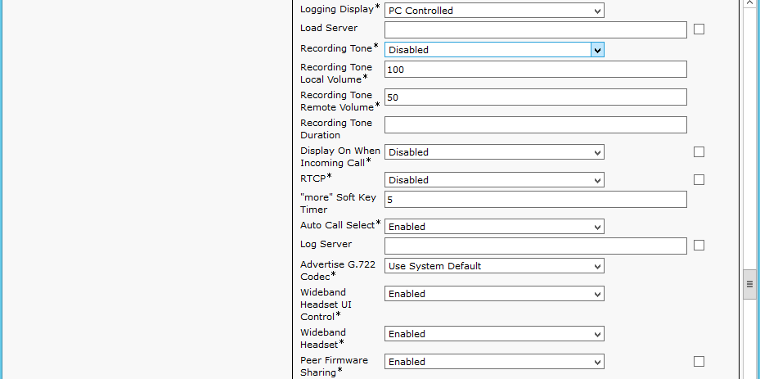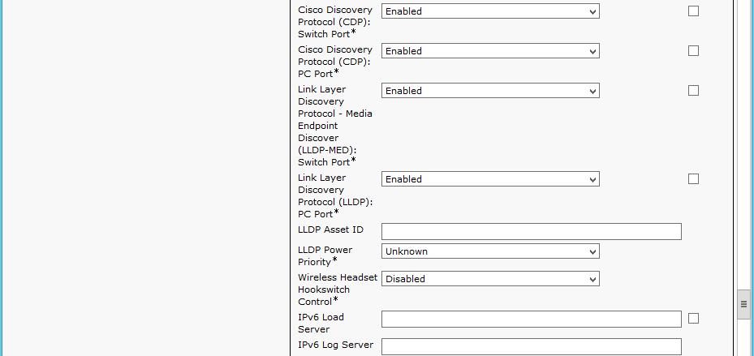

Cisco IP Phone 7975 SCCP Configuration (Continued…)
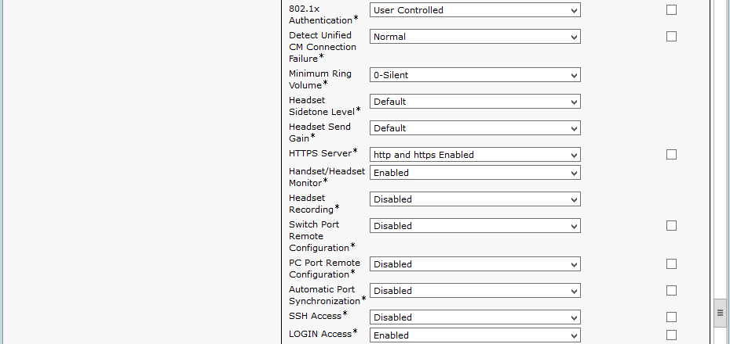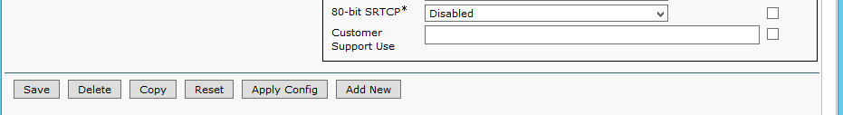

Cisco IP Phone 7975 SIP Configuration (Continued…)
Set Directory Number* = 2754. This is used in this example.
Set Description = 7322162754. This is used in this example.
Set Alerting Name = 7322162754. This is used in this example.
Set ASCII Alerting Name = 7322162754. This is used in this example.

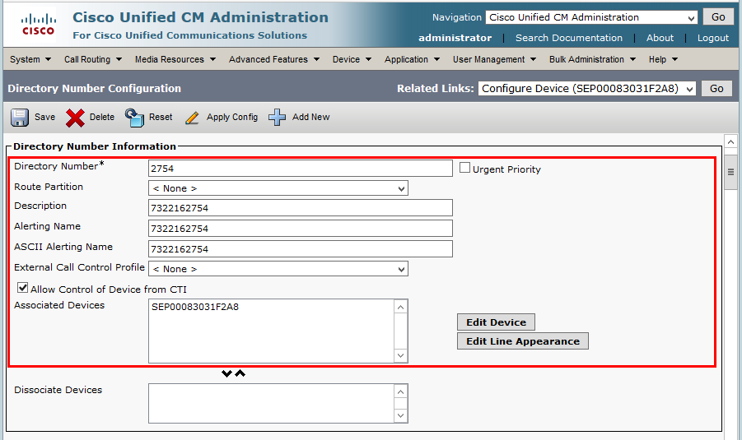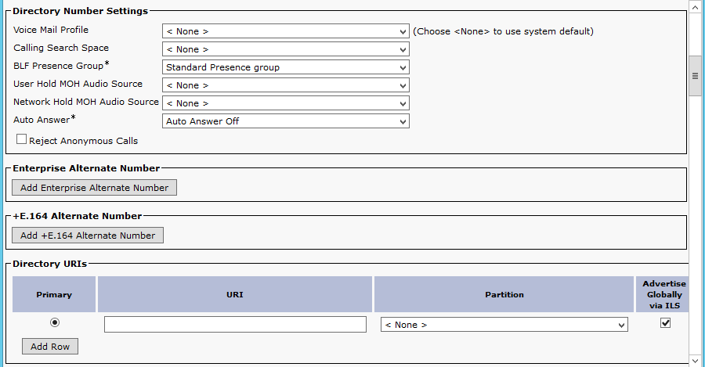
Cisco IP Phone 7975 SCCP Configuration (Continued…)
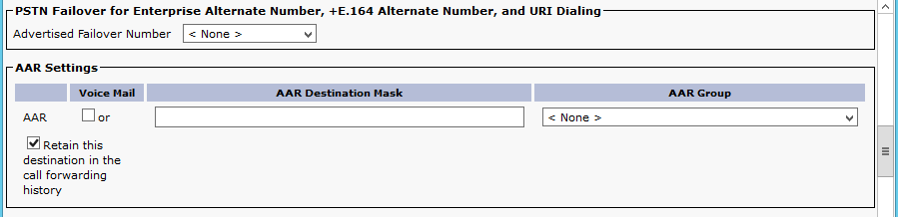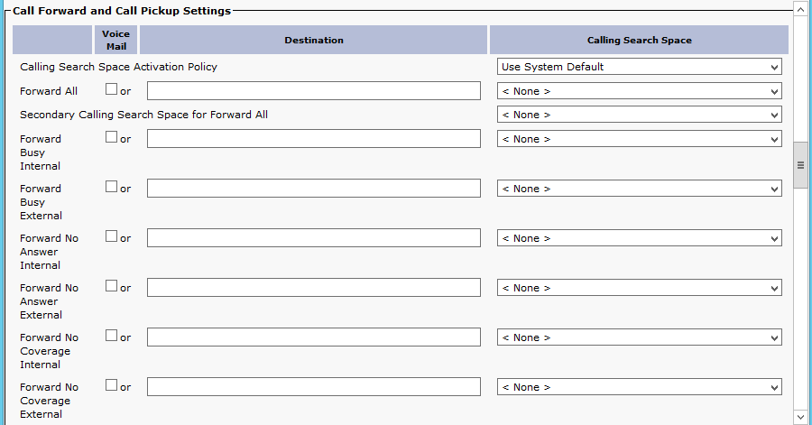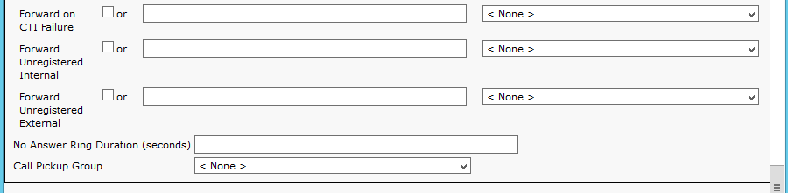

Cisco IP Phone 7975 SCCP Configuration (Continued…)
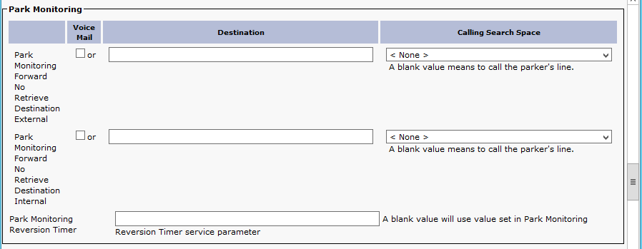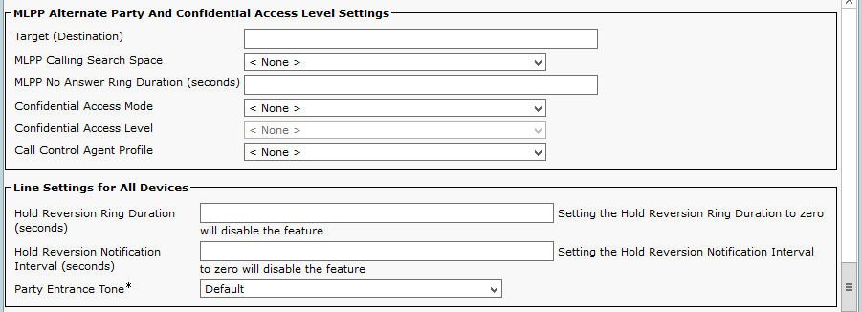

Cisco IP Phone 7975 SCCP Configuration (Continued…)
Set Display (caller ID) = 7322162753. This is used in this example.
Set ASCII Display (caller ID) = Cisco7975-Phone 1. This is used in this example.
Set Line Text Label = Cisco7975-Phone 1. This is used in this example.
Set External Phone Number Mask = 7323204350. This is used in this example.
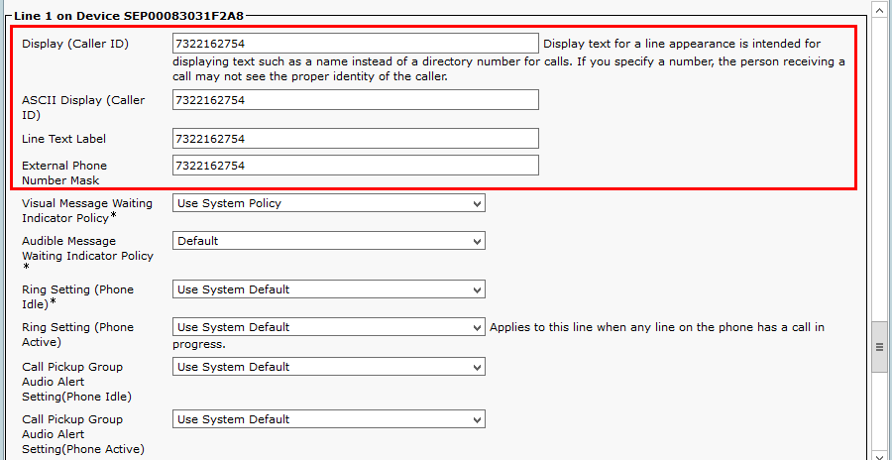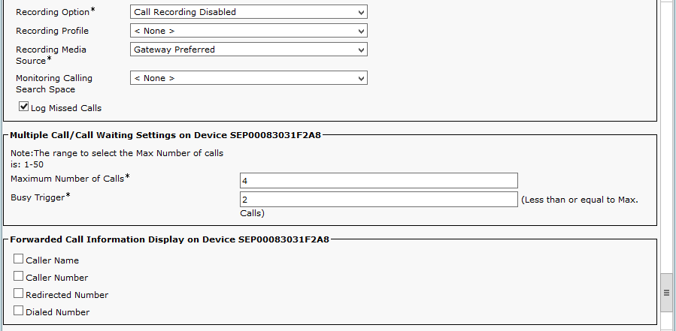

Cisco IP Phone 9971 SIP Configuration

Set MAC Address* = the below mac is used in this example.
Set Description = SIP-2753. This text is used to identify this Phone.
Set Device Pool*= G729. This is used in this example.
Set Phone Button Template*= Standard 9971 SIP. This is used in this example. Set Media Resource Group List = MRGL_MTP. This is used in this example.
Set User Hold MOH Audio Source = 1-SampleAudioSource.
Set Network Hold MOH Audio Source = 1-SampleAudioSource
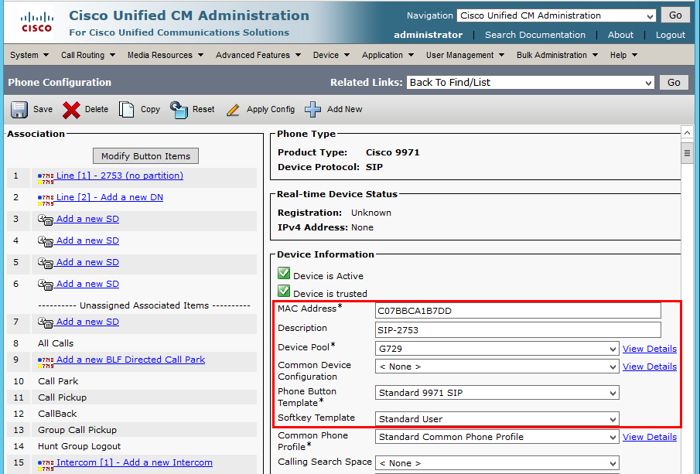
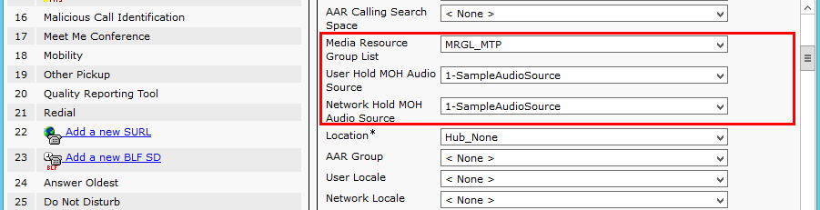
Cisco IP Phone 9971 SIP Configuration(Continued…)
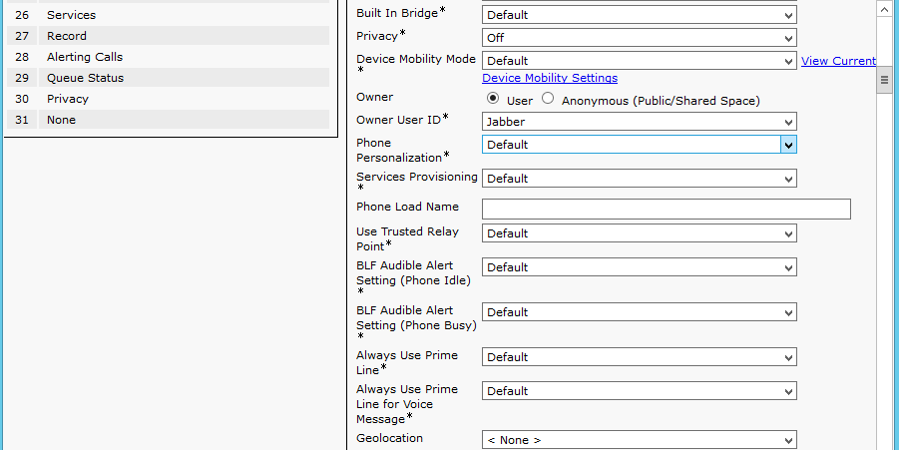
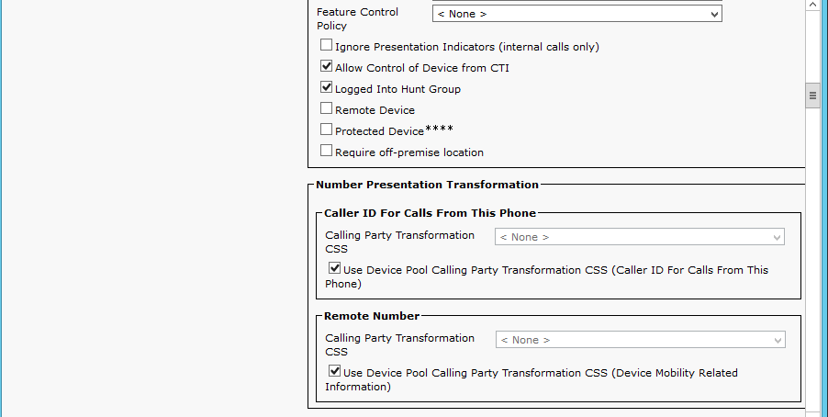

Cisco IP Phone 9971 SIP Configuration(Continued…)

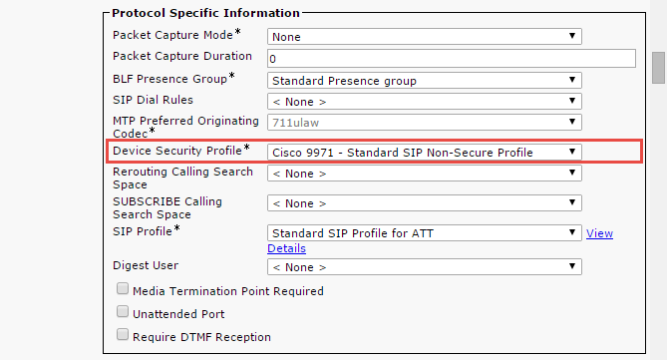
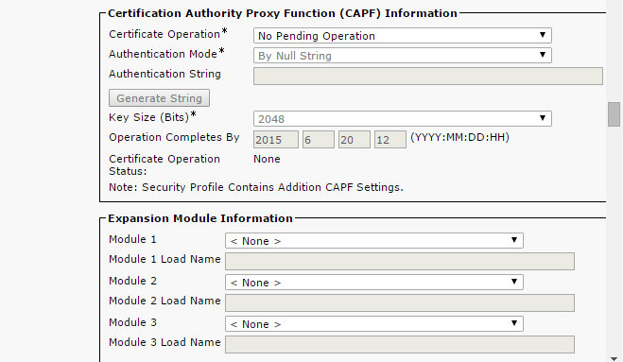
Cisco IP Phone 9971 SIP Configuration(Continued…)
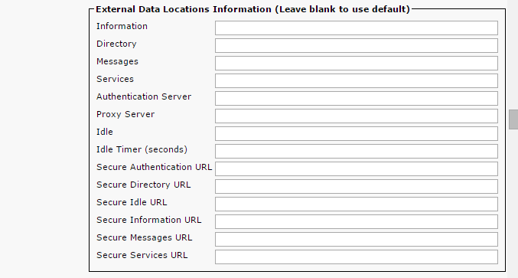
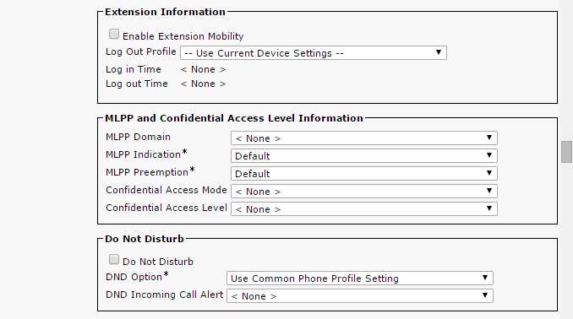

Cisco IP Phone 9971 SIP Configuration(Continued…)
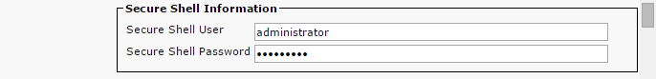
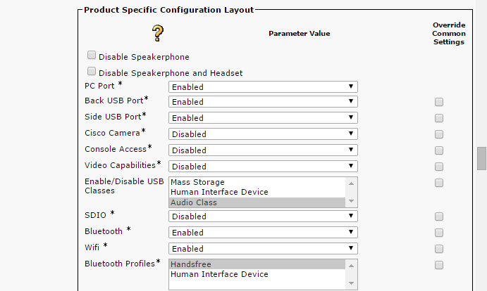
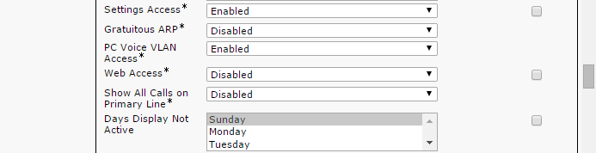

Cisco IP Phone 9971 SIP Configuration(Continued…)
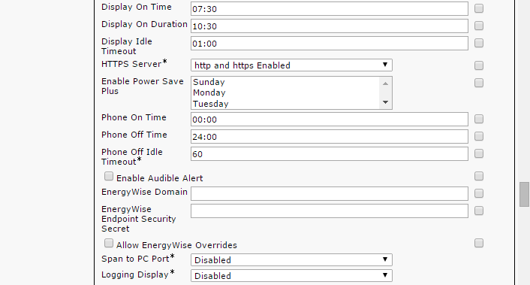
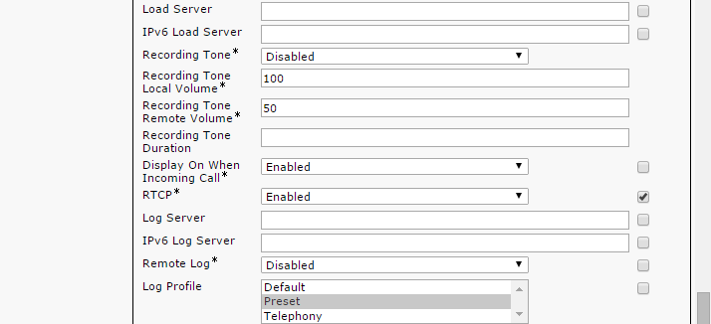

Cisco IP Phone 9971 SIP Configuration (Continued…)
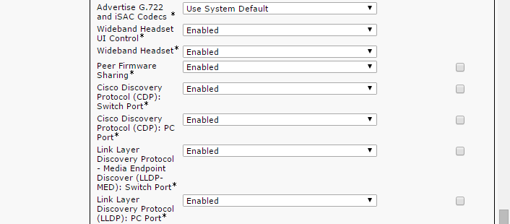
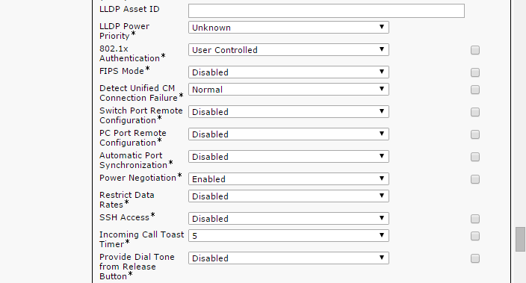

Cisco IP Phone 9971 SIP Configuration (Continued…)
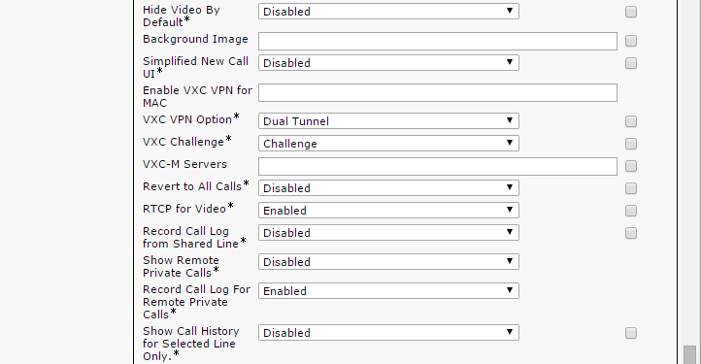
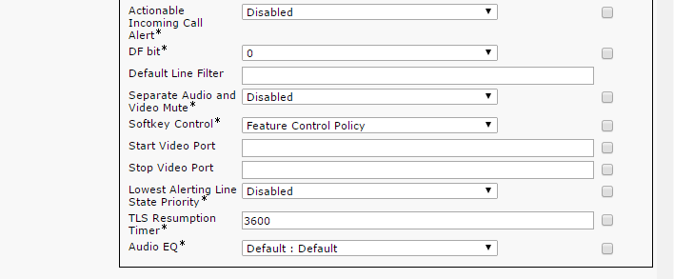

Cisco IP Phone 9971 SIP Configuration (Continued…)
Set Directory Number* = 2753. This is used in this example.
Set Description = 7322162753. This is used in this example.
Set Alerting Name = 7322162753. This is used in this example.
Set ASCII Alerting Name = 7322162753. This is used in this example.
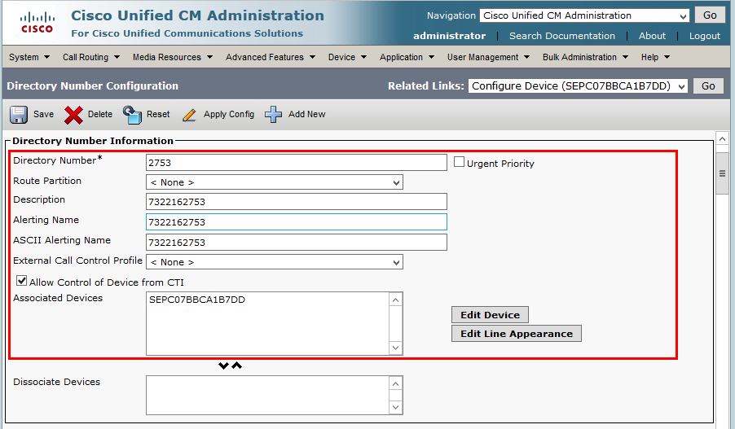
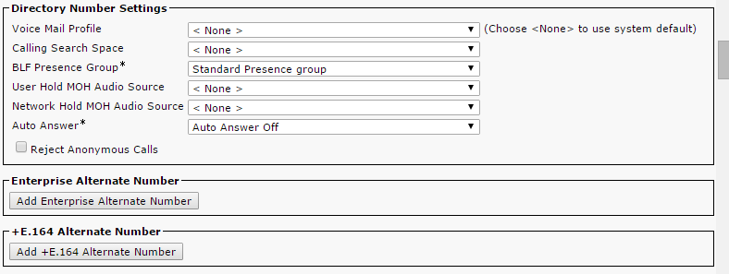

Cisco IP Phone 9971 SIP Configuration (Continued…)

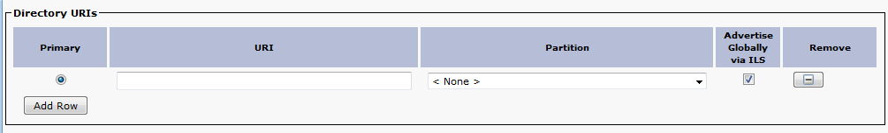
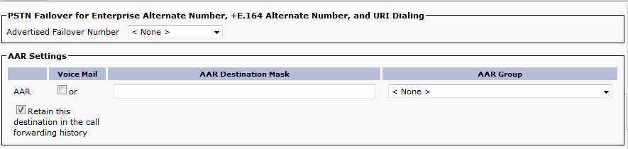
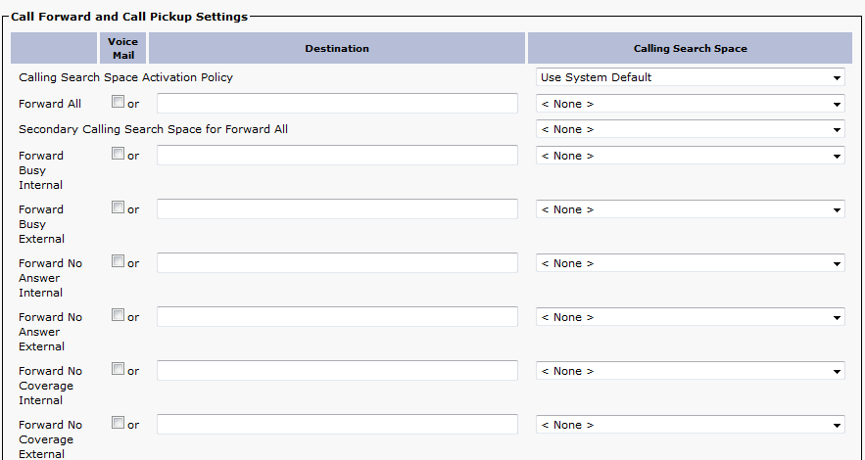

Cisco IP Phone 9971 SIP Configuration (Continued…)

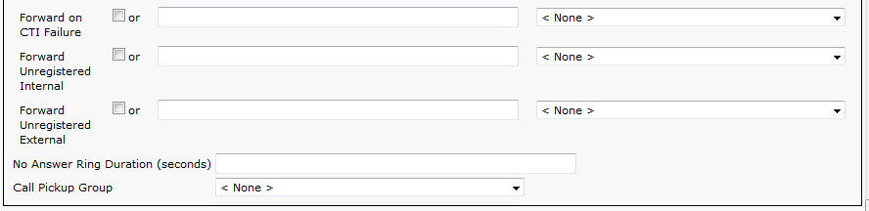
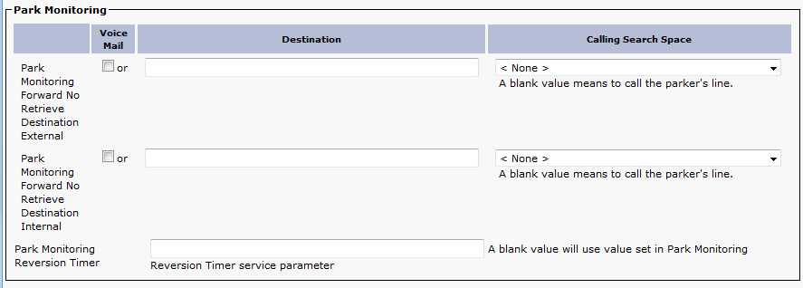
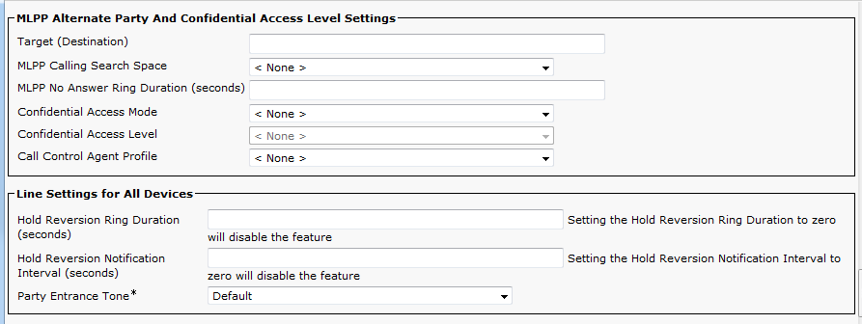

Cisco IP Phone 9971 SIP Configuration (Continued…)
Set Display (caller ID) = 7322162753. This is used in this example.
Set ASCII Display (caller ID) = 7322162753. This is used in this example.
Set Line Text Label = 7322162753. This is used in this example.
Set External Phone Number Mask = 7322162753. This is used in this example.
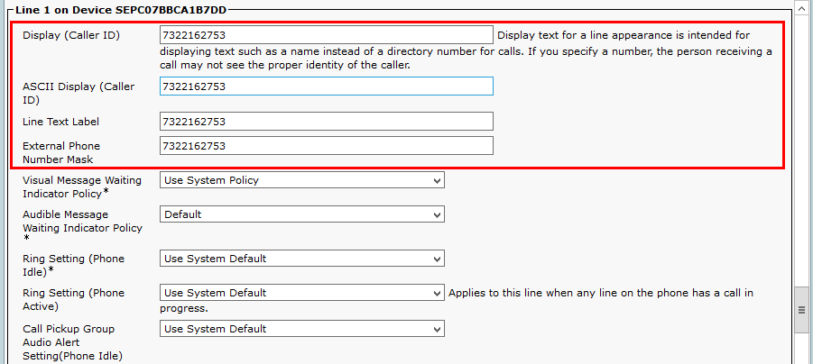
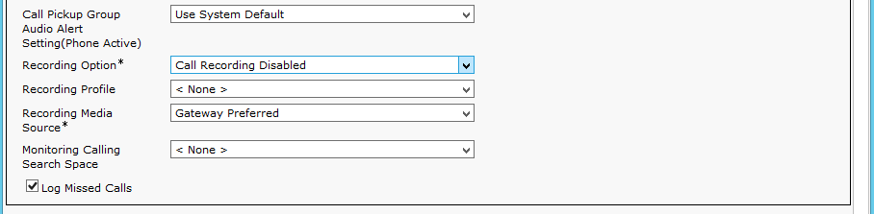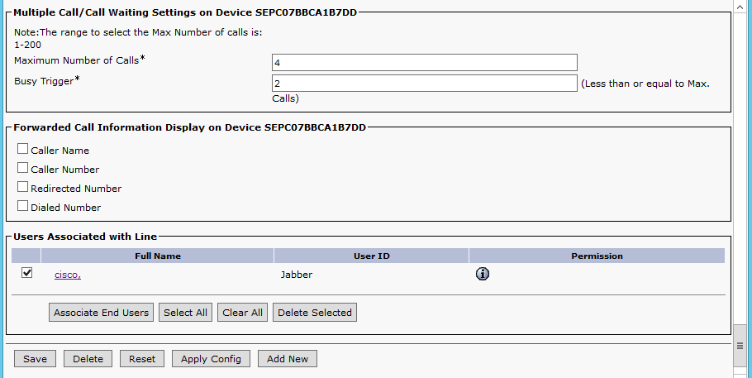

SIP Trunk Security Profile Configuration used by SIP trunk to Cisco UBE
Navigation: System Security SIP Trunk Security Profile
Set Name* = ATT Non Secure SIP Trunk Profile. This is used in this example.
Set Description = Non Secure SIP Trunk Profile authenticated by null String. This is used in this example.
Set Device Security Mode = Non Secure.
Set Incoming Transport Type* = TCP+UDP.
Set Outgoing Transport Type = UDP.

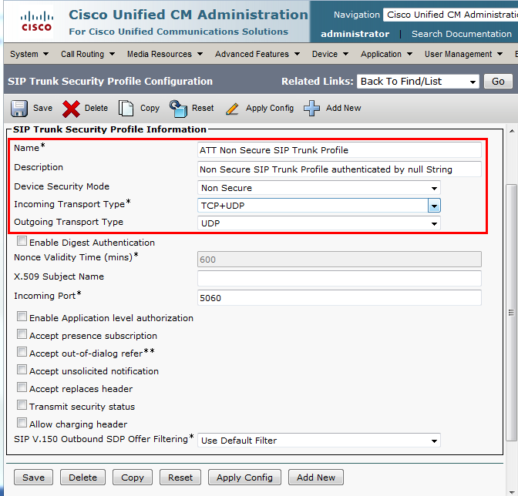

SIP Profile Configuration used by SIP trunk to Cisco UBE
Navigation: Device Device Settings SIP Profile
Set SIP profile Name * = Standard SIP Profile w/Early Media Disabled. This is used for this example
Check Disable Early Media on 180
Set SIP Rel1xx Options* = Send PRACK if 1xx contains SDP
Note*= Some PSTN network call prompters utilize early-media cut-through to offer menu options to the caller (DTMF select menu) before the call is connected. In order for Cisco UCM/Cisco UBE solution to achieve successful early-media cut-through, the Cisco UCM to Cisco UBE call leg must be enabled with SIP PRACK. To enable SIP PRACK on the Cisco UCM, the SIP Profile “SIP Rel1XX Options” setting must be set to “Send PRACK”.

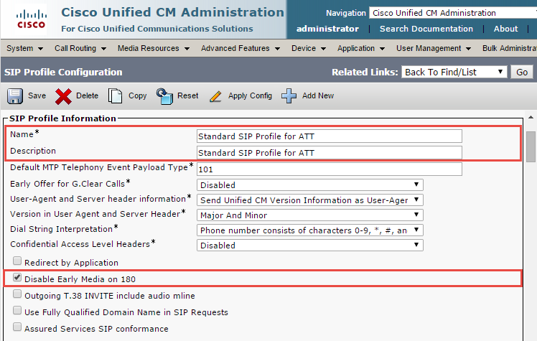

SIP Profile Configuration used by SIP trunk to Cisco UBE (Continued…)

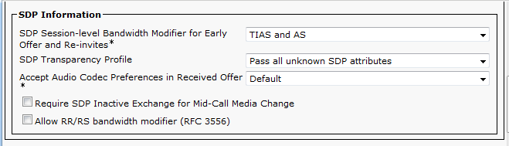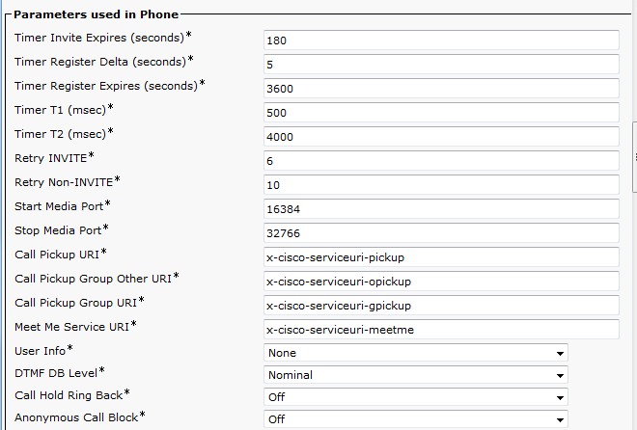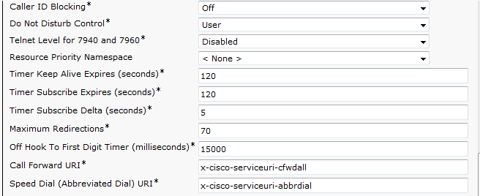
SIP Profile Configuration used by SIP trunk to Cisco UBE (Continued…)

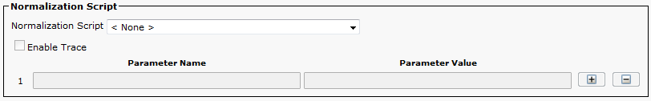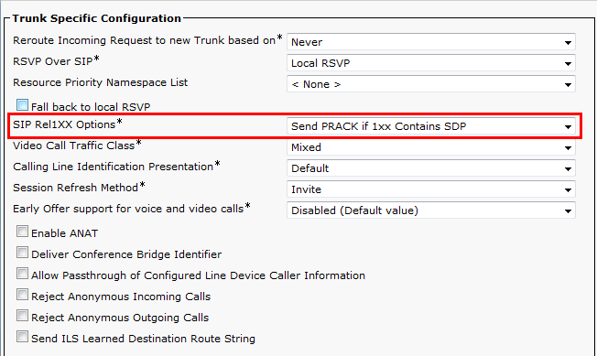

SIP Profile Configuration used by SIP trunk to Cisco UBE (Continued…)
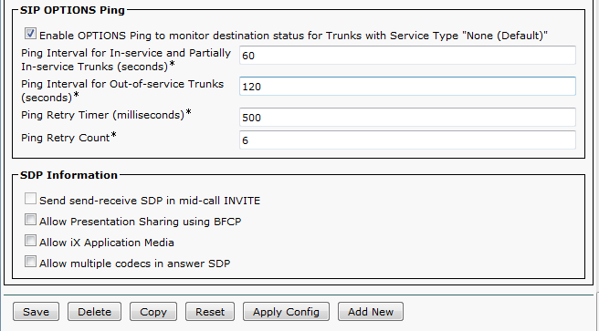

SIP Trunk to Cisco UBE Configuration
Navigation: Device Trunk
Set Device Name* = ATT_SIP_TRUNK. This is used for this example
Set Description = ATT SIP Trunk to PSTN. This is used for this example
Set Device Pool* = G729_pool. This is used for this example
Set Media Resource Group List = MRGL_MTP.

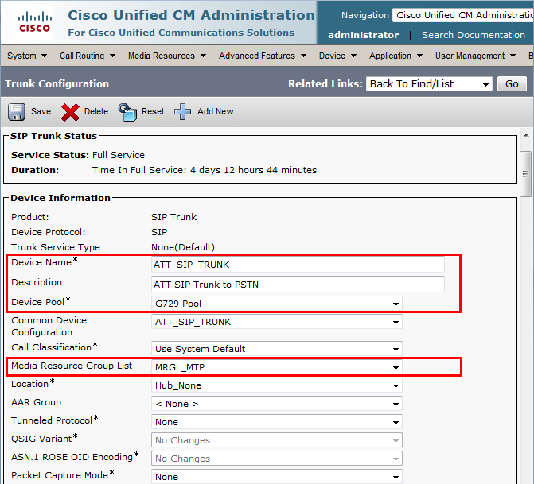

SIP Trunk to Cisco UBE Configuration (Continued…)
Set Significant Digits* = 4. This is used in this example.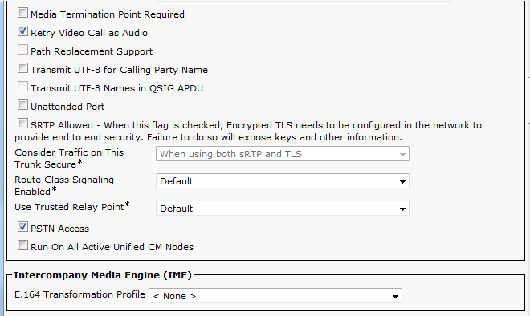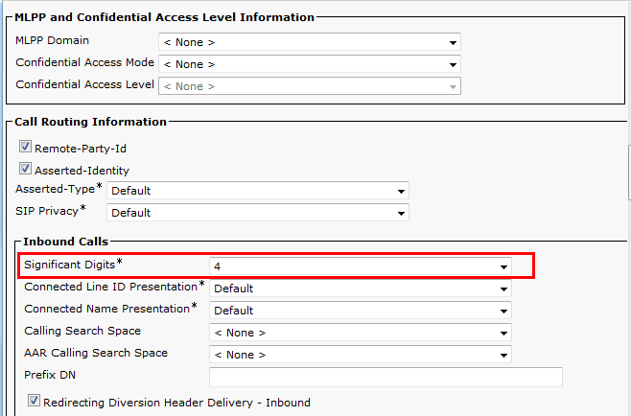
SIP Trunk to Cisco UBE Configuration (Continued…)
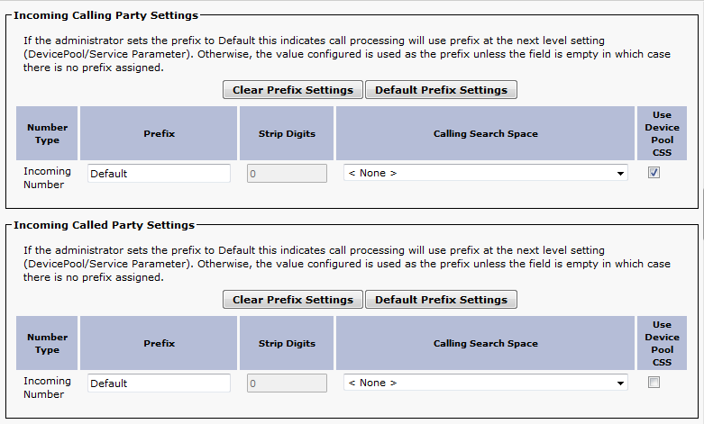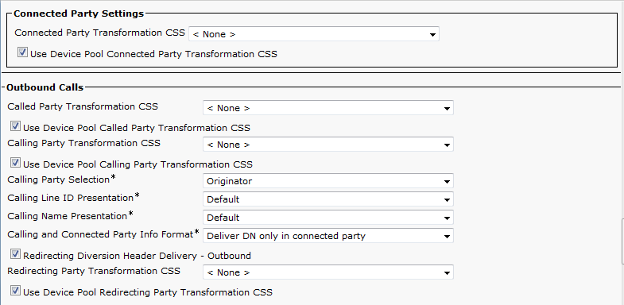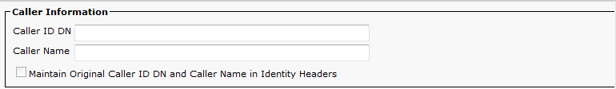

SIP Trunk to Cisco UBE Configuration (Continued…)
Set Destination Address = Set IP address of ISR-Cisco UBE.
Set SIP Trunk Security Profile* = ATT_Non Secure Sip Trunk Profile.
Set SIP Profile* = Standard SIP Profile w/Early Media Disabled. This is used in this example.
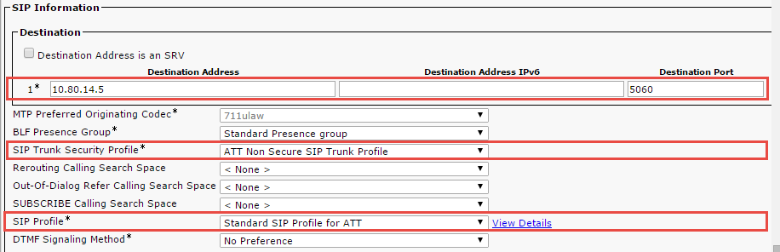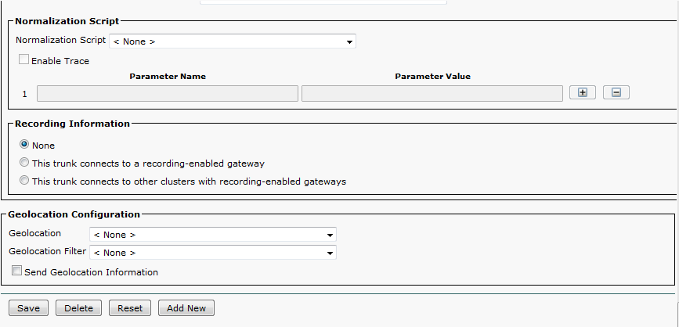

SIP Trunk to Fax Gateway Configuration.
Navigation: Device Trunk
Set Device Name* = Trunk_SIP_FAX_Gateway. This is used for this example
Set Description = Trunk_SIP_FAX_Gateway. This is used for this example
Set Device Pool* = G729 pool. This is used for this example
Set Media Resource Group List = MRGL_MTP.
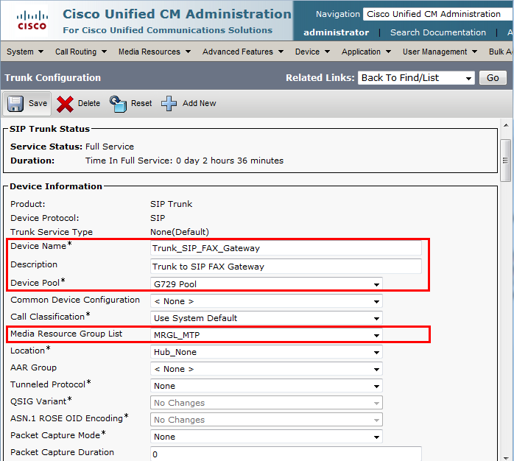

SIP Trunk to Fax Gateway Configuration (Continued…)
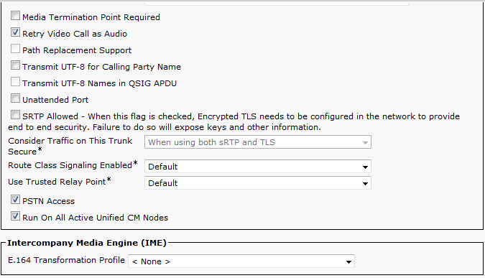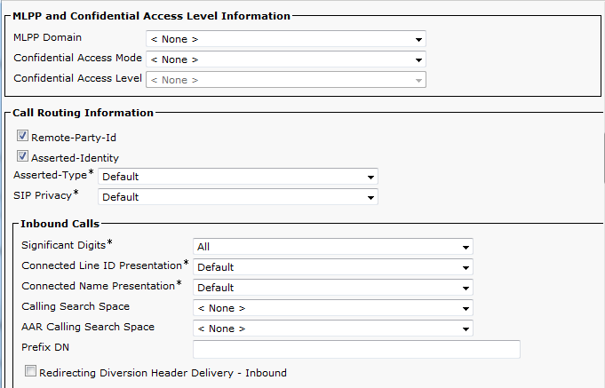
SIP Trunk to Fax Gateway Configuration (Continued…)
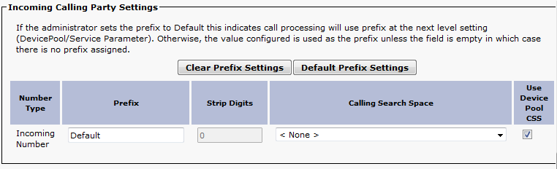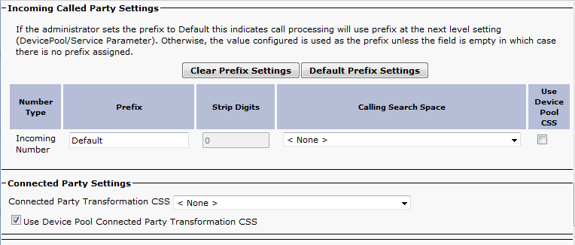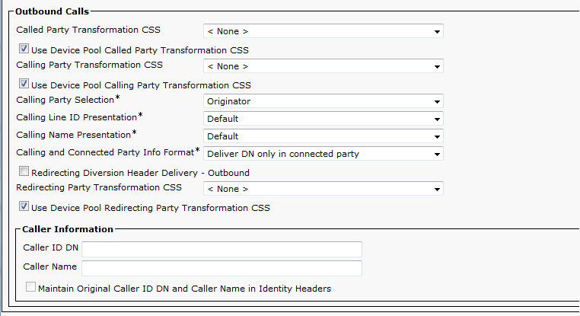
SIP Trunk to Fax Gateway Configuration (Continued…)
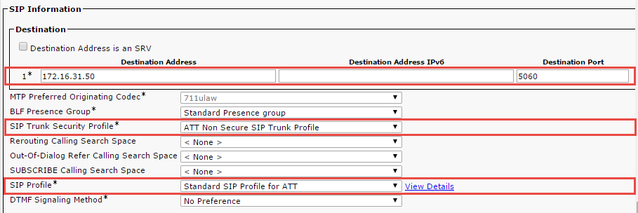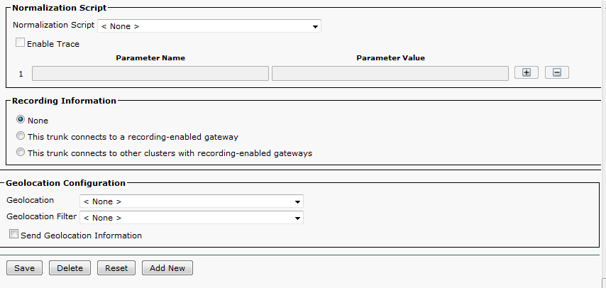

Route Pattern Configuration
Navigation: Call Routing Route/Hunt Route Pattern

Set Route Pattern* = 9. @ This is used to route to AT&T via ISR Cisco UBE.
Set Description = To PSTN via ATT SIP Trunk. This text is used to identify this Route Pattern.
Set Gateway/Route List* = ATT_SIP_TRUNK. This is used for this example.
All other values are default

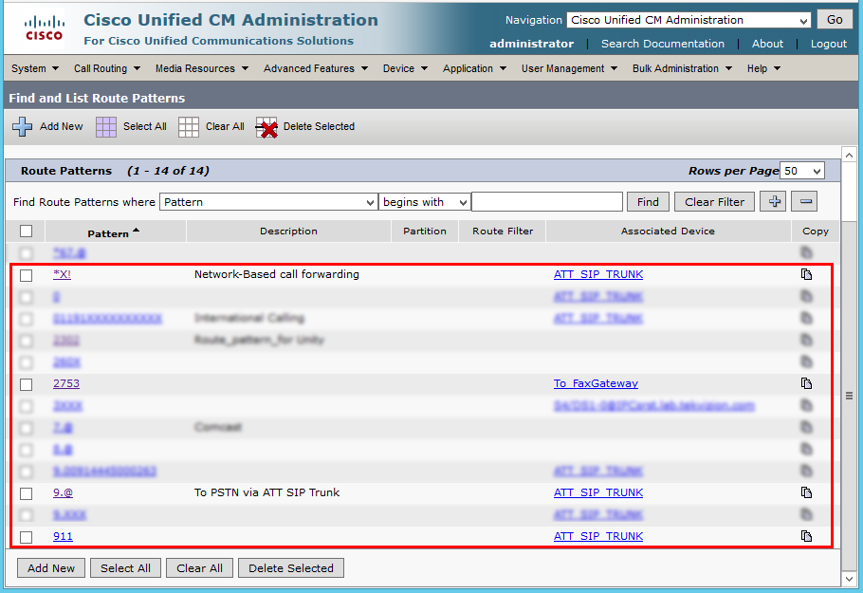

Route Pattern Configuration (Continued…)
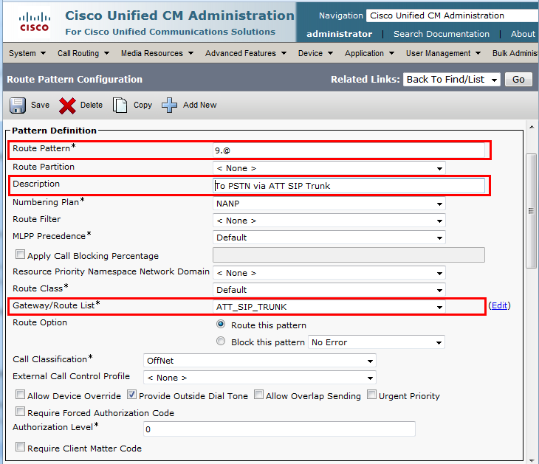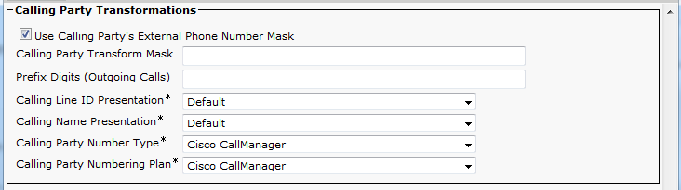

Route Pattern Configuration (Continued…)
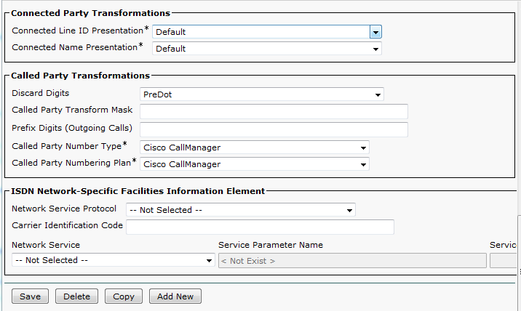

Route Pattern Configuration (Continued…)
Set Route Pattern* = *X! This is used to route to AT&T via ISR Cisco UBE.
Set Description = Network-Based Call Forwarding. This text is used to identify this Route Pattern.
Set Gateway/Route List* = ATT_SIP_TRUNK. This is used for this example.
All other values are default
Note: This Route pattern is used to Activate/De-activate Network Based Call Forwarding Features.
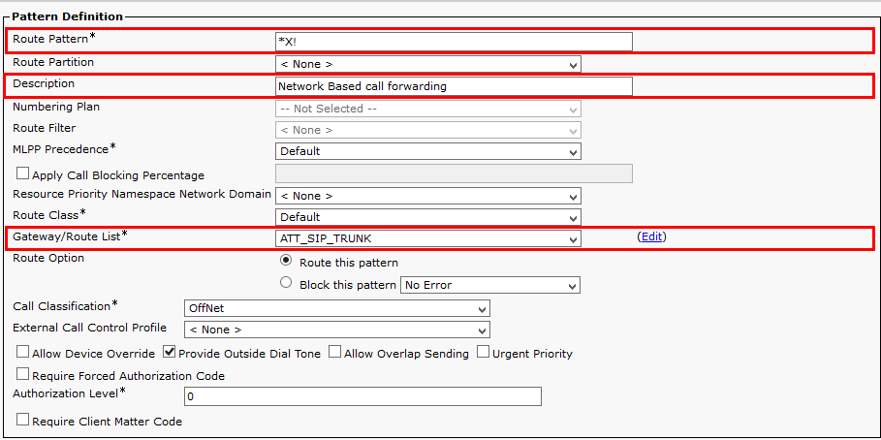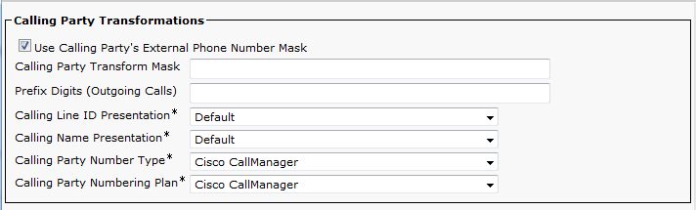

Route Pattern Configuration (Continued…)
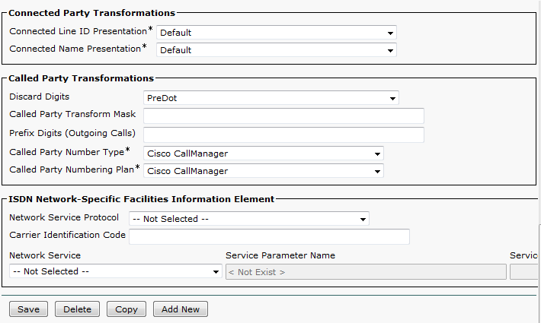

Route Pattern Configuration (Continued…)
Set Route Pattern* = 2753 this is used to route to Fax Client via Fax Gateway.
Set Description = To Fax Gateway. This text is used to identify this Route Pattern.
Set Gateway/Route List* = To_FaxGateway. This is used for this example.
All other values are default
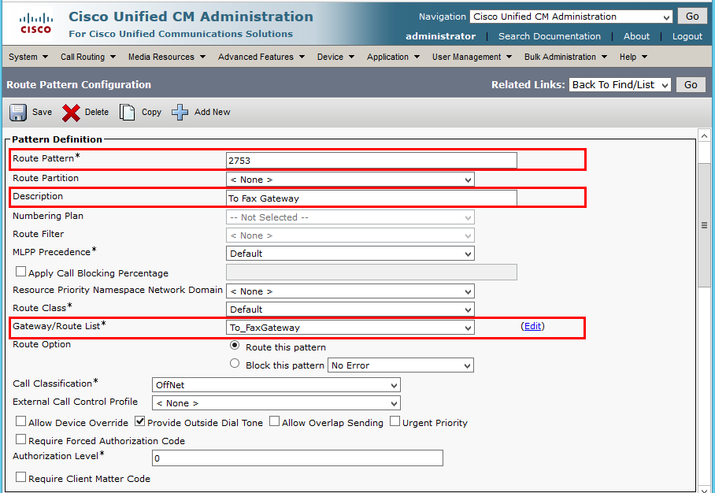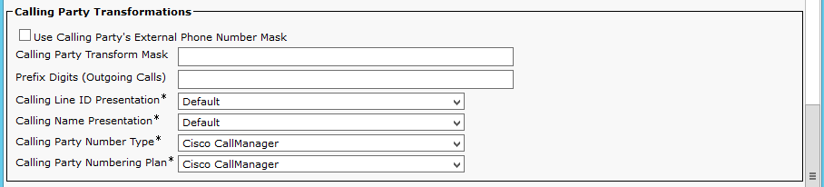

Route Pattern Configuration (Continued…)
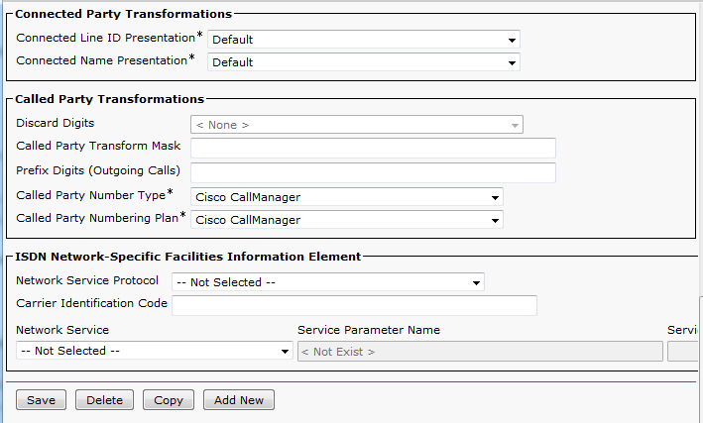

Jabber Client Configuration
Navigation: Device Phone
Select Phone Type* = Cisco Unified Client services framework
Set Device Name* = CSFUser1. This is used in this example.
Set Description = CSFUser1. This is used in this example.
Select Device Pool = G729. This is used in this example.
Select Phone Button Template* = Standard Client Services Framework.
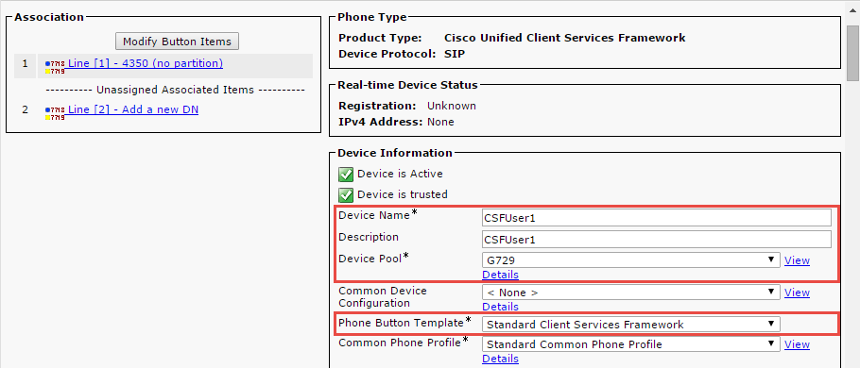

Jabber Client Configuration (Contd…)
Media Resource Group List = MRGL_MTP
Set Owner check box
Set Owner user ID* = jabber1. This is used for this example
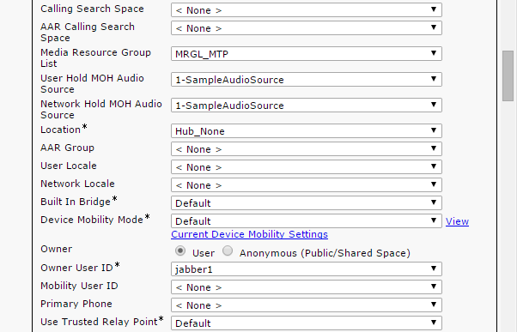
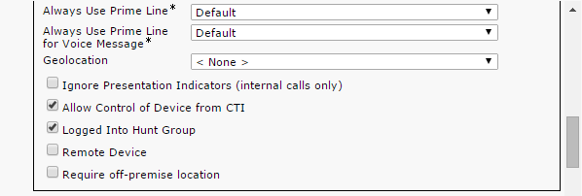

Jabber Client Configuration (Contd…)
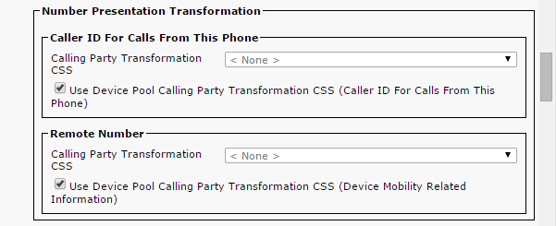
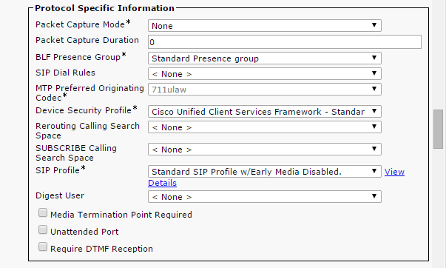

Jabber Client Configuration (Contd…)

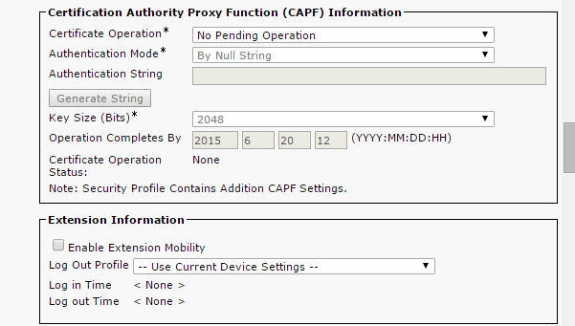
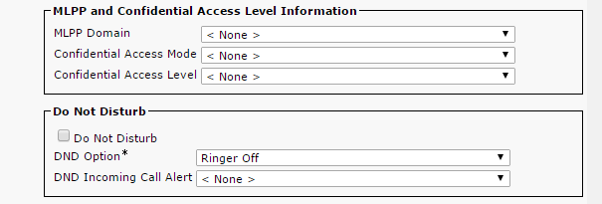

Jabber Client Configuration (Contd…)
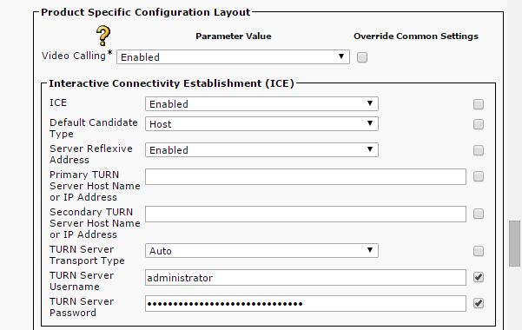

Jabber Client Configuration (Contd…)
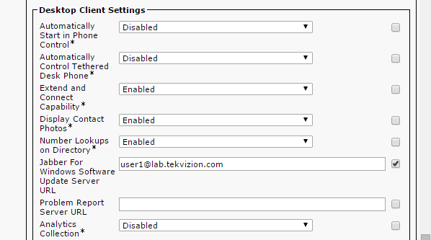

Voicemail Port Configuration
Navigation: Advanced Feature Voice Mail Cisco Voice Mail Port
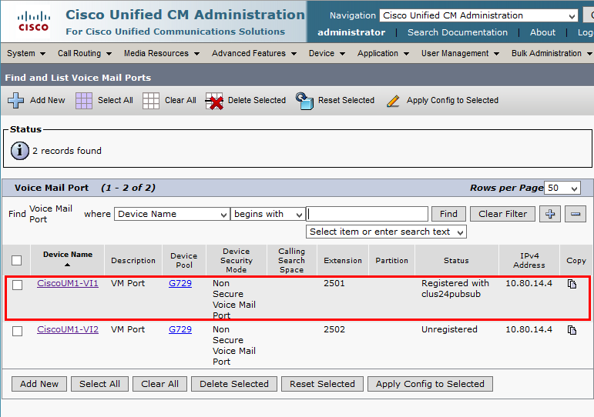

Voicemail Port Configuration (Continued…)
Set Port Name = CiscoUM1-VI1. This is used for this example.
Set Description = VM Port. This is used for this example.
Set Device Pool = G729
Set Directory Number* = 2501. This is used in this example.

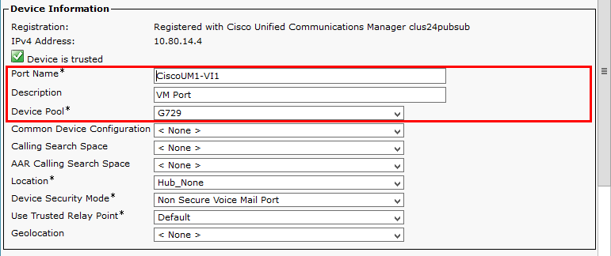
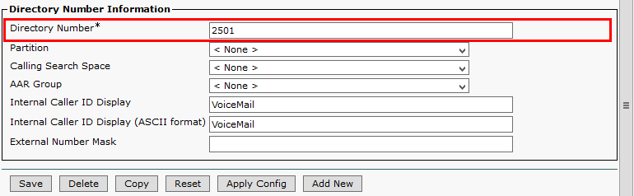

Voicemail Pilot Configuration
Navigation: Advanced Features Voice Mail Voice Mail Pilot
Set Voice mail Pilot Number = 2303. This is used for this example
Set Description = VoiceMail Pilot number with SIP
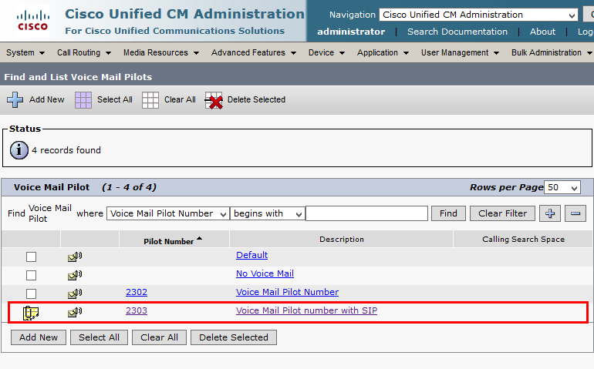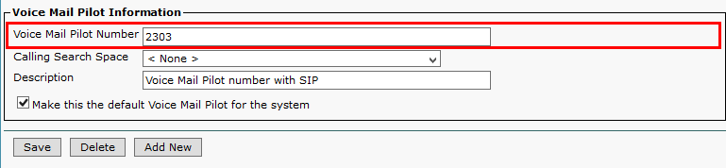

FAX Gateway Configuration

cme.in.tekvizion.com#sh version
Cisco IOS Software, 2800 Software (C2800NM-IPVOICEK9-M), Version 15.1(4)M5, RELEASE SOFTWARE (fc1)
Technical Support: http://www.cisco.com/techsupport
Copyright (c) 1986-2012 by Cisco Systems, Inc.
Compiled Tue 04-Sep-12 15:56 by prod_rel_team

ROM: System Bootstrap, Version 12.4(13r)T, RELEASE SOFTWARE (fc1)

cme.in.tekvizion.com uptime is 1 day, 5 hours, 59 minutes
System returned to ROM by reload at 14:27:25 IST Sun Jan 10 2016
System image file is "flash:c2800nm-ipvoicek9-mz.151-4.M5.bin"
Last reload type: Normal Reload

This product contains cryptographic features and is subject to United
States and local country laws governing import, export, transfer and
use. Delivery of Cisco cryptographic products does not imply
third-party authority to import, export, distribute or use encryption.
Importers, exporters, distributors and users are responsible for
compliance with U.S. and local country laws. By using this product you
agree to comply with applicable laws and regulations. If you are unable
to comply with U.S. and local laws, return this product immediately.

A summary of U.S. laws governing Cisco cryptographic products may be found at:
http://www.cisco.com/wwl/export/crypto/tool/stqrg.html

If you require further assistance please contact us by sending email to
export@cisco.com.

Cisco 2851 (revision 1.0) with 249856K/12288K bytes of memory.
Processor board ID FHK1137F4LY
2 Gigabit Ethernet interfaces
62 Serial interfaces
2 terminal lines
2 Channelized E1/PRI ports
4 Voice FXS interfaces
2 cisco service engine(s)
DRAM configuration is 64 bits wide with parity enabled.
239K bytes of non-volatile configuration memory.
62720K bytes of ATA CompactFlash (Read/Write)

License Info:

License UDI:

-------------------------------------------------
Device# PID SN
-------------------------------------------------
*0 CISCO2851 FHK1137F4LY

Configuration register is 0x2102

cme.in.tekvizion.com#sh running-config
Building configuration...

Current configuration : 7689 bytes
!
! Last configuration change at 14:02:24 IST Mon Mar 28 2016 by cisco
version 15.1
service timestamps debug datetime msec
service timestamps log datetime msec
no service password-encryption
!
hostname cme.in.tekvizion.com
!
boot-start-marker
boot-end-marker
!
!
enable password tekV1z10n
!
aaa new-model
!
!
aaa authentication login local_auth local
!
!
!
!
!
aaa session-id common
clock timezone IST 5 30
network-clock-participate wic 2
network-clock-participate wic 3
!
dot11 syslog
ip source-route
!
!
ip cef
!
!
!
ip host Clus1-862-Pub 172.16.26.2
no ipv6 cef
multilink bundle-name authenticated
!
!
!
!
isdn switch-type primary-qsig
!
!
voice rtp send-recv
!
voice service pots
!
voice service voip
no ip address trusted authenticate
allow-connections sip to sip
redirect ip2ip
fax protocol t38 version 0 ls-redundancy 0 hs-redundancy 0 fallback none
sip
midcall-signaling passthru
g729 annexb-all
!
voice class codec 2
codec preference 1 g711alaw
codec preference 2 g729r8
!
voice class codec 1
codec preference 1 g729r8
codec preference 2 g711alaw
!

!
voice class sip-profiles 1
response ANY sip-header Allow-Header modify "UPDATE," ""
request ANY sip-header Allow-Header modify "UPDATE," ""
response ANY sip-header Allow-Header modify "UPDATE," ""
response ANY sip-header Allow-Header modify "UPDATE," ""
!
!
!
!
!
voice-card 0
!
crypto pki token default removal timeout 0
!
!
!
!
license udi pid CISCO2851 sn FHK1137F4LY
username cisco password 0 tekV1z10n
!
!
controller E1 0/2/0
pri-group timeslots 1-31 service mgcp
!
controller E1 0/3/0
clock source internal
pri-group timeslots 1-31
!
ip tftp source-interface GigabitEthernet0/0
!
!
!
!
!
!
!
!
!
interface GigabitEthernet0/0
ip address 172.16.31.50 255.255.255.0
duplex auto
speed auto
!
interface Service-Engine0/0
no ip address
shutdown
!
interface GigabitEthernet0/1
no ip address
ip nat outside
ip virtual-reassembly in
shutdown
duplex auto
speed auto
!
interface Serial0/2/0:15
no ip address
encapsulation hdlc
isdn switch-type primary-qsig
isdn timer T310 120000
isdn protocol-emulate network
isdn incoming-voice voice
isdn map address .* plan isdn type national
isdn bind-l3 ccm-manager
isdn send-alerting
isdn sending-complete
no cdp enable
!
interface Serial0/3/0:15
no ip address
encapsulation hdlc
isdn switch-type primary-qsig
isdn timer T310 120000
isdn protocol-emulate network
isdn incoming-voice voice
no cdp enable
!
interface Service-Engine1/0
no ip address
shutdown
!
ip forward-protocol nd
!
ip http server
no ip http secure-server
!
ip route 0.0.0.0 0.0.0.0 172.16.31.1
ip route 0.0.0.0 0.0.0.0 172.16.29.1
!
!
snmp-server community public RO
snmp-server location Chennai
!
!
!
!
!
control-plane
!
!
voice-port 0/0/0
ring frequency 50
no echo-cancel enable
no vad
cptone IN
station-id name fax test
station-id number 7322162753
caller-id enable
!
voice-port 0/0/1
no vad
shutdown
!
voice-port 0/3/0:15
!
voice-port 0/2/0:15
!
voice-port 0/1/0
no vad
shutdown
!
voice-port 0/1/1
no vad
shutdown
!
no mgcp timer receive-rtcp
mgcp behavior rsip-range tgcp-only
mgcp behavior comedia-role none
mgcp behavior comedia-check-media-src disable
mgcp behavior comedia-sdp-force disable
!
mgcp profile default
!
!
!
!
!
!
dial-peer voice 110 pots
service session
destination-pattern 2753
no digit-strip
port 0/0/0
forward-digits all
!
dial-peer voice 200 voip
description CUCM to Gateway
service session
session protocol sipv2
session transport udp
incoming called-number 2753
voice-class codec 1
voice-class sip profiles 1
dtmf-relay rtp-nte
fax rate 14400
fax protocol t38 version 0 ls-redundancy 0 hs-redundancy 0 fallback none
no vad
!
dial-peer voice 201 voip
description Gateway to CUCM
service session
destination-pattern 9T
session protocol sipv2
session target ipv4:10.80.14.2
session transport udp
voice-class codec 1
voice-class sip profiles 1
dtmf-relay rtp-nte
fax rate 14400
fax protocol t38 version 0 ls-redundancy 0 hs-redundancy 0 fallback none
no vad
!
!
gateway
timer receive-rtp 1200
!
sip-ua
credentials username +19728522671 password 7 11584B5643475D realm bsrhelas.lab.tekvizion.com
no remote-party-id
retry register 5
timers connection aging 30
timers update 1000
no timers hold
timers register 1000
protocol mode dual-stack
!
!
telephony-service
max-ephones 50
max-dn 60
ip source-address 172.16.31.50 port 2000
service phone sshAccess 0
cnf-file perphone
max-conferences 8 gain -6
web admin system name Administrator password tekV1z10n
transfer-system full-consult
create cnf-files version-stamp 7960 Nov 22 2013 19:05:58
!
!
ephone-dn 1
!
!
ephone-dn 2
!
!
ephone-dn 5
!
!
ephone-dn 6 dual-line
!
!
ephone-dn 10
!
!
ephone 1
mac-address 001D.A21A.3577
type 7961
button 1:1
!
!
!
ephone 2
mac-address 001D.A21A.291D
type 7961
button 1:2
!
!
!
ephone 5
mac-address 0008.21DF.CEC5
type 7940
ssh userid cisco password cisco
button 1:5
!
!
!
ephone 6
!
!
!
ephone 10
mac-address 0C27.2431.5FB9
button 1:10
!
!
!
banner login ^CC
=================================================
WELCOME to CISCO CME 8.6
=================================================

Cisco IOS Software (C2800NM-IPVOICEK9-M)
Version 15.1(4)M5, RELEASE SOFTWARE (fc1)
Cisco 2851 with 249856K/12288K bytes of memory
Processor board ID FHK1137F4LY
2 Gigabit Ethernet interfaces
2 terminal lines
2 Voice FXS interfaces
2 cisco service engine(s)
239K bytes of non-volatile configuration memory
62720K bytes of ATA CompactFlash (Read/Write)

Warning: Access is restricted.
All user activity is logged!
For support, contact 'kkumaraguru@tekvizion.com'
=================================================
^C
!
line con 0
line aux 0
line 66
no activation-character
no exec
transport preferred none
transport input all
transport output pad telnet rlogin lapb-ta mop udptn v120 ssh
line 194
no activation-character
no exec
transport preferred none
transport input all
transport output all
line vty 0 4
session-timeout 180
exec-timeout 0 0
password tekV1z10n
login authentication local_auth
transport input all
!
scheduler allocate 20000 1000
ntp server 103.6.16.254
end

Cisco UCM SCCP Integration with Cisco Unity Connection (CUC)

CUC Version

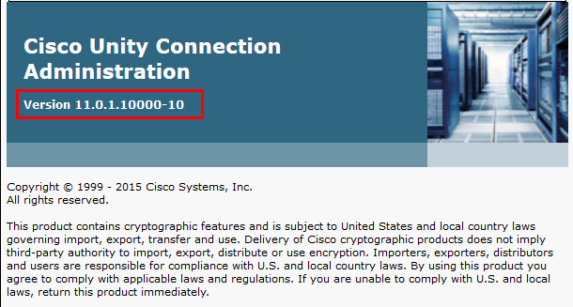

CUC Telephony Integration with Cisco UCM
Navigation: Telephony Integrations Phone system
Set Phone System Name* = SIP. This is used for this example

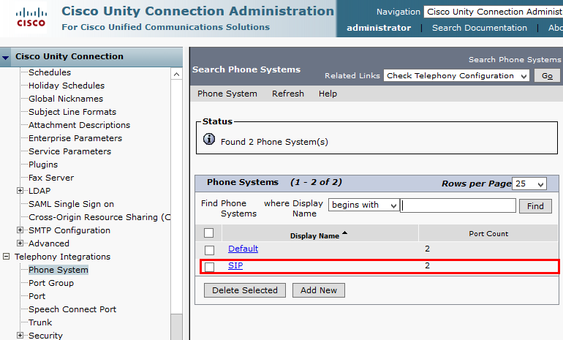

CUC Port Group
Navigation: Telephony Integration Port Group
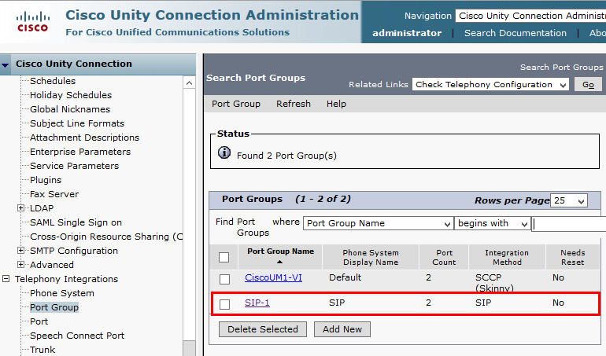

CUC Port Group(continued…)

Set Display Name* = SIP-1. This is used in this example.
Check Register with SIP Server.
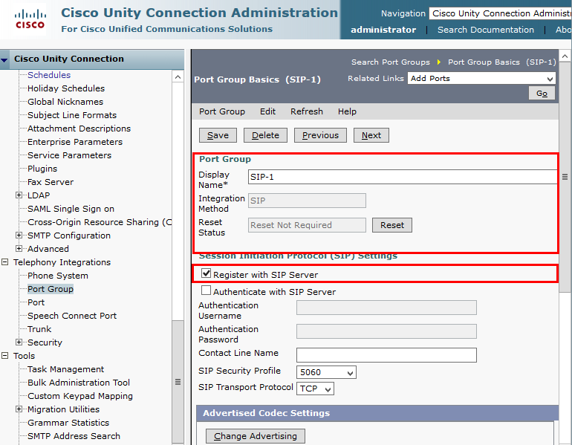

CUC Port Settings

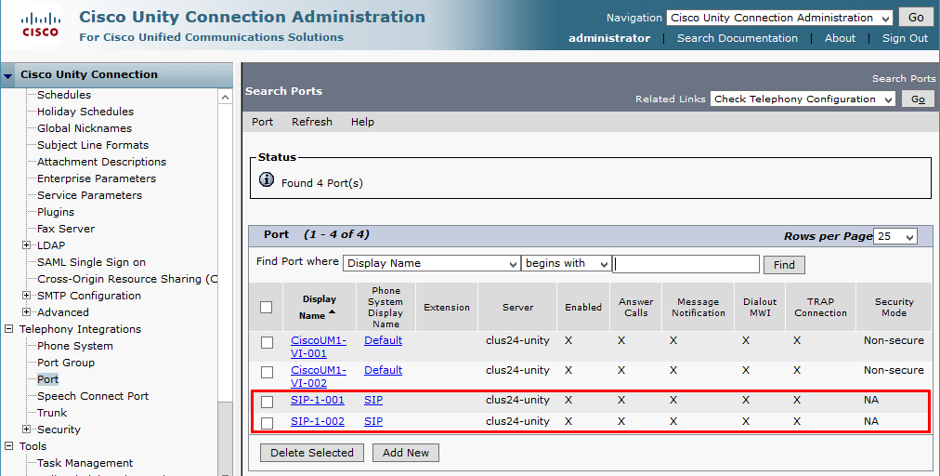

CUC Sample User Basic Settings
Navigation: Cisco Unity connection Users Users
Set Alias = 4051.This is one of the extension used for this testing.
Set Extension = 4051. This is used for this example.

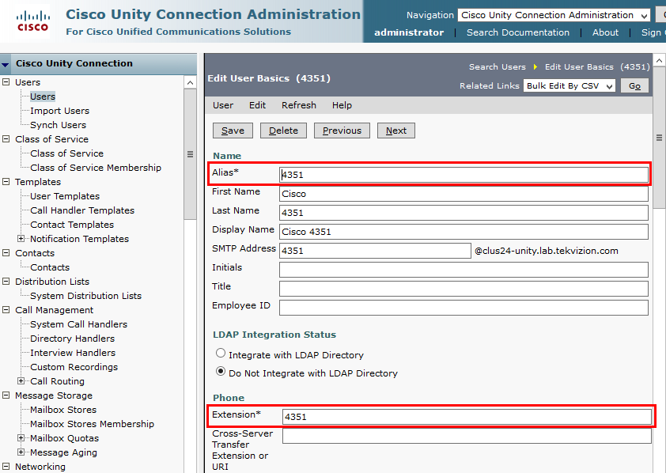

CUC Sample User Basic Settings (Continued…)
Set Partition = clus24-unity partition. This is used for this example.
Select Search Scope = clus24-unity Search Scope.
Select Phone System = SIP.

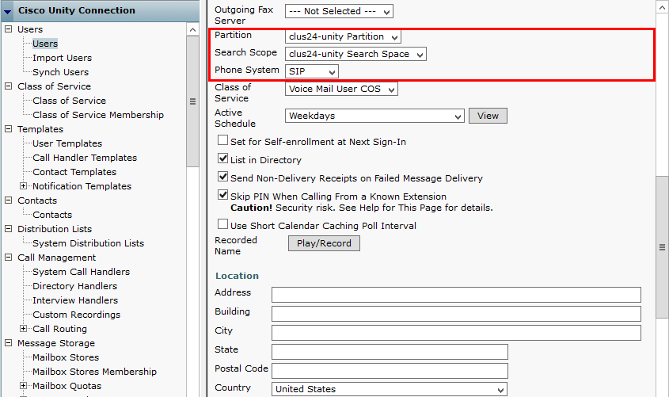
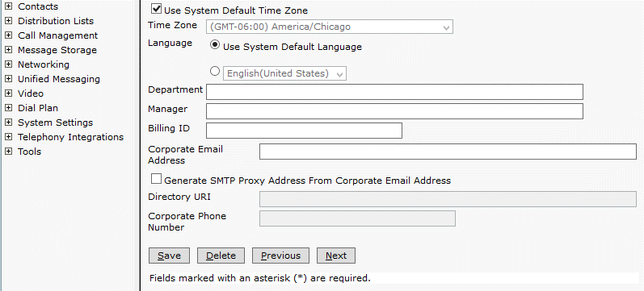

Auto Attendant
Navigation: Call Management System Call Handlers

Set Display Name = Demo auto attend. This is used for this example.
Set Phone System = SIP
Set Extension=2999. This number is used as Auto attendant on this set up.
Set Partition = Clus24-unity Partition. This is used for this example.

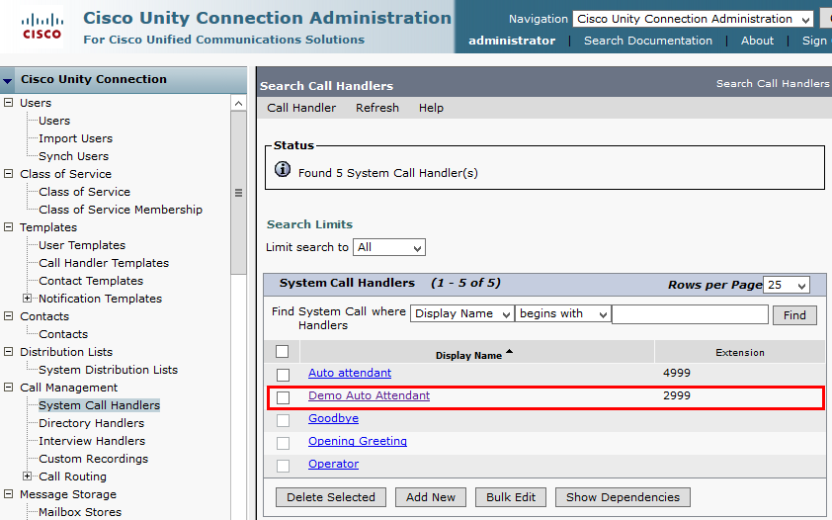

Auto Attendant (Continued…)
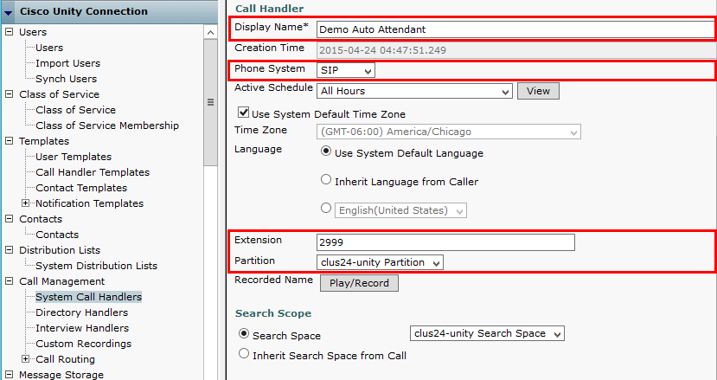

Cisco UCM Integration with Cisco Unified CM IM and Presence (CUP/IMP)

CUP/IMP Version
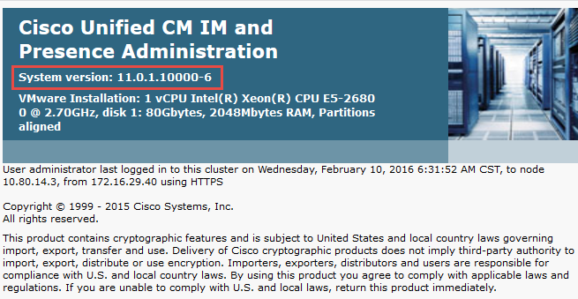

Presence Topology
Navigation: System Presence Topology
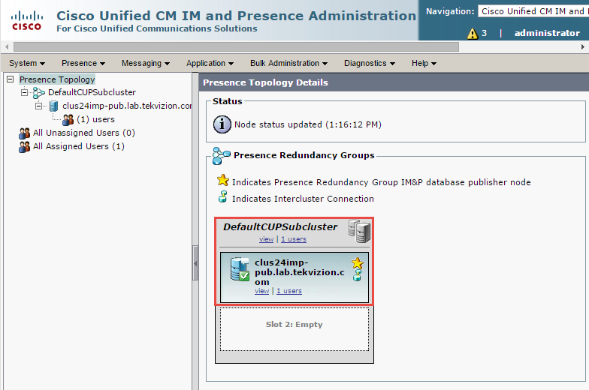

Node Configuration
Navigation: System Presence Topology Fully Qualified Domain Name

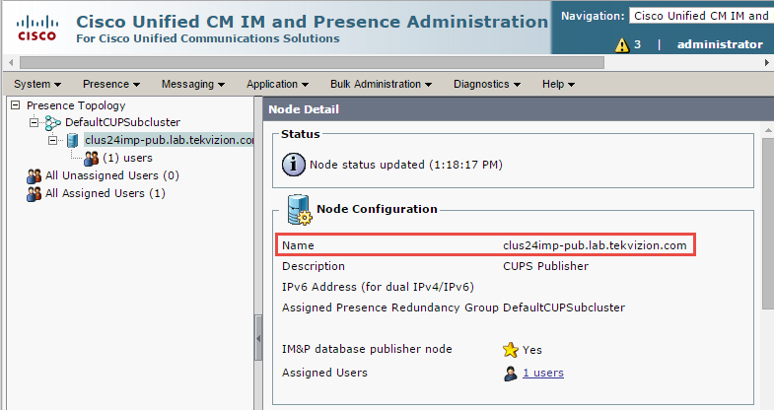

Users
Navigation: System Cluster Topology clus24imp.lab.tekvizion.com Users

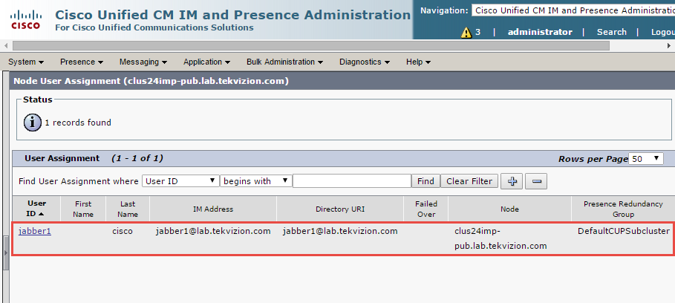

Presence gateway configuration
Navigation: Presence Gateways
Set Presence Gateway Type *= CUCM
Set Description *= Cluster 24. This is used for this example.
Presence Gateway * =clus24pubsub.lab.tekvizion.com
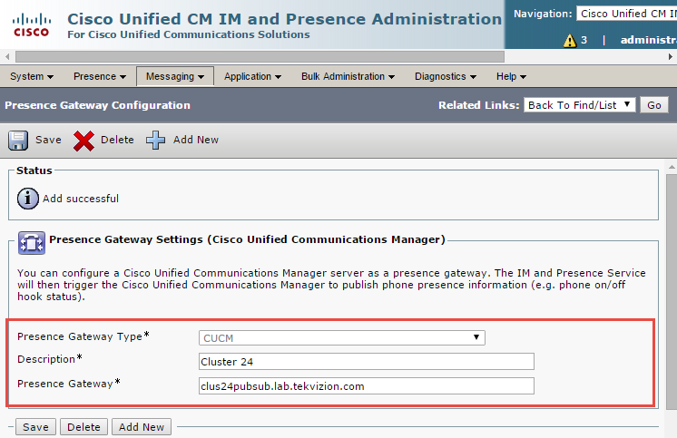

Acronyms
AVPN | AT&T Virtual Private Network
CODEC | Coder-Decoder (in this document a device used to digitize and undigitize voice signals)
Cisco UBE | Cisco Unified Border Element
Cisco UCM | Cisco Unified Communications Manager
IP | Internet Protocol
ISR | Integrated Services Router
MGCP | Media Gateway Control Protocol
MIS | Managed Internet Services
PNT | Private Network Transport
PSTN | Public switched telephone network
SCCP | Skinny Client Control Protocol
SIP | Session Initiation Protocol
SP | Service Provider
TDM | Time-division multiplexing

Important Information
THE SPECIFICATIONS AND INFORMATION REGARDING THE PRODUCTS IN THIS MANUAL ARE SUBJECT TO CHANGE WITHOUT NOTICE. ALL STATEMENTS, INFORMATION, AND RECOMMENDATIONS IN THIS MANUAL ARE BELIEVED TO BE ACCURATE BUT ARE PRESENTED WITHOUT WARRANTY OF ANY KIND, EXPRESS OR IMPLIED. USERS MUST TAKE FULL RESPONSIBILITY FOR THEIR APPLICATION OF ANY PRODUCTS. IN NO EVENT SHALL CISCO OR ITS SUPPLIERS BE LIABLE FOR ANY INDIRECT, SPECIAL, CONSEQUENTIAL, OR INCIDENTAL DAMAGES, INCLUDING, WITHOUT LIMITATION, LOST PROFITS OR LOSS OR DAMAGE TO DATA ARISING OUT OF THE USE OR INABILITY TO USE THIS MANUAL, EVEN IF CISCO OR ITS SUPPLIERS HAVE BEEN ADVISED OF THE POSSIBILITY OF SUCH DAMAGES.

Corporate Headquarters  Cisco Systems, Inc.  170 West Tasman Drive  San Jose, CA 95134-1706  USA  www.cisco.com  Tel: 408 526-4000  800 553-NETS (6387)  Fax: 408 526-4100 | European Headquarters  CiscoSystems International BV  Haarlerbergpark  Haarlerbergweg 13-19  1101 CH Amsterdam  The Netherlands  www-europe.cisco.com  Tel: 31 0 20 357 1000  Fax: 31 0 20 357 1100 | Americas Headquarters  Cisco Systems, Inc.  170 West Tasman Drive  San Jose, CA 95134-1706  USA  www.cisco.com  Tel: 408 526-7660  Fax: 408 527-0883 | AsiaPacific Headquarters  Cisco Systems, Inc.  Capital Tower  168 Robinson Road  #22-01 to #29-01  Singapore 068912  www.cisco.com  Tel: +65 317 7777  Fax: +65 317 7799
Cisco Systems has more than 200 offices in the following countries and regions. Addresses, phone numbers, and fax numbers are listed on the Cisco Web site at http://www.cisco.com/go/offices.

Argentina • Australia • Austria • Belgium • Brazil • Bulgaria • Canada • Chile • China PRC • Colombia • Costa Rica • Croatia • Czech Republic • Denmark • Dubai, UAE • Finland • France • Germany • Greece • Hong Kong SAR • Hungary • India • Indonesia • Ireland • Israel • Italy • Japan • Korea • Luxembourg • Malaysia • Mexico • The Netherlands • New Zealand • Norway • Peru • Philippines • Poland • Portugal • Puerto Rico • Romania • Russia • Saudi Arabia • Scotland • Singapore • Slovakia • Slovenia • South Africa • Spain • Sweden • Switzerland • Taiwan • Thailand • Turkey Ukraine • United Kingdom • United States • Venezuela • Vietnam • Zimbabwe

© 2016 Cisco Systems, Inc. All rights reserved.
CCENT, Cisco Lumin, Cisco Nexus, the Cisco logo and the Cisco Square Bridge logo are trademarks of Cisco Systems, Inc.; Changing the Way We Work, Live, Play, and Learn is a service mark of Cisco Systems, Inc.; and Access Registrar, Aironet, BPX, Catalyst, CCDA, CCDP, CCVP, CCIE, CCIP, CCNA, CCNP, CCSP, Cisco, the Cisco Certified Internetwork Expert logo, Cisco IOS, Cisco Press, Cisco Systems, Cisco Systems Capital, the Cisco Systems logo, Cisco Unity, EtherFast, EtherSwitch, Fast Step, Follow Me Browsing, FormShare, GigaDrive, HomeLink, Internet Quotient, IOS, iPhone, iQ Expertise, the iQ logo, iQ Net Readiness Scorecard, iQuick Study, LightStream, Linksys, Meeting Place, MGX, Networking Academy, Network Registrar, Packet, PIX, ProConnect, ScriptShare, SMARTnet, StackWise, The Fastest Way to Increase Your Internet Quotient, and TransPath are registered trademarks of Cisco Systems, Inc. and/or its affiliates in the United States and certain other countries.
All other trademarks mentioned in this document or Website are the property of their respective owners. The use of the word partner does not imply a partnership relationship between Cisco and any other company. (0705R)
Printed in the USA

Hide signaling and media peer addresses from endpoints other than gateway.
If the mode border-element command is not entered, border-element-related commands are not available for Cisco Unified Border Element voice connections on the Cisco 2900 and Cisco 3900 series platforms with a universal feature set. The mode border-element command is not available on any other platforms.
This command enables Cisco UBE basic IP-to-IP voice communication feature.
This command allows SIP error messages to pass-through end-to-end without modification through Cisco UBE.
This command enables delay offer-to-early offer conversion of initial SIP INVITE message to calls matched to this dial-peer level.
This command must be enabled at a global level to maintain integrity of SIP signaling between AT&T network and Cisco Unified Communications Manager (Cisco UCM) across Cisco UBE.
This command allows for privacy settings to be transparently passed between AT&T network and Cisco UCM. This command can either be set at a global level, such as in this example, or it can be set at the dial-peer level.
This command configures the codec preference to be assigned to dial-peers. Alternatively, single code can be configured into individual dial-peers.
This SIP profile expands the Diversion header number from a 4-digit extension to a full 10-digit DID number in order to obtain interoperability with AT&T’s served users during call-forward scenarios. The six digits in "sip: 732216" are variable and must be replaced with the first 6 digits of the DID's provisioned for the customer site.
Cisco 6900-series IP phones use ptime value of 20 ms. AT&T networks prefer ptime value of 30 ms. This SIP profile modifies SDP ptime value from 20 to 30 ms and it should be applied to dial-peers where G729 is the preferred codec. If the customer creates a dial-peer specifically for G711, a sip-profile without modifying the ptime value should be applied. This is because G711 RTP was not defaulting to 20ms.
This SIP profile is required in order to advertise the ptime=30 attribute in the outgoing SIP INVITE from Cisco UBE to AT&T. Currently RFC’s do not have a standard method to advertise ptime values for each offered codec within a SDP offering with multiple codecs. This SIP profile allows for Cisco UBE to include the ptime attribute with a value of 30ms.
This command used to convert 4 digit to 10 digit in contact header otherwise ATT will send 6xx error response while executing network related feature.
WAN interface to AT&T
LAN interface to Cisco UCM
Cisco UBE LAN interface IPv4 Address
Dial peer for AT&T facing network
Session protocol SIPv2 is used for this testing
Assigns voice class codec 1 settings to dial-peer (codec support and filtering).
Configures the dynamic SIP asymmetric payload support.
This command allows for privacy settings to be transparently passed between AT&T network and Cisco UCM. In this example, the command is set at the dial-peer level, you can also set the command at a global level to affect all dial-peers without necessarily setting the command on each dial-peer.
This command enables the dial peer to use SIP profile 1
Configure the Cisco UBE SIP messaging to use the HSRP virtual address in SIP messaging. Once HSRP is configured under the physical interface and the bind command is issued, calls to the physical IP address will fail. This is because the SIP listening socket is now bound to the virtual IP address but the signaling packets use the physical IP address, and therefore cannot be handled.
This command used to pass RTP NTE (RFC2833) DTMF with respect to the dial peers used for the call.
This command enables T38 fax protocol for calls terminating on this dial-peer

